**DRONE GUARDS AND OTHER FLIGHT TIPS**

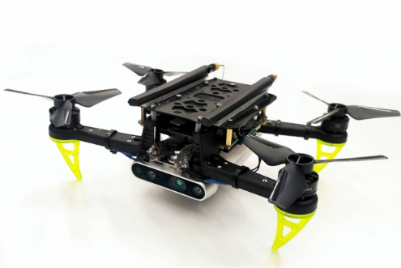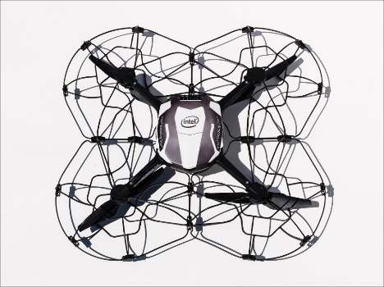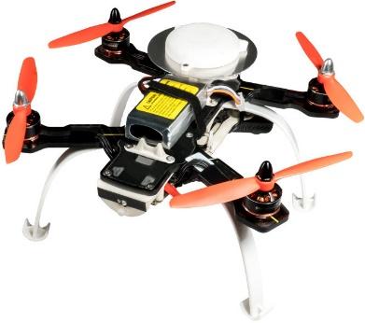

This tutorial is meant to cover the **maintenance procedures** for drones, based on my experience with a custom build and the Crazyflie drone. Some areas prone to problems are:

* Battery care
  + How-to-charge: explanatory videos
  + How to store: in a fridge else in a secluded space
* Propeller care
  + Balancing propellers

Propellers can create problematic vibrations in the drone, leading to wide ranging effects from drone stability, to an unnecessary drain on the batter. The propellers should be **checked** for damage, bending and unbalance. There are multiple procedures to balance propellers, of which my favourite:

* Balancing propellers using an application for drone vibration tests.
  + Buying spares
* Designing robust drone guards
  + Existing designs
* Motor care
  + Main risks to look out for
* Safekeeping the ESCs.

Some drone maintenance specific to the Crazyflie:

* Links to Crazyflie drone guard
* Added protection
* Drone vibration testing
* The optic flow deck
  + Main issue with current hardware.

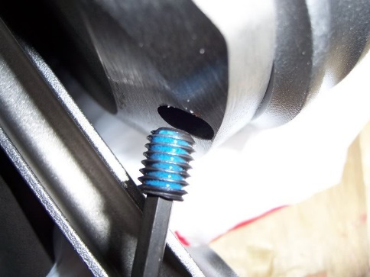

Loctite thread locker.

Further work that can be done:

