**ARENA MAINTENANCE**

This tutorial is meant to cover **the procedures used to take care of the Fablab drone arena.** In doing so, all the necessary equipment should be in the Fablab, unless indicated otherwise.

Last updated: August 2020.

# EQUIPMENT OUTLINE

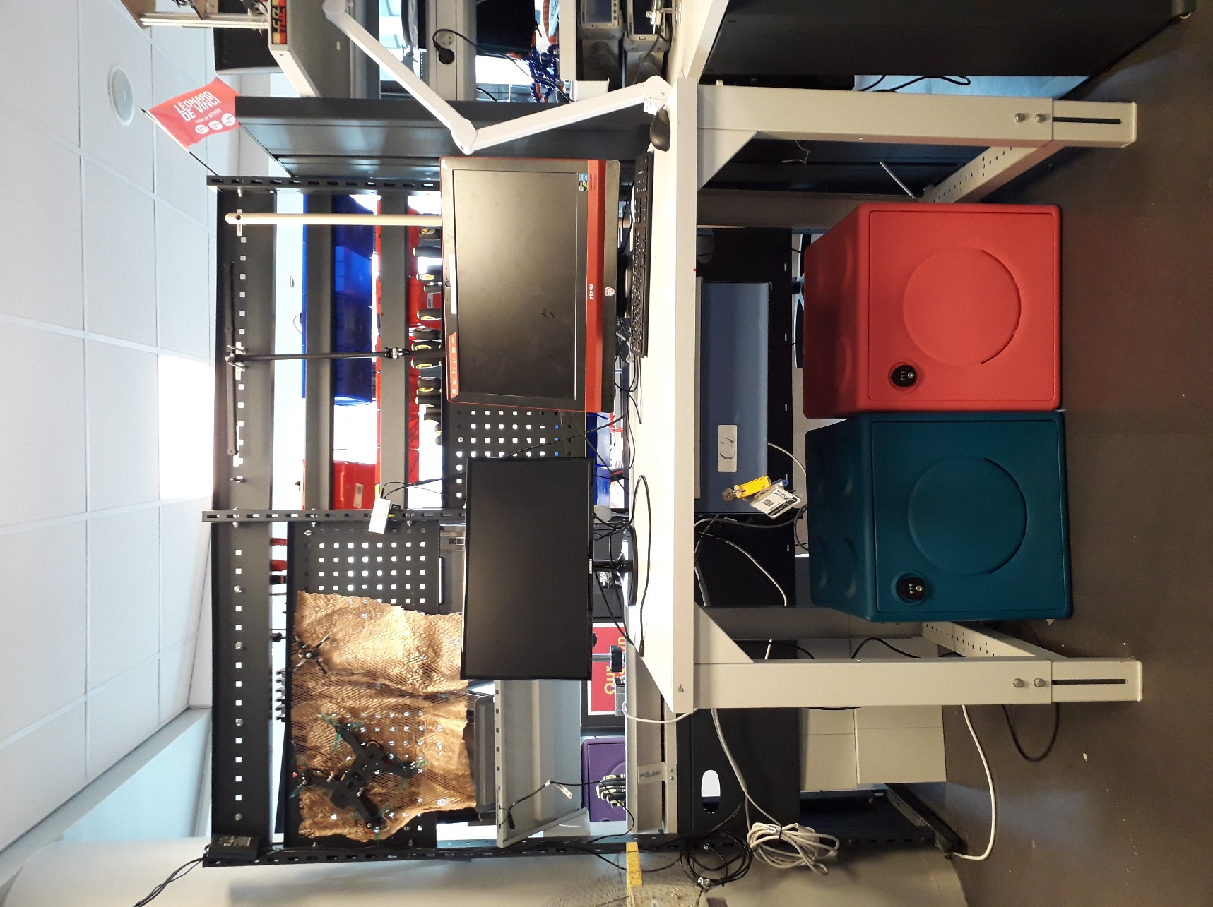

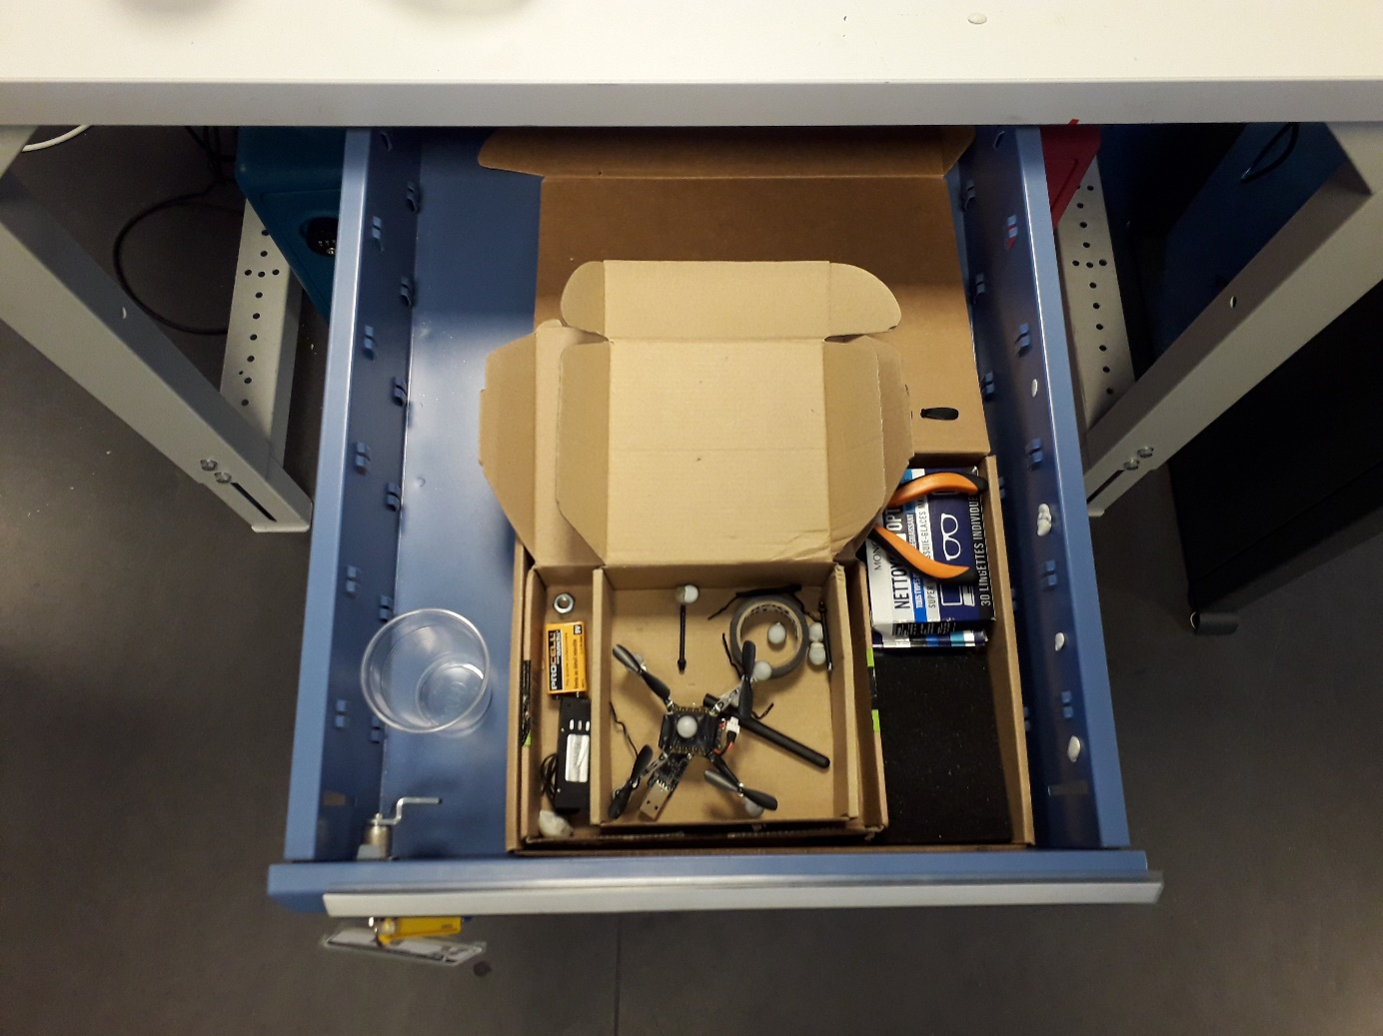

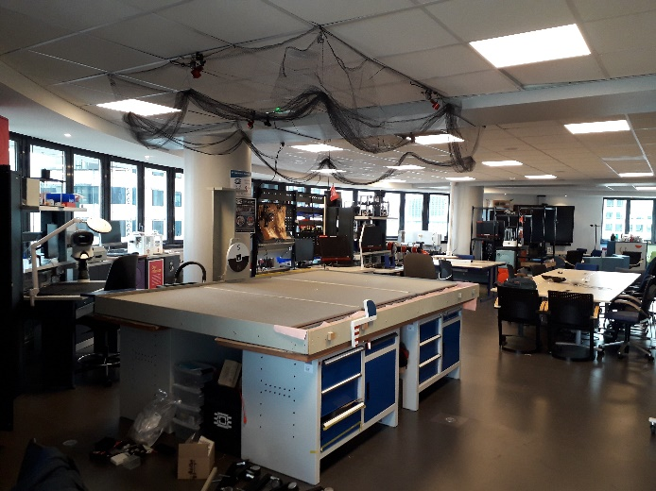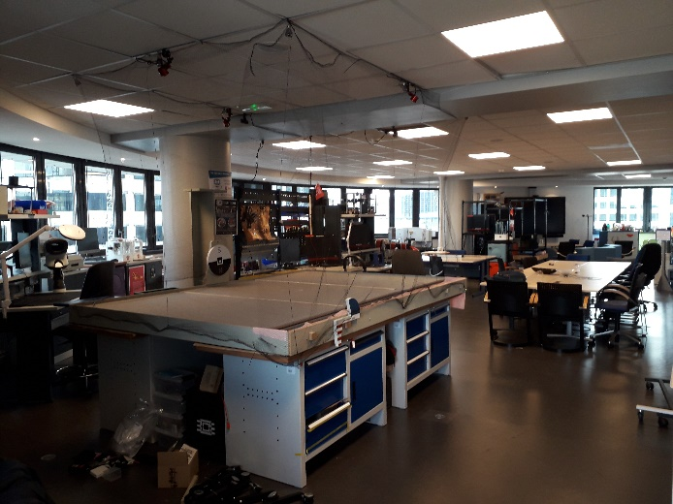

# OPTITRACK SETUP

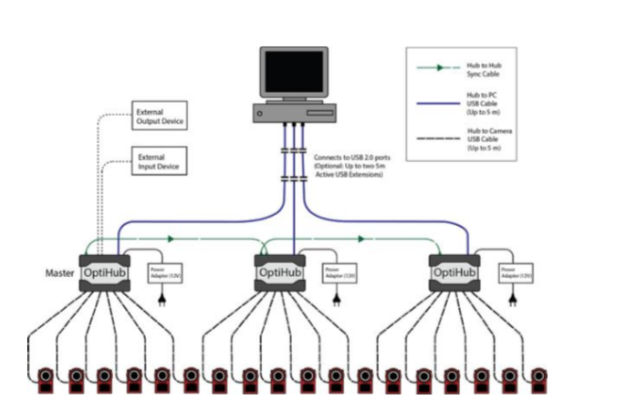

A general layout is offered here. For a quick start-guide, and more precision capture tips, consult the Optitrack tutorial below.

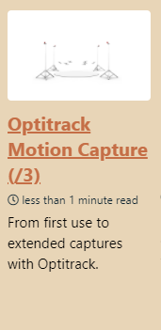

# GENERAL MAINTENANCE INSTRUCTIONS

* The netting is well attached (pulled back from the cameras, no disturbance by pully system)

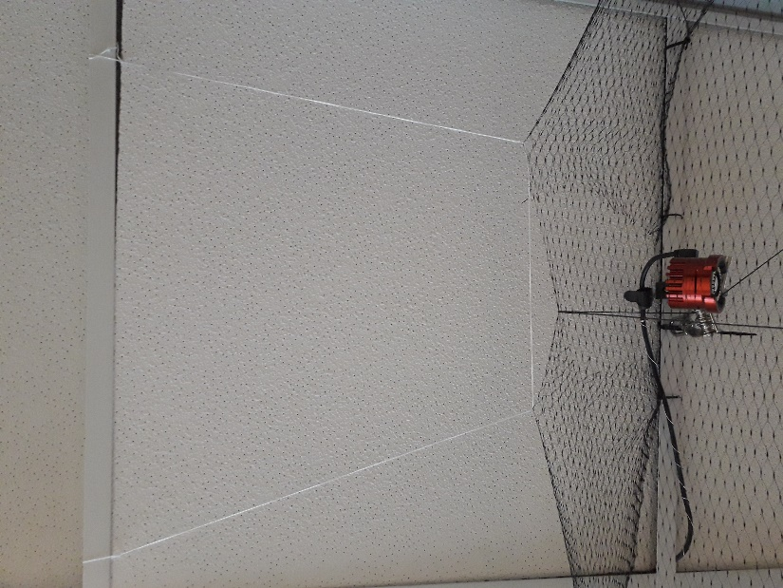

* The cameras are connected correctly (no tension in the cables)

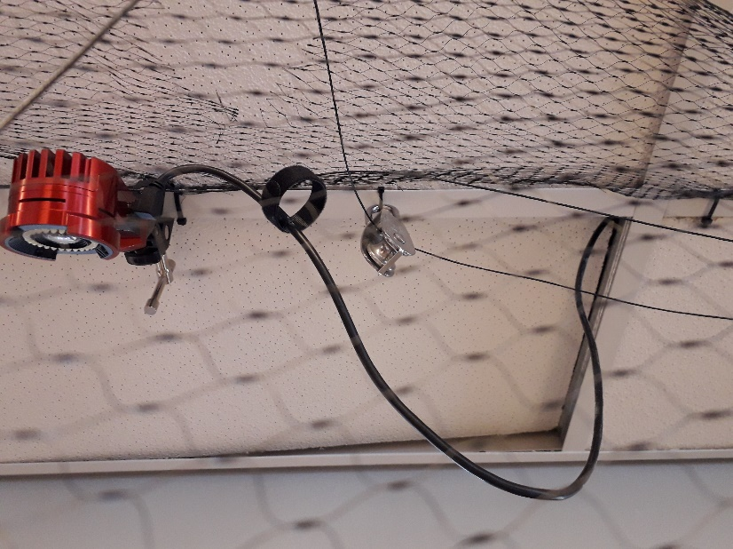

* The USB datahub has the correct flashdrives attached (necessary for use of Motive)

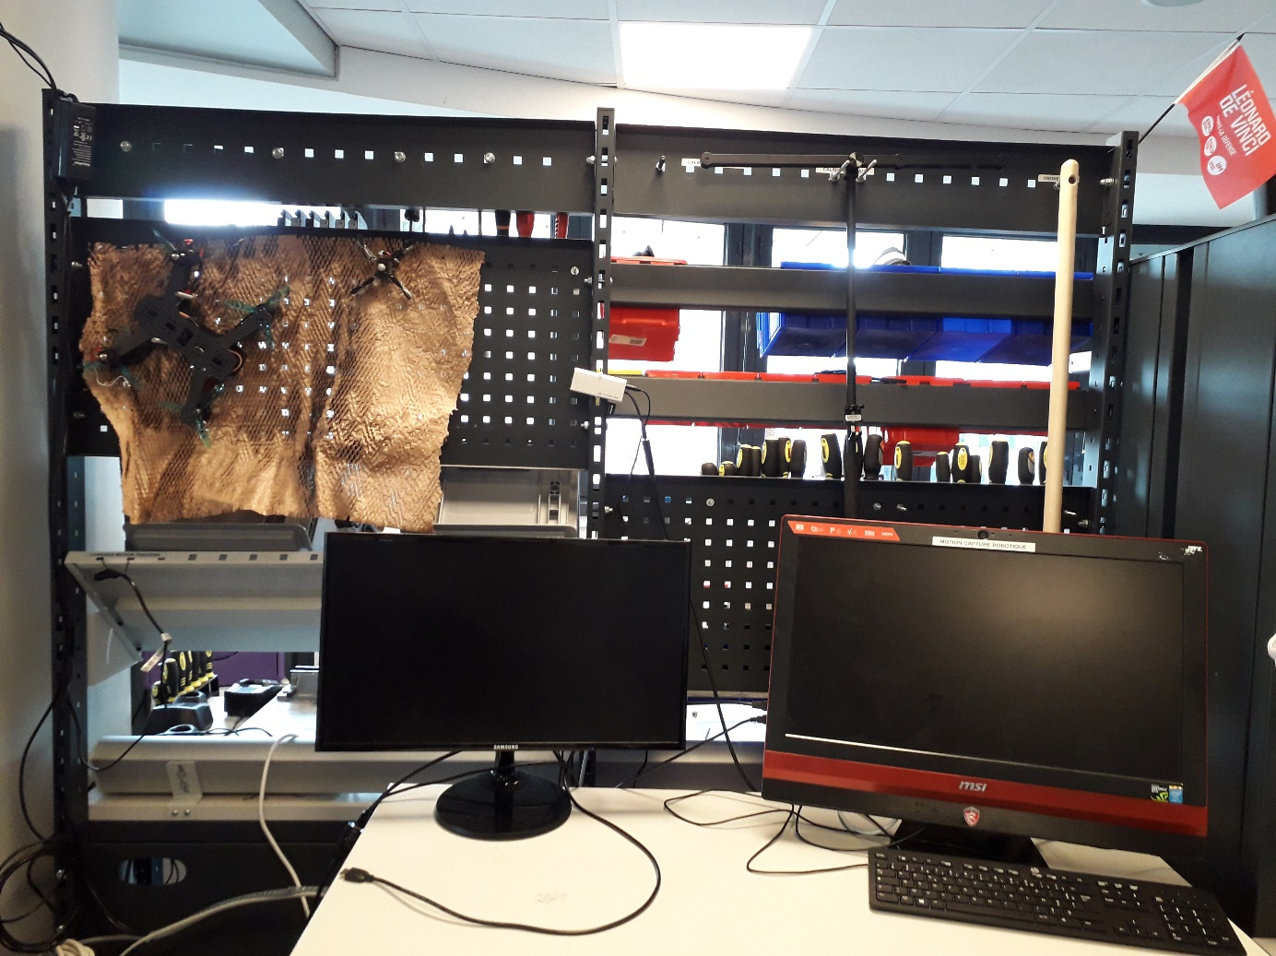

* The system is disconnected after use.



# USE OF THE TABLE

* 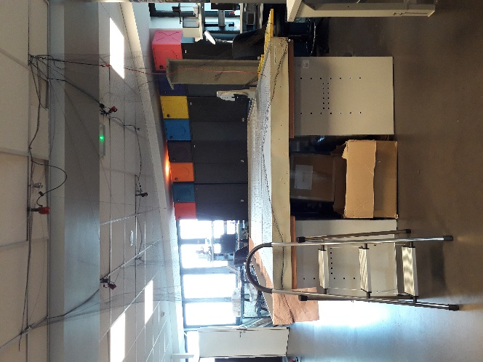The sides of the drone flight table are left undisturbed.
* The camera lens are focused for the correct distance (done after a new configuration)
* **Walking on the table** is not advised (**a stool** is intended for this use). Walking on the table should only be done to **change camera locations**. If necessary, use the right pressure points according to the table supports.
* Remove any reflective objects from the table. This is partly why the table is covered with a cushy layer. Make sure to cover any remaining spaces, as the table itself is reflective.

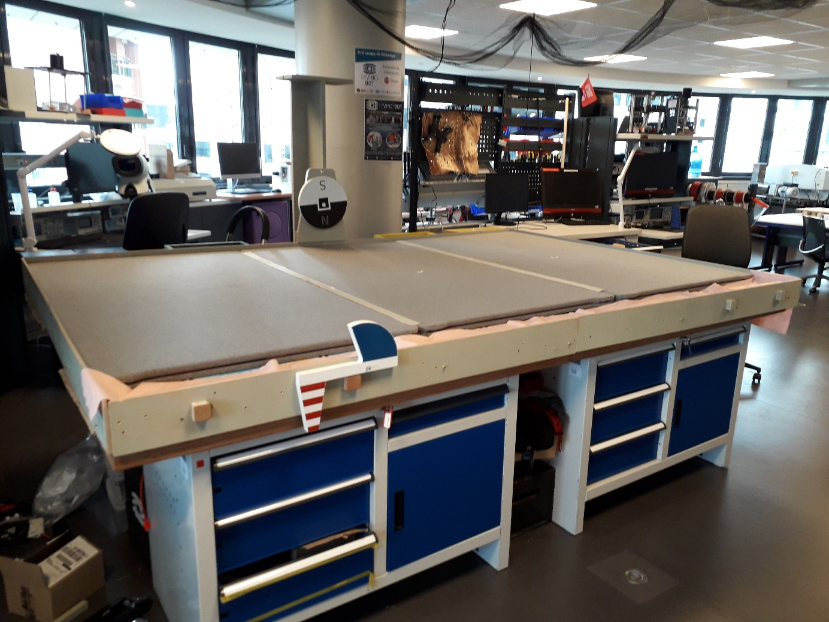

* Always **close the roof tiles after use**.

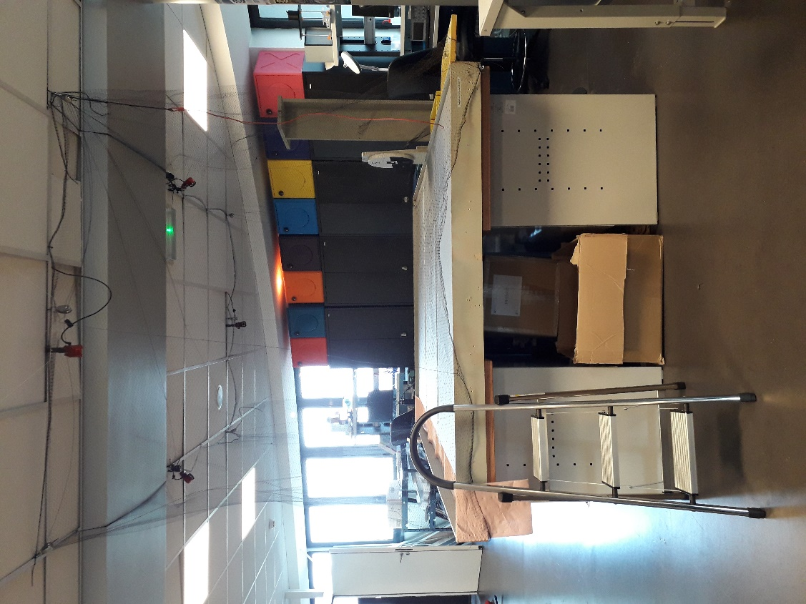

# EXPERIMENTAL SETUP: WEAKNESS POINTS

The setup is still experimental. It has a few issues that should be temporary:

* The net is attached to the table via screws. Do so delicately so to add no necessary pressure to the pulleys nor the table.
* The sides of the table are falling apart. Do not push them too hard. Adding screws **will worsen** the problem.
* Be aware that the string sometimes gets jammed in the pulley mechanism.



For the moment, the table is covered with room separators. Square blocks are meant to arrive to replace these. These room separators have just the right colouring for optic flow. However, the spaces between separators needs to be covered with tape **for optic flow**.

