**AUTONOMOUS DRONES**

This is a brief introduction to the field of autonomous drones. We are awaiting the next breakthrough in AI: to be able to pilot a vehicle better than a human can. In novel and challenging environments, a vehicle can easily get lost, use up all its energy or collide into other objects. The faster the vehicle can problem-solve, the faster it can safeguard the passengers. Split-second decisions can make all the difference.

This tutorial presents the field of autonomous drones to absolute beginners. It takes three axes: first, with a race that revealed the state of the art. Then, with a podcast that describes the daily life of an autonomous engineer. And finally, with a testing platform that shows what is possible in this field.

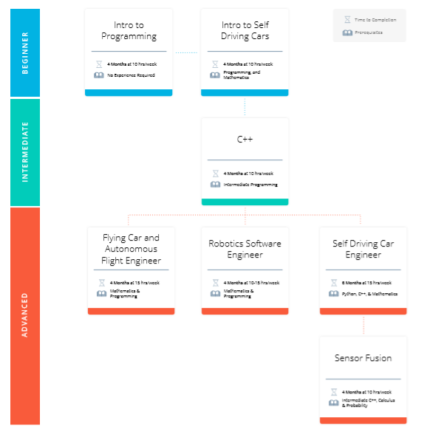

Table of Contents

AUTONOMOUS RACING DRONES 2

INTROSPECTIVE ROBOTICS 2

FLIGHT TESTS WITH FLIGHTGOGGLES 2

# AUTONOMOUS RACING DRONES

In Alpha Pilot, researchers race a drone through an obstacle course, and I train it using various forms of artificial intelligence. By bringing drones to their physical limits, they can serve as a testing ground for better decision-making and energy-efficiency in autonomous vehicles. This video looks into one paper in detail: the development of the winning drone. This recent competition thus brings to light the state of technology in the top robotics research laboratories.

My video: <https://www.youtube.com/watch?v=1FG0wuAW1hM>

# INTROSPECTIVE ROBOTICS

The way Nathan Michael describes it, this is a field that consists of managing robots subject to making decisions autonomously. His clear explanation of the different elements is something worth listening to once or twice. Published in August 2020.

Robohub Podcast, #316: Introspective Robots, with Nathan Michael.

[http://feedproxy.google.com/~r/robotspodcast/~3/jjy-sPGni_o/](http://feedproxy.google.com/~r/robotspodcast/~3/jjy-sPGni_o/?fbclid=IwAR0hx4PAyt9SZ7MAA1lOH0YgBrAnxkUDcIpvhJvqBztIHqznSPM9tCYvbWo)

<http://feedproxy.google.com/~r/robotspodcast/~5/Ye36blU5EV4/872981128-robohubpodcast-introspective-robots.mp3>

# FLIGHT TESTS WITH FLIGHTGOGGLES

Sertac Karaman is an MIT Professor that has used a virtualised environment to test drone algorithms. This video and many more, can give you an idea of what possibilities we have in a field called **crossreality**: to be able to interact with virtualised environments.

<https://www.youtube.com/watch?v=24175-D8qZI&ab_channel=SertacKaraman>