## #Flight scripts

Procedure to be found here:

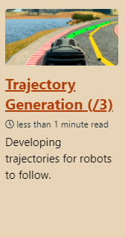

**A proprietary Python library** can get the Crazyflie up and going and is also used to control swarms of Crazyflies. The python client runs on a PC and communicates via CRTP, where it can monitor robot battery voltage level, flight state and aid with bootloading especially as large swarms become more difficult to manage.

* FLYING THE CRAZYFLIE PROJECT

The crazyflie_ros framework helps wrap CRTP within a ROS framework, which is useful for scenarios of **hovering** and **waypoint following** from a **single robot** to the more complex multi-UAV case.

**Theoretical underpinnings**

**crazyflie_ros: Flying Multiple UAVs using ROS**

<http://act.usc.edu/publications/Hoenig_Springer_ROS2017.pdf>

The external CrazySwarm project is a **lower latency framework** that has gradually been extended to **incorporate external localization systems** such as VICON or Optitrack.

Link to tutorial:

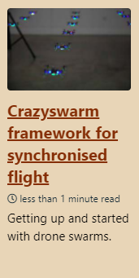

The **modularity** of this platform gives the Crazyflie extra capabilities in sensing, positioning or visualization. See website for more on the LED ring, an AI chip coupled to a small camera, an optic flow deck, etc.