**CHANGELOG: DRONE MAINTENANCE**

Last updated: August 2020.

This tutorial is meant to cover the **maintenance procedures I have adopted** for a custom build and the Crazyflie drone. Some areas prone to problems are:

Table of Contents

Crazyflie 2

Assembling the Crazyflie 2

Protecting the Internals 3

Interacting with the Crazyflie 3

1. Carry it by the guards 3

2. Use a soft surface in contact with it: drone stick covered with fabric. 4

3. Using gloves to catch it: gloves with trackers included. 4

4. Gets smoothly trapped in the net 4

Storing the Crazyflie 4

Propeller care 5

One solution: balancing the propellers 5

Another method is to buy spares, else print one’s own propellers. 5

Optic flow deck 5

FPV Build 5

Battery care 5

Other 6

# 

# Crazyflie

Some drone maintenance specific to the Crazyflie 2.1 available at the lab.

**MEASURES CURRENTLY IN PLACE TO TAKE CARE OF THE CRAZYFLIE**

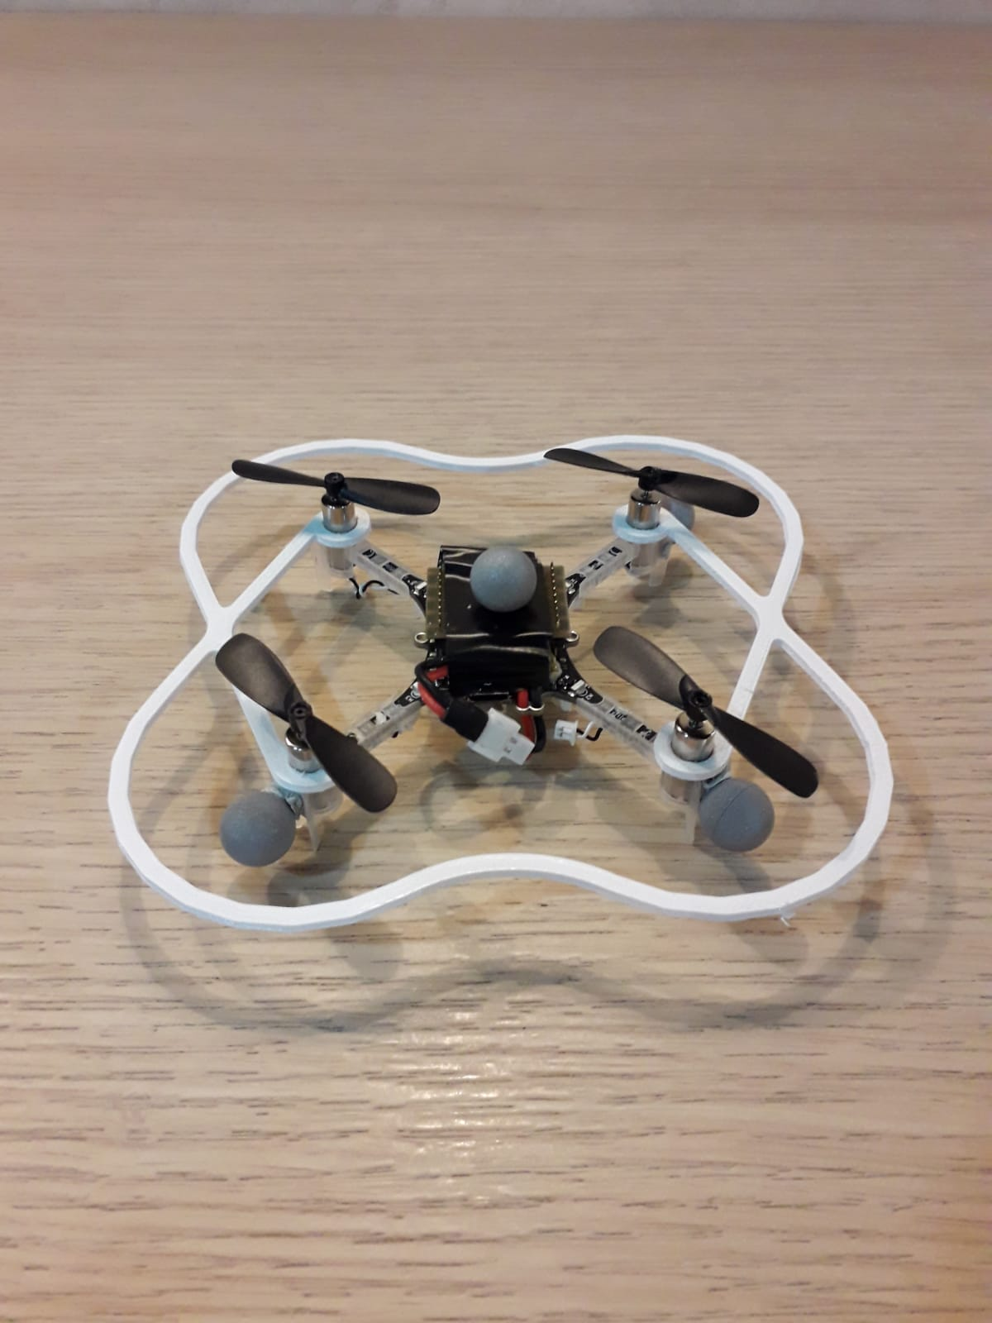

## Assembling the Crazyflie

* + Instructions online: <https://www.bitcraze.io/documentation/tutorials/getting-started-with-crazyflie-2-x/#assembling>

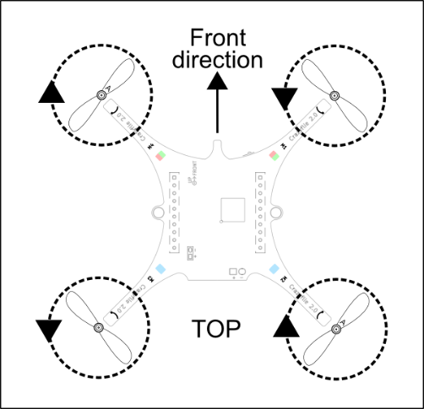

## Protecting the Internals

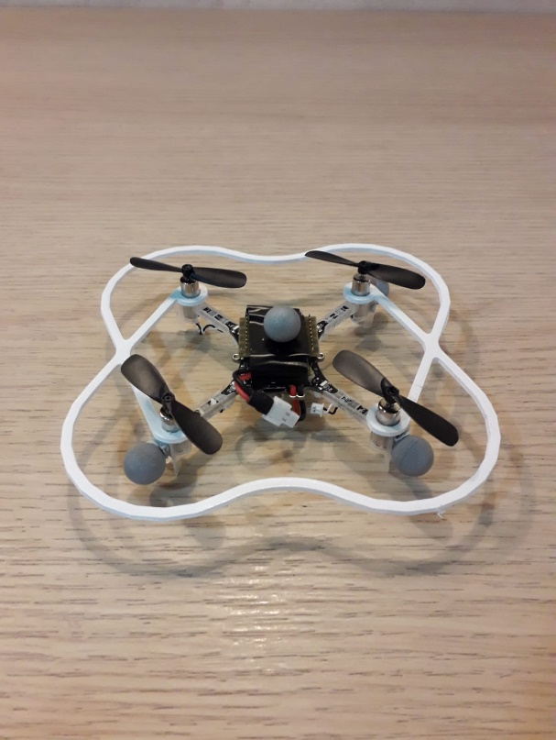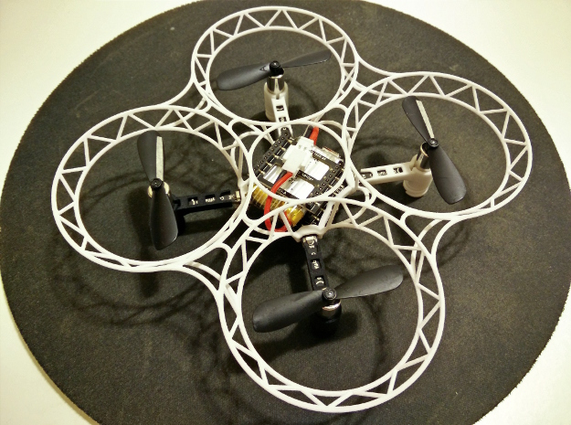

Left: publicly available model used on current Crazyflie.   
Right: private model that I’d like to replicate at some point, accessible at:  
<https://www.stlfinder.com/model/crazyflie-2-0-prop-guard/5102793/>

## Interacting with the Crazyflie

### Carry it by the guards

There are two points of contact where the guards are at their most rigid:

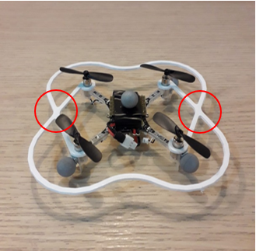

### Use a soft surface in contact with it: drone stick covered with fabric.

A drone stick is hung behind the control setup.

### Using gloves to catch it: gloves with trackers included.

Catch it by the guards!

**Note:** here’s an idea for hanging the gloves!

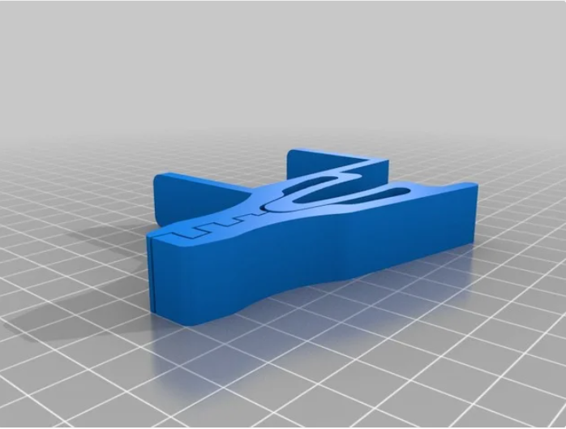

### Gets smoothly trapped in the net

## Storing the Crazyflie

* + Hung by the guards
  + Stored in a box

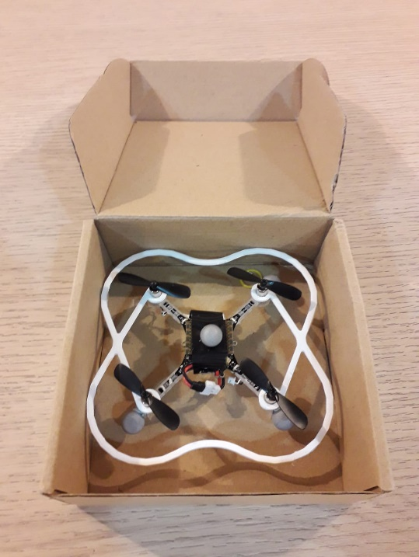

## Propeller care

Propellers are the first thing to break on a drone. In fact I have already damaged three propellers on my initial Crazyflie, and I am hoping to avoid any further damage. But it is inevitable, especially when executing complex flight behaviours. The best measures we have are preventive, otherwise corrective. And the best place to record these solutions, is on this tutorial.

### One solution: balancing the propellers

Propellers can create problematic vibrations in the drone, leading to wide ranging effects from drone stability, to an unnecessary drain on the batter. The propellers should be **checked** for damage, bending and unbalance. There are multiple procedures to balance propellers, of which my favourite:

<https://www.youtube.com/watch?v=nPY9etsSgjk>

“My way to Balance Motor for Quadcopter and Tricopter”

### Another method is to buy spares, else print one’s own propellers.

If someone is interested by this, go for it! However the research is scant:

* 3D printing in PLA, and then applying a **cold acetone vapor treatment.** Acetone vapor deposits on the surface of the 3D printed object, fuses the layers further, and gives it a smooth glossy finish. More at <https://www.instructables.com/id/3D-Printed-Propellers/>.
* Printing in resin: a more common take here: <https://formlabs.com/blog/diy-3d-printed-drone/>

## Optic flow deck

* Storage in a box
* Join Fragility, see issues

# FPV Build

Some drone maintenance specific to FPV Builds:

## Battery care

* + How-to-charge: beginner’s guide <https://www.youtube.com/watch?v=90C_LzpPBwc>
  + How to store: in a fridge else in a secluded space i.e. a box

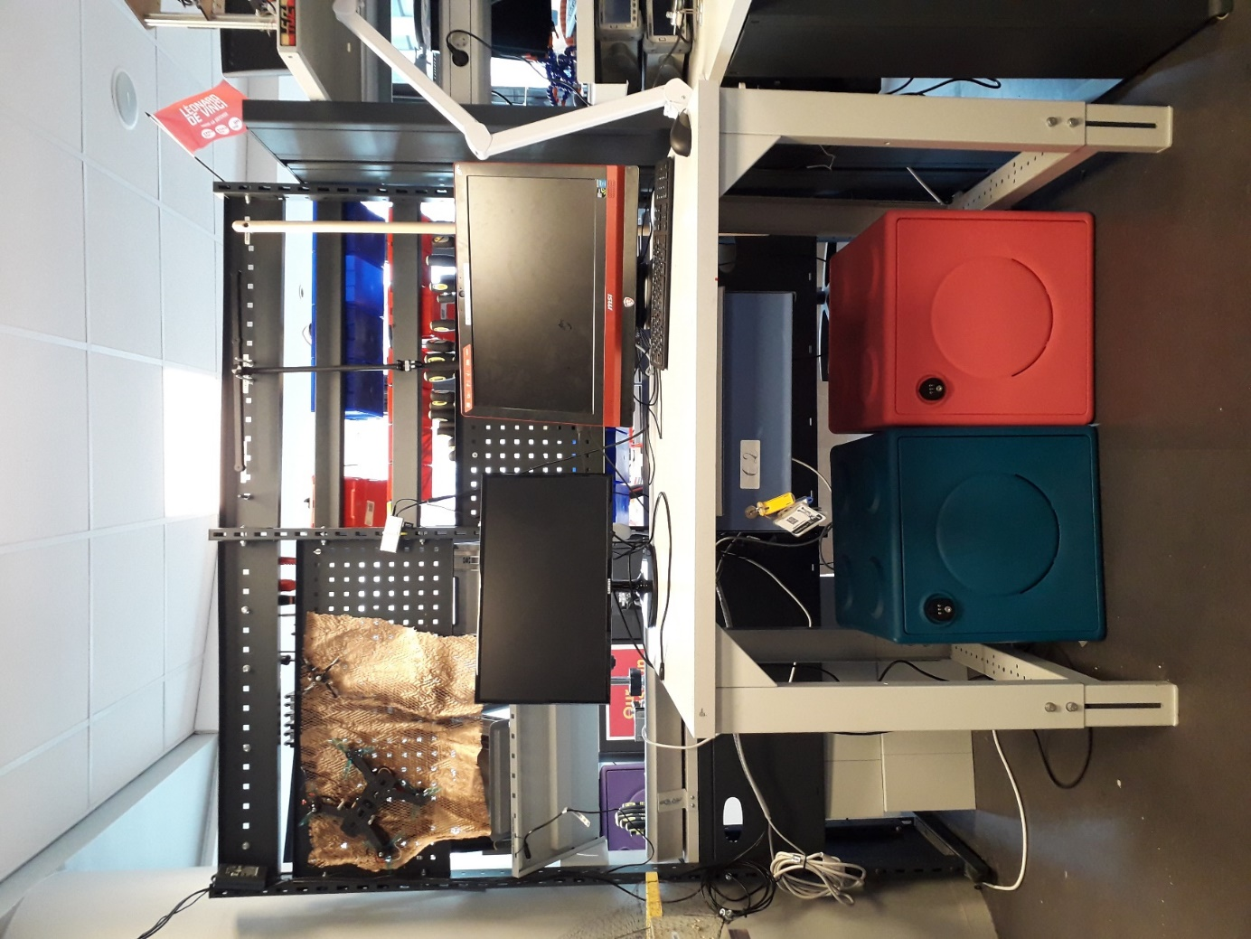

## Other

* Motor care
  + To be expanded.
* Safekeeping the ESCs.
  + To be expanded.