**DIY DRONE GUIDE**

**Contents**

1. **Background:** structure of a drone.
2. **Deeper understanding:** an intuitive understanding of the effects of physics.
3. **Advanced:** for now, links to other resources.

This tutorial is meant to cover **the technological intersection of First Person View drones.** In doing so, this tutorial examines each technology involved in FPV drones, and how it affects the system as a whole. This **deep dive** is necessary considering the amount of **confusion** online about FPV drone components, a confusion often exploited by companies selling **lower quality content**. The typical fpv drone has the following technologies:

* **A LiPo battery**

It delivers high energy density and a high discharge rate for relatively little weight.

* **A flight controller**

It runs a high-frequency control loop and integrates its measurement of drone pose data.

* **High frequency ESCs.**

Electronic speed controllers ensure **reliable** and **smooth** motor behaviour.

* Brushless DC Motors
* A signal receptor for radio control
* A signal transmitter for radio control
* A high-speed camera

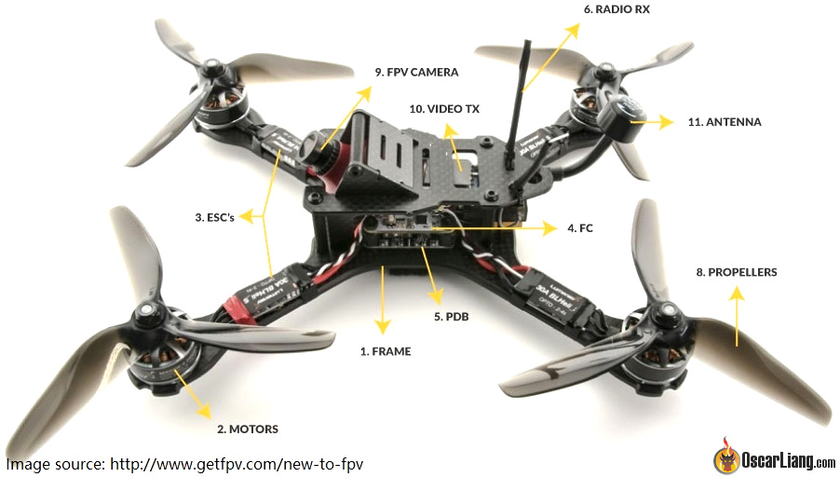

Each of these technologies is limited by **their intrinsic architecture**. Coupled with one another, we can derive a better understanding of the **interaction between power, weight and energy constraints.** This will serve to understand component specifications in future references.

**Quick links**

Quick drone guide: <https://oscarliang.com/fpv-drone-guide>

This includes “How to choose” for each component. My tutorial only serves as a general guideline.



# Different approaches to building a custom drone

In our case, we wish to build a custom drone from scratch. This is naturally going to require some understanding of all the technologies and their **inherent designs**, such as motor windings affecting drone **responsiveness** and **stability**, but also its **durability** given the wear and tear.

There are multiple approaches online. One is the PWR or **Power-to-Weight ratio**. It consists of ensuring that the motor-propeller combination can deliver a sufficient amount of **drone thrust**, first to overcome the drone’s gravity, and then to reach thrust ratios of 2:1 (gentle flying), 5:1 (FPV) and up to 15:1 ratios for top drone racers.

# Process to follow

The conventional way of building a drone is the following:

1. Choosing a **frame size**, which is going to limit the **propeller size**.
2. Then, a **set of propeller sizes** are coupled to the **motor size**. Choosing the propellers and following with the right **torque**-**speed** curve depends very much on the **flying style**, and an estimation of **flight time** might be useful to choose the best motor-prop combination.
3. Since the motors make up most of the drone’s **energy consumption**, this offers a good estimation of **voltage and current draw**. A type of ESC is then coupled with the choice of motors.
4. A suitable battery can then be selected, and the **energy that is delivered** is measured against other batteries based on energy stored, rate of discharge, **weight, size** and **current thresholds.**

A drone seller, like StudioSport here in France, will offer different types of drone based on what works with your equipment stack. Beginners might be tempted by the **RTF** (Ready To Fly) drone, or, if you have your own **batteries**, the **PNP** (Plug and Play) might come out just as useful. Finally, the **DIY** (Do It Yourself) drones need to be assembled **and** powered.

All in all, batteries are expensive. Drone enthusiasts might want to go a step further to find the optimal battery over a number of factors. A tutorial here will test **a single drone** with flight times at **different loads.** This is used to determine a discharge rate for different weights and create a **model of the flight time of the drone for other batteries on the market.**

# Drone flying style

Flying style isn’t all that relevant for autonomous drones as it is for drone pilots, however it hints at fundamental physical processes that should be mentioned as they have large effects going forward.

There are three main types of flying styles: **freestyle**, **racing** and **long-range**. As the names suggest, freestyle incorporates a lot more **agile flight**, while racing capitalises on **high speeds** and long-range is more relaxed with **smoother manoeuvres**. Flying styles are not to be confused with drone sizes, since, against what we might think, incredibly large X-sized drones can be flown freestyle while much smaller mini quads (5’’) can be flown long-range.

The “feel” of a drone or should we say, its **responsiveness,** will vary with any increase in **weight**, but it is also affected by the amount of **torque** on the motors, and the **angle of attack** of the propellers. These are topics worth covering in some detail to better understand how drone dynamics will play a part in our final designs.

# How does weight affect responsiveness?

Since motors are set up on the edges of the drone, they greatly increase the drone’s **angular** moment of inertia. As a result, the drone is **less responsive**: it takes more time to pick up angular acceleration, to move to the desired position and stop. This may be a desired behaviour – but this comes with a risk of the pilot **working the drone harder** to get the change in attitude, and the drone having to **weather frequent voltage spikes.** Voltage spikes is a phenomenon that we should design to avoid.

Larger batteries also come with their set of constraints. They offer longer flight times, but they lose agility (they “fly like a tank”).

Propellers that are steeper-angled offer more lift while flat-bladed props move through the air easier.

**POINTS TO ELABORATE LATER**

# Choosing your motors

Motor efficiency will **traditionally** be given as the **thrust to power** relationship for a specific motor, coupled to a specific propeller, when pushed to top throttle.

What is thrust to power?

It is the case for some motors that their efficiency is actually greater at lower throttles and decreases with increasingly high throttles.

Choosing a good motor is a tricky process. Manufacturers will not mention certain factors that might vary from one identical motor to another, at different atmospheric conditions etc.

MotorTestBench is an independent testbench for reputed brands of drone motors. As part of their work, they create empirical voltage-rpm charts for each motor, explored with a variety of propellers. This empirical relationship is still the most reliable resource for motor specifications.

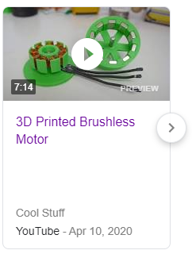# How to approach voltage spikes?

Voltage spikes have effects throughout the quad.

* The ESCs m

Current overshoots also have effects on the quad.

* ESCs must be rated for the maximum current of the motors.

# Designing one’s own motors

It’s possible to 3D print one’s own brushless DC motors.

However, custom motors will need accurate tuning to reach the **performance** of motors currently on the market.

A better understanding of DC brushless motors will make this more clear.

Bibliography

An amateur FPV channel that has caught my eye is RotorRiot. Not only do they test novel drones, but they have worked on a series of tutorials for beginner purchase of drone parts, they compare the methods of independent drone racers, and even more, they have a simulator called Liftoff that has become the practice simulator of choice.

An advanced FPV connoisseur is Oscar Liang, whose reviews of drone components are poignant and to the point.