**LINUX AND ROS BASICS**

This tutorial is meant to cover the **foundational techniques of Unix and ROS used to develop and debug code.** As I have explored the field of robotics, I have often learned the hard way not to dive straight into things – often taking a step back can be rewarding, and even more when someone can give you the correct content – effortlessly.

Unix: A beginners guide to the **Unix** and **Linux** operating system. Eight simple tutorials which cover the basics of UNIX / Linux commands.

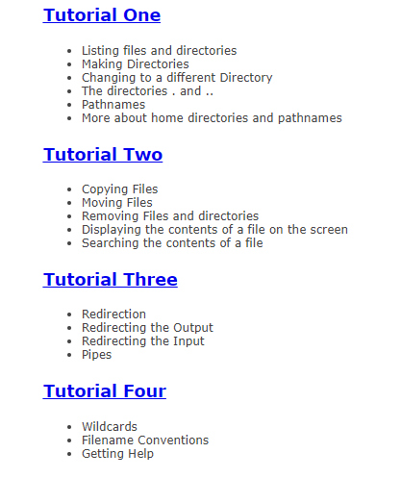 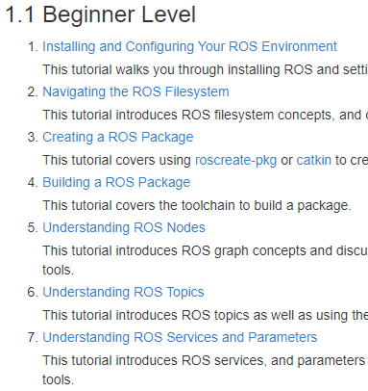

ROS: Tutorials front page. The ROS filesystem is fundamental, and stumbling into robotic development is ill-advised. Once you have done so, feel free to use the cheatsheets you can find here:

<http://air.imag.fr/images/f/f7/ROScheatsheet.pdf>

<https://clearpathrobotics.com/ros-robot-operating-system-cheat-sheet/>

