# An introduction to Optitrack Motion Capture

To get up to speed with Optitrack, you have 3 tutorials depending on your needs. Beginners who wish to use the setup unsupervised should look into **this Introduction to Optitrack**. Precision-dependant scenarios will make use of **the Optitrack changelog**. The changelog is where I compiled my list of issues with Optitrack. Finally, the long-term users might be interested in simplifying maintenance and capture processes with **the official changelog for arena maintenance**.

Last updated September 2020. Please contact me at [thomas.carstens@edu.devinci.fr](mailto:thomas.carstens@edu.devinci.fr) for any questions or system support.

**Part of a series**

1. **An introduction to Optitrack**
2. **DVIC Changelog**
3. **Arena maintenance**

## Gentle introduction

Motion capture is a discipline that consists of capturing elements in a 3D space and reconstructing the space virtually from such elements. Optitrack is frequently used in research in order to localize a object precisely without an internal localization mechanism.

### 

There are various applications when tracking real bodies, from sports and medical research, to interacting with virtual environments. An interesting application is the videogame God of War 4, one of the first games that based the character movement on that of real-life actors.

<https://www.youtube.com/watch?v=fm-A1lknrxE&ab_channel=FullSailUniversity>

My particular application uses position estimation for drone control. The position and orientation of each body is streamed into the ROS framework over the local network.

<https://www.youtube.com/watch?v=76VtqBVPX9E&ab_channel=InfiniumRobotics>

**Why use Optitrack for robotics?**

While the motion-capture system creates a single point of failure, we chose it over alternatives due to its high performance: typical position errors are less than one millimeter. In comparison, a state-of-the-art decentralized localization system using ultra-wideband radio triangulation showed position errors of over 10 centimeters, too large for dense formations. While vision-based methods are both accurate and decentralized, the required cameras and computers necessitate a much larger vehicle.

### Optitrack: Documentation and communities

Optitrack is a company that offers its own motion capture setup. The hardware setup and the software solution are both available as a package purchase. To use the Optitrack motion capture system, you will find information in these places.

* the online docs are very approachable. There is also a series of Youtube tutorial videos. However, be aware that these documents are deprecated at times, nevertheless they offer an overview of the technology as a whole ie. Optical motion capture.
* a gentle introduction to Motive (the PC software): interfacing with the cameras (covered), editing 3D reconstructions for optimisation (not covered), more functionality is available.
* The customer support is fast (under a day, remembering the time difference). Contact them at forums.naturalpoint.com.

## Foundational principles of optical motion capture

**Optical motion capture** uses reflective trackers coupled with infrared sensors. The tracking elements or trackers are small reflective balls. A camera pointed towards the tracker outputs infrared light via its LED illumination ring. The lens at the center of the ring capture any and all IR incoming light.

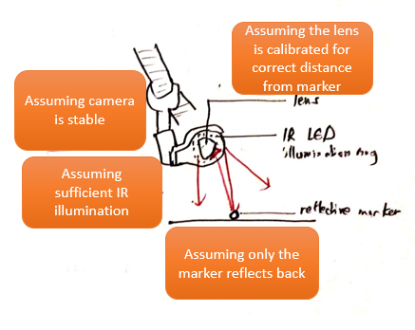

During operation, the system relies on reflected IR rays, so naturally we will examine the capture arena to capture light rays better. If this is set up in the right order, we expect the cameras to localize trackers accurately. The order we set here is the following three questions:

|  |
| --- |
| 1. How does our environment **affect the final image**?    * Space management    * Camera positioning 2. How is the **camera configured for this environment**?    * Image focus    * Image lighting 3. Is the **space reconstructed** as it should be?  * Wanding * Axis overlay |

Further additions (not in this tutorial):

1. The software component has multiple parameters to **work around a poor calibration**. This is where you can explore camera controls, marker ray management, pre-processing etc.
2. This technology has one inherent limitation: when passing from a 2D camera image to a 3D one, the markers might occlude one another, escape from the view overlap etc. An **object identification algorithm is used in the Crazyswarm framework** to minimize this.

## Overview of setup procedure

If all the components are at hand, the **hardware setup** typically takes 40 minutes, followed by 5-10 minutes of **calibration** depending on the quality desired. Then, a **rigid body is defined**, and its captured position estimates can be **streamed on the local network**, either live or through a recording.

*Using wifi has streaming latencies of under 20ms which is sufficient for our purposes.*

Make sure you have a PC running Windows (Motive 2.2.0 software is not available for Linux). To run Motive, you need to **insert the hardware key and generate the online license** within Motive software.

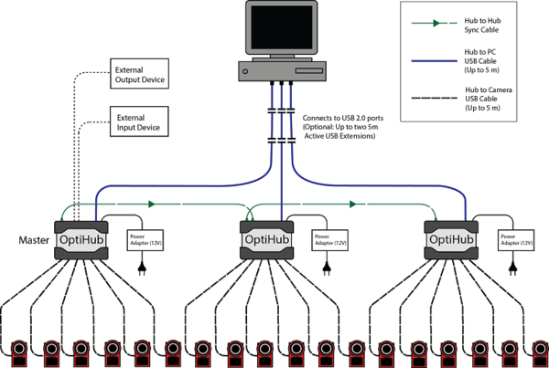

Figure 1: System layout

### Hardware Setup

We will cover checking that the hardware is available in the lab (list of hardware below), then a basic setup with a few tricks for optimising the system performance, a calibration with an active wand.

The basic setup is laid out diagrammatically as such. Note the use of a proprietary USB cable for camera to Optihub (extension cords are not recognised), and the use of a Data Cable for Optihub to PC.

**Components**

* 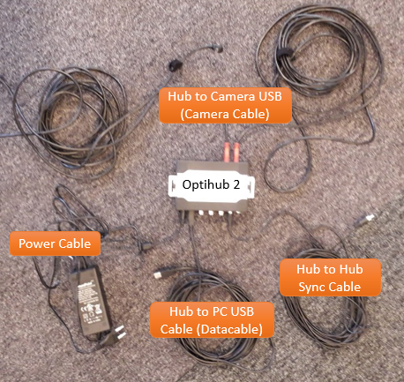That hardware key (USB)
* 4 Flex 13 cameras,
* Vicegrips and rotating stands for the cameras
* 100% stable zones to attach cameras (DVIC: consult the group before attaching to the ceiling)
* USB cables,
* 2 Optihubs (V2),
* 2 Data cables,
* 2 USB Extension cords
* Active calibration wand CWA-500 (DVIC: ask the members concerned)
* A minimum of 3 trackers per object (it’s apparently possible to do with less trackers)

DVIC Note: Since extension cords are not recognised between camera and Optihub, larger setups will require two Optihubs, connected to eachother via a master-slave cable (master port: hub in).

DVIC Note 2: With 2 Optihubs, 2 Data Cables will feed back to the PC. For best performance, connect the USB port to the PC on two different USB controllers (regarding latency issues).

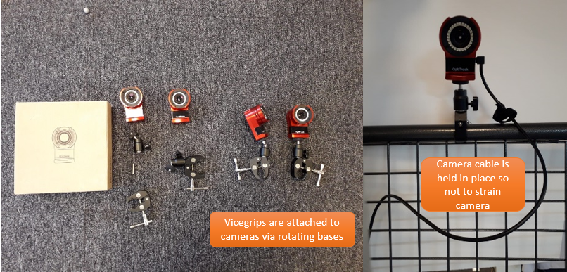

*Assembling the cameras*

## 1. A neat environment

|  |
| --- |
| 1. **How does our environment affect the final image?**    * **Space management**    * **Camera positioning** 2. How is the camera configured for this environment?    * Image focus    * Image lighting 3. Is the space reconstructed as it should be?  * The calibration process. |

**Space management**

First, we choose a space that reduces IR light reflections. A **darker non-reflective floor** and a **consistent level of illumination** might turn out useful to contrast markers effectively. The question is also whether to have a close-up configuration, or to span larger volumes. After all, motion capture usually takes place in large warehouses as such.

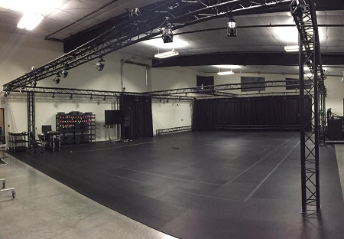

I use the camera output to make sure there are no extraneous reflections in the capture area. Toggle the LED options to turn the infrared light on and off. Evidently, the setup should be black without IR, and only the markers should light up with IR.

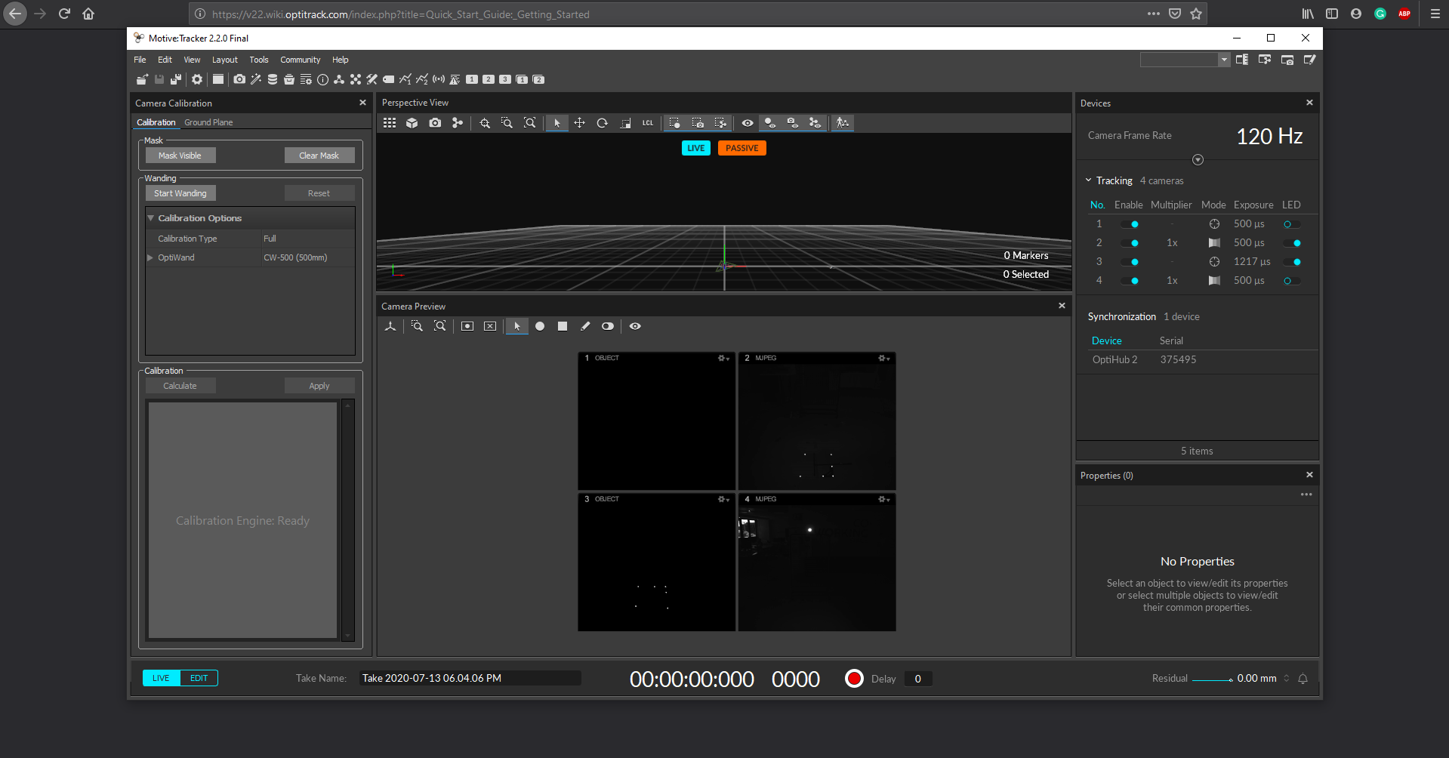

*Using camera modes to check for extraneous reflections*

**View overlap**

The usable portion of the Optitrack system is the overlap between the camera views. By default, Optitrack is configured such that a **view overlap** is usable with 3 cameras.

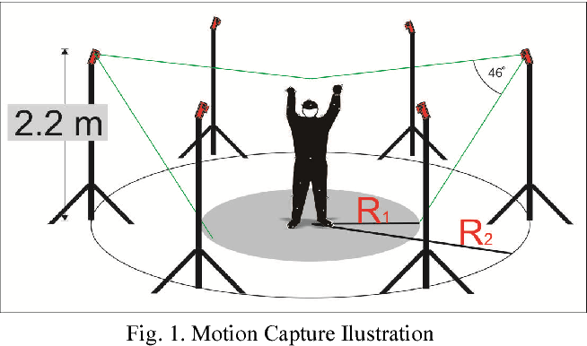

And once again, with less cameras:

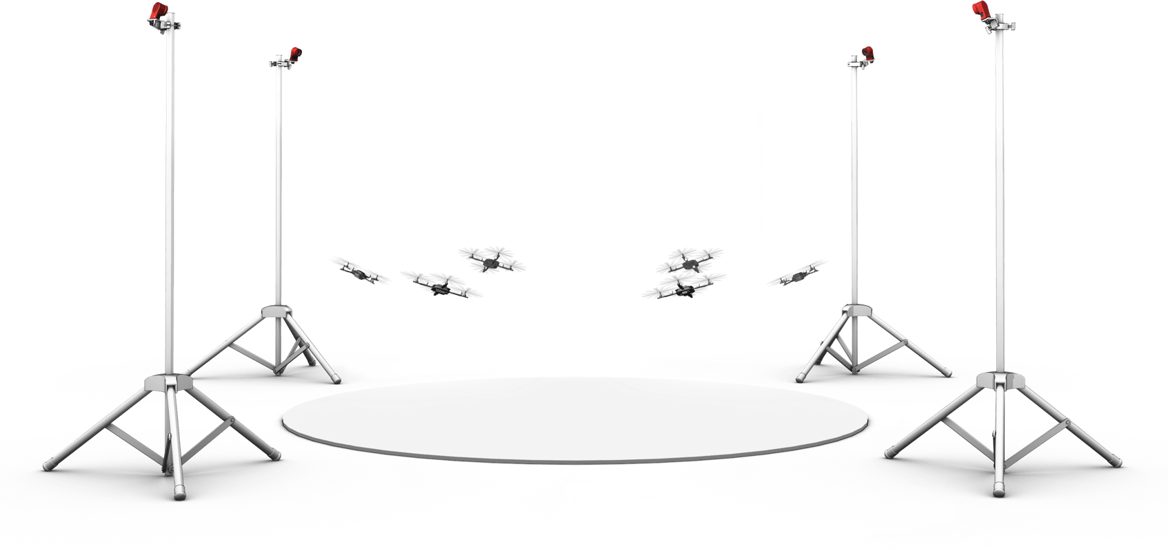

## 2. A camera configuration

|  |
| --- |
| 1. How does our environment affect the final image?    * Space management    * Camera positioning 2. **How is the camera configured for this environment?**    * **Image focus**    * **Image lighting** 3. Is the space reconstructed as it should be?  * The calibration process. |

**Camera positioning and aiming** : markers can be positioned on the ground for highly precise positioning. However, in most cases, this is not necessary, and this cannot be done to calibrate in altitude. Instead, I use a drone stick with markers to aim the cameras.

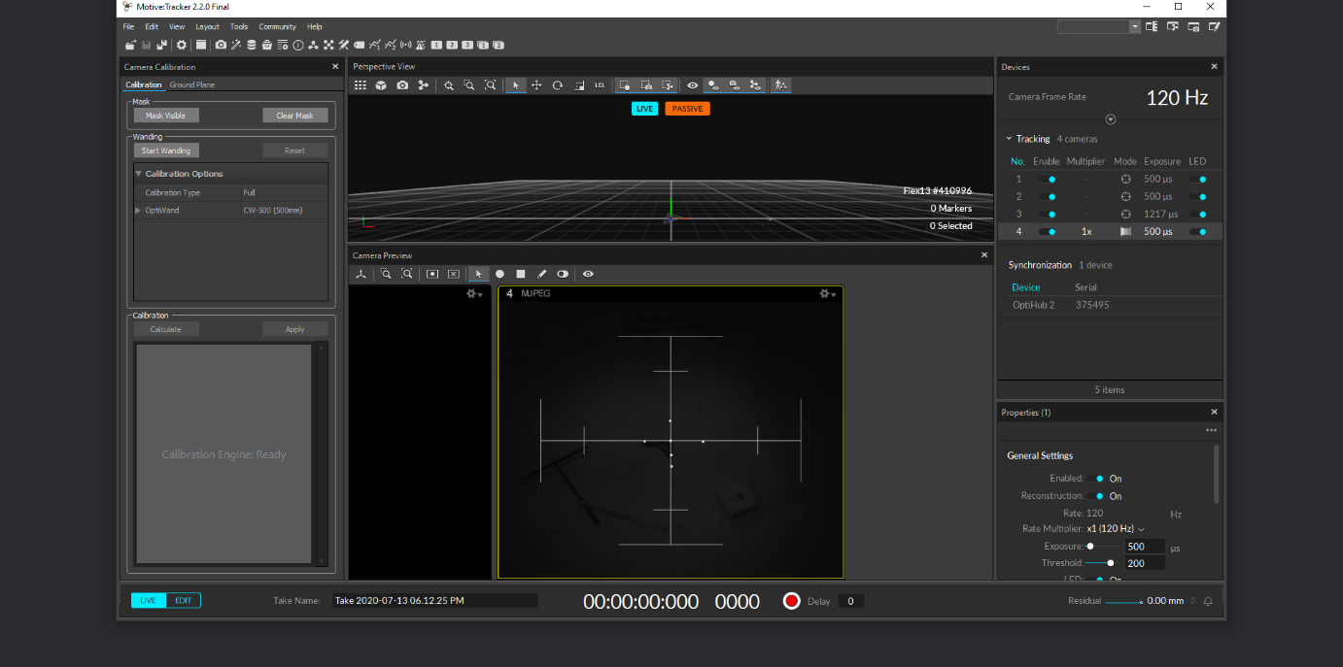

*Aiming the camera using the Grayscale option*

Bad camera configurations might blur the markers (poor lens focus) or contrast them poorly (poor exposure/threshold limit). This will end up affecting the calibration algorithm as it will compute the centroid of each marker badly, as seen below. For lens focus, you will need to open the camera’s front casing and adjust focus directly while comparing to live output on Motive.

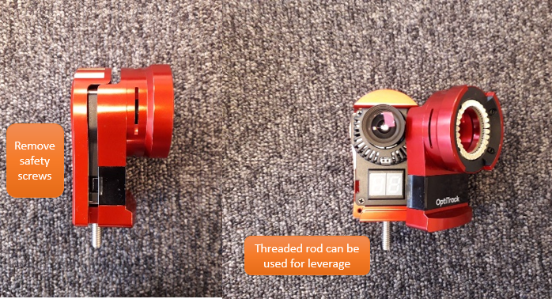

*Removing the camera cover for lens refocusing*

DVIC Note: the casing is fit very tightly, so be careful, these are $999 cameras. Ask for help from those who have focused the lens before.

DVIC Note 2: removing the casing also means there is no LED illumination of the markers. You might want to use a second camera to illuminate the markers.

Exposure and threshold values can be configured afterwards via Motive in the Camera pane.



## A first-hand calibration of the capture area.

With the system set up, tracker data is sampled through a process called calibration. Calibration essentially is about computing the relative positions of the cameras.

|  |
| --- |
| 1. How does our environment affect the final image?    * Space management    * Camera positioning 2. How is the camera configured for this environment?    * Image focus    * Image lighting 3. **Is the space reconstructed as it should be?**  * **The calibration process.** |

### What to look out for in a calibration

An “excellent” or “exceptional” calibration, as OT labels them, will have submillimetre accuracy to localize the position of trackers. This becomes desired when the OT system is affected by high latency. This occurs in high speed applications (e.g. racing drone) but more importantly applications with multiple bodies (e.g. drone swarming), or on a PC running other applications (e.g. wifi signal intensity for drone control might slow down PC processes).

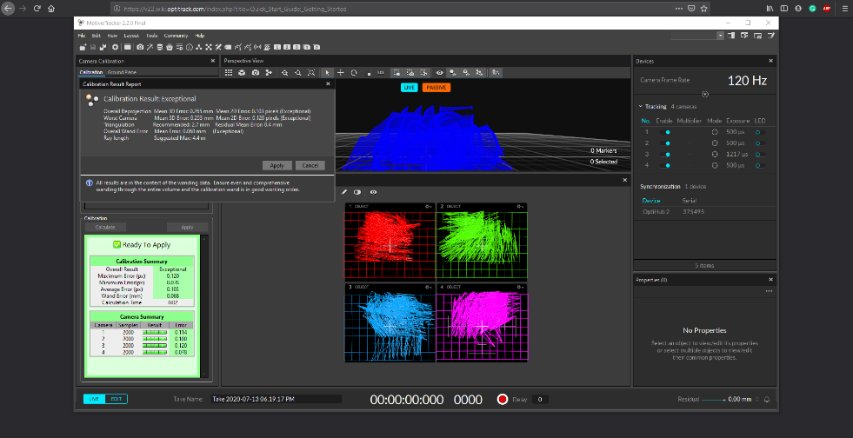

**More information on these criteria are available in the changelog article.**

**Wanding**

At its simplest, the data samples are collected by waving a 3-marker stick all across the motion capture arena. There are two types of wands: active calibration wands output IR light, while passive wands have reflective markers. Beyond that, the mechanical design of the wand reveals all potential hiccups through the wanding process.

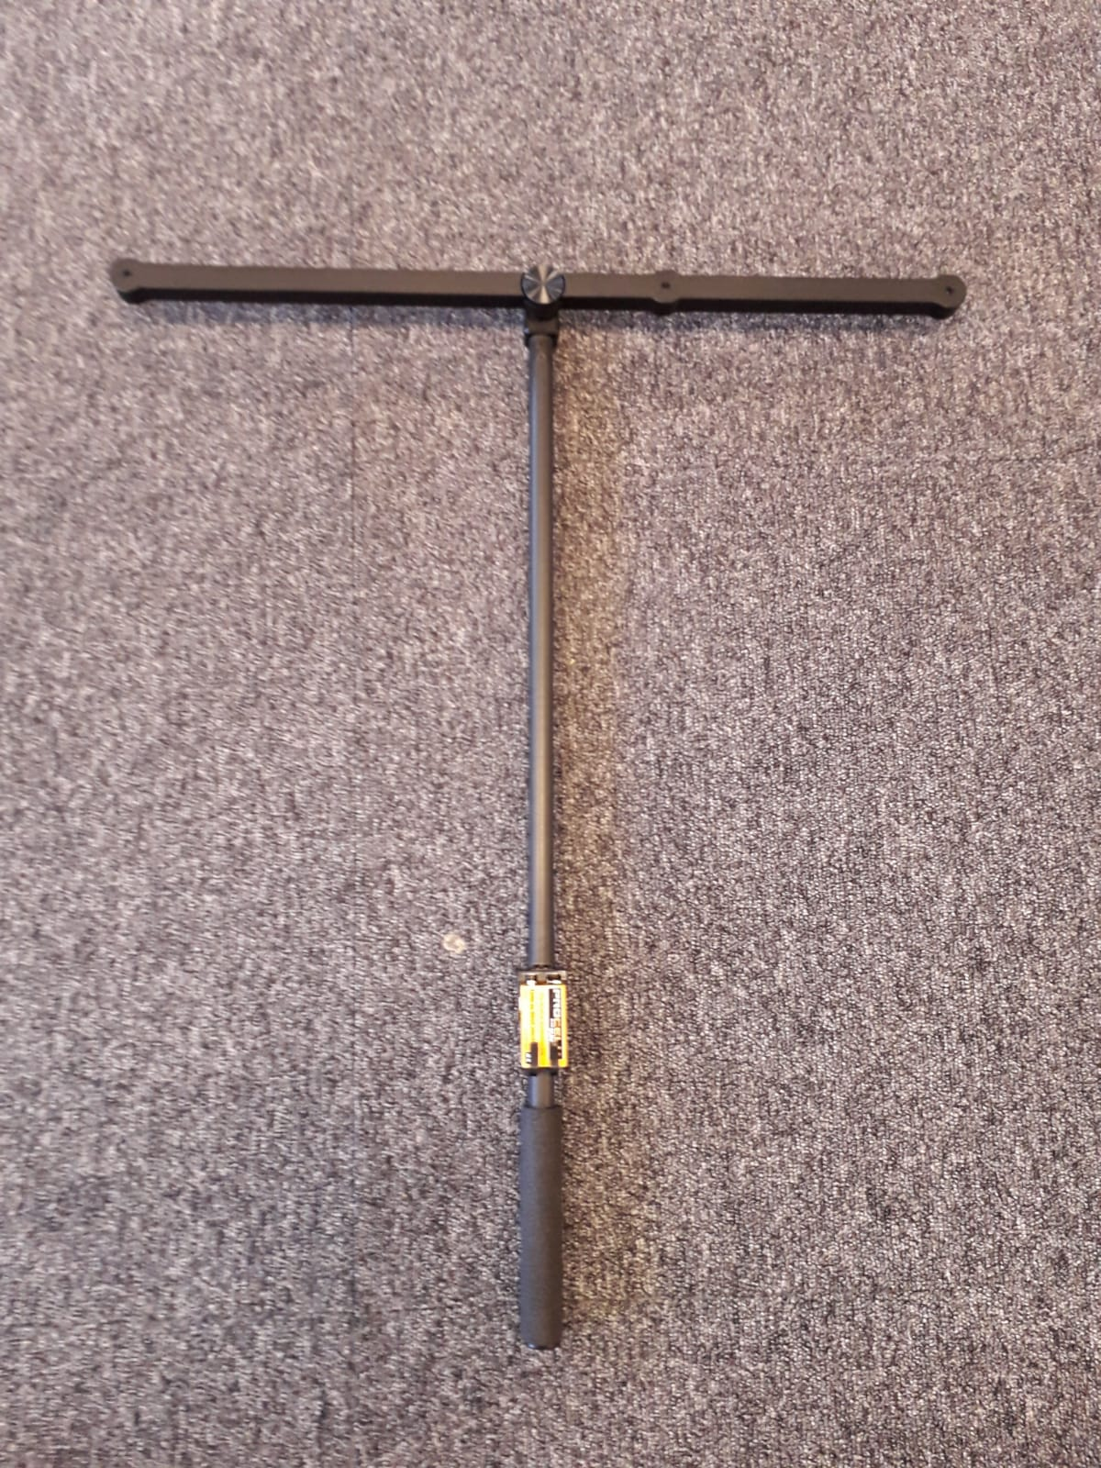

DVIC Note: constructing such a wand is not to be taken lightly, as the marginal error in the marker positions has a large effect on the calibration results, as such.

DVIC Note 2: there is no online documentation to use active wands – instead the Optitrack helpdesk has outlined the process as below.

To activate the wand, assemble it carefully and insert the provided battery. Select the Calibration Wand model CW-500 (the passive version of our CWA-500) and turn off LED illumination on the cameras as such. This greatly reduces the chance of reflection.

**Axis overlay**

Using the calibration square: place it in the capture area, make sure the camera LEDs are all on, and select it in the Reconstruction pane. Then, on Motive, choose the calibration square option.

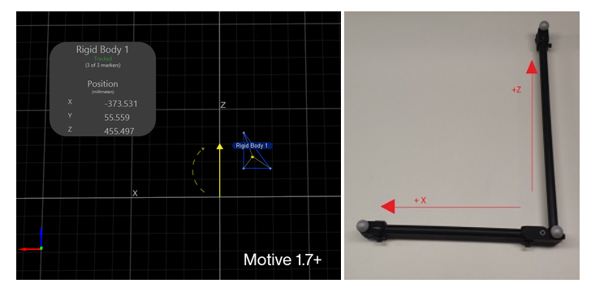

A **ground plane refinement** is possible to refine the levelling of the plan using custom added markers. This feature is especially useful when establishing a ground plane for a large volume, because the surface may not be perfectly uniform throughout the plane.

Save your configuration and that will do!

**That’s it!**

It is possible to go a step further and edit a take for better calibration. Badly positioned markers can be removed from the sample data. Always remember that the system heats up contributes to thermal distortions of the lens.

You might want to stream this data elsewhere, and clients are available in Windows and Linux. There might be troubleshooting problems related to the cameras themselves…

More information on this process, including bugs and kinks, available in the changelog article.

Please contact me at [thomas.carstens@edu.devinci.fr](mailto:thomas.carstens@edu.devinci.fr) for any questions or support.