**FLYING-THE-CRAZYSWARM PROJECT**

This project uses the Crazyflie drone specimen, and flies it within the Crazyswarm framework. This section covers drone setup and its flight **within the arena** designed to this effect.

Various functionalities are designed and we will be able to explore them in greater depth in a series of tutorials. This page, instead, looks at what was achieved in the project. Here are the tutorials for more information.

* Crazyswarm drone swarm architecture
* Use of Optitrack
* Arena maintenance

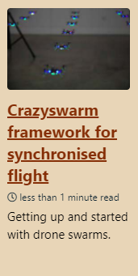 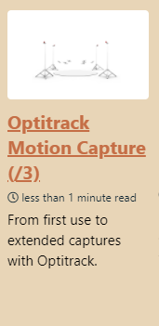 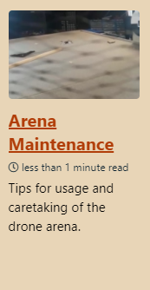

Algorithms aside, the trajectory behaviour planner needs to work in conjunction with the drone’s localization process. We choose to do this **via the swarm PC** since **the external localization system** is also obtained on the PC**.** A protocol needs to be developed that sends the drones their trajectories in coordination with input information, and this infrastructure is explored in the crazyswarm tutorial a little later.

SETTING UP OPTITRACK

Before building the current arena, the motion capture system is first set up. I learned to use the Motive software with their [online documentation](https://v22.wiki.optitrack.com/index.php?title=Motive_Documentation). One of my tutorials is a brief introduction to this.

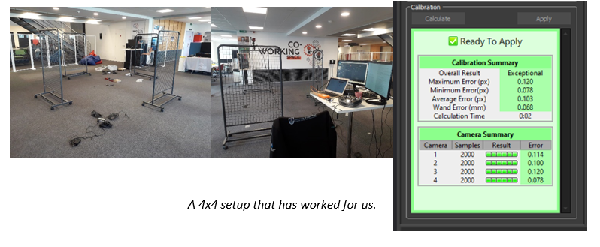

CONNECTING THE CRAZYFLIE

The crazyswarm framework has documentation as you can find here. The drone would therefore be connected to an Ubuntu system. However, the Motive software only worked on a Windows system. As Motive information was streamed, the crazyswarm framework functions as a multicast client. However on Ubuntu, the firewall needs to be opened to access the streamed data. This was achieved by following the multicast setup instructions <https://doc.ubuntu-fr.org/multicast>

SETTING UP THE ARENA

The Optitrack setup was set up on the Fablab table. The camera wiring was doen in the roof with cameras attached to the roof using vicegrips.

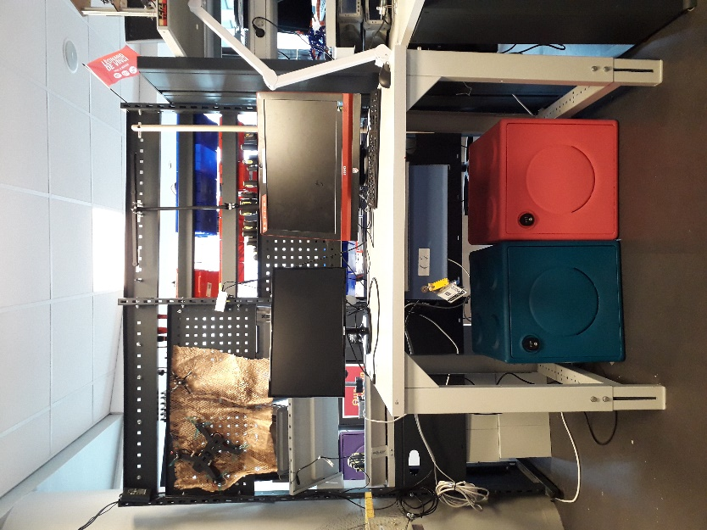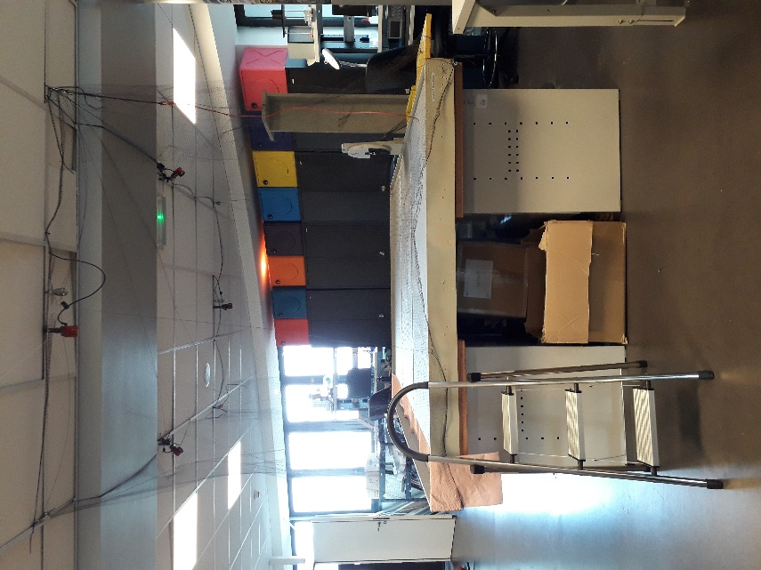

FINAL CONTROL TEST

After sufficient system calibration, the setup was ready for a control test. A video of the demo is accessible [here](https://youtu.be/2UsXnnARfos) (https://youtu.be/2UsXnnARfos).

