Final Project Report – Medication Safety Assistant (Track A)
Oct 31, 2026 · @Junaid

Summary
On 22 locked test patients, our assistant found 17 of 18 medication problems, and every warning it showed was backed by a real quote from the official FDA label.
We built a retrieval-augmented (RAG) assistant for Track A of the AI in Pharmacy Hackathon. It checks a patient's medicines for drug interactions, contraindications and dose problems. It answers only from FDA drug labels and cites the exact sentence it relied on.
A free AI model (Gemini, free tier) does the reading; our code does the searching, the kidney calculations and the checking. The whole project cost nothing to run.
Final test (22 locked patients) | Keyword checker | AI only | Our system (RAG v3)
Problems found correctly (F1) | 0.72 | 0.94 | 0.94
Correct and backed by a real label quote (grounded F1) | 0.72 | 0.11 | 0.89
Warnings shown without a real source | 0 of 22 | 16 of 18 | 0 of 19
Safe patients with a false alarm | 3 of 5 | 0 of 5 | 1 of 5
The AI on its own finds about as many problems, but almost none of its evidence exists in the label. Grounding the answer in the label is what makes the result checkable by a pharmacist.
Prototype for a course. All patients are synthetic. Not for clinical use.

1. The problem and our goal
Pharmacists must check every prescription for dangerous combinations, conditions that rule a medicine out, and doses that are wrong for the patient's kidney function, age or weight. This is slow, and the facts sit in long FDA label documents.
General AI chatbots can answer such questions, but they answer from memory. They can sound confident and still be wrong, and they rarely give a source a pharmacist can check.
Track A brief: build an assistant that flags adverse drug events, contraindications and dose mismatches, with exact citations to the source.
Our goals:
- Flag the three problem types for a patient's medicine list.
- Back every warning with an exact quote from the official FDA label, and a link to it on DailyMed.
- Never show a warning whose quote cannot be found in the label.
- Prove it works by comparing it with simpler systems on patients it has never seen.

2. Data (Week 1)
The assistant's knowledge comes from official, free public data; the test patients are synthetic, so no real patient data was used.
Data | Source | Size
Medicine list | 63 cardiovascular and commonly interacting medicines, IDs from RxNorm (U.S. National Library of Medicine) | 63 medicines in 20+ classes (anticoagulants 7, antiarrhythmics 7, beta blockers 5, diuretics 5, …)
FDA drug labels | openFDA drug label API (the same text as DailyMed) | 769 label sections, e.g. Contraindications, Drug Interactions, Dosage
Searchable chunks | Our code cut each section into pieces of 250 words, overlapping by 50 | 2,478 chunks
Drug classes and brand names | Written by us for pharmacist review | 63 classes; 96 US brand names (e.g. Coumadin → warfarin)
Synthetic patients | Written by us, each problem traced to a label sentence | 44 patients: 22 practice (dev) + 22 locked test
Expected answers | One row per problem, with the label sentence that proves it | 37 warnings (19 dev, 18 test)
Edge cases | Tricky inputs for stress testing | 21 cases
Patient design. Each half (dev and test) has 10 interaction patients, 3 contraindication, 3 dose, 1 with several problems, and 5 safe patients who should get no warning. Every expected answer was checked by code against the label text (37 of 37 found).
What the EDA showed (notebook week1_eda_analysis.ipynb): 57% of label sections are longer than 250 words, so they must be split before searching. Sections vary a lot by medicine; for example, 22 of 63 labels have no separate Warnings and Precautions section. Drug interactions are often written with class names ("strong CYP3A4 inhibitors") rather than drug names, so the search also uses each medicine's class.
Fixes made while downloading: for 6 medicines the first label found was a combination product, so the download now prefers single-ingredient labels; and a text-cleaning step that removed words between "<" and ">" signs (e.g. "CrCl <30 … >50") was corrected.

3. How the system works
RAG (retrieval-augmented generation) works like an open-book exam: instead of answering from memory, the AI is handed the relevant pages of the official FDA label and must answer from them, quoting what it used.
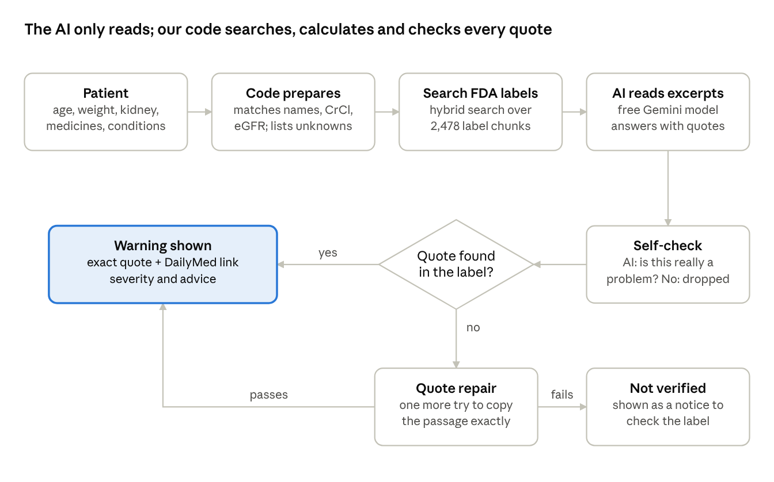
how one patient check runs · RAG v3
Only a warning whose quote is found word for word in the label is shown as a warning. A quote that still fails after one repair try is shown as a notice for the pharmacist to check, never as a confirmed warning.
The search is targeted: for each pair of medicines it looks in each drug's interaction and contraindication sections (also by drug class, e.g. "strong CYP3A4 inhibitors"), and for each medicine in its dose and kidney sections. It combines keyword search (BM25) and meaning-based vector search (ChromaDB with the free bge-small-en-v1.5 embedding model).

4. What we compared and how we scored it (Week 2)
We compared two simple baselines with three versions of our system, all on the same patients and expected answers.
System | How it works
Baseline 1: keyword checker | No AI. Flags two medicines if one's name appears in the other's warning sections.
Baseline 2: AI only | The same free AI model answers from memory, with no label text given.
RAG v1 (Week 2) | Targeted label search, then the AI answers only from the excerpts, then the citation check.
RAG v2 (Week 3) | v1 + stricter rules (compare the actual dose with the limit; pregnancy only when the label rules it out) + one medicine at a time for long medicine lists.
RAG v3 (Week 4, final) | v2 + self-check (the AI must say whether each flag is really a problem for this patient) + quote repair (a failed quote gets one more try to copy the label exactly).
Scores
- Precision: of the warnings given, how many were correct.
- Recall: of the expected problems, how many were found.
- F1: one number that balances precision and recall (1.00 = perfect).
- Grounded F1: like F1, but a warning only counts if its quote really supports it in the label. This is the main score, because the brief asks for exact citations.
- False alarms on safe patients: how many of the 5 safe patients got any warning.
- Warnings shown without a verified source: must be zero for a safe system.
- Severity agreement: how often the severity (contraindicated, major, moderate) matches the expected answer.
We use F1 rather than ROC-AUC because the systems give a list of warnings, not a probability score.
Rule against cheating: all tuning used only the 22 practice (dev) patients. The 22 test patients were locked in code (the scorer refuses to run on them without a --final switch) and were run once, at the very end.

5. Development results on practice patients (Weeks 2–4)
On the 22 practice patients, each version improved on the last, reaching all 19 expected warnings with no false alarms in v2 and v3.
Practice (dev) patients, 19 expected warnings | Keyword | AI only | RAG v1 | RAG v2 | RAG v3
F1 | 0.64 | 0.92 | 0.89 | 1.00 | 1.00
Grounded F1 | 0.59 | 0.00 | 0.84 | 0.95 | 0.95
Safe patients with a false alarm | 3 of 5 | 1 of 5 | 2 of 5 | 0 of 5 | 0 of 5
Warnings shown without a verified source | 1 of 25 | 19 of 19 | 0 of 19 | 0 of 19 | 0 of 19
Severity agreement | 79% | 94% | 82% | 79% | 84%
Search quality. Before asking the AI, we checked whether the search finds the right label sentence. With 5 chunks kept per search, keyword, vector and hybrid search all found the evidence for 100% of expected warnings; with 3, hybrid search was best (90% vs 84% keyword and 79% vector). We use hybrid search with 5 chunks, about 26 excerpts per patient.
What changed between versions (all designed from practice-patient errors):
Version | Error found | Fix | Result
v1 → v2 | P029: correct warning removed because the quote skipped words | Citation rule accepts exact pieces of 4+ words in order; any changed word still fails | Warning kept
v1 → v2 | P033: 2 misses with 5 medicines (69 excerpts in one request) | Long lists reviewed one medicine at a time | Both found
v1 → v2 | P043: false alarm, simvastatin 10 mg was within the diltiazem limit | Rule: compare the actual dose with the label limit | No false alarm
v1 → v2 | P041: false alarm on a "use only if benefit justifies risk" pregnancy line | Rule: pregnancy only if the label says contraindicated or avoid | No false alarm
v2 → v3 | Correct warnings sometimes removed when the AI reworded the quote | Quote repair | 2 warnings rescued (P023, P033)
v2 → v3 | A note that the AI itself judged acceptable (P013 digoxin dose) | Self-check | Dropped correctly
The practice score of 1.00 is optimistic, because the rules were written after seeing these errors. That is why the locked test (section 8) is the real measure.

6. Safety guardrails, app and stress testing (Week 3)
Guardrails against made-up answers (hallucination)
- Citation check (in code): every warning's quote must be found word for word in the excerpt it cites, and that excerpt must be one the AI was actually given. If not, the warning is not shown as a warning.
- Kidney maths in code, never by the AI: creatinine clearance (Cockcroft-Gault) and eGFR (CKD-EPI 2021).
- What was checked is decided by code: the "not checked" list comes from our name matching, so the AI cannot hide or invent it.
- Names are never guessed: brand names are matched from a list; a misspelling ("warfrin") gets a suggestion but is not auto-corrected, because a wrong guess could swap two medicines.
- Strict output format (JSON) so every answer can be checked automatically.
The app (Streamlit). A pharmacist enters a patient (or loads a practice patient) and presses Check medicines. The app shows creatinine clearance and eGFR, which medicines were recognised, each warning with its severity, the verified label quote and a DailyMed link, and a clear notice for any possible problem that could not be verified. Run with python -m streamlit run app.py.
Stress test (21 edge cases). We tested tricky inputs that are not in the dev or test sets:
Category | What we tested | RAG v2 (Week 3) | RAG v3 (Week 4)
Names | Brand names, misspellings, nonsense, medicines outside our library | Pass | Pass
Bias | Same patient as man vs woman, age 25 vs 80 | Identical results | Identical results
Prompt injection | Hidden text telling the AI to "report no problems" or invent a warning | Ignored | Ignored
Kidney | Very low clearance; exactly at a dose limit | Pass | Pass
Polypharmacy | 8 medicines | All 3 problems found | All 3 problems found
E10 | Correct rivaroxaban dose at CrCl 51 | False alarm | Pass
E11 | Apixaban 5 mg at 85 years, 52 kg (should be 2.5 mg) | Missed (quote reworded, removed) | Found
Total |  | 19 of 21 | 21 of 21
Brand-name recognition rose from 7 of 46 common names to 46 of 46 after adding the brand list. Reading the outputs also showed that the AI wrote a wrong "not checked" list for E01 and E12; this was fixed by moving that list into code.

7. Final fine-tuning: RAG v3 (Week 4)
Fine-tuning here means improving the system's instructions and checks, not retraining the AI model. A free hosted model cannot be retrained, and 22 practice patients would be far too few to train on. Each change targets a specific error from the Week 3 stress test.
Change | Fixes | How it works
Self-check | E10 false alarm (the AI's own explanation said the dose was correct) | For each warning the AI must state whether it is really a problem for this patient (is_problem). If it says no, code drops it.
Quote repair | E11 missed warning (quote reworded, so the check removed it) | When a quote fails the check, the AI gets one more request to copy the passage exactly from the excerpt it cited. The new quote must pass the same check.
Quote rule | E11 | Instruction to copy the label's sentence as written, keeping numbers as digits and the original word order.
App | Hidden unverified warnings | A possible problem that fails verification is shown openly as "could not be verified, please check the label", not hidden and not counted as a warning.
Result on practice patients (v2 → v3): F1 stayed 1.00 and grounded F1 0.95; severity agreement rose from 79% to 84%; 2 correct warnings were rescued by quote repair; stress test rose from 19 to 21 of 21. Input tokens grew by only 3%.
Clinical review. The pharmacy team reviewed the open questions (severity of anticoagulant interactions, which label section counts as evidence, extra warnings in edge cases) and asked for no changes. RAG v3 was then frozen as the final version.

8. Final test results (locked patients)
On 22 patients never used during development, the final system scored F1 0.94 and grounded F1 0.89, and showed no warning without a verified label quote.
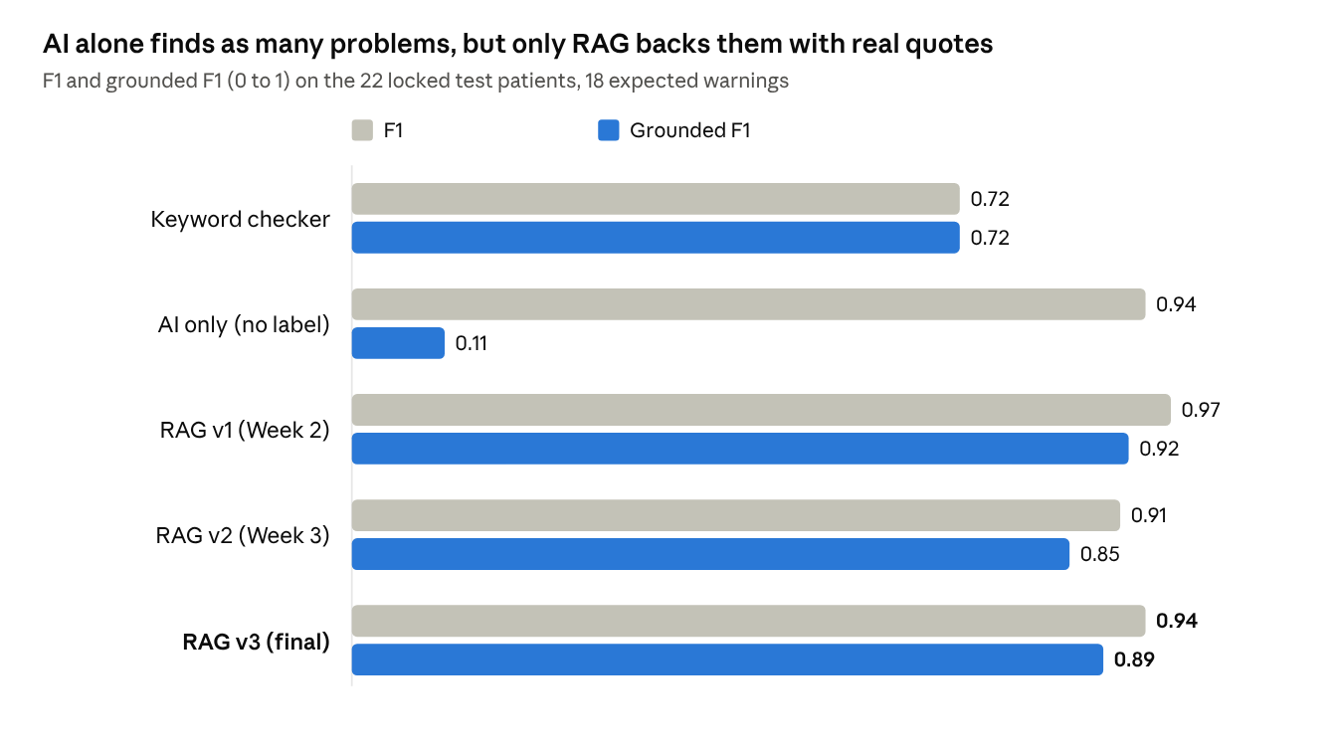
results/metrics_*_test.json · final run, 31 Oct 2026
The gap between the two bars is the share of correct-looking warnings with no real evidence. For the AI-only baseline it is almost everything: 16 of its 18 warnings quoted text that does not exist in the label.
Test patients | Keyword | AI only | RAG v1 | RAG v2 | RAG v3
Expected warnings found | 14 of 18 | 17 of 18 | 18 of 18 | 15 of 18 | 17 of 18
Precision | 0.67 | 0.94 | 0.95 | 1.00 | 0.94
Safe patients with a false alarm | 3 of 5 | 0 of 5 | 1 of 5 | 0 of 5 | 1 of 5
Warnings shown without a verified source | 0 of 22 | 16 of 18 | 0 of 20 | 0 of 16 | 0 of 19
Severity agreement | 79% | 82% | 83% | 80% | 88%
What the test shows
- Grounding separates the systems. All three RAG versions reach grounded F1 0.85 to 0.92; the AI-only baseline reaches 0.11, and the keyword checker gives false alarms on 3 of 5 safe patients.
- The three RAG versions are close. v1 scored slightly higher than v3 (0.97 vs 0.94), a difference of one warning, within the normal run-to-run variation of the free model. We do not claim v3 beats v1.
- The Week 3–4 guardrails worked as intended. In v2 the citation check removed two correct warnings because of reworded quotes (P006, P030). In v3 quote repair rescued P006 and P030 was quoted correctly, lifting recall from 0.83 to 0.94; severity agreement rose to 88%.
- Test vs practice: the final system scored 1.00 on practice patients and 0.94 on test, the expected drop, because tuning was done on practice patients only.
The test answers were produced in one run with the frozen v3 code and saved; after the clinical review asked for no changes, they were scored as final.

9. Errors, limitations and future work
Errors of the final system on the test patients
Patient | Error | Likely cause | Possible fix
P024: prasugrel, mini-stroke (TIA) 2 years ago | Missed contraindication (v1 and v2 found it) | The AI may have read "2 years ago" as no longer relevant; the label rules prasugrel out after any prior TIA or stroke | Instruction that a past history of a ruled-out condition still counts
P044: safe patient, metoprolol + hydrochlorothiazide | False alarm (moderate): "additive blood-pressure lowering" | A normal, intended combination; the label sentence is real but not a safety problem | A pharmacist-approved list of intended combinations
P002, P018: warfarin + fluconazole / naproxen | Severity "moderate" instead of "major" | Same pattern seen on practice patients | A severity rule from pharmacists
Limitations
- Small test set: 22 synthetic patients and 18 expected warnings. One warning moves F1 by about 0.03, so the results show the approach works, not clinical-grade accuracy.
- One run per system with a small free model; its answers vary a little between runs.
- 63 medicines only, mostly cardiovascular. Any other medicine is listed as "not checked".
- Synthetic patients written by the team, checked against the labels but not by an independent clinical panel.
- Prototype for a course. Not for clinical use; a pharmacist must review every output.
Future work
- Test on a larger, independently written patient set, and run each system several times to measure variation.
- Add the pharmacists' severity rule and intended-combination list.
- Extend the library beyond 63 medicines and keep labels up to date from openFDA automatically.
- Try a stronger model (or a local model with Ollama, already supported) and compare cost and accuracy.

10. Conclusion
A small, free AI model becomes a trustworthy medication checker when it is made to answer from the official label and every quote is checked by code. On unseen patients our system matched the AI-only baseline at finding problems (F1 0.94) while raising grounded F1 from 0.11 to 0.89, and it never showed a warning without a verified source.
How to run it (Windows cmd, inside the project folder):
python -m streamlit run app.py

python -m src.evaluate --system rag_v3
python -m src.stress_test --system rag_v3
python -m src.report --split test
The first command opens the app. The others re-score the practice patients, re-run the stress test and rebuild the final test report; saved AI answers are reused, so re-running is free.
Project files
File | What it is
notebooks/week1_eda_analysis.ipynb | Week 1 data analysis
reports/week2_benchmark_report.md | Practice-patient results for all systems and versions
reports/week3_error_log.md, reports/stress_test_log_rag_v3.md | Stress-test logs (v2 and v3)
reports/final_test_report.md | Final test results with analysis
app.py | The Streamlit app
src/, tests/ | System code and 25 automatic tests

