Medication Safety Assistant – Project Report (Weeks 1–2)
Oct 30, 2026 · @Junaid

Summary
We built a working prototype of a Medication Safety Assistant: it reads a patient's medicine list and flags dangerous drug combinations, unsafe medicines for that patient, and wrong doses for their kidney function. Every warning quotes the official FDA drug label it comes from, and a built-in check removes any warning whose quote cannot be found.
On 22 synthetic practice patients, our system reached F1 0.86 and a grounded F1 of 0.81 (correct and backed by a real label sentence), and it never showed a warning without a verified source. An AI answering from memory scored a similar F1 (0.92), but none of its 19 quotes existed in the real labels (grounded F1 0.00). A keyword checker scored F1 0.64 with false alarms for 3 of 5 safe patients.
The whole system runs on free, public data and a free AI model (Google Gemini free tier), at a cost of US$0. Project: Track A (Clinical Pharmacy & Patient Safety), [Team name]. Prototype for pharmacist decision support only; not for clinical use.

The problem
Medicine-related harm is common, costly and often preventable, and pharmacists reviewing long medicine lists face real cognitive overload.
- Common: a CDC study in JAMA estimated that about 1 in 250 Americans visited an emergency department for an adverse drug event each year in 2013–2014, rising to nearly 1 in 100 for people aged 65 and over (health.gov).
- Our drug classes are the main culprits: in older adults, those visits were mainly caused by anticoagulants and diabetes medicines, the core of our drug list (same source).
- Preventable and costly: a WHO review found that medicines account for half of avoidable harm in medical care, and WHO puts the cost of medication errors at about US$40 billion a year (Health Policy Watch, 2024).
The information needed to catch these problems already exists in official drug labels, but each label runs to thousands of words, and checking every pair of medicines by hand is slow. General AI chatbots answer quickly but can state things that are not in any label, which a pharmacist cannot verify.

Our solution
The assistant checks a patient's medicines against the official FDA labels and returns warnings a pharmacist can verify in seconds.
It flags three kinds of problems:
Type | Meaning | Example from our practice patients
Drug–drug interaction | Two medicines that are risky together | Simvastatin + clarithromycin: contraindicated
Contraindication | A medicine unsafe for this patient | Warfarin in pregnancy; propranolol with asthma
Dose problem | A dose that does not fit kidney function, age or weight | Dabigatran 150 mg twice daily with CrCl 30 mL/min (label: 75 mg)
What a warning looks like:
[MAJOR] Interaction: warfarin + naproxen NSAIDs increase bleeding risk with warfarin. Source (verified): naproxen label, Drug Interactions: "Naproxen and anticoagulants such as warfarin have a synergistic effect on bleeding." + DailyMed link
Scope: 63 medicines: 50 heart, blood-thinner and diabetes medicines, plus 13 common drugs that interact with them (antibiotics, antifungals, painkillers, antidepressants, a PPI). The input is the medicine list plus age, sex, weight, serum creatinine, pregnancy, conditions and allergies. Kidney function (CrCl and eGFR) is calculated in code, not by the AI.

Data
All data is free, public and needs no licence; all patients are synthetic.
Source | What we use it for | Size in our project
openFDA drug labels | The official label text the assistant searches and quotes | 63 labels (62 prescription, 1 over-the-counter), 769 sections, about 443,000 words, cut into 2,478 search chunks
RxNorm (US National Library of Medicine) | One standard ID per medicine, so brand and generic names match | 63 of 63 drugs matched
DailyMed | A link to the full official label for every citation | 1 link per label
ONCHigh list (Phansalkar et al., JAMIA 2012) | Expert list of high-risk drug pairs, used to design test patients | Reference
Our practice patients (synthetic) | The test set: patients plus the warnings a pharmacist would expect | 44 patients, 37 expected warnings
Practice patients. 20 interaction cases, 6 contraindication cases, 6 dose cases, 2 patients with several problems, and 10 safe patients with no expected warning (some designed as traps that look risky but are fine). Every expected warning is tied to the exact sentence in the FDA label that supports it, and a script checks all 37 against the label text (37/37 pass). Patients are split into 22 dev (used while building) and 22 test (locked until the final evaluation).
Data quality fixes found along the way: the first download picked combination-product labels for 7 drugs (e.g. butalbital + aspirin + caffeine for aspirin) and deleted clinical text between "<" and ">" signs (e.g. "heart rate <50 bpm"). Both were found, fixed in the download script and re-checked.

What the data told us
The exploratory analysis (Week 1 EDA notebook) shaped five design decisions.
Finding | Design decision
Labels often name a drug class instead of the drug: for 5 of 24 expected interactions, the partner drug is not named in the cited sentence (e.g. "strong CYP3A4 inhibitors" rather than "clarithromycin") | Add a drug-class list (clarithromycin = strong CYP3A4 inhibitor) and search by class as well as name
Section length ranges from 7 to 4,493 words; 57% are longer than 250 words; the whole library is ~443,000 words, far too much to give the AI at once | Cut the text into ~250-word chunks with 50-word overlap, each keeping its drug, section and link for citation
Kidney information is scattered: 97% of drugs mention kidney function, but only 54% in the Dosage section | Dose searches also cover Use in Specific Populations, Geriatric Use and Precautions
Two label formats: 42 new-format labels (Warnings and Precautions), 20 old-format (Warnings + Precautions) | Treat these sections as one group in search
Aspirin only has an over-the-counter label, without Contraindications or Drug Interactions sections | Always search both drugs' labels for every pair

How it works
The system runs in four steps, and only warnings that pass the last step reach the pharmacist.
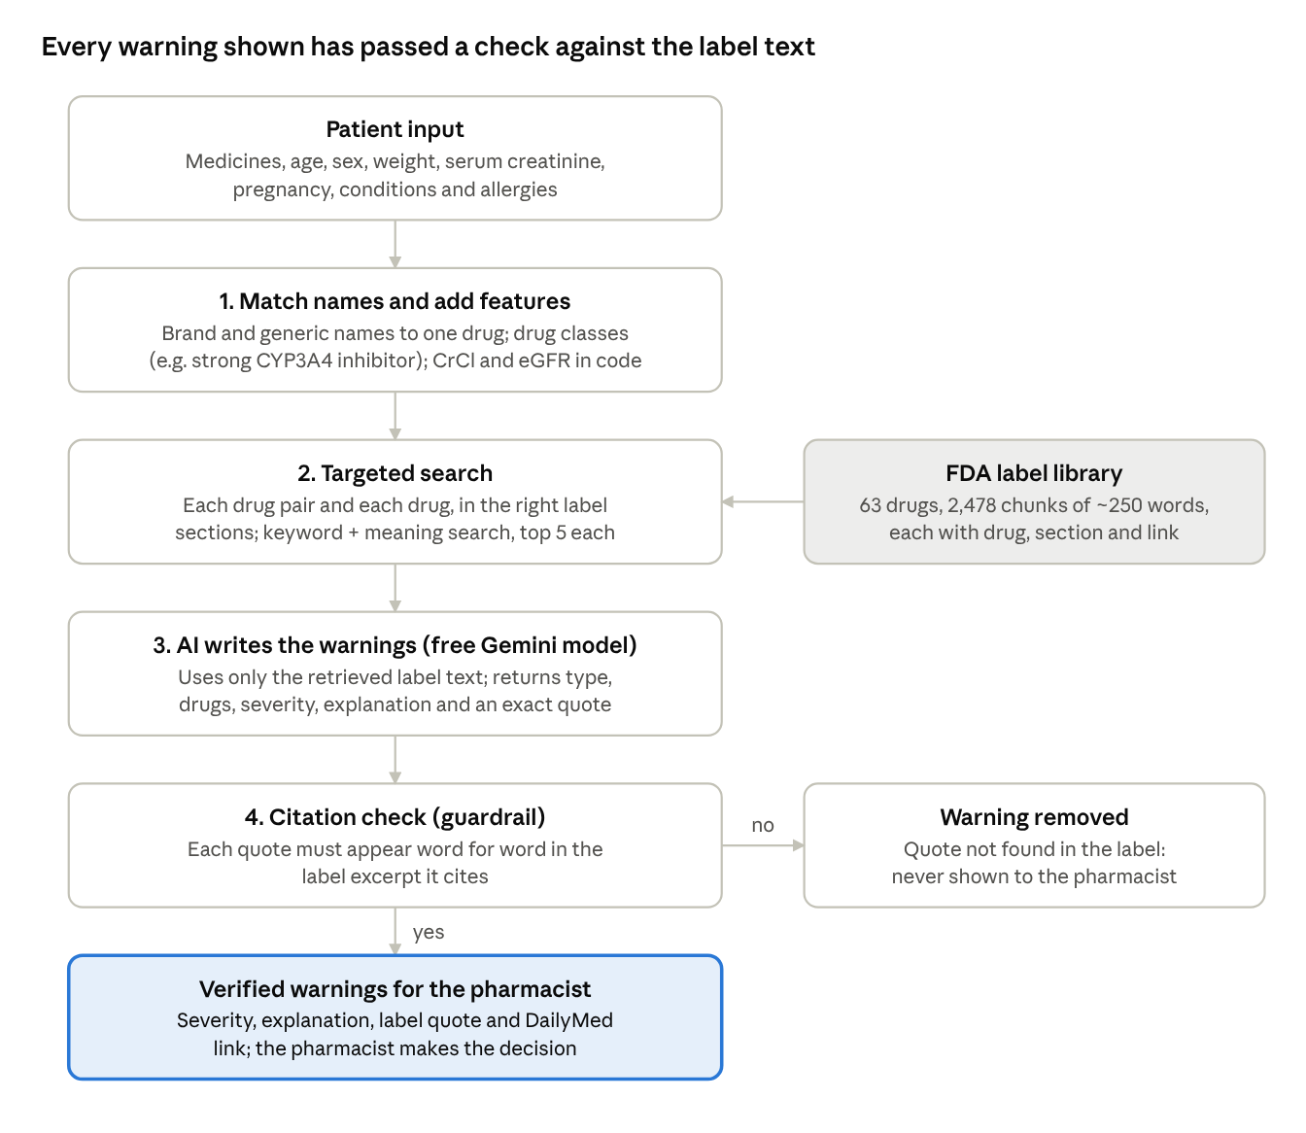
Pipeline from patient to cited warning · src/ in the project repository
The search is restricted to the right label and sections for each drug pair and each drug, which is why the right evidence reached the AI for every expected warning. The AI never sees the whole library, only the 5 best pieces per search (about 26 pieces for a typical patient).

How we tested it
We compared our system with two simpler baselines on the same 22 dev patients (19 expected warnings), using scores that reward correct and checkable answers.
Systems compared
System | How it works
Baseline 1: keyword checker | Flags two drugs if one's name appears in the other's warning sections; flags a contraindication if a patient condition word appears in a label. No AI.
Baseline 2: AI only | The same AI model reviews the patient from memory, with no label text. Its quotes are then searched for in the real labels.
Our system: RAG + citation check | Targeted search of the labels, AI answers only from what was found, then every quote is checked against the cited text.
Scores
- Precision: of the warnings given, how many were correct. Recall: of the expected warnings, how many were found. F1 combines the two.
- Grounded F1 (our main score): like F1, but a warning only counts if its quoted evidence really supports it.
- Citation accuracy: share of correct warnings with supporting evidence.
- False alarms on safe patients and warnings shown without a verified source.
- Search recall@k: whether the correct evidence sentence reached the AI.
ROC-AUC, suggested in the brief, does not apply: our systems return a list of warnings, not a probability per drug pair.
Keeping the test honest
- The 22 test patients are locked: the scoring script refuses to run on them without a --final flag, so prompts and settings are tuned on dev patients only.
- A warning matches the answer when it names the same patient and the same drugs. Duplicates count once. Agreed "acceptable extras" (e.g. intended dual antiplatelet therapy after a stent) are neither rewarded nor penalised.
- Every AI answer is saved, so anyone can re-run the evaluation and get identical results. 15 automated tests cover the pipeline.

Results
Our system is the only one that is both accurate and checkable: grounded F1 0.81, against 0.00 for the AI answering from memory.
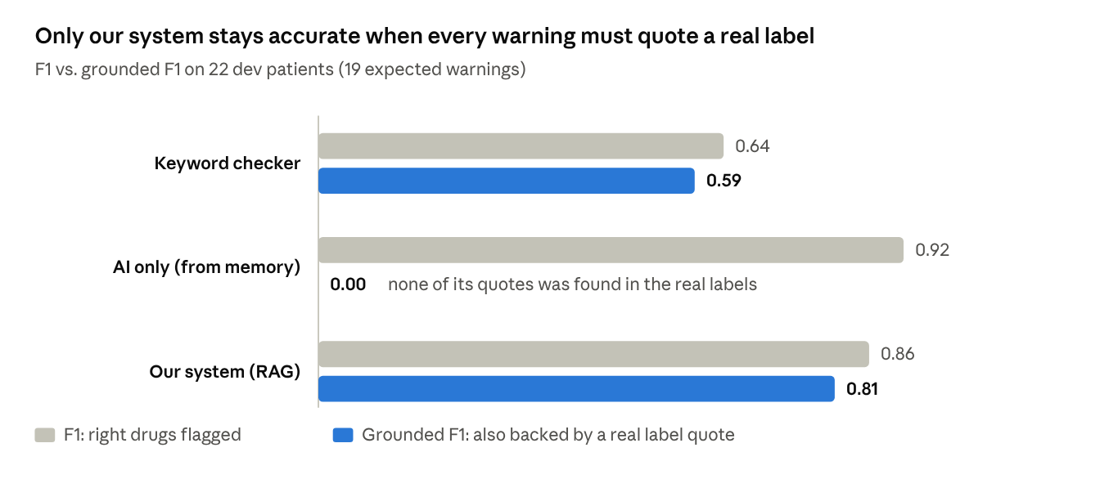
results/metrics_*_dev.json · run of 29 Oct 2026, gemini-3.1-flash-lite, hybrid search k = 5
The AI from memory finds slightly more problems, but on 19 expected warnings the gap in plain F1 is one or two warnings and within noise. The grounding gap is not.
Score | Keyword checker | AI only | Our system (RAG)
Precision (warnings given that were correct) | 0.56 | 0.94 | 0.89
Recall (expected warnings found) | 0.74 | 0.89 | 0.84
Citation accuracy (correct warnings with supporting evidence) | 93% | 0% | 94%
Warnings shown without a verified source | 1 of 25 | 19 of 19 | 0 of 18
Safe patients with a false alarm | 3 of 5 | 1 of 5 | 2 of 5
Severity matches the expected answer | 79% | 94% | 81%
F1, interactions | 0.92 | 0.92 | 0.92
F1, contraindications | 0.27 | 1.00 | 0.86
F1, dose problems | 0.40 | 0.86 | 0.67
Search quality: hybrid search (keyword + meaning, bge-small-en-v1.5 embeddings) brought the correct evidence sentence to the AI for 100% of expected warnings with 5 pieces per search (90% with 3). Cost: US$0 (Google Gemini free tier, about 220,000 input tokens for the RAG run).

Mistakes and what we learned
Search is not the weak point: the right evidence reached the AI for every expected warning. All five RAG mistakes happened after that, in the AI's reasoning or in our checks.
Patient | What happened | Cause | Planned fix (dev patients only)
P029: enoxaparin, CrCl 23 mL/min | Correct dose warning removed by the citation check | The AI joined two separate passages into one "quote" | Ask for one continuous quote; accept quotes made only of exact pieces of 4+ words, in order
P033: 5 medicines | Missed the apixaban dose (age 81, 54 kg) and apixaban + ibuprofen | 69 label pieces in one request; the small model lost track | Split large patients into one request per drug
P043: simvastatin 10 mg + diltiazem | False alarm | The label limit is 10 mg and the patient is within it | Tell the AI to compare the actual dose with the limit
P041: pregnant, hydralazine | False alarm (moderate) | The label says "use only if benefit justifies risk", not a contraindication | Flag pregnancy only when the label says contraindicated, avoid, or has a boxed warning
P001, P003: severity | Said "moderate"; the expected answer says "major" | The labels describe bleeding / INR risk without saying "avoid" | Pharmacy team to agree the severity rule for anticoagulant interactions
Lessons
- Correct is not enough; it must be checkable. The AI from memory found the right problems, but its quotes were reworded (e.g. "except in women with mechanical heart valves" where the label says "pregnant women"). Only exact, retrieved text can be verified.
- The guardrail works in both directions. It blocked every unsupported warning (0 shown), but once it also blocked a correct one (P029), so the quote rule needs tuning.
- Long contexts hurt small models. Most patients needed about 26 label pieces; the 5-medicine patient needed 69, and that is where the misses were.
- Clinical judgement belongs to pharmacists. Severity disagreements came from our own rules, not the AI; the pharmacy team will settle them.

Safety, limitations and honesty notes
Built-in safety
- No unsupported warnings: a warning is shown only if its quote is found in the label text the AI was given.
- Says what it doesn't know: medicines outside the 63-drug library (e.g. an albuterol inhaler) are listed as "not checked", never guessed.
- Arithmetic in code: kidney function is calculated by formulas (Cockcroft–Gault CrCl, CKD-EPI 2021 eGFR), not by the AI.
- Human in the loop: the output supports a pharmacist's decision; it does not replace it.
Limitations
- Small test set: 19 expected warnings on the dev patients. One warning more or less changes F1 by about 0.03, so the AI-only vs. RAG difference in plain F1 (0.92 vs. 0.86) is within noise. The grounding difference (0.00 vs. 0.81) is not.
- Synthetic patients: written by the team and still being reviewed by pharmacy members; real patients are more varied.
- Narrow scope: 63 mainly cardiovascular medicines and US FDA labels; local labelling may differ.
- Free model: results use gemini-3.1-flash-lite; a stronger model may score differently. Google may use free-tier inputs to improve its models, which is acceptable here only because we send public label text and synthetic patients.
- Not for clinical use: this is a course prototype and has not been validated on real patients.

Next steps
Week 3 turns the pipeline into a usable app with stronger guardrails; Week 4 runs the final, locked test.
Week 3: Application and guardrails
- Apply the four fixes from the mistakes table and re-score on dev patients (before vs. after).
- Pharmacy team agrees the severity rule and reviews the drug-class list, practice patients and acceptable extras.
- Build a simple web app (Streamlit): enter a patient, see warnings with severity, quotes and DailyMed links.
- Edge-case and bias testing: misspelled or brand names, missing kidney values, out-of-library drugs, very long medicine lists, pregnancy and older adults. Record results in an error log.
- Add 16–56 more practice patients (target 60–100), including 5+ medicine patients, more "moderate" warnings and the 20 drugs not yet used.
Week 4: Final validation and pitch
- Run the final evaluation once on the locked test patients.
- Clinical relevance review by the pharmacy members.
- Public GitHub repository with README, pitch deck, 3–5 minute demo video, live pitch and code audit.

For the presentation and pitch video
The pitch has one core message: an AI can sound right; ours shows the proof.
Three key messages
- Medicine harm is common and preventable, and the answers are already in official drug labels, just too long to check by hand.
- Our assistant finds the problems and quotes the exact label sentence, with a link; unsupported warnings are removed automatically.
- Tested honestly: AI from memory had 0 checkable quotes; ours had a verified source for every warning shown, at zero cost.
3-minute outline
Time | Section | What to say or show
0:00–0:30 | Problem | 1 in 100 older adults visit an emergency department each year because of a medicine; anticoagulants and diabetes drugs lead. Pharmacists can't read every label for every pair.
0:30–1:00 | Solution | Medicine list in, cited warnings out. Show the warfarin + naproxen example with its label quote.
1:00–1:45 | How it works | The pipeline diagram: name matching, targeted search with drug classes, AI answering only from the label text, citation check.
1:45–2:30 | Results | The F1 vs. grounded F1 chart: AI from memory 0.00 grounded vs. ours 0.81; 0 unverified warnings shown.
2:30–3:00 | Honesty and next steps | Small synthetic test set, one guardrail false block, fixes planned; web app and final locked test in Weeks 3–4. Not for clinical use.
Demo idea for the video: run patient P001 (warfarin + aspirin) live, show the warning and click its DailyMed link to prove the quote is real; then show the same patient from the AI-only baseline, whose quote cannot be found.

Sources
- health.gov: New study reinforces importance of implementing the National Action Plan for ADE Prevention (CDC study in JAMA, data 2013–2014)
- Health Policy Watch: WHO issues new guidance for reducing avoidable harm from medicines (14 March 2024)
- openFDA drug label API
- RxNorm APIs, US National Library of Medicine
- DailyMed
- Phansalkar et al., High-priority drug–drug interactions for use in electronic health records, JAMIA 2012
- Project files: reports/week2_benchmark_report.md, notebooks/week1_eda_analysis.ipynb, GitHub: Autumn-21/AUA-medication-safety-assistant

