Causes of Corruption

by Autumn Erickson

1. **Overview of Global Corruption**

The corruption index is a measurement created by Transparency International that uses information from numerous international institutions to calculate the index. Corruption overall means the misuse of public office for private gain

1. **Determinants of Corruption**
2. **Corruption and GDP per capita**

The graph shows that corruption index is higher in poorer nations. This can be due to many factors, like institutions in developing nations being weaker and participating in rent seeking behavior. There is also a possibility of reverse causality where more corrupt nations are less capable of improving economically due to the weakness of their institutions. Corruption within developing nations creates an uneven distribution of resources and wealth and makes social welfare programs less effective.

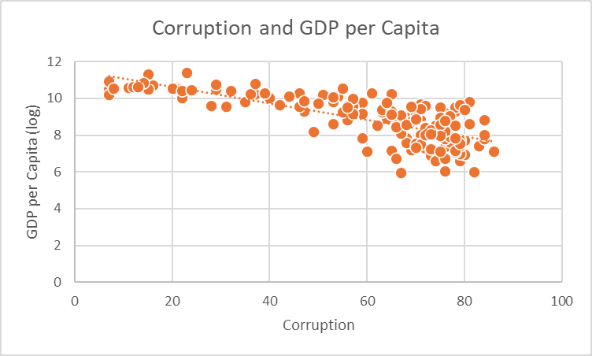

1. **Corruption and Human Development**

This graph is very similar to the GDP and Corruption graph. The main difference between the two is that this graph has more outliers than the GDP graph since human development measures education and life expectancy as well. There is less correlation between the two as corruption gets to be above 60, this means that once corruption is to a certain amount, it has less of an effect on education and life expectancy.

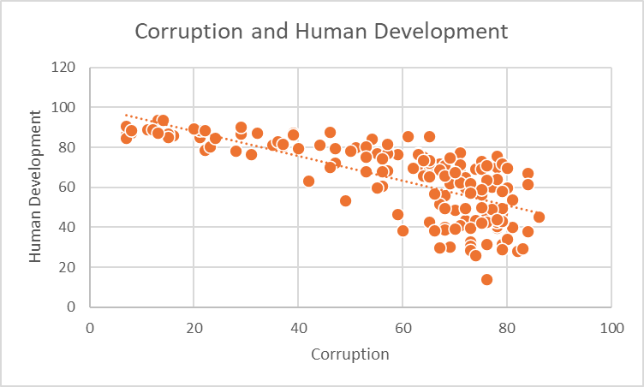

**GDP per capita and Human Development**

Human development is highly correlated with GDP, which is due largely to income being one of the determinants of the human development index. Countries with a higher GDP also usually have better education and life expectancy.

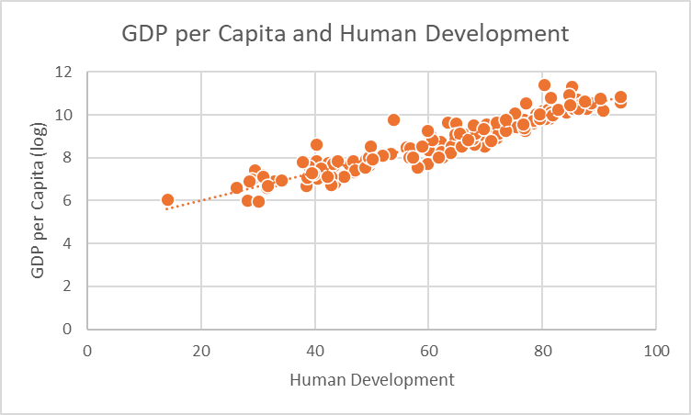

The human development index is an instrumental variable because its relation with corruption is through its relationship with GDP per capita. The graphs of GDP and corruption and human development are very similar, making the two variables almost interchangeable. In addition, the graph of GDP and human development shows a very strong correlation between the two variables. The human development index acting as an instrumental variable further shows the causal relationship of corruption and GDP.

**Corruption and GDP per capita by high and low values of Human Development**

These two graphs reflect what I speculated in the last section. When separating the graphs based on low and high human development, we see the GDP separated that way as well. The median log GDP 8.97, and the graphs separate around this point on the y-axis. This is what would be expected if human development were an instrumental variable, with median GDP and median human development separating the graph with corruption similarly. When separating GDP into low and high groups, we see the median fall near the same spot as the median human development, with 8 outliers below that point and 8 outliers above.

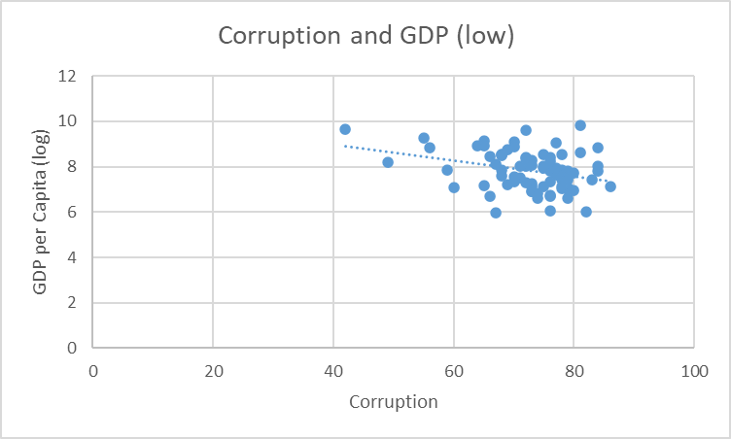

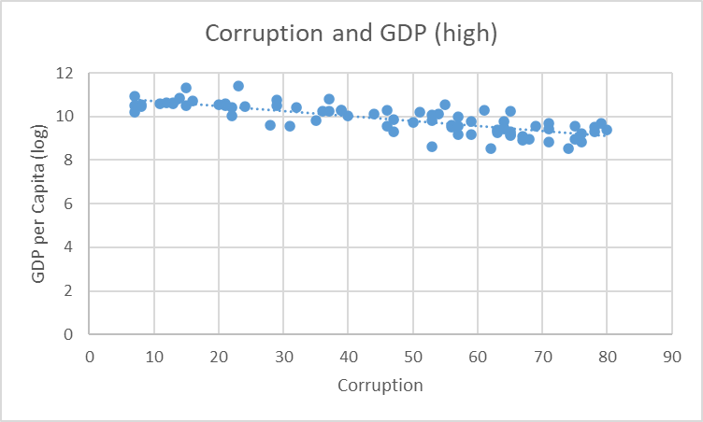

1. **Conclusion**

The relationship between GDP per capita and corruption is most likely a causal one, with GDP effecting corruption. With the use of the human development index as a instrumental variable, this is proven more likely to be the case. With the data showing GDP and human development to be highly correlated, and the graphs of GDP and corruption, and human development and corruption being very similar, we can see that GDP has a large effect on corruption. However, since HDI and GDP did not have an identical effect on corruption, this raises the question of what other variables have an effect on levels of corruption.