Population Assessment

by Autumn Erickson

# The Demographic Dividend

The demographic dividend is the economic growth that results from a decline in a country’s birth and death rates.

# Population Pyramids

The data illustration of a country’s age and gender demographics at a given time.

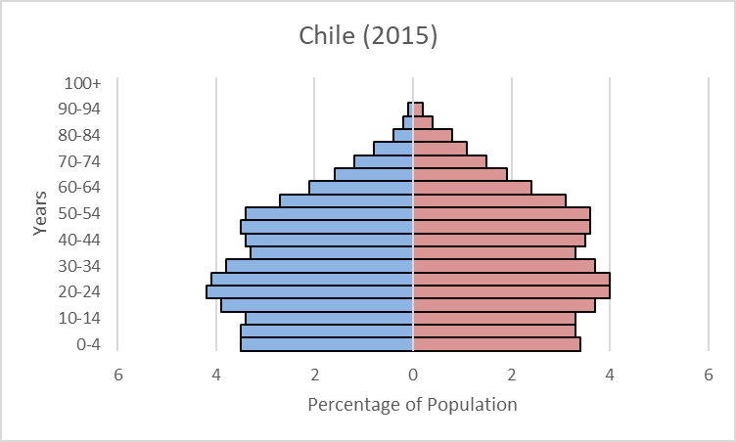

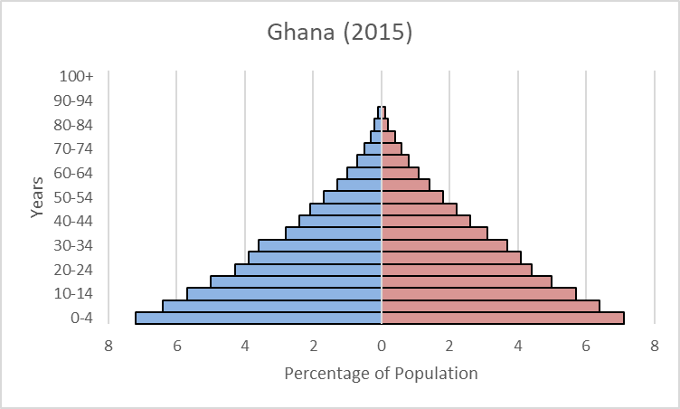

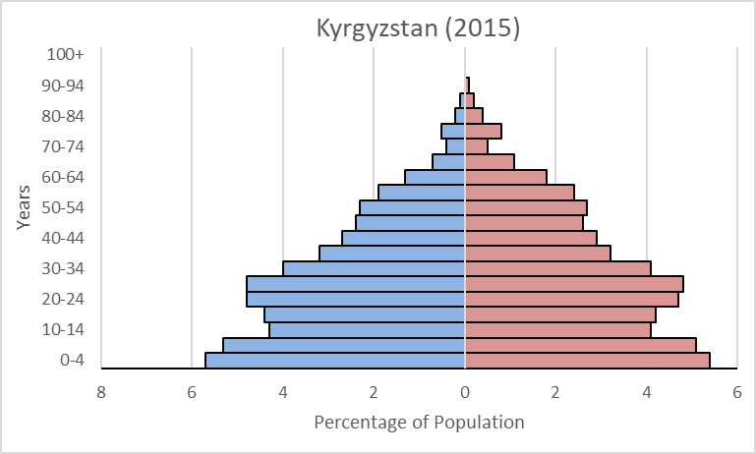

# Dependency Burden

## Dependency ratios

|  |  |
| --- | --- |
| Country | Dependency Ratio |
| Chile | 6.2:10 |
| Ghana | 11:10 |
| Kyrgyzstan | 7.7:10 |

Young dependent: 0 to 19 years old

Working population: 20 to 64

Old dependent: 65 to 100+

## Analysis of dependency ratios

The higher the dependency ratio, the more of an economic burden the country experiences from supporting the dependent population. Chile has the lowest dependency ratio of the three countries and is benefiting from a demographic dividend. Kyrgyzstan follows with a similarly low ratio. Ghana’s dependency ratio shows that there are more dependents than working-aged people, and they experience a dependency burden.

# Analysis of Fertility Rates

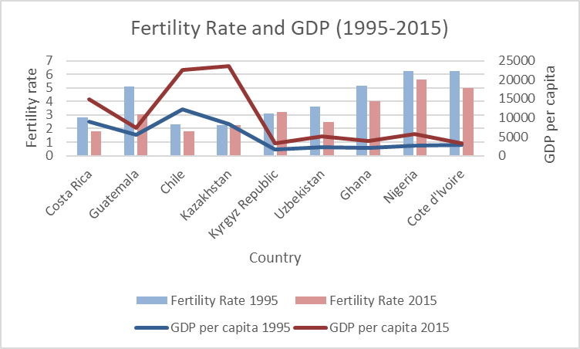

In all cases besides Kazakhstan and the Kyrgyz Republic, fertility rates have decreased and GDP per capita has increased from 1995 to 2015. The countries with the lowest fertility rates (Costa Rica, Chile, and Kazakhstan) also have the highest GDP. This reflects what was found with the dependency ratios earlier. Countries with a higher fertility rate have a higher dependency burden and the working population cannot fully support the dependent population. Kazakhstan and the Kyrgyz Republic are the only two countries that experienced an increased fertility rate from 1995 to 2015. Kazakhstan’s Fertility rate increased by .1, and the country’s population growth was negative in 1995, making such an increase in GDP in 2015 surprising. By looking at Kazakhstan’s population pyramid this can be explained. The negative population growth recorded in 1995 is seen mostly in the 10-14 age range, and also the 15-19 range, meaning this decreased the dependent population in 2015. However, this could cause an increase to the dependency ratio in a couple years as this negative population growth reaches the working population and if the fertility rate continues to increase.