hw 2

Qiuying Li UNI ql2280

2/15/2017

# We have seen that in p = 2 dimensions, a linear decision boundary takes the form β0 + β1X1 + β2X2 = 0. We now investigate a non-linear decision boundary

1. Sketh the curve (1+X1)^2 +(2−X2)^2 =4.

plot(NA, NA, type = "n", xlim = c(-3, 1), ylim = c(0, 4), asp = 1, xlab = "X1", ylab = "X2");symbols(c(-1), c(2), circles = c(2), add = TRUE, inches = FALSE);points(-1,2,col = "red");text(-1,2.2,"center")

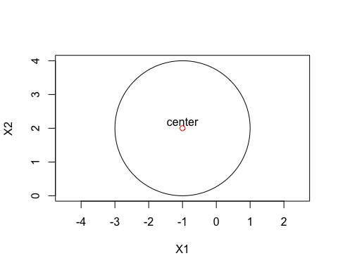 (b) On your sketch, indicate the set of points for which as well as the set of points for which (1+X1)^2 +(2−X2)^2 >4, (1+X1)^2 +(2−X2)^2 ≤4.

plot(NA, NA, type = "n", xlim = c(-3, 1), ylim = c(0, 4), asp = 1, xlab = "X1", ylab = "X2");symbols(c(-1), c(2), circles = c(2), add = TRUE, inches = FALSE);text(c(-1), c(2), "f(x1,x2)≤4");text(c(-4), c(2), "f(x1,x2)>4");

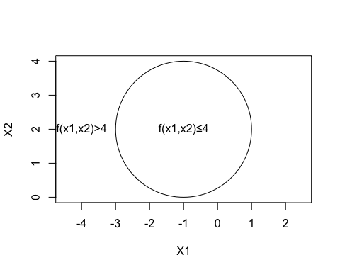 (c) Suppose that a classifier assigns an observation to the blue class if (1+X1)2 +(2−X2)2 >4,and to the red class otherwise. To what class is the observation (0,0) classified? What about (−1,1),(2, 2) or (3, 8)?

plot(c(0, -1, 2, 3), c(0, 1, 2, 8), col = c("green", "red", "green", "green"),   
 type = "p", asp = 1, xlab = "X1", ylab = "X2");symbols(c(-1), c(2), circles = c(2), add = TRUE, inches = FALSE)

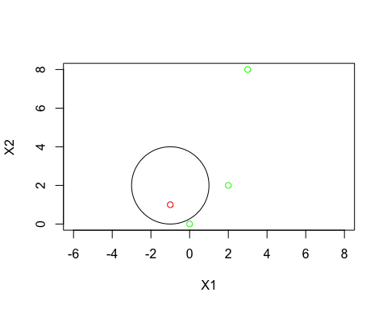 (d) Argue that while the decision boundary in (c) is not linear in terms of X1 and X2, it is linear in terms of X1, X12, X2 and X2.

