hw5

Qiuying Li UNI ql2280

4/9/2017

# 1. load histogram data  
#A matrix of histograms, denoted H, which contains one histogram vector in each row.   
#Each column corre-lation sponds to a histogram bin.  
setwd("~/Desktop/2017 spring/GR 5241/HW/hw5")  
file = ("histograms.bin")  
data = readBin(file, "double", 640000)  
W = matrix(data,4000,16)  
dire = "~/Desktop/2017 spring/GR 5241/HW/hw5/"  
file_name = paste(dire, "histograms.bin", sep="")

# H has dimension n * d

# We denote the histogram vectors by H1 , ..., Hn

H <- matrix(readBin(file_name, "double", 640000), 40000, 16)  
  
#The centroids t1 , ..., tK . These are Rd vectors (just like the input features). We set tau = 0.0001  
MultinomialEM <- function(H, K, tau=0.0001){  
  
 n = dim(H)[1]  
 d = dim(H)[2]  
 index = sample(n, K, replace=F)  
 #The centroids t1 , ..., tK . These are Rd vectors  
 #T has dimension K * d  
 #Each centroid is the parameter vector of a multinomial distribution and can be regarded as the center of a cluster.  
 T = diag(1 / rowSums(H[index, ] + 0.01)) %*% (H[index, ]+0.01)  
 #Ck is the cluster weight  
 #Ck = (num of points in k) / n   
 c = rep(1 / K, K)  
 iter_cut = c()  
 #The entry aik specifies the probability of feature i to be assigned to cluster k.  
 A0 = matrix(rep(0, n * K), n, K)  
   
 # E step formula   
 theta_1 = t(apply(tcrossprod(H, log(T)), 1, minusMax))  
 theta = exp(theta_1) %*% diag(c)  
 A = t(apply(theta, 1, normalize))  
  
 # M step formula  
 c = colSums(A) / n  
 bk = crossprod(A, H)  
 tk = diag(1 / rowSums(bk)) %*% bk  
  
   
 # Compute a measure of the change of assignments during the current iteration:  
 #δ := ||A − Aold||  
 #Terminate the iteration when δ < τ  
 while (norm(A - A0, type="1") > tau){  
 A0 = A  
 # E step formula  
 theta_1 = t(apply(tcrossprod(H, log(T)), 1, minusMax))  
 theta = exp(theta_1) %*% diag(c)  
 A = t(apply(theta, 1, normalize))  
 # M step formula  
 c = colSums(A) / n  
 bk = crossprod(A, H)  
 tk = diag(1 / rowSums(bk)) %*% bk  
 iter_cut = c(iter_cut, norm(A-A0, type="1"))  
 }  
  
 # Turn the soft assignments into a vector m of hard assignments   
 # mi := arg max aik   
 m = apply(A, 1, which.max)  
 return(list(m=m, A=A, T=T, c=c, iter_cut=iter_cut))   
}  
  
normalize <- function(v) v / sum(v)  
minusMax <- function(v) v - max(v)  
  
K_ = c(3, 4, 5)  
plot_address = paste(dire, "visualization results with", K_, ".pdf", sep="")  
for (i in 1:length(K)){  
 result = MultinomialEM(H, K=K_[i], tau=0.01)  
 image(matrix(result$m, 200, 200, byrow=T), col=gray((0:16)/16), main=paste("K=", K_[i], sep=""))  
}

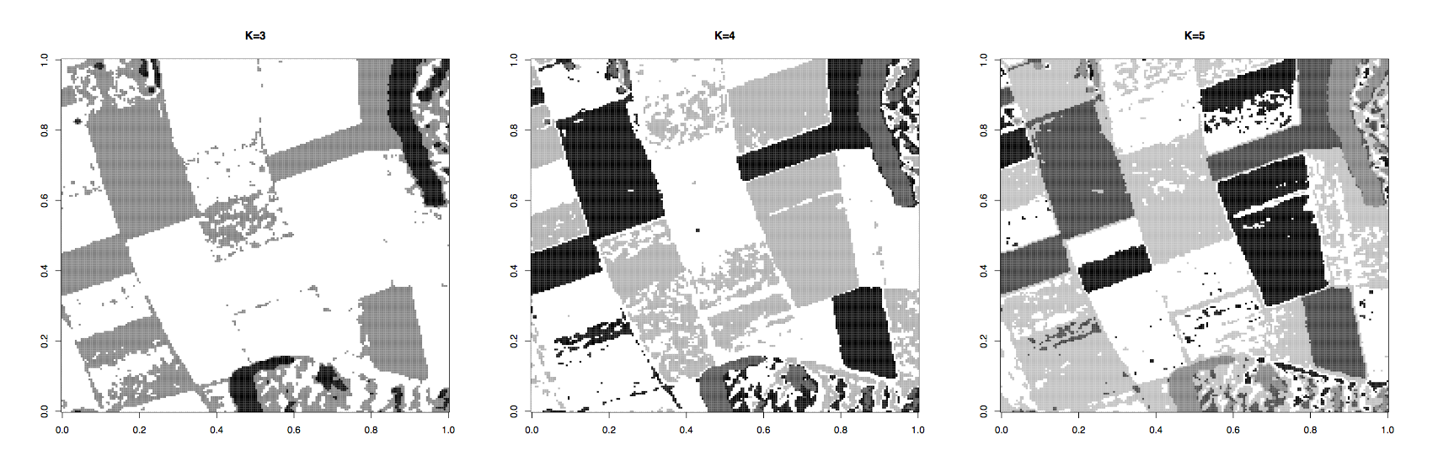

plot(1:length(result$iter_cut), result$iter_cut, type="o", xlab="number of iterations", ylab="||A-A0||", main="K=5, tau=0.01")  
