Co-Designing an AI Literacy Curriculum for Elementary Education Using Design Thinking
Iqbal, R. A., Islam, R. S., Cockerham, D.
As artificial intelligence (AI) becomes integral to education, AI literacy is essential for preparing young learners to navigate and critically engage with AI technologies. However, existing AI literacy curricula for elementary education often lack guidelines, educator involvement, and practical lesson plans, resulting in limited applicability and alignment with classroom needs. This design case study documents the co-design of an AI literacy curriculum using Design Thinking, incorporating insights from teachers, administrators, and parents. Through an iterative process, the study identifies key challenges, pedagogical strategies, and content gaps. The resulting curriculum, informed by educational stakeholders, provides structured, age-appropriate AI literacy experiences to support early AI comprehension, responsible engagement, and critical thinking.

Introduction
As Artificial Intelligence (AI) is increasingly integrated into formal and informal education, AI literacy instruction can empower learners to take advantage of the benefits while minimizing undesirable consequences (Zawacki-Richter et al., 2019; Wang & Cheng, 2021; Celik et al., 2022; Ouyang et al., 2022; Crompton & Burke, 2023). AI technologies in education (AIEd) can support and enhance both learning and teaching. AIEd merges human expertise with algorithmic precision, enhancing personalized learning and operational efficiency (Chiu et al., 2023).
AIEd research has focused on the evaluation and prediction of student performance, administrative tasks, classroom management, AI assistant and recommendation systems, and data-informed personalized learning (Yu et al., 2024). For example, Dimitriadou & Lanitis (2023) and Hashem et al. (2024) suggest that AI enables teachers to focus on pedagogy by handling administrative tasks and improving classroom management. Other studies have shown how AI capacities in tasks such as performance prediction, personalized learning systems, and recommendation systems can streamline learning by offering customized resources and pathways for both students and teachers (Huang et al., 2023, Ouyang et al., 2023). Rizvi et al.’s (2023) systematic literature review highlights the cognitive and affective benefits of AI interventions, showing increased student interest and engagement with AI-related topics.
However, along with opportunities, AIEd also introduces risks: privacy, security, ethical concerns, teacher replacement, and algorithmic bias (Cardona et al., 2023). In addition, an analysis of 31AIEd case studies found an over-emphasis on technical skills, with limited attention to user perspectives and ethical considerations (Olari et al., 2023).
AI literacy emphasizes not just technical competencies and conceptual understanding, but also ethical awareness and critical thinking regarding AI's influence and potential consequences (Long & Magerko, 2020). When integrated with practical knowledge, AI literacy can lead to appropriate AI use. This includes knowing AI concepts, understanding how AI impacts society, recognizing AI applications in daily life, and having the skills and abilities to critically and responsibly assess and engage with AI systems (Long & Magerko, 2020).
In recent years, researchers and designers have conducted numerous studies to address appropriate AI usage. However, there is still an urgent need for systematic design of age-appropriate AIEd literacy in elementary education (Su & Zhong, 2022; Yang, 2022; Yue, Jong & Dai, 2022). In multiple systematic reviews, constructivist or exploratory learning approaches (Ng et al., 2021; Olari et al., 2023) and “holistic, active, and collaborative pedagogical strategies” (Casal-Otero et al., 2023, p. 12) were found to be more useful in different learning experiences and supported students in thinking more critically. A constructivist approach to learning assists learners in actively constructing or making their knowledge (Elliott et al., 2000, p. 256). Yang’s (2022) pedagogical model for AI literacy suggests embodied and culturally responsive teaching methods such as interactive experiences situated in real-world, meaningful, and social contexts. The support for this approach can be drawn from Papert’s (1980) theory and work on teaching technology to children through learning based on making and interaction (Yue Yim, 2024).
However, more research is needed to explore the efficacy of different pedagogical approaches in AIEd; assess the impact of AI literacy on students' critical thinking, inquiry skills, and ethical understanding; address equity and access issues; and integrate AI concepts and applications into existing educational standards. Yet, existing elementary-level AI education curriculum lacks educators’ involvement in the design process (Ottenbreit-Leftwich et al., 2022). The primary aim of this study is to design an effective, age-appropriate AI literacy curriculum for upper elementary classes based on the diverse perspectives of key elementary school stakeholders: parents, administrators, and teachers.

Summary of Relevant Literature

Elementary Students and AI Technology
In the United States, elementary schools are typically designed to teach students in grades K-5 (approximately 5-12 years old). Elementary grades are often a time of tremendous growth and change (Flais, 2018). When students enter elementary school, they may still be dependent upon a family or caregiver for support, even for simple needs such as tying shoes. As they develop skills in logical thinking, problem-solving, academics, and socialization, they become increasingly independent and may begin to prioritize friends over family in the higher elementary school years.
Researchers' attitudes toward elementary student use of technology vary. The findings of Li et al. (2019) suggest that elementary teachers who use technology frequently in the classroom give more directions and have less spontaneous student discussion than teachers who rarely use technology. In contrast, a meta-analysis by Chauhan (2017) showed that technology that is carefully integrated into elementary pedagogy can be a dynamic aid for learning.
Traditionally, elementary school literacy has focused on reading and writing, but the rise of digital technology has shifted the concept to include skills like interpreting images and videos. Although definitions of AI literacy vary somewhat, AI literacy is generally seen as the ability to understand and interact with AI systems; critically evaluate their societal, ethical, and practical implications; and communicate clearly about AI-driven processes (Druga et al., 2021; Hwang et al., 2023).

Current State of AIEd and AI Literacy
As researchers around the world work toward standardizing AIEd concepts and competencies for young children (Ng et al., 2023), the lack of explicit AIEd guidelines remains a key challenge for integrating AI into schools (Wang & Cheng, 2021). In a review of 179 studies on AI literacy in K-12, Casal-Otero et al. (2023) found that the majority either had no theoretical foundation or were heavily focused on ethical content issues or on analysis of learning outcomes. This may be due to the limited research on AI literacy, but it is difficult for educational institutes to adopt strategies without clear benchmarks. The development of such clear policies depends on identifying promising pedagogical practices, and Wang and Cheng (2021) suggest that schools must lead the way by piloting curricula with clear learning objectives based on existing literature.

Challenges of AI Literacy Integration in Elementary Education
Efforts to establish AI literacy standards in K-12 education vary in focus. Recommendations by AI4K12, the working group behind national guidelines for K-12 AI education, are focused on the technical aspects of AI, such as perception, representation, reasoning, learning, and natural interaction (Touretzky et al., 2019). These recommendations do not encompass ethical and societal implications such as privacy, employment, misinformation, and bias (Long & Magerko, 2020). Moreover, a theoretical curriculum that is developed without practitioner input and guidelines might be seen as irrelevant to teachers' needs or inconsistent with their existing knowledge and experiences (Chounta et al., 2021). Identifying competencies through real-world teaching practice, including educator involvement in design and development, could bolster relevance, applicability, and adoption (Karimi et al., 2018; Zhao et al., 2021).
However, one of the biggest challenges of integrating AI into teaching includes system errors and the often-limited technology skills and interests among educational stakeholders (Farrokhnia et al., 2023; Casal-Otero et al., 2023). Although teachers may have strong pedagogical knowledge, effective AI literacy education requires that teachers also develop a foundational understanding of AI, including technological knowledge that supports translating complex concepts into simple, relatable terms for children. Moreover, along with a strong pedagogical and conceptual knowledge of AI, educators need to have expertise in creating interactive activities, using analogies, and providing hands-on experiences that help children grasp the basic principles of AI. Educators, especially those without a technical background, may be severely challenged when developing and implementing an AI literacy curriculum (Su et al., 2023; Islam et al., 2024).
Velander et al. (2023) found that educators often have an ambiguous understanding of AI, struggling to distinguish it from other technologies. Educators’ AI knowledge may be minimal, with incidental learning being a common means of acquiring information. Additionally, they may be anxious, skeptical, or hesitant about using AI. The lack of clear guidelines and well-defined learning outcomes, along with widespread misconceptions, can complicate teachers’ decisions on curriculum content and instructional strategies. This uncertainty can result in educators misrepresenting AI, distorting students’ understanding of the subject, or completely avoiding AI topics (Velander et al., 2023).

The Myth of Digital Natives
Integrating AI into early childhood education raises ethical considerations. While fostering AI awareness is essential for developing responsible digital citizens, children must also learn to balance digital engagement with real-world interactions. Yang (2022) outlines the importance of integrating AI literacy into early childhood education, emphasizing its role in ensuring digital equity, fostering digital literacy, enhancing interdisciplinary learning, and enabling children to understand and interact with AI technologies meaningfully. A common misconception in education policy assumes that students born in the digital era are inherently tech-savvy “digital natives.” Romero et al. (2013) refute this claim in an empirical study showing that students over thirty exhibited more “digital native” characteristics than younger students, with 58% exhibiting behaviors typically associated with the “Net Generation”, a term used to describe individuals who actively and comfortably use technology. The participants over age 30 engaged with digital tools more fluently than younger participants considered “digital immigrants,” who may struggle to adapt to new technologies. Recognizing this gap, educators should avoid assuming that students have innate technological proficiency and instead focus on explicitly teaching digital literacy and AI-related competencies (Kirschner et al., 2017). Structured opportunities for all students to develop AI knowledge, skills, and ethical awareness can ensure that participants can responsibly navigate an increasingly AI-driven world.
AI literacy modules for young children should be developed through a holistic design approach to ensure their effectiveness (Yang, 2022). While creating age-appropriate learning modules could add to the already substantial workload of elementary teachers (Islam et al., 2024), implementing inquiry-based learning can enhance content retention. This method involves a structured series of tasks that allow students to engage actively in exploring and solving problems independently or in groups, especially when experiential learning is included
(Ernst et al., 2017).

Rationale for Stakeholder Inclusion in Curriculum Design
Educators, administrators, and parents all play key roles in the successful integration and facilitation of technology into the classroom. Parent involvement in schools can enhance the educational process by providing insights and background knowledge. This information complements the professional skills of educators and highlights the learning needs of children (Comer & Haynes, 1991). Parents also shape out-of-school technology norms and thus provide critical ecological validity. However, parental involvement in curriculum development is often limited, suggesting a need for targeted strategies to include these and other stakeholders (Maharaj, 2021). Another group of stakeholders, educators, also play critical roles (Cockerham et al, 2021; Islam et al, 2024) in identifying appropriate pedagogy and resources needed for the implementation of any new curriculum. Currently, available elementary-level AI education curriculum lacks stakeholder involvement in the design process (Ottenbreit-Leftwich et al., 2022).
Participatory approaches such as co-design have been seen to enable a more robust identification of needs and expectations in early curriculum development stages (Hilliger et al., 2023; Islam et al, 2024). They also facilitate mutual learning and promote creative problem-solving that resonates (Hilliger et al., 2023). This approach is particularly beneficial when designing inclusive education resources for children (Hyett et al., 2020). Moreover, a collaborative curriculum development approach can lead to a sense of ownership among stakeholders and better alignment with community needs (Keogh et al., 2010). Design Thinking approaches can be meaningful when facilitating stakeholder involvement (Molloy et al., 2023).
Research on AI literacy development is in process, but few researchers focus on the elementary level. Learning design for AI literacy can vary greatly, depending on the learning environment, settings, and goals (Casal-Otero et al., 2023). Involvement of educators and other stakeholders in the process of co-designing an AI curriculum or guidelines can lead to a solid, age-appropriate curriculum design (Chiu et al., 2021; Lin & Van Brummelen, 2021; Yau et al., 2022).

Methodology
For this study, the team used a design case study method (Yang et al., 2023; Yu, 2023) to document and focus on the rigorous process and critical practices utilized during the development of the AI Literacy curriculum. Boling (2010) notes that design cases can be considered as a “precedent” contributing to the knowledge of pedagogy, learning, and design practices. Reporting differs from other research methods (e.g., Design-Based Research) by emphasizing detailed descriptions of the design process rather than building theory. The main question in the design case study method is “How did the design come to be as it is?” and methods in this context here imply “methods of design” rather than “statement of research methods” (Boling, 2010; Howard, 2011)
Rigorous design cases should provide authentic representations of design efforts and outcomes, drawing from naturalistic inquiry and action research methods (Boling & Smith, 2009). When reporting the current design case, the focus was on situating and describing the design, depicting the experience in the process while ensuring reliability through transparency and reflection, and removing confounding elements (Howard, 2011). In other words, a good design case should clearly describe the complex design process to ensure transferability while also being transparent about steps taken to ensure rigor in practice.

Settings and Participants Demographics
The study received Institutional Review Board (IRB) approval from a large public university in Southwest USA. The research and design team included a faculty member and doctoral students from a Learning Technologies program. The research and design team brought together significant knowledge and experience in academic research in K-12, teaching, and training in elementary education, and instructional and interaction design. Nonetheless, the team had limited direct experience with teaching AI, or with AI, at the elementary school level.
A key objective of this research was to ensure elementary stakeholder involvement in the design process. This would also enable the design team to produce an inclusive and comprehensive AI Literacy curriculum that is informed and vetted by the stakeholders' practical experiences and may be applied in various educational settings. As part of the iterative co-design process, the research team engaged in comprehensive literature reviews on AI Literacy. The co-design process began as researchers identified key stakeholder groups involved and recruited participants who could share valuable insights and observations. Brinck et al. (2020) propose that participants in the co-design process can have various roles and levels of participation such as “Whisperer” (informing, guiding, and supporting others' initiatives) or “Actor” (taking initiative). Within this study, the research and design team took the role of actors, and the educational stakeholders were assigned as the whisperers guiding and making final decisions about the directions and outcomes of design. The participants actively engaged in key processes such as identifying issues and sharing insider knowledge as well as reviewing and editing all design outcomes and materials.
Figure 1
Mapping educational stakeholders and their relation based on interaction within elementary education settings
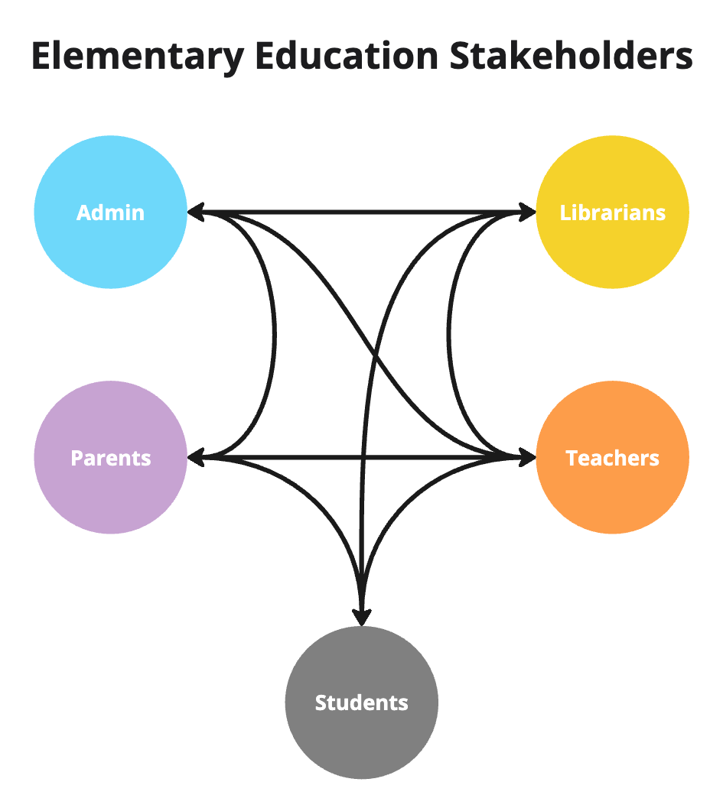

The methodological choice to include a wide range of stakeholder perspectives aligns with the commitment to creating an inclusive, relevant, and sustainable curriculum aligned with real-world classroom contexts and stakeholder needs. These groups (Figure 1) were intentionally chosen to offer diverse, contextually rich perspectives critical to the development and successful implementation of an AI literacy curriculum. In this design context, educators provided essential pedagogical insights, administrators contributed practical perspectives on resource availability and policy alignment, and parents offered important considerations related to children’s learning experiences and safety concerns. Although students are primary stakeholders in the education process, due to ethical considerations and the young age of the student population (elementary level), children themselves were not directly involved as participants in this study. As an alternative, stakeholders with direct interactions with the students, including parents, were asked to reflect on their experience with children and voice student opinion as an adult proxy.
Figure 2
AI Literacy Curriculum for Elementary Education Design Process Map
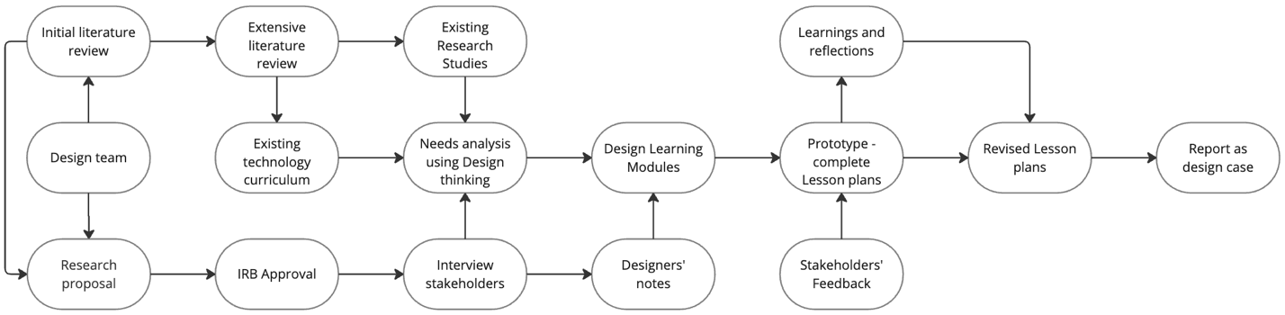

A small sample size of participants were recruited through the snowballing method. Participants (Both male and female; ages 35 through 55; minimum 4 years of experience in elementary education) included key educational stakeholders from multiple elementary schools located in a southern metropolitan city in the United States. Initial seed contacts were peers, known to the authors, who were then asked to nominate educators, administrators, and parents with varied years of experience and school settings. The final recruited sample included teachers, support staff and administrators, and parents. The recruited participants had little to average AI exposure and all were associated with private schools.
The design process (Figure 2) began with a scope and needs analysis in which the team conducted an extensive literature review on AI literacy, reviewed content analysis of existing guidelines, and led semi-structured interviews with key stakeholders. During the interviews, stakeholders contributed their expertise and insights into student needs. This feedback guided the design decisions.

Data Collection and Analysis in Practice
As part of data collection to guide the iterative co-design process, the interviews were conducted with the participants individually in two different stages of the design process (before Learning Module design and after Learning Module design). (See Figure 1 and Figure 3.) Each interview lasted around an hour. In the first stage, the needs analysis interview identified design requirements exploring stakeholder perspectives on challenges, pedagogical strategies, perceived needs, and evaluation indicators critical for effectively integrating AI literacy into elementary classrooms. In the second stage, design critique and feedback elicited fact-checking and formative evaluation of the prototype lesson plan, consistent with iterative co-design practice. All interviews were video-recorded and transcribed for further analysis. Figure 3 exhibits a closer look at the process of data collection and analysis in different phases and how it complemented the co-design practice.
Figure 3
The process of data collection and analysis in different phases to guide the design outcome
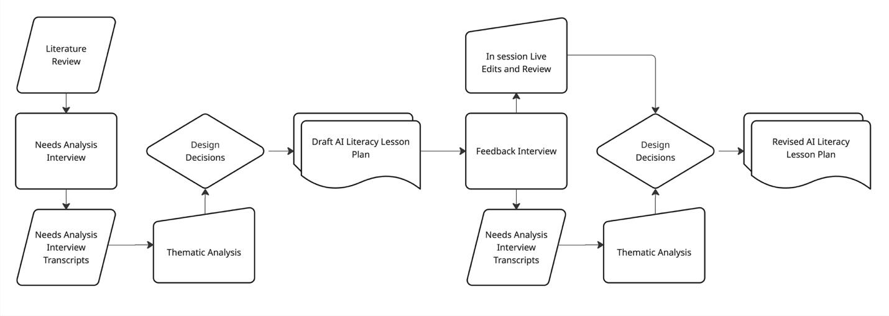
During the interviews, stakeholders may have provided aspirational rather than fully candid responses regarding their AI expertise or classroom readiness, a common limitation of interview-based research (Ravitch & Carl, 2016). Brown (2018) noted the practical use of thematic analysis as a tool in the design process. To reduce bias and misinterpretation, an inductive thematic analysis approach was employed to examine the transcripts with open coding, thereby allowing emergent patterns and themes to arise directly from the participants’ perspectives and experiences (Braun & Clarke, 2006).
This approach in the design process enabled researchers to identify themes and patterns within the data collected from interviews. The themes and patterns identified needs, guided design decisions, and evaluated design outcomes through a valid and reliable research method within the reiterative design process. Furthermore, to ensure rigor and reliability, the coding process also included members of the research team. Initial coding was completed independently before the researchers engaged in discussions and repeated readings of the transcripts. During peer review and dialogic engagement, themes emerged (Ravitch and Carl, 2016). The themes and quotations from the interview transcripts were also adopted for use in various design thinking tools to aid the inclusive design outcome. After age-appropriate learning materials, activities, and assessments were designed, identified project goals and the data from feedback sessions were used for evaluating the iterative design process.

Design Phases and Activities
While there are many design thinking models, “Design Thinking for Educators” (IDEO, 2012) was developed to meet the needs of educators. IDEO can be applied with modifications in various design tasks: learning activities, space, tools, and other tasks. The model has five non-linear and iterative phases (see Figure 4), 1. Discover, 2. Interpretation, 3. Ideation, 4. Experimentation, and 5. Evolution. For the AI Literacy curriculum design, this toolkit was simplified and adapted to the context pre-plan stage of the process.
Figure 4
Adapted from “Design Thinking for Educators” (IDEO, 2012) Design Thinking Process Map

Discovery
In the discovery phase, the team completed a comprehensive review of relevant literature on AI literacy in K-12 settings. This process supported their understanding of the design task and clarified the challenges faced by designers and educators involved in the process. Multiple participants from key stakeholder groups were also identified and recruited to help co-design an inclusive curriculum. Stakeholders were then interviewed by the researchers on their a. perceptions and concerns about AI Literacy, b. challenges faced in teaching or integrating AI in classes, c. suggestions on pedagogical strategies, and d. success indicators for effective elementary AI literacy curriculum. As demonstrated in Table 1, transcripts from first round needs analysis interviews were thematically analyzed (See Figure 3 above) and the findings were used to establish design scope and guidelines.

Table 1
Findings from stakeholders’ initial scoping and needs analysis interview
Perception | Concerns | Challenges | Suggestions | Success indicators
Acknowledges the importance and future benefits of AI Literacy and believes that basic concepts should be introduced at the elementary level  Compares it to learning other essential digital skills  Recognizes that educators and students are both still in the early stages of AI literacy | AI dependency and its potential to overshadow Cognitive Skill Development  Safety, privacy, and other ethical considerations  Lack of teacher training  The developmental readiness of younger learners  Current resources are more suited for older students, and there’s a need to adapt content for younger learners | Understanding AI concepts may be too complex for younger children  Lack of AI Literacy resources for elementary education  Lack of teacher confidence  Teacher’s time constraints and teachers’ lack of comfort with AI | Students need to be taught the limitations of AI.  Educator-supervised or guided AI use  Interactive tools and exploratory learning  Teachers need ready-to-use resources  Teacher training is crucial to building confidence in using AI tools and effectively introducing AI literacy at the elementary level | Children learn to use AI responsibly, creatively, and critically, without becoming dependent on it  Students understand foundational AI concepts and incorporate AI literacy into other subjects  Teachers are confident in incorporating AI into their lessons

Interpretation
During the interpretation phase, the interview data collected from the participants was analyzed to identify needs, constraints, and meaningful solutions. Interview transcriptions were then independently coded and thematically analyzed, revealing recurring themes around different categories (see Table 1). Quotations from the transcripts were also used in various design thinking tools, including empathy mapping for key stakeholders (see Figure 5). As a design thinking tool, empathy mapping can reveal insights into educational stakeholder needs, emotions, and motivations. Challenges beyond explicit needs were determined by visualizing stakeholder experiences from multiple perspectives (Floor, 2020). In the context of this study, which is missing student voices as stakeholders in the co-design process due to age and ethical considerations, initial interview data was used to understand learner experiences and characteristics through the creation of an empathy map based on other stakeholders' observations and insights about elementary students (see Figure 5).
Figure 5
Empathy Mapping with elementary students based on stakeholder interview
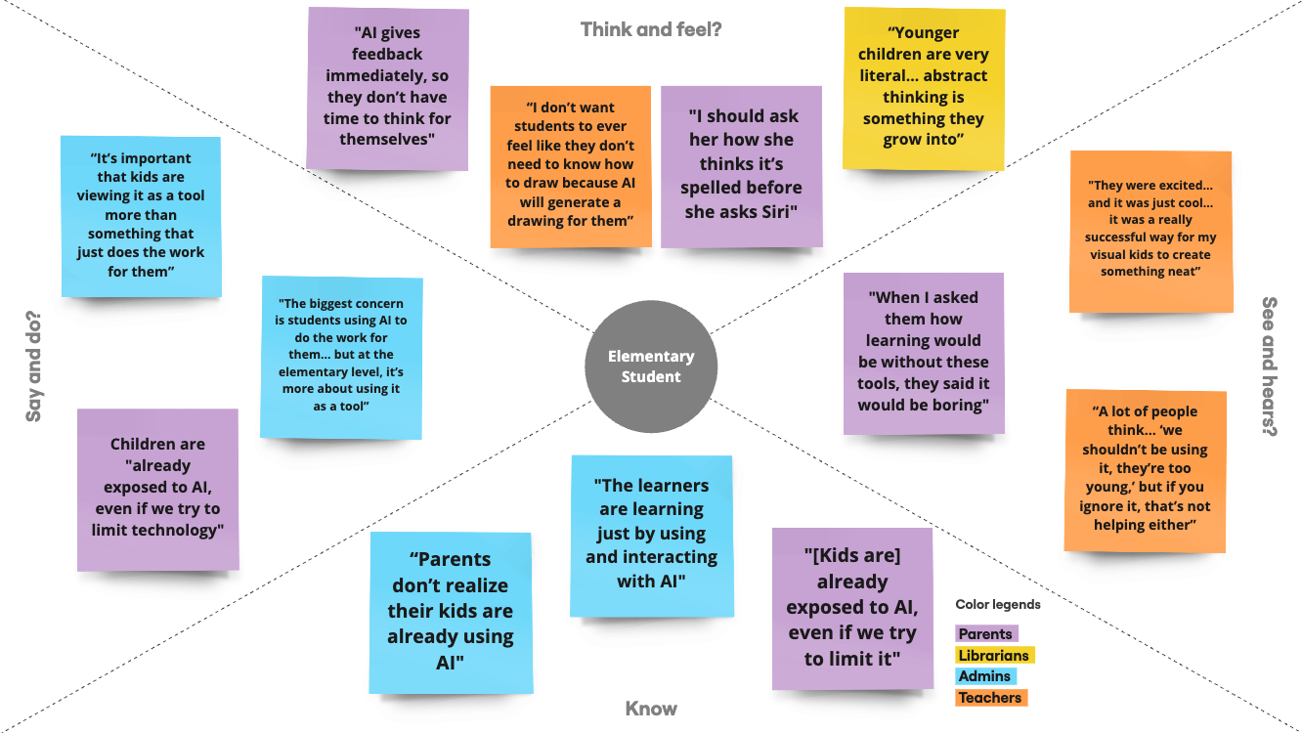

Ideation and Experimentation
The above findings and more detailed analysis (see Table 2) guided the ideation and experimentation phase underpinning the draft lesson plan. The design team reviewed the proposed AI literacy curriculum and learning activities used in other studies, and also searched and experimented with available resources, tools, or platforms. The primary goal here was to curate and compile contextually useful and easily accessible strategies, resources, and platforms that can be adopted by educators in multiple schools.
Table 2
AI Literacy Lesson Plan Rationale (First Draft after initial need analysis interview)
Stakeholder Comments | Supporting Literature | Need Identified | Lesson Activity | Design Rationale
“It's really about exposing kids to it in an appropriate way, and I think we're still figuring out what that looks like... wanting kids to start to get familiar with it.” (Admin 1)  “A lot of people think… ‘we shouldn’t be using it, they’re too young,’ but if you ignore it, that’s not helping either” - (Teacher 2) | Understanding AI concepts, everyday use, and responsible use (Long & Magerko, 2020) | Students need a foundational understanding of AI | Ask students, what they think AI is. Give the handouts for the students to write down what they think AI is. What can AI do? Tell them to give some examples of AI they know of with drawings. Give 15 mins to finish answering. | Introduce AI through tools and videos to spark curiosity
“The visual experience might be a more appropriate way to engage kiddos with AI” - (Librarian 1)  “We want them to understand the ethical implications… like bias, misinformation.” (Admin 2) | Young learners need an exploratory and constructive approach to learning through interacting with the tool which supports them in thinking more critically. (Ng et al., 2021; Olari et al., 2023 | Hands-on learning by engaging with the tool helps young learners understand AI better. | Review previous class discussions.  Prepare some images created by AI using AI image tools Which Face is Real? for discussion about the responsible use of AI. Discuss how AI can generate realistic images and that can be deceiving. Try Siri/Alexa to ask questions and how AI responds to different questions. | Understanding AI strengths and weaknesses through experiential learning.
“You want the learners to know how AI can be useful to them and develop their own thinking, not just rely on AI. I think it’s a success when children can safely navigate this AI.” (Parent –1)  “We need in-depth age-appropriate stuff that does really focus on how does AI and machine learning work”. (Admin 2) | AI literacy emerges as the ability not only to understand and interact with AI systems but also to acquire skills needed to work with AI tools (Druga et al., 2021; Hwang et al., 2023). | Students need to understand the concept about training AI. | Show the machine learning video.  Discuss how machines learn.  Ask them to work on training a robot on Code.org Ocean AI. Give handouts and ask them to write what they think about how AI works for 15 minutes. | Promotes basic understanding of machine learning with existing open resource platform.
“What it is, how it works, maybe some of the different things AI can do” (Admin 2)  “They’re excited to use it, but they’re also seeing firsthand that it’s not perfect and requires more critical thinking” (Teacher 2) | A pedagogical model for AI literacy is suggested to embody responsive teaching methods such as interactive experiences situated in real-world, meaningful, and social contexts (Yang, 2022). | Students need to engage in training AI Bot to understand how AI works. | This class should be taken to train an AI bot using Teachable Machine. The students will train the bot to sort different items for shape recognition or for color sorting. Take the first 15 mins to explain the process. The students will try different items to train the bot for 30 minutes. | Introducing machine learning and how it works in real-world contexts and experiences.
“I think the critical thinking piece is the overarching thing how do you know it when you see it, how could you use it, how could it get in the way of your learning?” - (Teacher 1)  “A big part of what we do is cooperative learning... I’d like to learn more about how AI can be used in small group projects” - (Admin 1) | Recognizing AI applications in daily life and having the skills and ability to critically assess and engage with AI systems responsibly and reflect on what they have learned (Long & Magerko, 2020). | Students should reflect on their learning | The students will try and test the bot. After testing give handouts to write what they think AI is. How it works and What they can do? Ask for examples. | Encourages individual reflection but lacks synthesis or communication opportunities

Evolution
Once the draft curriculum was created, stakeholders were invited to participate in the feedback interview. (see Figure 3). The purpose was to understand how well the design outcome met the needs of the stakeholders and to revisit the “interpret” phase in the iterative process. The participants reviewed the design outcome, i.e. lesson plan and supplementary resources, before the interview and edited the documents with their comments. During the interview, they were asked to provide constructive criticism on components of the design outcome, including module structure, teaching strategies, and learning activities. Based on their professional experience, they were also encouraged to take the perspective of elementary students and reflect on how well the proposed modules might be received. The comments and suggestions in this phase were again analyzed and helped the design team make final modifications.

Design Outcome, Discussion, and Implications
Comparing this design process with the lack of elementary-level educators’ involvement in the AI literacy curriculum design process (Ottenbreit-Leftwich et al., 2022), the Design Thinking methodology was considered to design an inclusive and relevant curriculum. The research focused on designing a practical curriculum, considering the iterative design thinking process, which prioritizes the stakeholders' needs. Stakeholders participated in two semi-structured interviews. The first interview was conducted to understand the challenges and do a needs analysis for integrating AI in elementary education. The second interview provided feedback after the AI lesson plan first draft was developed. The AI Literacy Lesson Plan developed as part of the design outcome can be found in Appendix 1.

Initial Design
Informed by needs analysis interviews, the initial five-day AI literacy curriculum was designed to introduce foundational concepts, ethical reasoning, and interactive tools in an age-appropriate and developmentally responsive format, aligning with the study’s goal of co-designing curriculum for elementary learners.
Stakeholder feedback from parents, educators, and administrators reflected both excitement and concern around implementing AI literacy at this level. While participants recognized AI's educational potential, they emphasized the need for responsible, guided use: “Is their information safe online? Do they know how to safely navigate this AI?” (Parent 1). Several stakeholders highlighted the importance of introducing fundamental concepts early, with a strong focus on ethics and awareness of bias and misinformation: “We want them to understand the ethical implications… like bias, misinformation” (Admin 2). As one teacher noted, “You have to start understanding AI pretty young because… knowing what is real is getting harder” (Teacher 1).
These insights, supported by existing research, informed a curriculum grounded in scaffolded, exploratory learning. Prior studies emphasize that AI should be introduced through explainable, accessible tools (Long & Magerko, 2020). As a tool, it should foster creativity and analytical skills, not technological dependency (Ng et al., 2023).

Redesign and Final Outcomes
Findings from the first round of stakeholder interviews prompted key revisions to the initial curriculum. Originally, the lesson included Siri/Alexa-based interaction and written reflection tasks, but these were later removed due to concerns about accessibility and developmental appropriateness. As one administrator noted, “Introduce an art project where students use AI to generate imagery, enriching their understanding of interdisciplinary applications” (Admin 2). Stakeholders emphasized the need for more visual, flexible, and low-prep formats. In response, activity durations were removed to allow adaptation across diverse classroom settings. Similarly, the Code.org training bot was replaced with more tactile and exploratory tools such as Teachable Machine and Tiny Sorter to better support hands-on, experiential learning aligned with the cognitive and developmental levels of younger students. These tools provide an intuitive and flexible platform for students to engage with machine learning concepts without relying on advanced reading or coding skills. To reinforce learning, the curriculum concludes with a group presentation task. Students visually synthesize what they’ve learned, allowing for peer feedback and deeper comprehension (Yang, 2022; Ernst et al., 2017).
Stakeholders were also concerned that foundational concepts of AI lessons for elementary education are currently missing. The AI curriculum designed for elementary students combines conceptual AI understanding with creative exploration and ethical reasoning, to address stakeholder concerns and promote a holistic view of AI among learners. Some of the Design considerations of the five-day lesson plan for addressing the foundations of AI literacy are, the use of Which Face is Real? and AI art tools like Quick Draw to discuss bias and misinformation, digestible modules from 30-45 minutes on What is AI? How does AI work? Machine Learning, Teachable Machine + Tiny Sorter used to demonstrate training and recognition to address exploratory and constructive approaches to learning through interacting with the tool which supports them in thinking more critically (Ng et al., 2021; Olari et al., 2023). The revised curriculum, developed through iterative application of the Design Thinking framework, emphasized human-centered, exploratory learning. Final design decisions were informed by stakeholder insights and aligned with existing literature on developmentally appropriate AI instruction.

Challenges & Feedback
While the co-design process yielded valuable insights and led to a developmentally appropriate curriculum, challenges and tensions emerged among stakeholders that shaped key design decisions. For example, while Administrator 1 emphasized keeping the lesson “balanced… to prevent cognitive overload”, Librarian 1 and Administrator 2 suggested adding more exploratory, hands-on activities such as art projects or cause-and-effect experiments).
“There are things about the way AI works that we could teach our kiddos early on, but probably with something hands-on and literal rather than abstract.” (Librarian 1)
The iterative nature of the design process brought to light several design tensions, particularly around interactivity, accessibility, and cognitive load. This required careful negotiation across stakeholder perspectives. Admin 2 encouraged shifting away from “extensive writing” toward conversational sharing. Librarian 1 asked, “What opportunity is there for students to ‘share’ their learning or product of process?” While one participant emphasized process-oriented verbal reflection, another wanted visible outcomes or artifacts. This led to the addition of both discussion-based and presentation-based activities, balancing formative and summative expression.
These differing priorities informed a curriculum design that balances simplicity, engagement, and visibility of learning. Nonetheless, stakeholder feedback received during the review of the AI lesson plan were positive, “This is hands-on and with experimentation in cause & effect, which allows for open-ended exploration and constructive thinking” (Librarian 1). These varying perspectives ultimately enriched the design process by prompting critical decisions about accessibility, developmental appropriateness, and learner engagement. Rather than viewing these tensions as obstacles, they served as catalysts for a more inclusive and adaptable curriculum design.

Implications

AI Literacy Can be Integrated with Digital Citizenship as an Essential Part of Digital Training
This study presents a co-designed, age-appropriate AI literacy curriculum for elementary students that integrates foundational AI concepts with ethical reflection and exploratory learning. The design process, informed by stakeholder input, emphasized simplicity, accessibility, and developmental appropriateness. The result is a flexible five-day unit that uses free, low-preparation tools such as QuickDraw and Teachable Machine, enabling integration into existing digital literacy instruction with minimal disruption.
One key implication for practice is the importance of balancing conceptual instruction with interactive, hands-on activities. Stakeholders, particularly educators, and administrators, highlighted the need for cognitively manageable lessons that promote engagement without overwhelming young learners. This aligns with prior research emphasizing that constructivist, inquiry-based experiences help students develop both conceptual understanding and critical thinking in technology-rich environments (Ng et al., 2021; Yang, 2022).
This study reinforces the potential for AI literacy to be integrated into digital citizenship education. As students increasingly encounter AI-mediated systems, early exposure to ethical concerns, such as algorithmic bias, misinformation, and data privacy, is critical (UNESCO, 2022; Long & Magerko, 2020). Embedding AI within digital citizenship frameworks can help students become not only competent users of AI but also reflective and responsible participants in an AI-driven world.

More AI-Related Professional Development (PD) and Training Opportunities are Needed for Educators
Another important consideration raised by stakeholders, but not directly addressed in the current curriculum, is the need for teacher support. Many educators expressed low confidence in introducing AI content without additional training or structured guidance. This echoes broader findings in K–12 AI education research pointing to gaps in professional development and teacher readiness (Ghamrawi et al., 2023; Kim et al., 2023; Sun et al., 2022). Future iterations of this curriculum should include companion resources such as instructional job aids and embedded PD supports to enhance implementation fidelity.

Limitations and Future Research
This design case contributes a descriptive and actionable, stakeholder-informed AI-literacy curriculum that other instructional designers and elementary educators may adapt to meet their needs. The study enriches the “precedent knowledge” base of instructional design and responds to the urgent call for age-appropriate, ethics-infused AI instruction in K-5 settings. Despite methodological rigor, this design work is intentionally iterative and limited by school context. Although the current approach supports our school needs, it may impact transferability.
In addition, elementary learners were not direct participants and ethical safeguards led us to rely on adult stakeholders such as teachers and parents as proxies. Although common in early design work, this choice may overlook children’s own language, misconceptions, and intrinsic motivations. Second, the stakeholder sample recruited from a small cluster of U.S. public and private schools reflects a limited socio-cultural range and districts. Because of this, different technological infrastructures, policy mandates, or community norms may require adaptation. Third, the curriculum’s effectiveness remains hypothetical until pilot testing and empirical evaluation are completed.
Future investigations should, therefore, integrate pilot studies and evaluate the curriculum in diverse contexts, using mixed-method designs that capture learner engagement, knowledge gains, ethical reasoning, and learning outcomes. This is also an opportunity to integrate student voice through age-appropriate focus groups, participatory sketching, or classroom observations, ensuring that design decisions and iterations reflect children’s lived experiences.
To extend the curriculum’s usefulness, future work should also broaden and diversify the sample by recruiting from multiple institutions and demographic profiles. This will allow for cultural adaptability and scalability mechanisms examinations in the research process. These studies can include the development of professional development models that build teacher AI competence and curricular “update protocols” that keep examples current as technologies shift. Furthermore, longitudinal studies may also enable us to trace how early AI literacy experiences influence later digital citizenship, critical-thinking dispositions, and STEM interests. Addressing these avenues will refine the curriculum, validate its impact, and contribute a robust evidence base for elementary AI literacy instruction.

References
Ayanwale, M. A., Sanusi, I. T., Adelana, O. P., Aruleba, K. D., & Oyelere, S. S. (2022). Teachers’ readiness and intention to teach artificial intelligence in schools. Computers and Education. Artificial Intelligence, 3, 100099. https://doi.org/10.1016/j.caeai.2022.100099
Boling, E. and Smith, K. M. (2009). Exploring Standards of Rigour for Design Cases. In: Undisciplined! Design Research Society Conference 2008, Sheffield Hallam University, Sheffield, UK, 16-19 July 2008.
Boling, E. (2010). The Need for Design Cases: Disseminating Design Knowledge. International Journal of Designs for Learning, 1(1). https://doi.org/10.14434/ijdl.v1i1.919
Braun, V., & Clarke, V. (2006). Using thematic analysis in psychology. Qualitative Research in Psychology, 3(2), 77–101.
Brinck, J., Leinonen, T., Lipponen, L., & Kallio-Tavin, M. (2020). Zones of participation – A framework to analyse design roles in early childhood education and care (ECEC). CoDesign, 18(2), 208–226. https://doi.org/10.1080/15710882.2020.1812667
Brown, N. (2018). Evaluating the usefulness of the adapted thematic analysis in the process of design. Electronic Workshops in Computing. https://doi.org/10.14236/ewic/hci2018.145
Druga, S., & Ko, A. J. (2021). How do children’s perceptions of machine intelligence change when training and coding smart programs? Interaction Design and Children. https://doi.org/10.1145/3459990.3460712
Cardona, M. A., Rodríguez, R. J., & Ishmael, K. (2023). Artificial Intelligence and Future of Teaching and Learning. U.S. Department of Education. Retrieved November 27, 2023, from https://tech.ed.gov/ai-future-of-teaching-and-learning/
Celik, I., Dindar, M., Muukkonen, H., & Järvelä, S. (2022). The promises and challenges of artificial intelligence for teachers: A systematic review of research. TechTrends, 66(4), 616-630.
Chiu, T. K. F. (2021). A holistic approach to the design of artificial intelligence (AI) education for k-12 schools. TechTrends, 65(5), 796–807. https://doi.org/10.1007/s11528-021-00637-1
Chounta, I., Bardone, E., Raudsep, A., & Pedaste, M. (2021). Exploring Teachers’ Perceptions of Artificial Intelligence as a Tool to Support their Practice in Estonian K-12 Education. International Journal of Artificial Intelligence in Education, 32(3), 725–755. https://doi.org/10.1007/s40593-021-00243-5
Cockerham, D., Lin, L., Ndolo, S., & Schwartz, M. (2021). Voices of the students: Adolescent well-being and social interactions during the emergent shift to online learning environments. Education and Information Technologies, 26(6), 7523-7541.
Comer, J.P., & Haynes, N.M. (1991). Parent Involvement in Schools: An Ecological Approach. The Elementary School Journal, 91, 271 - 277.
Crompton, H., & Burke, D. (2023). Artificial intelligence in higher education: the state of the field. International Journal of Educational Technology in Higher Education, 20(1), 22.
Dimitriadou, E., & Lanitis, A. (2023). A critical evaluation, challenges, and future perspectives of using artificial intelligence and emerging technologies in smart classrooms. Smart Learning Environments, 10(1), 12.
Elliott, S.N., Kratochwill, T.R., Littlefield Cook, J. & Travers, J. (2000). Educational psychology: Effective teaching, effective learning (3rd ed.). Boston, MA: McGraw-Hill College.
Ernst, D. C., Hodge, A., & Yoshinobu, S. (n.d.). (2017). What is Inquiry-Based Learning? Notices of the American Mathematical Society, 64(06), 570–574. https://doi.org/10.1090/noti1536
Farrokhnia, M., Banihashem, S. K., Noroozi, O., & Wals, A. (2023). A SWOT analysis of CHATGPT: Implications for educational practice and research. Innovations in Education and Teaching International, 1–15. https://doi.org/10.1080/14703297.2023.2195846
Flais, S. V. (2018). Caring for your School-age Child: Ages 5-12. Bantam.
Floor, N. (2020). Empathy map for learners. Learning Experience Design. https://lxd.org/news/empathy-map-for-learners-and-learning-experience-design/
Forehand, M. (2010). Bloom’s taxonomy. Emerging perspectives on learning, teaching, and technology, 41(4), 47-56.
Ghamrawi, N., Shal, T., & Ghamrawi, N. A. R. (2023). Exploring the impact of AI on teacher leadership: Regressing or expanding? Education and Information Technologies, 29(7), 8415–8433. https://doi.org/10.1007/s10639-023-12174-w
Hashem, R., Ali, N., El Zein, F., Fidalgo, P., & Abu Khurma, O. (2024). AI to the rescue: Exploring the potential of ChatGPT as a teacher ally for workload relief and burnout prevention. Research and Practice in Technology Enhanced Learning, 19, 023. https://doi.org/10.58459/rptel.2024.19023
Hilliger, I., Miranda, C., Celis, S., & Pérez-Sanagustín, M. (2023). Curriculum analytics adoption in higher education: A multiple case study engaging stakeholders in different phases of design. British Journal of Educational Technology, 55, 785-801.
Howard, C.D. (2011). Writing and rewriting the instructional design case: A view from two sides. International Journal of Designs for Learning, 2(1), 40-55. Retrieved from http://scholarworks.iu.edu/journals/index.php/ijdl/index
Hwang, Y., Lee, J. H., & Shin, D. (2023). What is prompt literacy? An exploratory study of language learners' development of new literacy skill using generative AI. arXiv preprint arXiv:2311.05373.
Hyett, N., Bagley, K., Iacono, T., McKinstry, C., Spong, J., & Landry, O. (2020). Evaluation of a Codesign Method Used to Support the Inclusion of Children With Disability in Mainstream Schools. International Journal of Qualitative Methods, 19. https://doi.org/10.1177/1609406920924982
IDEO. (2012). Design Thinking for Educators 2nd Edition. http://www.designthinkingforeducators.com/
Islam, R.S., Iqbal, R. A., Cockerham, D. (2024). Leveraging design thinking for creative lesson development in elementary classrooms: A case study. Association for Educational Communications & Technology (AECT).
Karimi, M. N., & Zade, S. S. H. (2018). Teachers’ use of motivational strategies: effects of a motivation-oriented professional development course. Innovation in Language Learning and Teaching, 13(2), 194–204. https://doi.org/10.1080/17501229.2017.1422255
Keogh, J.J., Fourie, W., Watson, S., & Watson, S. (2010). Involving the stakeholders in the curriculum process: a recipe for success? Nurse Education Today, 30(1), 37-43.
Kim, K., & Kwon, K. (2023). Exploring the AI competencies of elementary school teachers in South Korea. Computers and Education. Artificial Intelligence, 4, 100137. https://doi.org/10.1016/j.caeai.2023.100137
Kirschner, P. A., & De Bruyckere, P. (2017). The myths of the digital native and the multitasker. Teaching and Teacher Education, 67, 135–142. https://doi.org/10.1016/j.tate.2017.06.001
Lin, P., & Van Brummelen, J. (2021). Engaging teachers to co-design integrated AI curriculum for K-12 Classrooms. Proceedings of the 2021 CHI Conference on Human Factors in Computing Systems, 1–12. https://doi.org/10.1145/3411764.3445377
Long, D., & Magerko, B. (2020). What is AI Literacy? Competencies and Design Considerations. ACM Digital Library. https://doi.org/10.1145/3313831.3376727
Maharaj, A. (2021). Unmasking the Phenomenon of Inclusion: Parents’ Perspectives on Early Childhood Curriculum. International Education Studies, 14, 46.
Molloy, R., Hansen, A., Robinson, E., D’Astoli, P., Wood, T., & Buus, N. (2024). Stakeholder perspectives on co-designing a post-registration mental health nursing curriculum: A case study. Journal of Psychiatric and Mental Health Nursing, 31, 303–312. https://doi.org/10.1111/jpm.12988
Ng, D. T. K., Leung, J. K. L., Chu, K. W. S., & Qiao, M. S. (2021). AI Literacy: definition, teaching, evaluation, and ethical issues. Proceedings of the Association for Information Science and Technology, 58(1), 504–509. https://doi.org/10.1002/pra2.487
Ng, D. T., Wu, W., Leung, J. K., Chiu, T. K., & Chu, S. K. (2023). Design and validation of the AI literacy questionnaire: The affective, behavioral, cognitive and ethical approach. British Journal of Educational Technology. https://doi.org/10.1111/bjet.13411
Olari, V., & Romeike, R. (2021). Addressing AI and Data Literacy in Teacher Education: A Review of Existing Educational Frameworks. ACM Digital Library. https://doi.org/10.1145/3481312.3481351
Ottenbreit-Leftwich, A., Glazewski, K., Jeon, M., Jantaraweragul, K., Hmelo-Silver, C. E., Scribner, A., & Lester, J. (2022). Lessons learned for AI education with elementary students and teachers. International Journal of Artificial Intelligence in Education, 33(2), 267-289.
Ouyang, F., Zheng, L., & Jiao, P. (2022). Artificial Intelligence in Online Higher Education: A systematic review of empirical research from 2011 to 2020. Education and Information Technologies, 27(6), 7893–7925. https://doi.org/10.1007/s10639-022-10925-9
Papert, S. (1980). Mindstorms – Children, Computers and Powerful Ideas. New York: Basic Books, Inc.
Romero, M., Guitert, M., Sangra, A., & Bullen, M. (2013). Do UOC students fit in the Net Generation profile? An approach to their habits in ICT use. International Review of Research in Open and Distance Learning, 14(3), 158. https://doi.org/10.19173/irrodl.v14i3.1422
Sanusi, I. T., Oyelere, S. S., & Omidiora, J. O. (2022). Exploring teachers’ preconceptions of teaching machine learning in high school: A preliminary insight from Africa. Computers and Education Open, 3, 100072. https://doi.org/10.1016/j.caeo.2021.100072
Su, J., & Zhong, Y. (2022). Artificial Intelligence (AI) in early childhood education: Curriculum design and future directions. Computers and Education: Artificial Intelligence, 3. https://doi.org/10.1016/j.caeai.2022.100072
Su, J., Ng, D. T. K., & Chu, S. K. W. (2023). Artificial intelligence (AI) literacy in Early Childhood education: the challenges and opportunities. Computers and Education. Artificial Intelligence, 4, 100124. https://doi.org/10.1016/j.caeai.2023.100124
Sun, J., Ma, H., Zeng, Y., Han, D., & Jin, Y. (2022). Promoting the AI teaching competency of K-12 computer science teachers: A TPACK-based professional development approach. Education and Information Technologies, 28(2), 1509–1533. https://doi.org/10.1007/s10639-022-11256-5
Touretzky, D., Gardner-McCune, C., Martin, F., & Seehorn, D. (2019). Envisioning AI for K-12: What should every child know about AI? Proceedings of the AAAI Conference on Artificial Intelligence, 33(01), 9795-9799. https://doi.org/10.1609/aaai.v33i01.33019795
Velander, J., Taiye, M. A., Otero, N., & Milrad, M. (2023). Artificial intelligence in K-12 education: Eliciting and reflecting on Swedish teachers' understanding of AI and its implications for teaching & learning. Education and Information Technologies, 1-21. https://doi.org/10.1007/s10639-023-11990-4
Wang, T., & Cheng, E. C. (2021). An investigation of barriers to Hong Kong K-12 schools incorporating artificial intelligence in Education. Computers and Education: Artificial Intelligence, 2, 100031. https://doi.org/10.1016/j.caeai.2021.100031
Wang, X., Li, X., and Huang, J. (2023) Junior High School Artificial Intelligence Literacy: Connotation, Evaluation and Promotion Strategy. Open Journal of Social Sciences, 11, 33-49. doi: 10.4236/jss.2023.115004.
Yang, W. (2022). Artificial Intelligence education for young children: Why, what, and how in curriculum design and implementation. Computers and Education. Artificial Intelligence, 3, 100061. https://doi.org/10.1016/j.caeai.2022.100061
Yang, M., Lowell, V., Long, Y., & Farmer, T. (2023). Designing for accessibility in online learning: A design case. Journal of Postsecondary Education & Disability, 36(1), 75-87.
Yau, K. W., Chai, C. S., Chiu, T. K., Meng, H., King, I., Wong, S. W.-H., Saxena, C., & Yam, Y. (2022). Developing an AI literacy test for Junior Secondary students: The first stage. 2022 IEEE International Conference on Teaching, Assessment and Learning for Engineering (TALE), 59–64. https://doi.org/10.1109/tale54877.2022.00018
Yue, M., Jong, M. S. Y., & Dai, Y. (2022). Pedagogical Design of K-12 Artificial Intelligence Education: A Systematic Review. Sustainability, 14(23). MDPI. https://doi.org/10.3390/su142315620
Yue Yim, I. H. (2024). A critical review of teaching and learning artificial intelligence (AI) literacy: Developing an intelligence-based AI literacy framework for Primary School Education. Computers and Education: Artificial Intelligence, 7, 100319. https://doi.org/10.1016/j.caeai.2024.100319
Yue, M., Jong, M.S. and Dai, Y. (2022) Pedagogical Design of K-12 Artificial Intelligence Education A Systematic Review. Sustainability, 14, Article 15620.
Yu, J. H. (2023). Learning Experience Design as Collective Praxis: Two Design Cases from Higher Education. The Journal of Applied Instructional Design, 12(3). https://doi.org/10.59668/515.12902
Zawacki-Richter, O., Marín, V. I., Bond, M., & Gouverneur, F. (2019). Systematic review of research on artificial intelligence applications in higher education–where are the educators? International Journal of Educational Technology in Higher Education, 16(1), 1-27.
Zhao, X., Guo, Z., & Liu, S. (2021). Exploring key competencies and professional development of music teachers in primary schools in the era of artificial intelligence. Scientific Programming, 2021, 1–9. https://doi.org/10.1155/2021/5097003

Appendix 1
Table 3
AI Literacy Lesson Plan
Time | Topic | Materials  Needed | Activity | Competencies | Learning Objective
Day 1  30-45 mins | Learning about AI:  What is AI & What can AI do?  How do learners perceive AI? | Prepared Multiple-choice handouts.  Internet service to access the YouTube video | Start with asking 4th Grade students: What do you think is AI? What can AI do? Write responses. Tell students to give some examples of AI they know of. After completion, collect the answers and show the video “What is AI?” https://www.youtube.com/watch?v=G6de8L7cVvM / https://www.youtube.com/watch?v=ttIOdAdQaUE  Discussion: Ask students: How accurate were your ideas about AI before the video? What was most surprising? What was new? What did you discover about AI? | Recognizing AI | Understanding the fundamentals of AI
Day 2  30-45 mins | Ethical Considerations of AI  How should AI be used? | Prepared Visuals created using AI to show students/use AI on a device for visuals  Laptops/tablets for Quick Draw (free website) with access to Siri/Alexa/Google Assistant | Overview of AI (review from previous class discussion) on a slide.  Prepare some images created by AI using the below links for discussion about the responsible use of AI. You can use the links below to explain how AI can generate realistic images and that can be deceiving. Engage in discussion about how AI can generate drawings that can represent misinformation if not using appropriate prompts and how this impacts professional artists and illustrators. Use the following links.  https://www.whichfaceisreal.com/  https://www.craiyon.com/  Discuss privacy, misinformation & transparency as part of digital citizenship while using AI technology and using it responsibly.  Let students try out Quick Draw (an AI guessing game) on their own to see how AI recognizes patterns and can identify objects. | Understanding AI Intelligence  Ethics  Representation  AI strengths and weaknesses | Remembering the fundamentals and analyzing the strengths and weaknesses through image representation and discussion to evaluate the ethical considerations of AI.
Day 3  30-45 mins | Learning About AI:  How does AI work? | Laptops  Tiny sorter  https://experiments.withgoogle.com/tiny-sorter/view/ | Show the machine learning video. https://youtu.be/mrJeRNOPBTU  Discuss how machines learn after the video for a few minutes.  After the discussion, the students will train an AI bot the teachers will prepare from before, and using Teachable Machine the students will train the bot to sort different items, cereals for shape recognition, and small pieces of colored wires for color sorting. This will be done in groups through collaboration and interaction with the bot. The students will test the bot after they train it. | Machine learning  Effectively communicating & collaborating with AI system | Understanding the machine learning process and applying their knowledge to train a bot as a group.
Day 4  30-45 mins | Learning for Life with A: How does AI work? | Laptops | After testing, students will create a presentation, in groups, of what they have learned about AI and how it works showing what they think AI is and what they can do. Ask for examples with pictures. They will add images and charts representing what they learned about AI. They will continue the work on their own time if class time is not enough. | Ability to consider potential future applications and implications of AI. | Remembering what they have learned and create a presentation for reflection.
Day 5  30-45 mins | How do learners (People) perceive AI? |  | Students will present their slides to the class.

Read this online at https://edtechbooks.org/jaid_14_3/nsuqflljsd

