作图模版

Auzzer_Pang

6/18/2020

#生成随机数  
y1 = rnorm (20,mean = 1 , sd = 1 )  
y2 = rnorm (20,mean = 0 , sd = 1)

#x轴长度  
x = c(1:20);  
plot ( x , y1 , type = "b" ,pch=15, lty=1, col="red",  
 xlim = c(1,20), ylim = c(-4,4))  
axis(1, at=x,las=1,tck = -0.01)  
lines ( x , y2 , type = "b" , pch=17, lty=2, col="blue")

par(family='STKaiti')  
#一种点线图的模板  
##此处以随机数为例  
y1 = rnorm (20,mean = 1 , sd = 1 )  
y2 = rnorm (20,mean = 0 , sd = 1)  
##以plot函数绘图  
x = c(1:20);  
par(mgp = c(1,0.5,0))#表示标题在第二行，刻度表潜在0.5行，刻度线在0行  
plot ( x , y1 ,main = "主标题为", sub = "副标题为",  
 type = "b",  
 pch=15,  
 lty=1,  
 col="red",#线条颜色  
 xlim = c(1,20),#x轴范围  
 ylim = c(-5,5),  
 tck = 0.03#为正时刻度朝里  
)  
#添加次要刻度线(此处为y=0)  
abline(h=0, lty=2, col="green")  
#坐标轴控制  
axis(1, at=x,las=1,tck = -0.01)  
#添加另一条线  
lines ( x , y2 , type = "b" , pch=17, lty=2, col="blue")  
#添加图例  
legend("bottomleft", inset=.05, title="aqa", c("y1","y2"),  
lty=c(1, 2), pch=c(15, 17), col=c("red", "blue"))

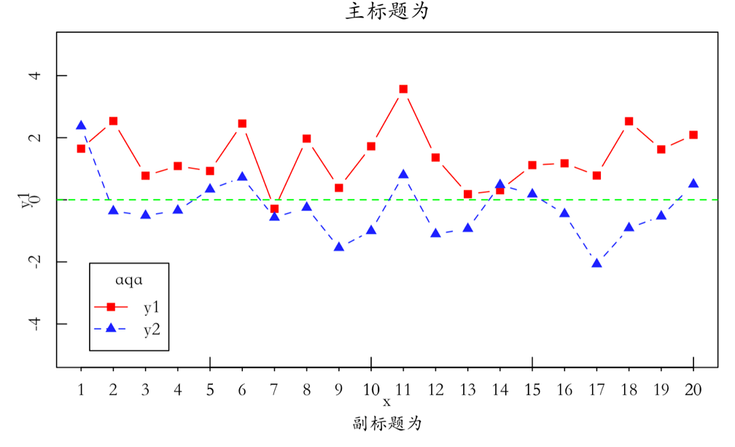

set.seed(1234)  
y1=c(rnorm(20))  
y2=c(rnorm(20))  
x=c(1:20)  
opar <- par(no.readonly=TRUE)   
par(lty=3)  
par(pin=c(5,3))  
par(oma=c(0,0,0,0))  
par(mar=c(5,4,4,2))  
plot(x,y1,  
 xlim=c(0,20),ylim=c(-3,3),  
 pch=15,type ="b",col="black",  
 xlab="x",ylab="y",main=expression(y%~%N(0,1)),  
 xaxt='n'#禁用x轴刻度线  
 )  
lines(x,y2,type="b",pch=0,col="red")  
legend("bottomleft", inset=0.01,c("group1", "group2"),   
 col=c("black", "red"), lty = 2,pch=c(15,0),bty='n')  
axis(side=1,at=x,labels =1:20,gap.axis=0.25)

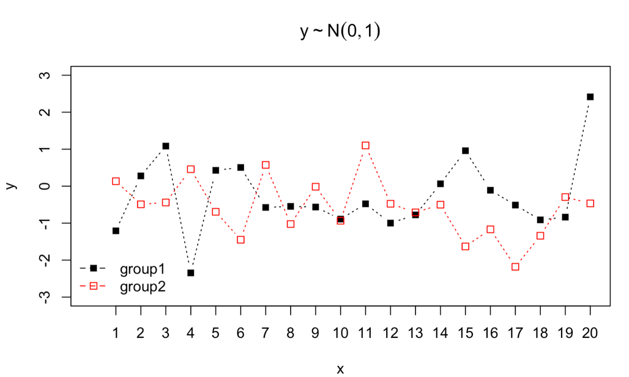

par(family='STKaiti')  
#一页多图  
library(vcd)

## Loading required package: grid

opar <- par(no.readonly=TRUE)   
layout(matrix(c(1,1,2,3), 2, 2, byrow = TRUE))  
d=density(mtcars$mpg)  
plot(d,main="核密度曲线图")  
text(x=42.3,y=0.068,labels='a',cex=1.5)  
plot(mtcars$mpg,type="b",main="散点图")  
text(x=32.5,y=34,labels='b',cex=1.5)  
boxplot(mtcars$mpg,main="箱线图",ylab="Miles per Gallon")  
text(x=1.51,y=34,labels='c',cex=1.5)

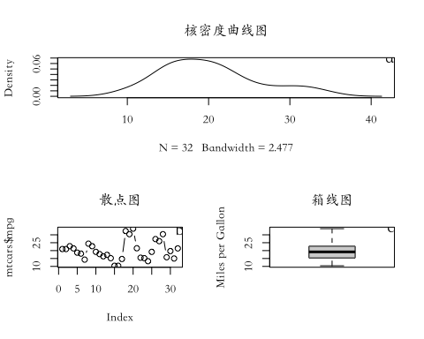

#+++++++++++++++++++++++++++++++++++++++++++++++++++++++++++++++#  
  
par(mfrow=c(2,3))  
par(xpd=T)  
par(bty="n")  
par(pin=c(4,2.5))  
par(mar=c(6,2,1,2))  
xy=par("usr")  
xy

## [1] 0.46 1.54 9.46 34.84

#++++++++++++++++++++++++++++++++++++++++++++++++++++++++++++#  
plot(x,y1,xlim = c(0,20),ylim = c(-3,3),pch = 17,type = "b",  
 col = "#900021",xlab = "x",ylab = "y")  
lines(x,y2,type="b",pch=16,col="#002FA7")  
  
plot(x,y1,xlim=c(0,20),ylim=c(-3,3),pch=17,  
 type = "b",col="#900021",  
 xlab="x",ylab="y")  
lines(x,y2,type="b",pch=16,col="#002FA7")  
  
#+++++++++++++++++++++++++++++++++++++++++++++++++++++++++++++++#  
  
plot(x,y1,xlim=c(0,20),ylim=c(-3,3),pch=17,type = "b",col="#900021",xlab="x",ylab="y")  
lines(x,y2,type="b",pch=16,col="#002FA7")  
  
#+++++++++++++++++++++++++++++++++++++++++++++++++++++++++++++++#  
  
plot(x,y1,xlim=c(0,20),ylim=c(-3,3),pch=17,  
 type = "b",col="#900021",  
 xlab="x",ylab="y")  
lines(x,y2,type="b",pch=16,col="#002FA7")  
  
#+++++++++++++++++++++++++++++++++++++++++++++++++++++++++++++++#  
  
plot(x,y1,xlim=c(0,20),ylim=c(-3,3),pch=17,  
 type = "b",col="#900021",xlab="x",ylab="y")  
lines(x,y2,type="b",pch=16,col="#002FA7")  
  
#+++++++++++++++++++++++++++++++++++++++++++++++++++++++++++++++#  
  
legend(x=xy[2]-xinch(1.5),y=xy[3]-yinch(0.35),  
 legend=c("group1", "group2"),  
 ncol=2,bty="n",  
 col=c("#900021","#002FA7"),   
 lty=1,lwd=2,xpd=T,pch=c(17,16))  
  
#+++++++++++++++++++++++++++++++++++++++++++++++++++++++++++++++#  
  
plot(x,y1,xlim=c(0,20),ylim=c(-3,3),  
 pch=17,type = "b",col="#900021",  
 xlab="x",ylab="y")  
lines(x,y2,type="b",pch=16,col="#002FA7")

