COSC450 Assignment 1 Report
Procedural City Generation in Blender
13th September 2015

In this assignment I have written a python script that generates a Manhattan-style like city in the 3D modelling software Blender, where the building are placed into a grid like structure where the streets create borders for the buildings and other structures in the city.

The Script
The script has some global parameters at the top of the file that can be modified to change the size of the city and how long the city takes to generate.
- TILENUMBER_X: Changes the number of columns of tiles that are generated
- TILENUMBER_Y: Changes the number of rows of tiles that are generated
- CHANCE_OF_BUILDING: Is a probability chance of more or less buildings showing up in the city, if the number is lower, then there will be more parks that are generated in the city. This variable set to 0 will mean the city will be made entirely of parks, while if is set to 1, it will mean the city will be made up of entirely buildings.
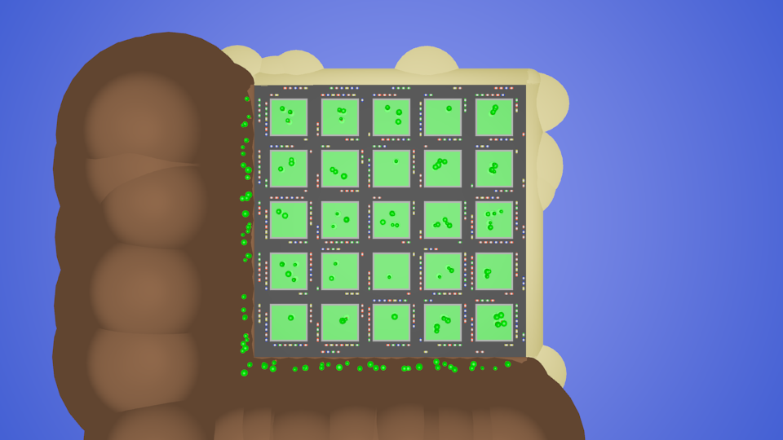
Fig 1: A city made up of only parks
- CHANCE_OF_CUBE_BUILDING: Is a probability chance of more or less cube shaped buildings being generated through out the city. The lower this variable is set will mean there will be more circular shaped buildings. This variable being set to 0 will mean that the city will be made up of entirely circular buildings, while the variable being set to 1 will mean the city will be made up of entirely cube buildings. I thought it would be best to have a lower number of circular buildings as they are more of unique type of building.
- CHANCE_OF_CUBE_SKYSCRAPER: Has the same affect as the above variable but affects the generation of skyscrapers instead.
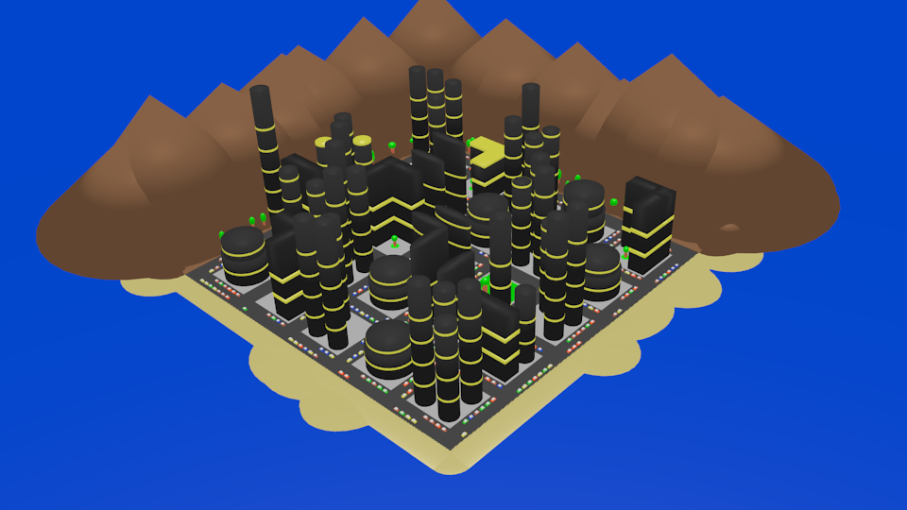
Fig 2: A city made up of circular buildings
- MAX_CARS_IN_LINE: This affects the maximum number of cars that are generated for each line or lane on the streets. A random number between 0 and the variable is selected to decide the number that are generated. The variable shouldn't be more than 7 or the cars could possibly be generated inside of each other or even off the city island.
- MAX_TREES_IN_PARK: This affects the number of trees that are generated for each park tile. A random number between 1 and the variable is selected to decide the number of tree that are generated. The higher the variable the longer it takes for a park tile to be generated.
The following variables can be turned on or off to change the finished generation of the city, can be used to test specific parts of the generation or speed up the generation.
- DO_BUILDINGS: Turns on or off buildings being generated
- DO_PARKS: Turns on or off parks being generated
- DO_GROUND: Whether the ground plane is generated
- DO_OCEAN: Whether the ocean plane is generated
- DO_BORDER: Whether the city border is generated, include both the beach front and mountain outskirts.
- DO_CARS: Whether the cars are generated for each tile or not
- DO_SKYBOX: Whether the two planes that make the sky box are generated or not

How it is Built
My city is built up with a grid, where each grid location is referred to as a tile. Each tile has a chance to either have a combination of buildings occupying it or have a park tile. With this in mind, I have used a two-dimensional array to store what are in each of the tiles, the array is populated from the function “fill_tile_array()” where there is a chance for each tile to be a building tile or park tile. The chance which is defined by the variable CHANCE_OF_BUILDING. I have made two constants for these which are BUILDING and PARK, which are defined near the top of the file. I was planning to have more than two different types of tiles, which is why I have made the array and corresponding variables. Once the tiles array has been filled the function “render_tile_array()” is called, which goes through the two-dimensional array and renders what is in it, calling the corresponding methods for each tile type. The function that generates the buildings decides how many buildings will occupy a single tile, which is 1 to 4. For each building that is generated there is a chance for it to be either a circular or cube shaped building. Parks are just a single green coloured plane with a certain number of trees on it. Each tile has random number of cars on them, on the four sides of each tile with two lanes of cars. Each car is made up of two cubes and two cylinders. The border to the city is half beach front and half mountain outskirts. The beach is made up of cylinders and sphere, while the mountains are made up of cylinders and cones. The mountain outskirts also have a tree line. There is a single plane that represents the seas level or ocean and another plane that is the ground of the city.

Gallery of Different City Generations
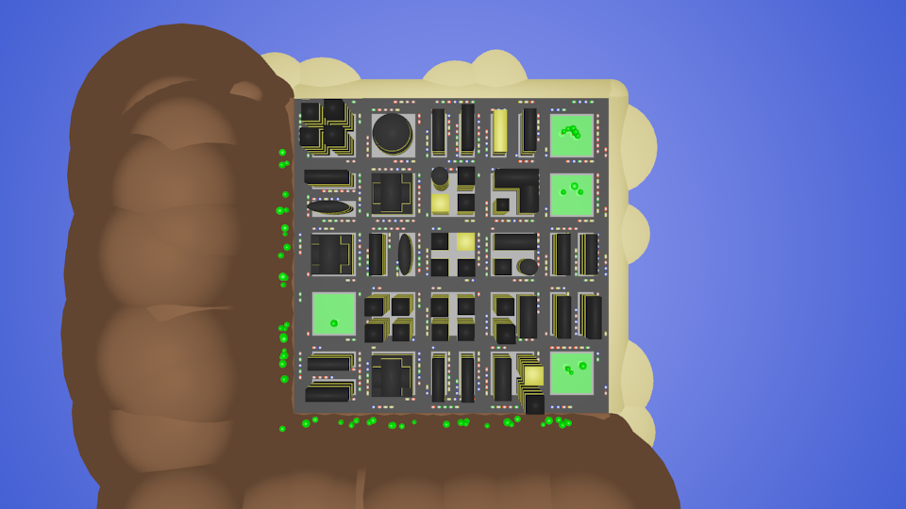
Fig 3: 5x5 tiled city from above
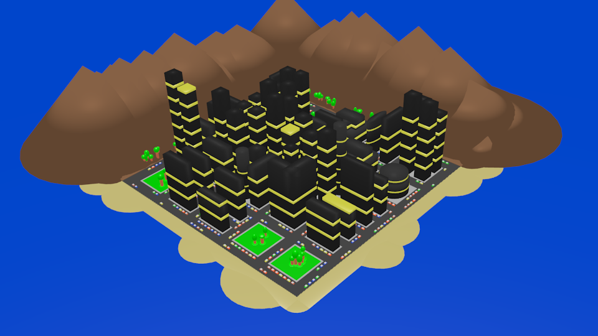
Fig 4: 5x5 tiled city from an angle
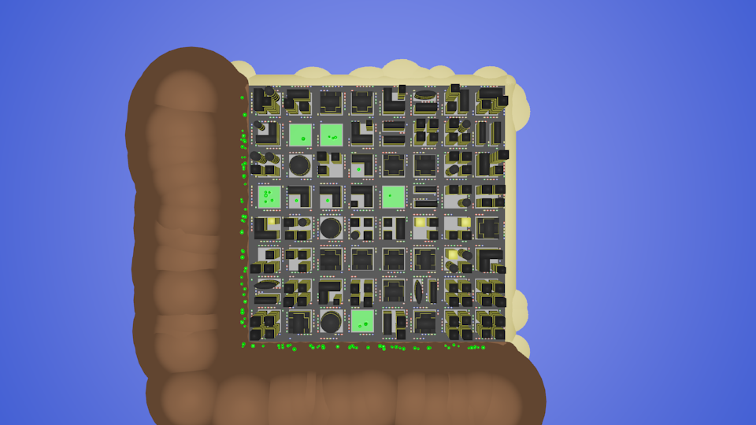
Fig 5: 8x8 tiled city from above
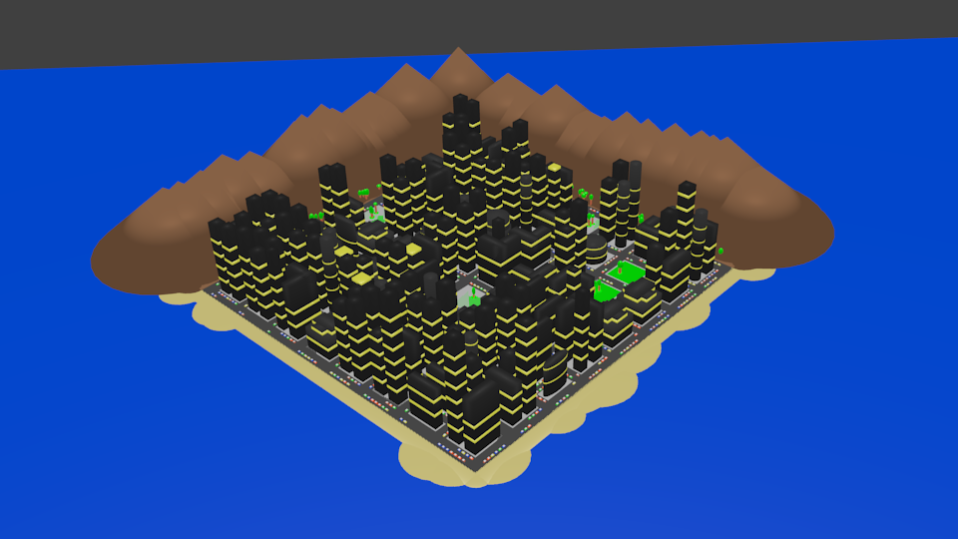
Fig 6: 8x8 tiled city from an angle
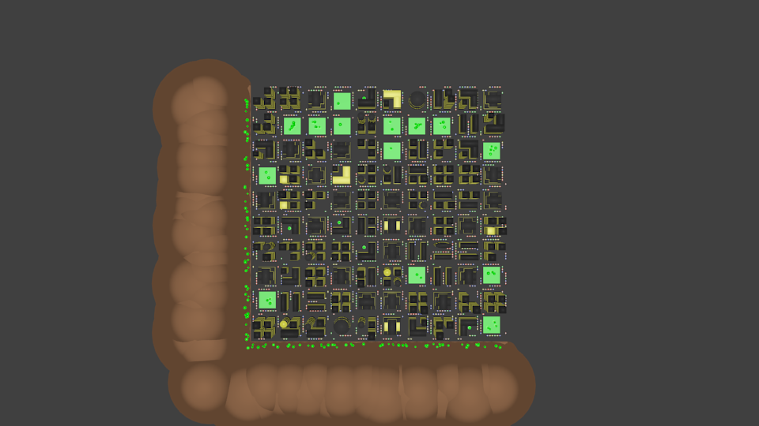
Fig 7: 10x10 tiled city from above
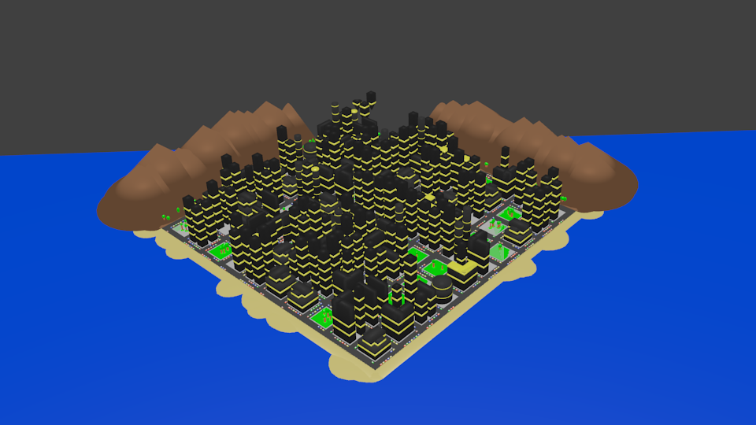
Fig 8: 10x10 tiled city from an angle

