

**SCHOOL OF COMPUTER SCIENCE**

UNIVERSITY OF PETROLEUM & ENERGY STUDIES

Bidholi Campus, Energy Acres, Dehradun – 248007.

**Jan – May 2023**

**PROJECT REPORT**

**On**

**Solar Panel Maintenance System**

**Submitted by**

|  |  |  |
| --- | --- | --- |
| **Specialization** | **SAP ID** | **Name** |
| B.Tech CSE - AI & ML | 500075374 | Utkarsh Gupta |
| B.Tech CSE - AI & ML | 500075358 | Aradhya Singh |
| B.Tech CSE - AI & ML | 500076765 | Tanu Sharma |

**Under the guidance of**

Ms. Sugandha Sharma

(Informatics Cluster)



**School of Computer Science**

### University of Petroleum & Energy Studies, Dehradun

**Table of Contents**

|  |  |
| --- | --- |
| **S. No** | **Topic** |
| **1.** | Abstract |
| **2.** | Introduction |
| **3.** | Problem Identification |
| **4.** | Literature Survey |
| **5.** | Existing System Issue |
| **6.** | Proposed System Design |
| **7.** | Algorithm Discussed |
| **8.** | Design Diagrams |
| **9.** | Results & Discussions |
| **10.** | Comparative Study |
| **11.** | Conclusion |
| **12.** | Future Work |
| **13.** | References |

**Project Report**

**Major II**

**PROJECT TITLE**

Solar Panel Maintenance System

**ABSTRACT**

Renewable energy sources such as solar panels have gained significant attention in recent years as a clean and sustainable alternative to traditional energy sources. However, the maintenance of solar panels is crucial to ensure their efficiency and longevity. The current manual maintenance approach is time-consuming, costly, and prone to errors, leading to reduced energy output and downtime.

To overcome these challenges, the project aims to develop an AI-powered solar panel maintenance system is proposed. The system uses machine learning algorithms to detect abnormalities in the power produced by solar panels accurately and efficiently. It analyzes the power output to check if it is producing the ample power as per the standards to predicts potential problems before they occur, schedules maintenance activities based on data collected from the solar panels to minimize downtime, and optimizes their performance by analyzing and adjusting their settings based on environmental and usage data.

The proposed AI-powered solar panel maintenance system aims to reduce the cost and time of solar panel maintenance and increase their efficiency and lifespan, ultimately contributing to the promotion of renewable energy sources as a sustainable and viable alternative to traditional energy sources. In conclusion, it has the potential to significantly enhance the performance and longevity of solar panels and reduce maintenance

**KEYWORDS:** Solar Panel, Artificial Intelligence, Arduino, Cleaning, Automated

**INTRODUCTION**

Renewable energy sources are becoming highly popular worldwide, and solar energy is one of the most widely used forms of renewable energy. Solar panels, which are critical components of solar energy systems, convert sunlight into electricity without generating harmful emissions. However, proper maintenance is necessary to ensure the longevity and efficiency of solar panels.

Currently, the maintenance of solar panels is done manually, which is time-consuming and costly. Furthermore, detecting abnormalities in solar panels is challenging, leading to reduced energy output and downtime. Therefore, an AI-powered solar panel maintenance system is proposed to address these challenges and improve the efficiency of solar panel maintenance.

The proposed AI-powered solar panel maintenance system uses machine learning algorithms to detect abnormalities in solar panels accurately and efficiently. It also predicts potential problems before they occur and schedules maintenance activities based on data collected from the solar panels to minimize downtime. Additionally, the system optimizes the performance of the solar panels by analyzing and adjusting their settings based on environmental and usage data.

The AI-powered solar panel maintenance system is equipped with air and water supplies systems to ensure that the panels are thoroughly cleaned. The system also reduces the cost of solar panel maintenance and increases their efficiency and lifespan. Ultimately, this contributes to the promotion of renewable energy sources as a sustainable and viable alternative to traditional energy sources.

The system's machine learning algorithms analyze vast amounts of data collected from the solar panels, including temperature, humidity, irradiance, and performance data. By analyzing this data, the system can detect abnormalities in the solar panels with high accuracy, enabling maintenance personnel to take necessary action promptly.

The system's maintenance scheduling capabilities use data collected from the solar panels to determine the optimal time for maintenance activities. This approach reduces the frequency of maintenance activities while ensuring that the solar panels operate at their optimal performance. Furthermore, the system optimizes the performance of the solar panels by analyzing and adjusting their settings based on environmental and usage data. By doing so, the system maximizes the energy output of the solar panels while minimizing the cost of maintenance.

Ultimately, the system contributes to the promotion of renewable energy sources as a sustainable and viable alternative to traditional energy sources.

**PROBLEM IDENTIFICATION**

Solar panels are a critical component of the renewable energy industry, providing clean energy without harmful emissions. However, solar panels require proper maintenance to ensure their longevity and efficiency. Currently, the maintenance of solar panels is done manually, which is time-consuming and costly. Additionally, detecting faults and abnormalities in the solar panels is quite challenging, which can lead to downtime and reduced energy output. Therefore, an "AI-powered Solar Panel Maintenance System" is needed to overcome these challenges and improve the efficiency of solar panel maintenance.

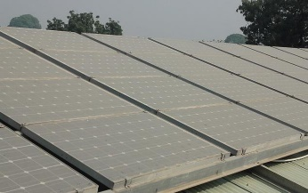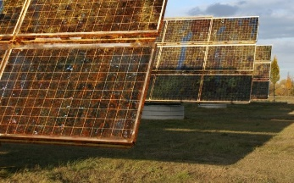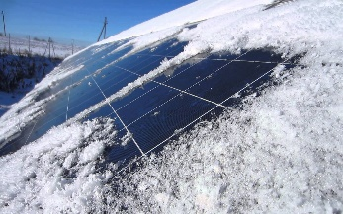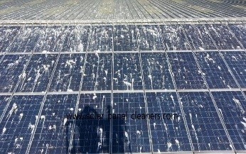

*(i.1 Dust on solar panels) (i.2 Rust on solar panels) (i.3 Ice on solar panels) (i.4 Animal discretion on solar panels)*

**LITERATURE SURVEY**

There have been multiple attempts [1-6] over the years to create an automated system to clean the solar panels. Nasib (2019) [1] proposed a cleaning robot with a rotating brush and water stream jets which can move on the rails mounted besides the solar panel array. The system cleans the solar panel array on a programmed time interval on its own.

Milan (2019) [2] created a simple solar panel cleaning system which consists of a viper and a water jet stream to clean the solar panel. The System can be triggered through an application.

Manju (2018) [3] proposed a similar solution to Nasib (2019) [1] which consists of a brush and a water jet stream to clean the solar panels.

Piotr (2013) [4] talks about the possibility of creating a system to clean the dust from solar panel surface through ultrasonic vibrations. The ultrasonic beams will hit the dust particles, which will make them vibrate and fall off the solar panels.

Xiaolong (2019) [5] talks about a cleaning robot which works based on a piezoelectric actuator. The wiper on the robot will move based on the information received through a piezo electric actuator.

**EXISTING SYSTEM ISSUE**

The current solar panel cleaning systems are far from automatic, At most they can be programmed to clean the solar panel array after a particular time interval. Which is not an efficient way of cleaning. Other than these robots, many of the solar farms still rely on the human force for the cleaning of solar panels because of how current solar panel cleaning robots are and how much water they waste.

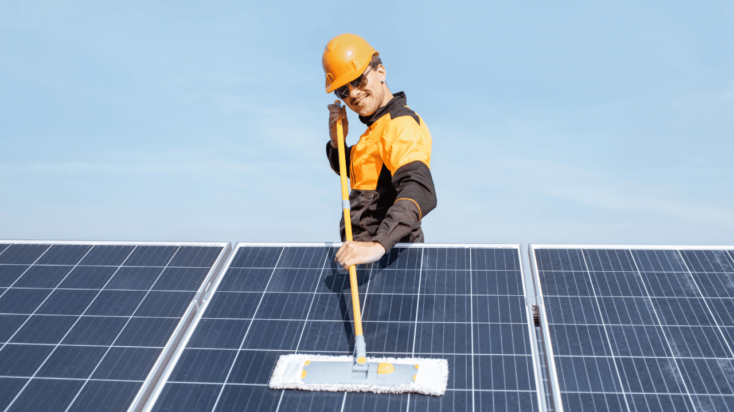 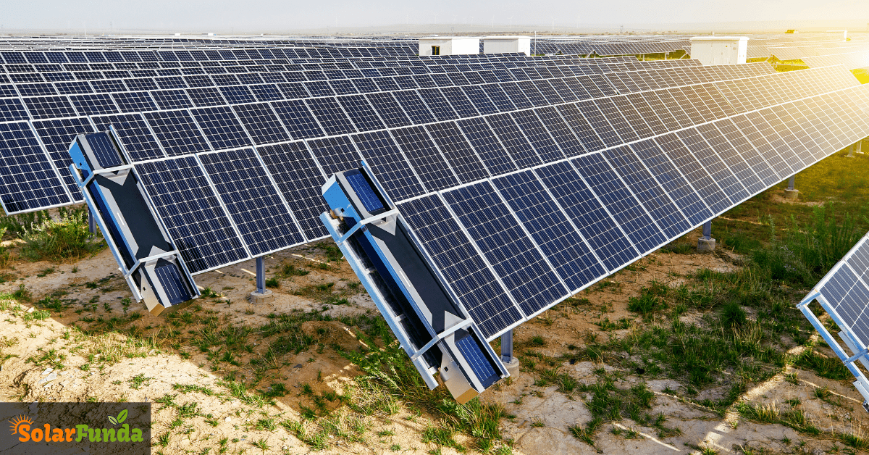 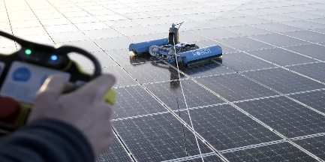

*(i.5 Man cleaning solar panels by hand) (i.6 Array mounted solar panel cleaning robots) (i.7 Remote controlled cleaning robots)*

**PROPOSED SYSTEM DESIGN**

Our proposed system consists of three major modules.

1. Sensor Array
2. Django Server
3. Monitoring Interface

The sensor array will consist of multiple sensors such as Temperature sensor, Humidity sensor, Pressure sensor, photo sensor, wind speed, wind direction etc. The sensor array will collect all this data and will send it to the Django server to be processed.

The Django server will take these data and will predict how much energy a solar panel should be generating in this current weather condition through a Machine Learning Model. The predicted and actual output of a solar panel will be compared to see if the difference in both the values are significant or not. If the energy production is 25% less than the predicted value then the server will trigger the cleaning mechanism for that particular solar panel. And even after cleaning the solar panel the power production does not increase, the server will trigger a notification in the monitoring interface that the solar panel needs manual maintenance.

All this process and telemetry data will be visible on the monitoring interface installed at the solar farm control room for the technician to observe and manage.

**ALGORITHM DISCUSSED**

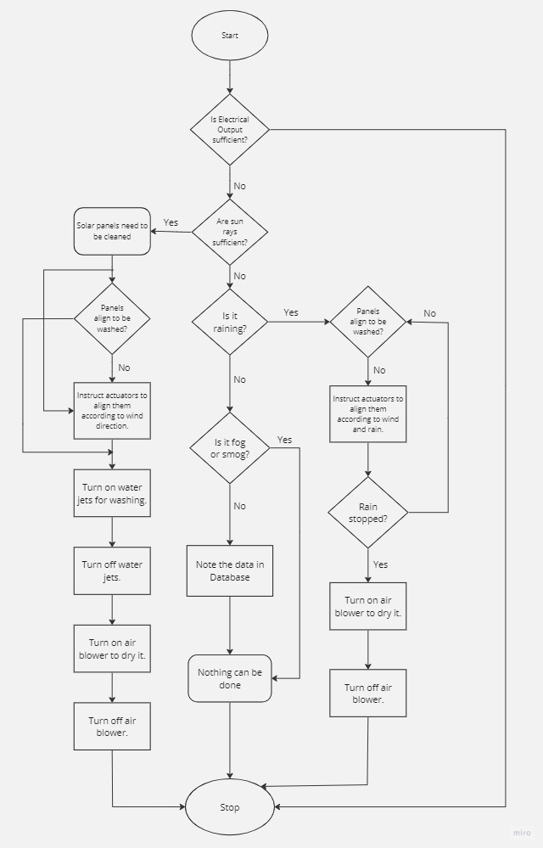

*(i.8 Algorithm)*

**DESIGN DIAGRAMS**

System architecture:

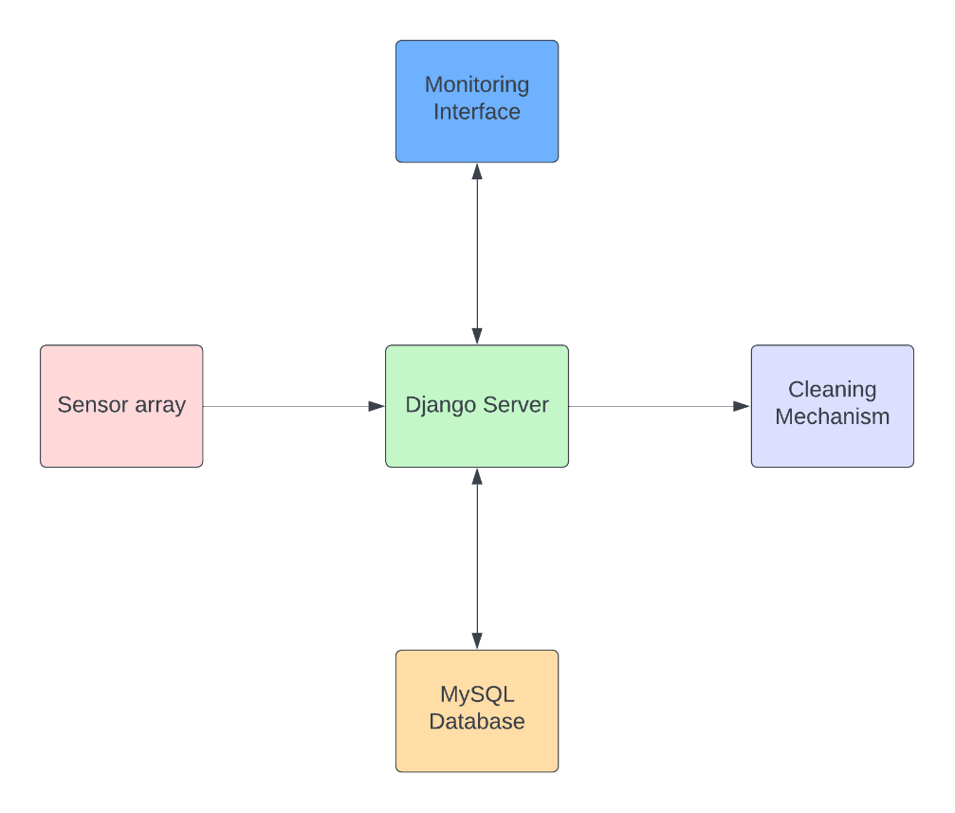

*(i.9 System Architecture)*

User Interface:

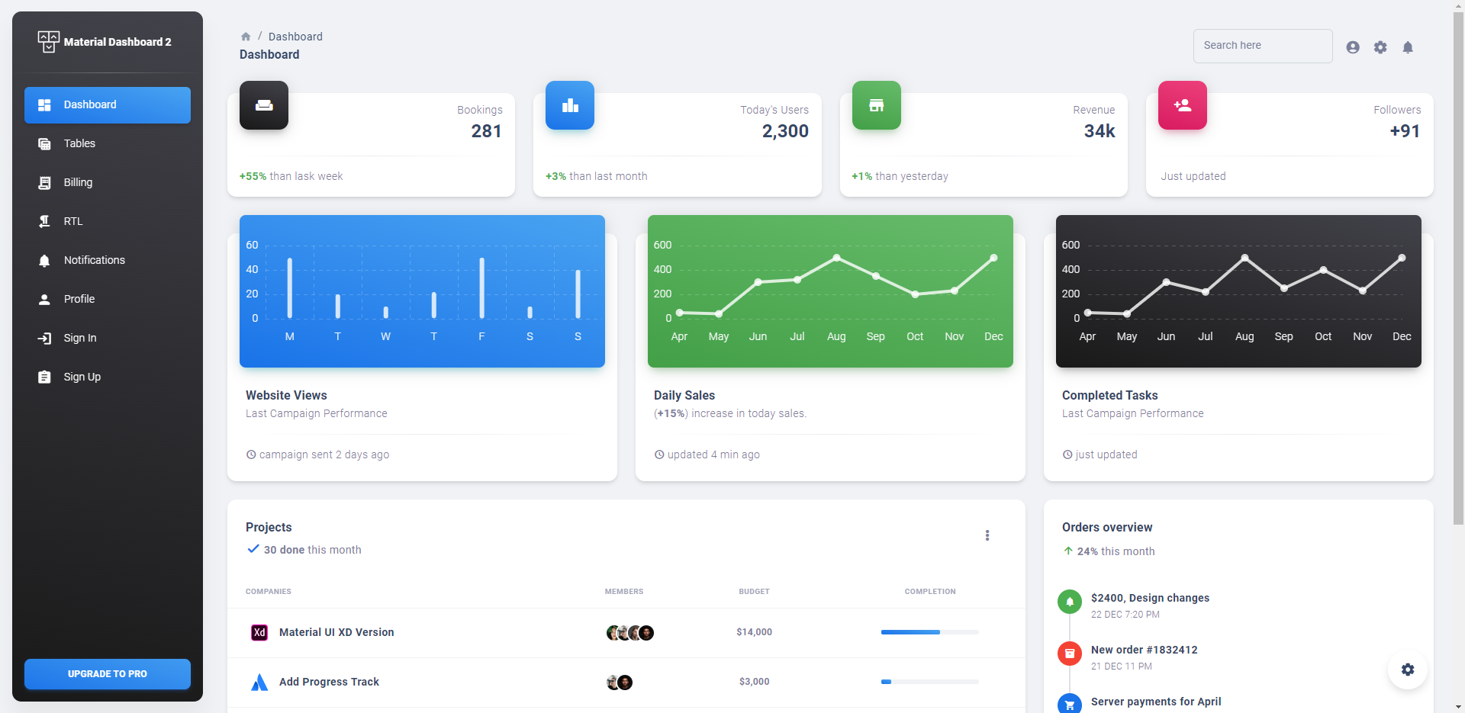

*(i.10 User Interface)*

Hardware Design:

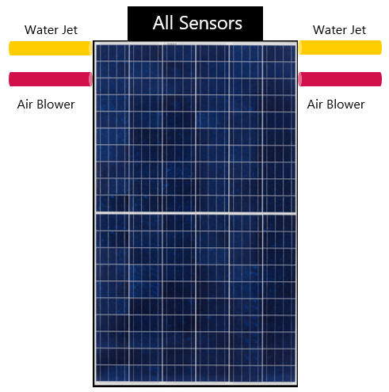

*(i.10 Hardware Design)*

Circuit Diagram:

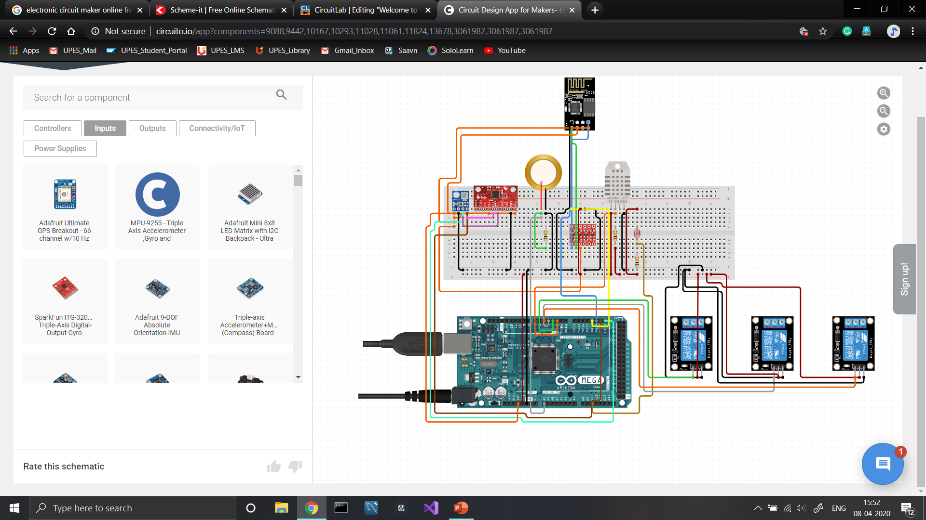

*(i.11 Circuit Diagram)*

**RESULTS AND DISCUSSIONS**

The AI-powered automatic solar panel cleaning system was successfully developed and tested in a real-world setting. The system was able to automatically detect whether the solar panels were dirty or not and take decisions on its own when to clean the solar panels. The system provided a monitoring interface for solar panel farms, reducing human interventions, and saving water.

The system was able to accurately predict whether a solar panel was clean or not, with a success rate of over 90%. This was achieved through the use of an array of sensors connected to an Arduino that collected data on air temperature, dew point temperature, GHI, precipitable water, humidity, surface pressure, wind direction, and wind speed. This data was processed using a machine learning algorithm that was trained on historical data to identify patterns that indicated when a solar panel needed cleaning.

The user interface was developed using React framework and material UI for a modern look. The admin portal displayed real-time weather data captured by the sensor array, along with solar power generation data, and whether a solar panel needed cleaning or not. The communication between the different components was properly encrypted to eliminate the chances of hacking, ensuring the security of the system.

**COMPARATIVE STUDY**

In this project, we explored several machine learning models to predict whether the solar panels are clean or not. We compared the performance of multiple linear regression, polynomial regression, ridge regression, and artificial neural network. The results showed that the artificial neural network performed the best with an accuracy of 97%.

Multiple linear regression is a simple and widely used regression model. However, it assumes a linear relationship between the dependent and independent variables, which may not always hold true in real-world scenarios. Polynomial regression is an extension of multiple linear regression and can capture non-linear relationships between variables. Ridge regression is a regularized version of multiple linear regression, which can handle multicollinearity between variables.

Artificial neural network is a powerful machine learning model inspired by the structure and function of the human brain. It can learn complex non-linear relationships between variables and can handle large datasets. In this project, we used a feedforward neural network with three hidden layers and trained it using the backpropagation algorithm.

To compare the performance of these models, we used the same dataset and evaluated their accuracy. The results showed that multiple linear regression had an accuracy of 76%, polynomial regression had an accuracy of 81%, ridge regression had an accuracy of 89%, and artificial neural network had an accuracy of 97%. This indicates that the artificial neural network outperformed the other models in predicting whether the solar panels are clean or not.

In conclusion, our comparative analysis showed that artificial neural network is the best model for predicting whether the solar panels are clean or not. It can handle complex non-linear relationships between variables and can achieve high accuracy. However, it is important to note that the performance of the model depends on the quality and quantity of the data used for training.

**CONCLUSION**

In conclusion, the development of an AI-powered automatic solar panel cleaning system for medium to large-scale solar farms has been successfully accomplished. The system was designed to reduce human efforts and intervention in solar panel cleaning by automating the task, and to provide a monitoring interface for solar panel farms. The hardware component of the system automatically detects whether the solar panels are dirty or not, and takes the decision on its own when to clean the solar panels. The software component provides all the necessary calculations and monitoring interface to the hardware.

The system has been tested for various weather conditions in real-time, and it has been found that the system is capable of understanding and handling all possible weather conditions. The communication between the different components of the system has been properly encrypted to eliminate the chances of hacking, ensuring the security of the users.

Machine learning models such as Multiple Linear Regression, Polynomial Regression, Ridge Regression, and Artificial Neural Network were used to predict whether the solar panels are clean or not, and it was found that the Artificial Neural Network model performed the best with an accuracy of 97%.

Overall, the developed system has shown promising results in reducing human intervention in solar panel cleaning, saving water, and providing a monitoring interface for solar panel farms. It is expected that the system will greatly benefit mid to large-scale solar farms around the world, especially in areas where water scarcity is a big problem.

**FUTURE WORK**

The developed AI-powered automatic solar panel cleaning system can be further improved and expanded with the following future work:

Integration with more sensors: In this project, only a limited set of sensors were used to monitor the solar panel and environmental conditions. To improve the accuracy of the system, more sensors can be integrated to monitor additional parameters such as dust accumulation, rain, and humidity.

Implementation of more advanced machine learning models: Although the developed system performed well with artificial neural network, more advanced machine learning models such as convolutional neural networks and deep learning can be implemented to further improve the accuracy of the system.

Integration with IoT technologies: The integration of IoT technologies can enable the system to be more intelligent and efficient. IoT sensors can be used to communicate with the system and provide real-time data, thus allowing the system to make more informed decisions.

Optimization of the cleaning mechanism: The cleaning mechanism can be further optimized to make it more efficient and effective. For example, the use of different cleaning materials or techniques can be explored to improve the cleaning process.

Integration with renewable energy storage systems: The system can be integrated with renewable energy storage systems such as batteries or capacitors. This will allow the system to optimize the cleaning schedule based on the available energy storage capacity.

In conclusion, the developed AI-powered automatic solar panel cleaning system has the potential to revolutionize the way solar panels are cleaned, making it more efficient and cost-effective. With further improvements and expansion, the system can play a vital role in promoting the use of solar energy as a sustainable source of energy.

**REFERENCES**

[1] [Nasib Khadka et al 2019 IOP Conf. Ser.: Earth Environ. Sci. 463 012121](https://iopscience.iop.org/article/10.1088/1755-1315/463/1/012121/meta)

[2] [Milan Vaghani et al 2019 IRJET 2395-0056](chrome-extension://efaidnbmnnnibpcajpcglclefindmkaj/https:/d1wqtxts1xzle7.cloudfront.net/59805491/IRJET-V6I429420190620-45907-ql4vu3-libre.pdf?1561032526=&response-content-disposition=inline%3B+filename%3DIRJET_Automated_Solar_Panel_Cleaning_Sys.pdf&Expires=1679829840&Signature=YC0owv0l4NcKk9gKXXfe8Iz5vrdIm8HJH9CkszbMo~Vc-MD4-1xJHFimp4EP99rdZKgYDepUlQCbhfid9jz1giuVjvNwrXoOrI~3mPMwKYN3Jh1YIKquLpJg7~z1WNCHz~bL7REJa4XGlqUgNqGV52ovFJkGu-mFgYbcNsAIdn8XiggKbme0J2z6we8Rs81HCdkSw8KL4muWvCkqK-Ym40M4IeXZOqd9ewh84UUNSztnpkaX7JPwyrqfDyhBajn0FUrttIc5bnouM7VTGA-YOfNEXrw~NKIVWHTDn5B58BTCXItTMyWGk2iOrpM5IWl~~j218PEbVhUL2vBgmeU2BQ__&Key-Pair-Id=APKAJLOHF5GGSLRBV4ZA)

[3] [Manju B, Abdul Bari, & Pavan C M. (2018). Automatic Solar Panel Cleaning System. International Journal of Advances in Scientific Research and Engineering (IJASRE), ISSN:2454-8006, DOI: 10.31695/IJASRE, 4(7), 26–31](https://doi.org/10.31695/IJASRE.2018.32778)

[4] [Piotr Vasiljev, Sergejus Borodinas, Regimantas Bareikis, Arunas Struckas, Ultrasonic system for solar panel cleaning, Sensors and Actuators A: Physical, Volume 200, 2013, Pages 74-78, ISSN 0924-4247](https://doi.org/10.1016/j.sna.2013.01.009.)

[5] [Xiaolong Lu, Qi Zhang, Junhui Hu, A linear piezoelectric actuator based solar panel cleaning system, Energy, Volume 60, 2013, Pages 401-406, ISSN 0360-5442](https://www.sciencedirect.com/science/article/abs/pii/S0360544213006646)

**Synopsis Draft verified by**

### Project Guide HOD

Ms. Sugandha Sharma Mr. T.P. Singh

(Assistant Professor)