

**SCHOOL OF COMPUTER SCIENCE**

UNIVERSITY OF PETROLEUM & ENERGY STUDIES

Bidholi Campus, Energy Acres, Dehradun – 248007.

**Jan – May 2023**

**PROJECT REPORT**

**On**

**Solar Panel Maintenance System**

**Submitted by**

|  |  |  |
| --- | --- | --- |
| **Specialization** | **SAP ID** | **Name** |
| B.Tech CSE - AI & ML | 500075374 | Utkarsh Gupta |
| B.Tech CSE - AI & ML | 500075358 | Aradhya Singh |
| B.Tech CSE - AI & ML | 500076765 | Tanu Sharma |

**Under the guidance of**

Ms. Sugandha Sharma

(Informatics Cluster)



**School of Computer Science**

### University of Petroleum & Energy Studies, Dehradun

**Table of Contents**

|  |  |
| --- | --- |
| **S. No** | **Topic** |
| **1.** | Abstract |
| **2.** | Introduction |
| **3.** | Problem Identification |
| **4.** | Literature Survey |
| **5.** | Existing System Issue |
| **6.** | Proposed System Design |
| **7.** | Algorithm Discussed |
| **8.** | Design Diagrams |
| **9.** | References |

**Project Report**

**Major II**

**PROJECT TITLE**

Solar Panel Maintenance System

**ABSTRACT**

Renewable energy sources such as solar panels have gained significant attention in recent years as a clean and sustainable alternative to traditional energy sources. However, the maintenance of solar panels is crucial to ensure their efficiency and longevity. The current manual maintenance approach is time-consuming, costly, and prone to errors, leading to reduced energy output and downtime.

To overcome these challenges, the project aims to develop an AI-powered solar panel maintenance system is proposed. The system uses machine learning algorithms to detect abnormalities in the power produced by solar panels accurately and efficiently. It analyzes the power output to check if it is producing the ample power as per the standards to predicts potential problems before they occur, schedules maintenance activities based on data collected from the solar panels to minimize downtime, and optimizes their performance by analyzing and adjusting their settings based on environmental and usage data.

The proposed AI-powered solar panel maintenance system aims to reduce the cost and time of solar panel maintenance and increase their efficiency and lifespan, ultimately contributing to the promotion of renewable energy sources as a sustainable and viable alternative to traditional energy sources. In conclusion, it has the potential to significantly enhance the performance and longevity of solar panels and reduce maintenance

**KEYWORDS:** Solar Panel, Artificial Intelligence, Arduino

**INTRODUCTION**

Renewable energy sources are becoming highly popular worldwide, and solar energy is one of the most widely used forms of renewable energy. Solar panels, which are critical components of solar energy systems, convert sunlight into electricity without generating harmful emissions. However, proper maintenance is necessary to ensure the longevity and efficiency of solar panels.

Currently, the maintenance of solar panels is done manually, which is time-consuming and costly. Furthermore, detecting abnormalities in solar panels is challenging, leading to reduced energy output and downtime. Therefore, an AI-powered solar panel maintenance system is proposed to address these challenges and improve the efficiency of solar panel maintenance.

The proposed AI-powered solar panel maintenance system uses machine learning algorithms to detect abnormalities in solar panels accurately and efficiently. It also predicts potential problems before they occur and schedules maintenance activities based on data collected from the solar panels to minimize downtime. Additionally, the system optimizes the performance of the solar panels by analyzing and adjusting their settings based on environmental and usage data.

The AI-powered solar panel maintenance system is equipped with air and water supplies systems to ensure that the panels are thoroughly cleaned. The system also reduces the cost of solar panel maintenance and increases their efficiency and lifespan. Ultimately, this contributes to the promotion of renewable energy sources as a sustainable and viable alternative to traditional energy sources.

The system's machine learning algorithms analyze vast amounts of data collected from the solar panels, including temperature, humidity, irradiance, and performance data. By analyzing this data, the system can detect abnormalities in the solar panels with high accuracy, enabling maintenance personnel to take necessary action promptly.

The system's maintenance scheduling capabilities use data collected from the solar panels to determine the optimal time for maintenance activities. This approach reduces the frequency of maintenance activities while ensuring that the solar panels operate at their optimal performance. Furthermore, the system optimizes the performance of the solar panels by analyzing and adjusting their settings based on environmental and usage data. By doing so, the system maximizes the energy output of the solar panels while minimizing the cost of maintenance.

Ultimately, the system contributes to the promotion of renewable energy sources as a sustainable and viable alternative to traditional energy sources.

**PROBLEM IDENTIFICATION**

Solar panels are a critical component of the renewable energy industry, providing clean energy without harmful emissions. However, solar panels require proper maintenance to ensure their longevity and efficiency. Currently, the maintenance of solar panels is done manually, which is time-consuming and costly. Additionally, detecting faults and abnormalities in the solar panels is quite challenging, which can lead to downtime and reduced energy output. Therefore, an "AI-powered Solar Panel Maintenance System" is needed to overcome these challenges and improve the efficiency of solar panel maintenance.

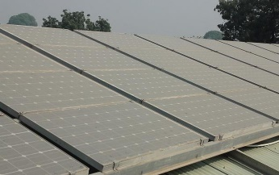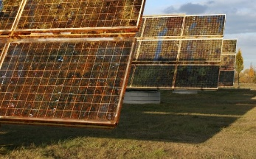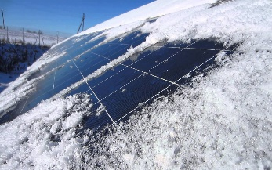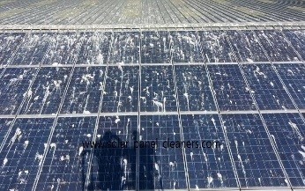

*(i.1 Dust on solar panels) (i.2 Rust on solar panels) (i.3 Ice on solar panels) (i.4 Animal discretion on solar panels)*

**LITERATURE SURVEY**

There have been multiple attempts [1-6] over the years to create an automated system to clean the solar panels. Nasib (2019) [1] proposed a cleaning robot with a rotating brush and water stream jets which can move on the rails mounted besides the solar panel array. The system cleans the solar panel array on a programmed time interval on its own.

Milan (2019) [2] created a simple solar panel cleaning system which consists of a viper and a water jet stream to clean the solar panel. The System can be triggered through an application.

Manju (2018) [3] proposed a similar solution to Nasib (2019) [1] which consists of a brush and a water jet stream to clean the solar panels.

Piotr (2013) [4] talks about the possibility of creating a system to clean the dust from solar panel surface through ultrasonic vibrations. The ultrasonic beams will hit the dust particles, which will make them vibrate and fall off the solar panels.

Xiaolong (2019) [5] talks about a cleaning robot which works based on a piezoelectric actuator. The wiper on the robot will move based on the information received through a piezo electric actuator.

**EXISTING SYSTEM ISSUE**

The current solar panel cleaning systems are far from automatic, At most they can be programmed to clean the solar panel array after a particular time interval. Which is not an efficient way of cleaning. Other than these robots, many of the solar farms still rely on the human force for the cleaning of solar panels because of how current solar panel cleaning robots are and how much water they waste.

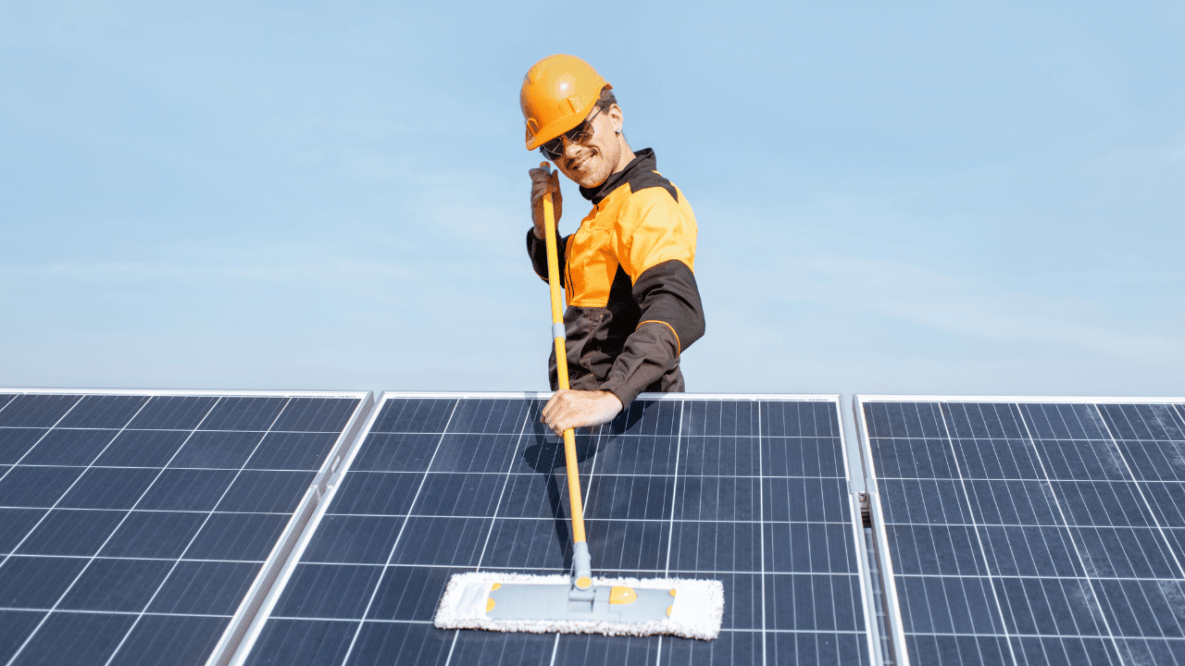 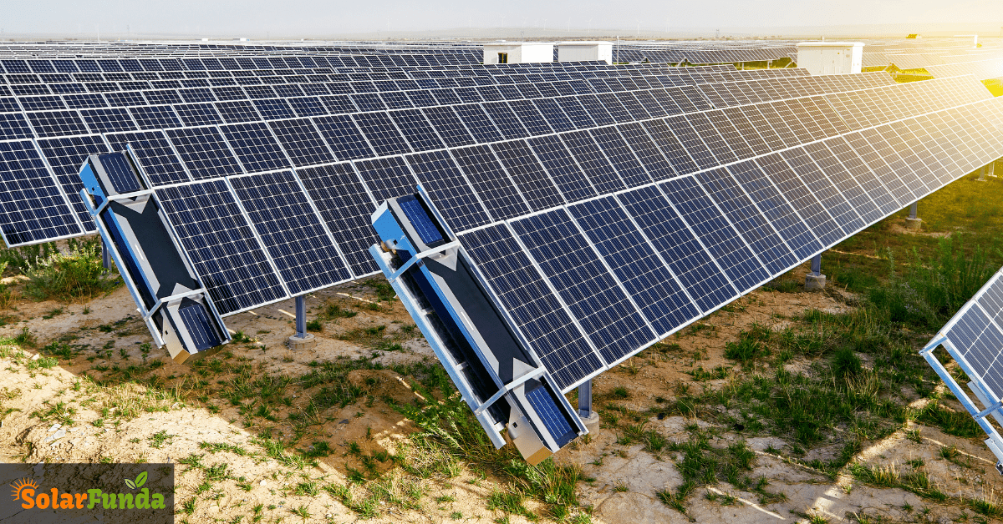 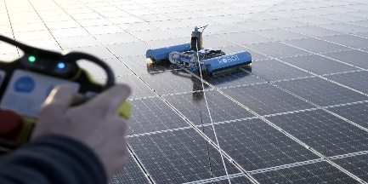

*(i.5 Man cleaning solar panels by hand) (i.6 Array mounted solar panel cleaning robots) (i.7 Remote controlled cleaning robots)*

**PROPOSED SYSTEM DESIGN**

Our proposed system consists of three major modules.

1. Sensor Array
2. Django Server
3. Monitoring Interface

The sensor array will consist of multiple sensors such as Temperature sensor, Humidity sensor, Pressure sensor, photo sensor, wind speed, wind direction etc. The sensor array will collect all this data and will send it to the Django server to be processed.

The Django server will take these data and will predict how much energy a solar panel should be generating in this current weather condition through a Machine Learning Model. The predicted and actual output of a solar panel will be compared to see if the difference in both the values are significant or not. If the energy production is 25% less than the predicted value then the server will trigger the cleaning mechanism for that particular solar panel. And even after cleaning the solar panel the power production does not increase, the server will trigger a notification in the monitoring interface that the solar panel needs manual maintenance.

All this process and telemetry data will be visible on the monitoring interface installed at the solar farm control room for the technician to observe and manage.

**ALGORITHM DISCUSSED**

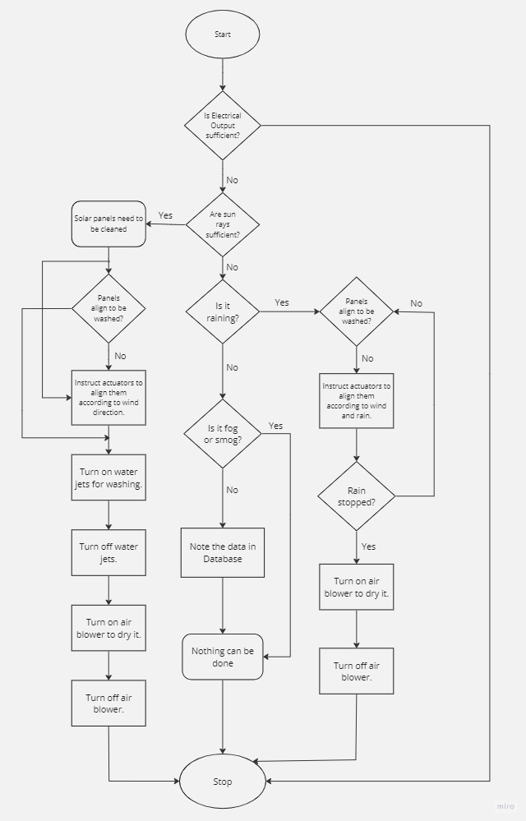

*(i.8 Algorithm)*

**DESIGN DIAGRAMS**

System architecture:

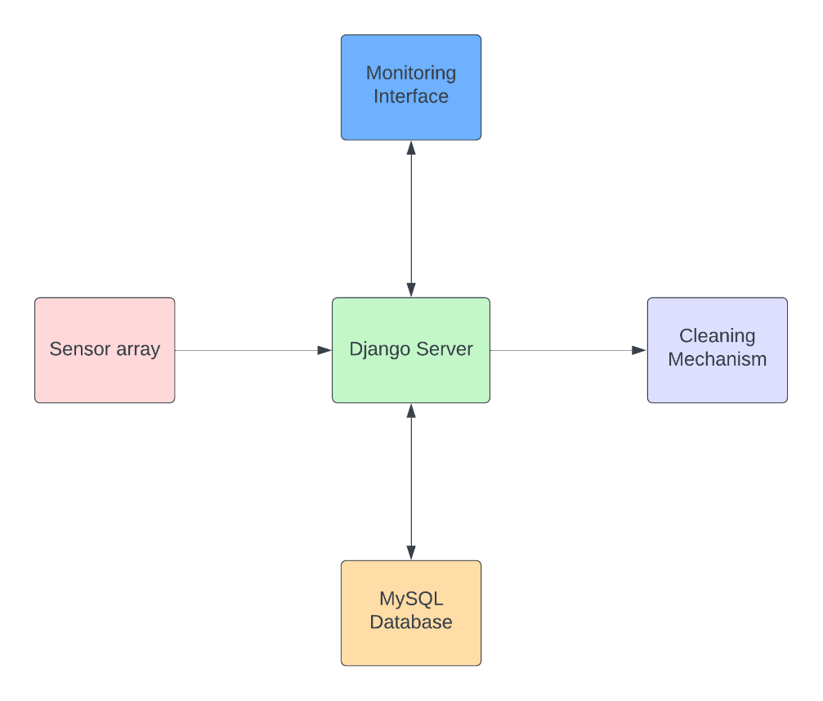

*(i.9 System Architecture)*

User Interface:

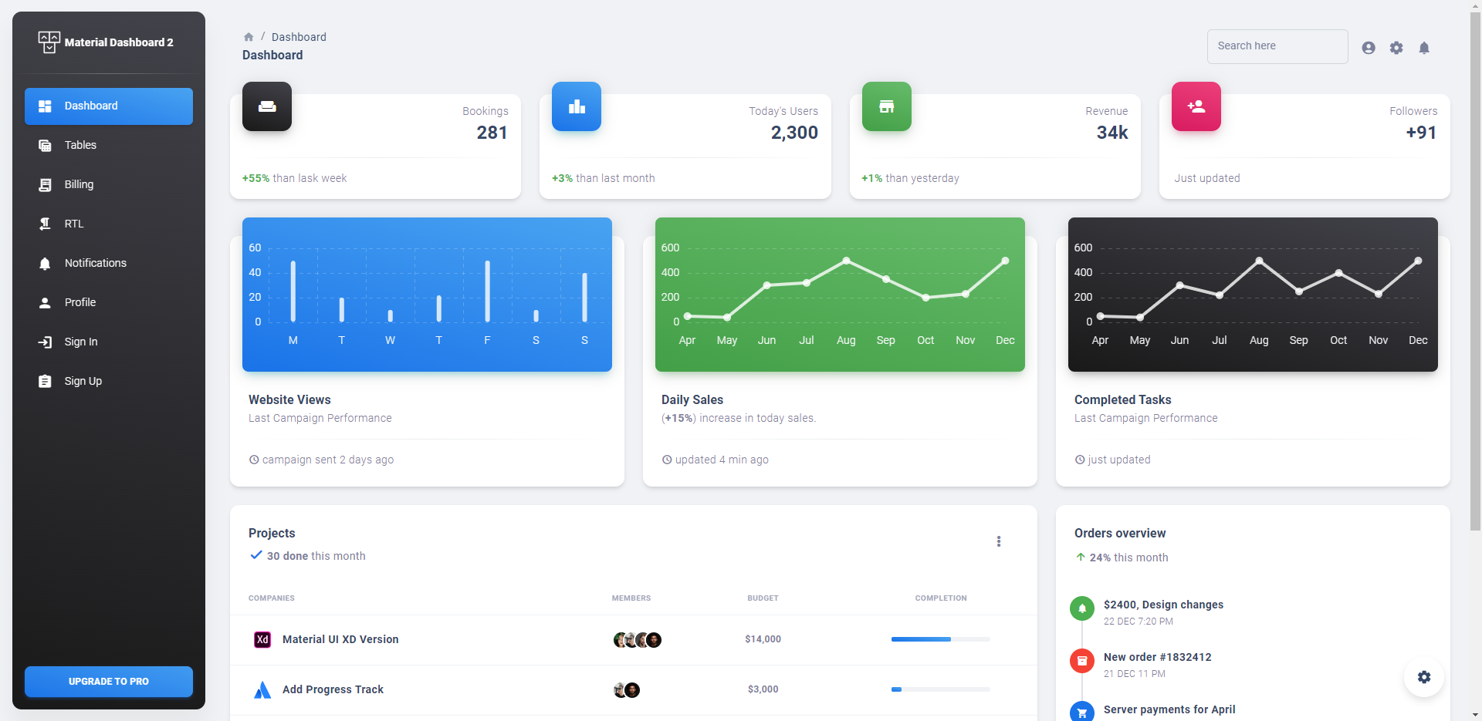

*(i.10 User Interface)*

Hardware Design:

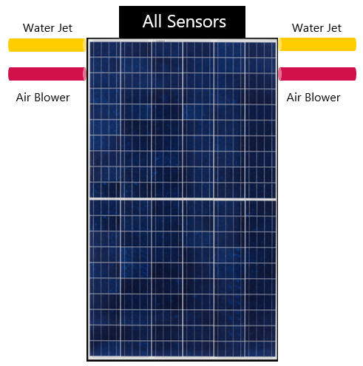

*(i.10 Hardware Design)*

Circuit Diagram:

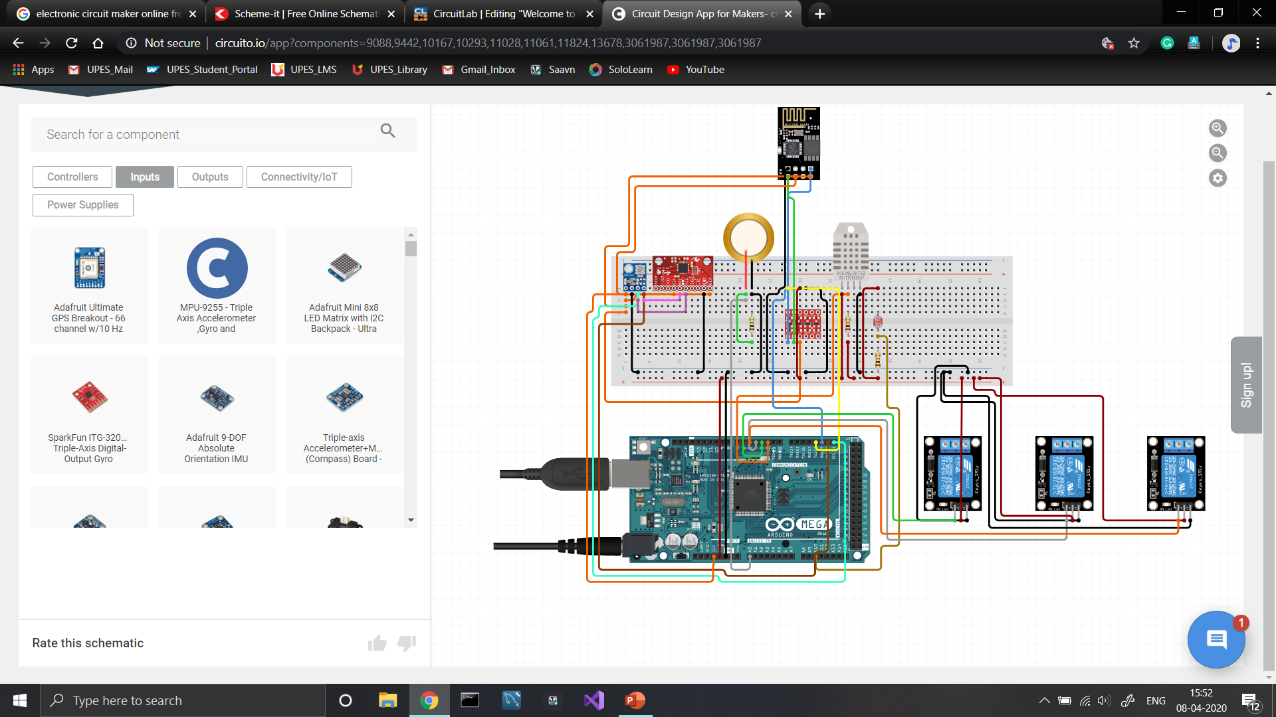

*(i.11 Circuit Diagram)*

**REFERENCES**

[1] [Nasib Khadka et al 2019 IOP Conf. Ser.: Earth Environ. Sci. 463 012121](https://iopscience.iop.org/article/10.1088/1755-1315/463/1/012121/meta)

[2] [Milan Vaghani et al 2019 IRJET 2395-0056](chrome-extension://efaidnbmnnnibpcajpcglclefindmkaj/https:/d1wqtxts1xzle7.cloudfront.net/59805491/IRJET-V6I429420190620-45907-ql4vu3-libre.pdf?1561032526=&response-content-disposition=inline%3B+filename%3DIRJET_Automated_Solar_Panel_Cleaning_Sys.pdf&Expires=1679829840&Signature=YC0owv0l4NcKk9gKXXfe8Iz5vrdIm8HJH9CkszbMo~Vc-MD4-1xJHFimp4EP99rdZKgYDepUlQCbhfid9jz1giuVjvNwrXoOrI~3mPMwKYN3Jh1YIKquLpJg7~z1WNCHz~bL7REJa4XGlqUgNqGV52ovFJkGu-mFgYbcNsAIdn8XiggKbme0J2z6we8Rs81HCdkSw8KL4muWvCkqK-Ym40M4IeXZOqd9ewh84UUNSztnpkaX7JPwyrqfDyhBajn0FUrttIc5bnouM7VTGA-YOfNEXrw~NKIVWHTDn5B58BTCXItTMyWGk2iOrpM5IWl~~j218PEbVhUL2vBgmeU2BQ__&Key-Pair-Id=APKAJLOHF5GGSLRBV4ZA)

[3] [Manju B, Abdul Bari, & Pavan C M. (2018). Automatic Solar Panel Cleaning System. International Journal of Advances in Scientific Research and Engineering (IJASRE), ISSN:2454-8006, DOI: 10.31695/IJASRE, 4(7), 26–31](https://doi.org/10.31695/IJASRE.2018.32778)

[4] [Piotr Vasiljev, Sergejus Borodinas, Regimantas Bareikis, Arunas Struckas, Ultrasonic system for solar panel cleaning, Sensors and Actuators A: Physical, Volume 200, 2013, Pages 74-78, ISSN 0924-4247](https://doi.org/10.1016/j.sna.2013.01.009.)

[5] [Xiaolong Lu, Qi Zhang, Junhui Hu, A linear piezoelectric actuator based solar panel cleaning system, Energy, Volume 60, 2013, Pages 401-406, ISSN 0360-5442](https://www.sciencedirect.com/science/article/abs/pii/S0360544213006646)

**Synopsis Draft verified by**

### Project Guide HOD

Ms. Sugandha Sharma Mr. T.P. Singh

(Assistant Professor)