**MAJOR-2 PROJECT**

**SRS**

For

Solar Panel Maintenance System

Submitted By

|  |  |  |
| --- | --- | --- |
| **Specialization** | **SAP ID** | **Name** |
| B.Tech CSE - AI & ML | 500075374 | Utkarsh Gupta |
| B.Tech CSE - AI & ML | 500075358 | Aradhya Singh |
| B.Tech CSE - AI & ML | 500076765 | Tanu Sharma |



Informatics Cluster

School Of Computer Science

UNIVERSITY OF PETROLEUM & ENERGY STUDIES,

DEHRADUN- 248007. Uttarakhand

Mrs. Sugandha Sharma Mr. T.P. Singh

**Project Guide Cluster Head**



**School of Computer Science**

University of Petroleum & Energy Studies, Dehradun

**Table of Contents**

|  |  |  |
| --- | --- | --- |
| **Topic** | | **Page No** |
| Table of Content | |  |
| Revision History | |  |
| 1 | Introduction | 3 |
|  | 1.1 Purpose of the Project | 3 |
|  | 1.2 Target Beneficiary | 3 |
|  | 1.3 Project Scope | 3 |
|  | 1.4 References | 3 |
| 2 | Project Description | 3 |
|  | 2.1 Development Environment | 3 |
|  | 2.2 Data/ Data structure | 4 |
|  | 2.3 SWOT Analysis | 4 |
|  | 2.4 Project Features | 5 |
|  | 2.5 User Classes and Characteristics | 5 |
|  | 2.6 Design and Implementation Constraints | 5 |
|  | 2.7 Design diagrams | 5 |
|  | 2.8 Assumption and Dependencies | 6 |
| 3 | System Requirements | 6 |
|  | 3.1 User Interface | 6 |
|  | 3.2 Software Interface | 6 |
|  | 3.3 Database Interface | 6 |
|  | 3.4 Protocols | 6 |
| 4 | Non-functional Requirements | 7 |
|  | 4.1 Performance requirements | 7 |
|  | 4.2 Security requirements | 7 |
|  | 4.3 Software Quality Attributes | 7 |

**Synopsis Report**

**Project Title:** Solar Panel Maintenance System

1. **Introduction**
   1. **Purpose of the project**

The project aims to develop an AI powered automatic solar panel cleaning system for medium to large scale solar farms around the world. The project specifically aims to decrease the human efforts and intervention in solar panel cleaning by automating the task.

* 1. **Target Beneficiary**

The target beneficiary of the project is mid to large scale solar farms all around the world. Specially in the areas where the water scarcity is a big problem. The system can also be equipped to a small-scale solar farm but would be less efficient in this case.

* 1. **Project Scope**

The system can be equipped to any medium to large scale farm to automatically clean the solar panel array automatically.

* 1. **References**

There have been multiple attempts [1-6] over the years to create an automated system to clean the solar panels. Nasib (2019) [1] proposed a cleaning robot with a rotating brush and water stream jets which can move on the rails mounted besides the solar panel array. The system cleans the solar panel array on a programmed time interval on its own.

Milan (2019) [2] created a simple solar panel cleaning system which consists of a viper and a water jet stream to clean the solar panel. The System can be triggered through an application.

Manju (2018) [3] proposed a similar solution to Nasib (2019) [1] which consists of a brush and a water jet stream to clean the solar panels.

Piotr (2013) [4] talks about the possibility of creating a system to clean the dust from solar panel surface through ultrasonic vibrations. The ultrasonic beams will hit the dust particles, which will make them vibrate and fall off the solar panels.

Xiaolong (2019) [5] talks about a cleaning robot which works on the basis of a piezoelectric actuator. The wiper on the robot will move based on the information received through a piezo electric actuator.

1. **Project Description**

**2.1 Development Environment**

|  |  |
| --- | --- |
| Type | Name |
| Operating System | Windows 10 V-23H1 B-19045. 2728 64bit |
| Memory | 16 GB 2400 MHz DDR4 |
| Storage | 250 GB SATA3 2.4 SSD |
| Python version | Version 3.9 |
| Python IDE version | PyCharm 2022 V16.11 |
| Arduino IDE version | 4.2 |
| React Version | 18 |
| Django | 4.1 |

**2.2 Data/Data structure**

The data we are going to be using is self-generated data through an array of sensors connected to an Arduino. The data consists of the following columns:

1. Date
2. Time
3. Air Temperature
4. Dew Point Temperature
5. GHI
6. Precipitable Water
7. Humidity
8. Surface Pressure
9. Wind Direction
10. Wind Speed

**2.3 SWOT Analysis**

|  |  |
| --- | --- |
| Strength | Weakness |
| * No human intervention needed * Saves water * Increases solar array’s efficiency * Can automatically detect whether the solar panels are dirt or not. | * Requirement of a smart system to run the application. * Not always accurate in prediction. |
| Opportunities | Threat |
| * The system will be able to clean the solar panels on its own. * The system will reduce human efforts. |  |

**2.4 Project Features**

* Automatically detects whether the solar panels are dirty or not.
* Takes decision on it’s own when to clean the solar panels.
* Provides a monitoring interface for solar panel farms.
* Reduces human interventions.
* Saves water.

**2.5 User classes and characteristics**

They system will have only one user class which is the solar farm controller who will be able to monitor all the functioning of the system.

**2.6 Design and Implementation constraints**

The system will be in two components, one is the hardware and another one is the software. The software will provide all the necessary calculations and monitoring interface to the hardware and the hardware will clean the solar panels.

**2.7 Design Diagrams**

Circuit diagram: -

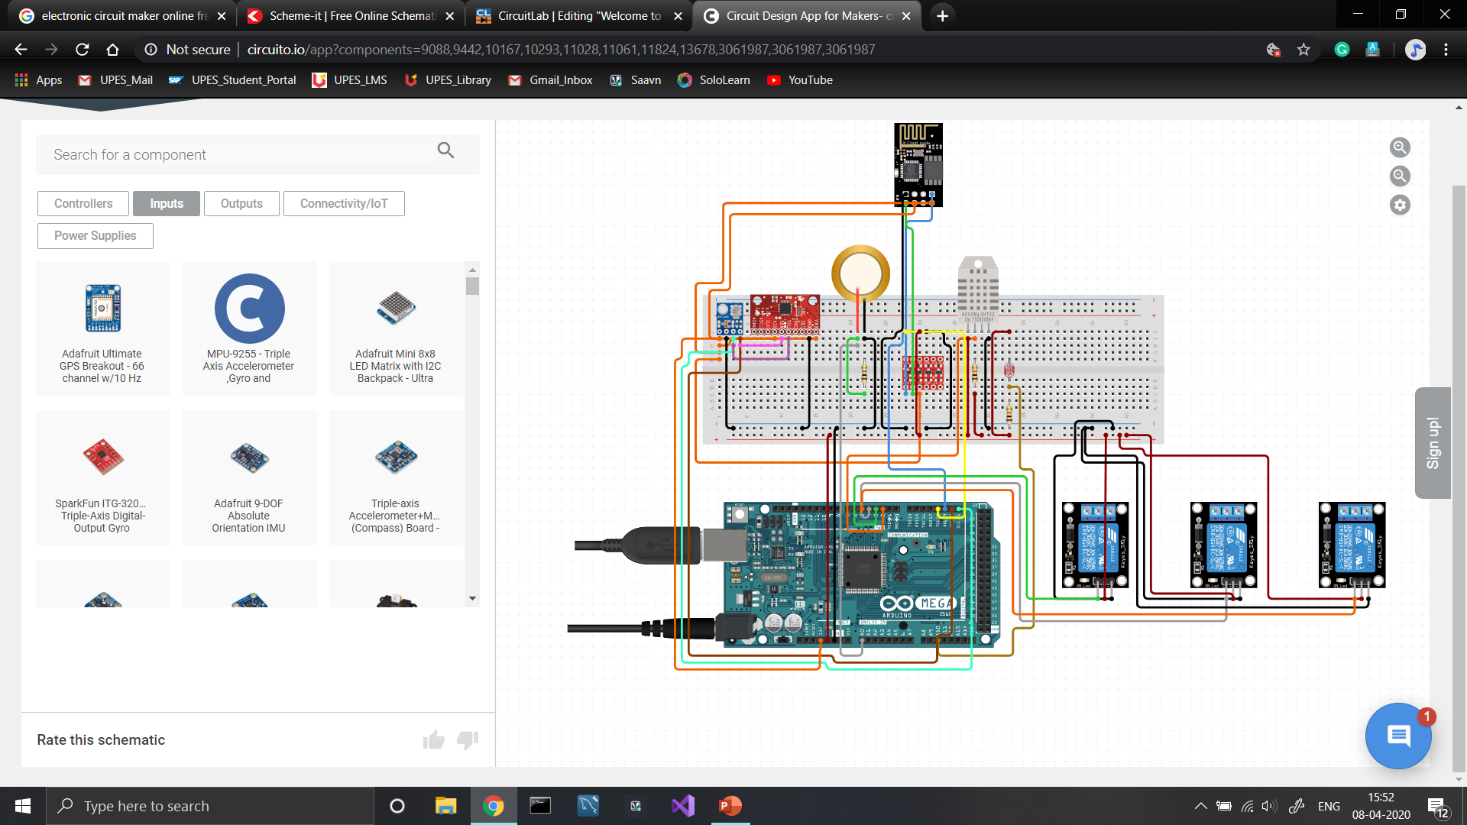

User interface: -

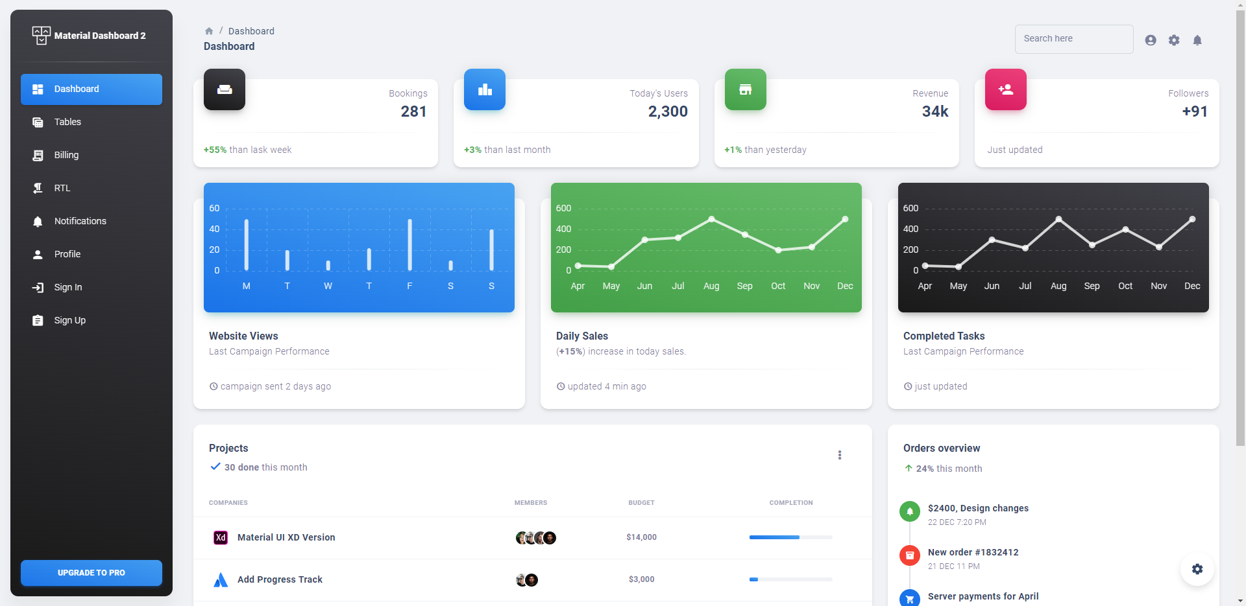

**2.8 Assumptions and Dependencies**

During the development of the project, we are assuming that the solar farm has water connection for every solar panel available in the solar farm.

1. **System Requirements**

**3.1 User Interface**

User interface will be made with react framework and will use the material UI for the modern look for the admin portal, The admin portal will show the real time weather data captured by the sensor array along with the solar power generation. It will also show whether a solar panel needs to be cleaned or not.

**3.2 Software Interface**

Different components in the system will communicate through a central server. Most of the processing will be done by the Django server.

**3.3 Database Interface**

Oracle’s MySQL database will be used by the system to log all the telemetry data for future use.

**3.4 Protocols**

POST protocol will be used most of the time for sending data from User application to the Django server.

1. **Non-functional Requirements**

**4.1 Performance Requirements**

* The system should be quite accurate in predicting whether a solar panel is clean or not.
* The system should not consume more energy that it saves.
* The system should not consume enormous amount of water.

**4.2 Security Requirements**

The communication between the different components should be properly encrypted to eliminate the chances of hacking.

**4.3 Software Quality Attributes**

The system will be tested for all possible weather conditions in real time to ensure that the system is capable of understanding and handling all possible weather conditions. The server will also undergo penetration test to ensure the privacy of the users.