**MAJOR-2 PROJECT**

**SYNOPSIS**

For

Solar Panel Maintenance System

Submitted By

|  |  |  |
| --- | --- | --- |
| **Specialization** | **SAP ID** | **Name** |
| B.Tech CSE - AI & ML | 500075374 | Utkarsh Gupta |
| B.Tech CSE - AI & ML | 500075358 | Aradhya Singh |
| B.Tech CSE - AI & ML | 500076765 | Tanu Sharma |



Informatics Cluster

School Of Computer Science

UNIVERSITY OF PETROLEUM & ENERGY STUDIES,

DEHRADUN- 248007. Uttarakhand

Mrs. Sugandha Sharma Mr. T.P. Singh

**Project Guide Cluster Head**



**School of Computer Science**

University of Petroleum & Energy Studies, Dehradun

**Content**

|  |  |  |
| --- | --- | --- |
| **S.No** | **Topic** | **Page.No** |
| **1.** | Abstract | 3 |
| **2.** | Introduction | 3 - 4 |
| **3.** | Literature Review | 4 - 5 |
| **4.** | Problem Statement | 5 |
| **5.** | Objectives | 5 |
| **6.** | Methodology | 5 - 6 |
| **7.** | Pert Chart | 6 |
| **8.** | References | 7 |

|  |  |
| --- | --- |
| **S.No** | **Images** |
| **i.1** | System Architecture |
| **i.2** | User Interface |
| **i.3** | Circuit Diagram |
| **i.4** | Hardware Design |
| **i.5** | Pert Chart |

**Synopsis Report**

**Project Title:** Solar Panel Maintenance System

**Abstract**

Renewable energy sources such as solar panels have gained significant attention in recent years as a clean and sustainable alternative to traditional energy sources. However, the maintenance of solar panels is crucial to ensure their efficiency and longevity. The current manual maintenance approach is time-consuming, costly, and prone to errors, leading to reduced energy output and downtime.

To overcome these challenges, an AI-powered solar panel maintenance system is proposed. The system uses machine learning algorithms to detect abnormalities in the power produced by solar panels accurately and efficiently. It analyze the power output to check if it is producing the ample power as per the standards to predicts potential problems before they occur, schedules maintenance activities based on data collected from the solar panels to minimize downtime, and optimizes their performance by analyzing and adjusting their settings based on environmental and usage data.

The proposed AI-powered solar panel maintenance system aims to reduce the cost and time of solar panel maintenance and increase their efficiency and lifespan, ultimately contributing to the promotion of renewable energy sources as a sustainable and viable alternative to traditional energy sources. In conclusion, it has the potential to significantly enhance the performance and longevity of solar panels and reduce maintenance costs.

**Keywords:** Solar Panel, Artificial Intelligence, Arduino

**1. Introduction**

Renewable energy sources are becoming highly popular worldwide, and solar energy is one of the most widely used forms of renewable energy. Solar panels, which are critical components of solar energy systems, convert sunlight into electricity without generating harmful emissions. However, proper maintenance is necessary to ensure the longevity and efficiency of solar panels.

Currently, the maintenance of solar panels is done manually, which is time-consuming and costly. Furthermore, detecting abnormalities in solar panels is challenging, leading to reduced energy output and downtime. Therefore, an AI-powered solar panel maintenance system is proposed to address these challenges and improve the efficiency of solar panel maintenance.

The proposed AI-powered solar panel maintenance system uses machine learning algorithms to detect abnormalities in solar panels accurately and efficiently. It also predicts potential problems before they occur and schedules maintenance activities based on data collected from the solar panels to minimize downtime. Additionally, the system optimizes the performance of the solar panels by analyzing and adjusting their settings based on environmental and usage data.

The AI-powered solar panel maintenance system is equipped with air and water supplies systems to ensure that the panels are thoroughly cleaned. The system also reduces the cost of solar panel maintenance and increases their efficiency and lifespan. Ultimately, this contributes to the promotion of renewable energy sources as a sustainable and viable alternative to traditional energy sources.

The system's machine learning algorithms analyze vast amounts of data collected from the solar panels, including temperature, humidity, irradiance, and performance data. By analyzing this data, the system can detect abnormalities in the solar panels with high accuracy, enabling maintenance personnel to take necessary action promptly.

The system's maintenance scheduling capabilities use data collected from the solar panels to determine the optimal time for maintenance activities. This approach reduces the frequency of maintenance activities while ensuring that the solar panels operate at their optimal performance. Furthermore, the system optimizes the performance of the solar panels by analyzing and adjusting their settings based on environmental and usage data. By doing so, the system maximizes the energy output of the solar panels while minimizing the cost of maintenance.

Ultimately, the system contributes to the promotion of renewable energy sources as a sustainable and viable alternative to traditional energy sources.

**2. Literature Review**

There have been multiple attempts [1-6] over the years to create an automated system to clean the solar panels. Nasib (2019) [1] proposed a cleaning robot with a rotating brush and water stream jets which can move on the rails mounted besides the solar panel array. The system cleans the solar panel array on a programmed time interval on its own.

Milan (2019) [2] created a simple solar panel cleaning system which consists of a viper and a water jet stream to clean the solar panel. The System can be triggered through an application.

Manju (2018) [3] proposed a similar solution to Nasib (2019) [1] which consists of a brush and a water jet stream to clean the solar panels.

Piotr (2013) [4] talks about the possibility of creating a system to clean the dust from solar panel surface through ultrasonic vibrations. The ultrasonic beams will hit the dust particles, which will make them vibrate and fall off the solar panels.

Xiaolong (2019) [5] talks about a cleaning robot which works on the basis of a piezoelectric actuator. The wiper on the robot will move based on the information received through a piezo electric actuator.

**3. Problem Statement**

Solar panels are a critical component of the renewable energy industry, providing clean energy without harmful emissions. However, solar panels require proper maintenance to ensure their longevity and efficiency. Currently, the maintenance of solar panels is done manually, which is time-consuming and costly. Additionally, detecting faults and abnormalities in the solar panels is quite challenging, which can lead to downtime and reduced energy output. Therefore, an "AI-powered Solar Panel Maintenance System" is needed to overcome these challenges and improve the efficiency of solar panel maintenance.

**4. Objectives**

The objectives for this project are:

* Detect whether the solar panel is dirty or not.
* Predict potential problems before they occur and take necessary action to prevent them.
* Schedule maintenance activities based on data collected from the solar panels to minimize downtime.
* Optimize the performance of the solar panels by analysing and adjusting their settings based on environmental and usage data.
* Provide real-time monitoring of the solar panels and alert maintenance personnel of any issues.
* Reduce the cost of solar panel maintenance and increase their efficiency and lifespan.

Overall, the goal of an AI-powered solar panel maintenance system is to improve the reliability and efficiency of solar panels and reduce their maintenance costs.

**5. Methodology**

* First step in the making of this project is Data Collection. To collect the data an apparatus with a sensor array and a solar panel is connected to Arduino UNO. The apparatus is then setup in an open area to log all the sensory data along with power output from the solar panel. The following column will be collected:
  + Date & Time
  + Air Temperature
  + Cloud Opacity
  + Dew Point
  + GHI
  + Precipitable Water
  + Relative Humidity
  + Surface Pressure
  + Wind Direction
  + Wind Speed
  + Solar Output
* In the next step multiple types of ML models such as Multiple Linear Regression, Polynomial Regression, Ridge Regression and Artificial Neural Network will be trained and analysed.
* Further, A comparative analysis will be done between all the trained models. Based on that comparative analysis the best performing model will be chosen for the project.
* A Django server will be developed containing the chosen ML model so that monitoring interface and the hardware can access the ML model.
* Finally, the prototype of the hardware will be constructed to simulate the working of the system in the real world.

System Architecture: -

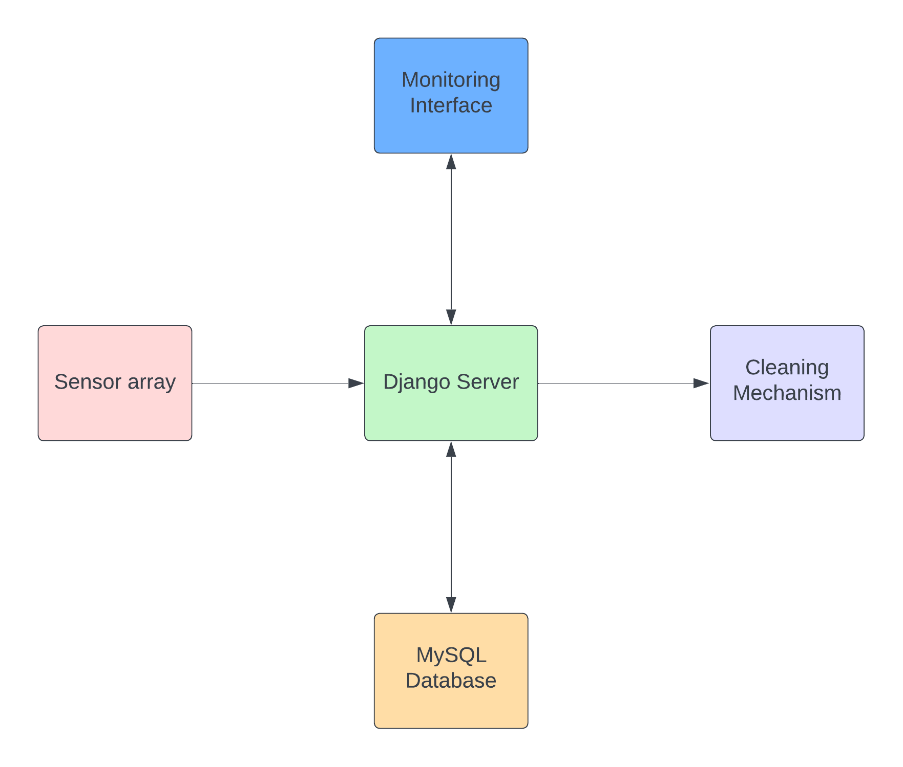

(i.1)

User Interface: -

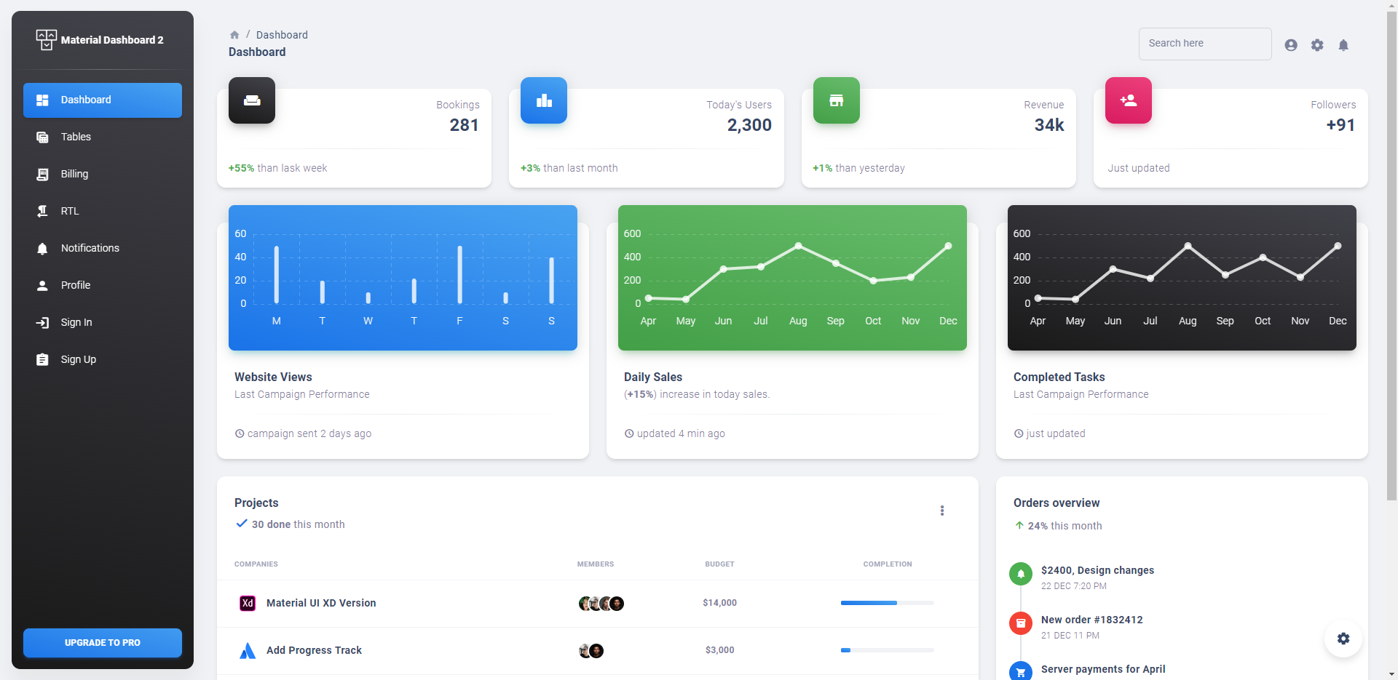

(i.2)

Circuit Diagram: -

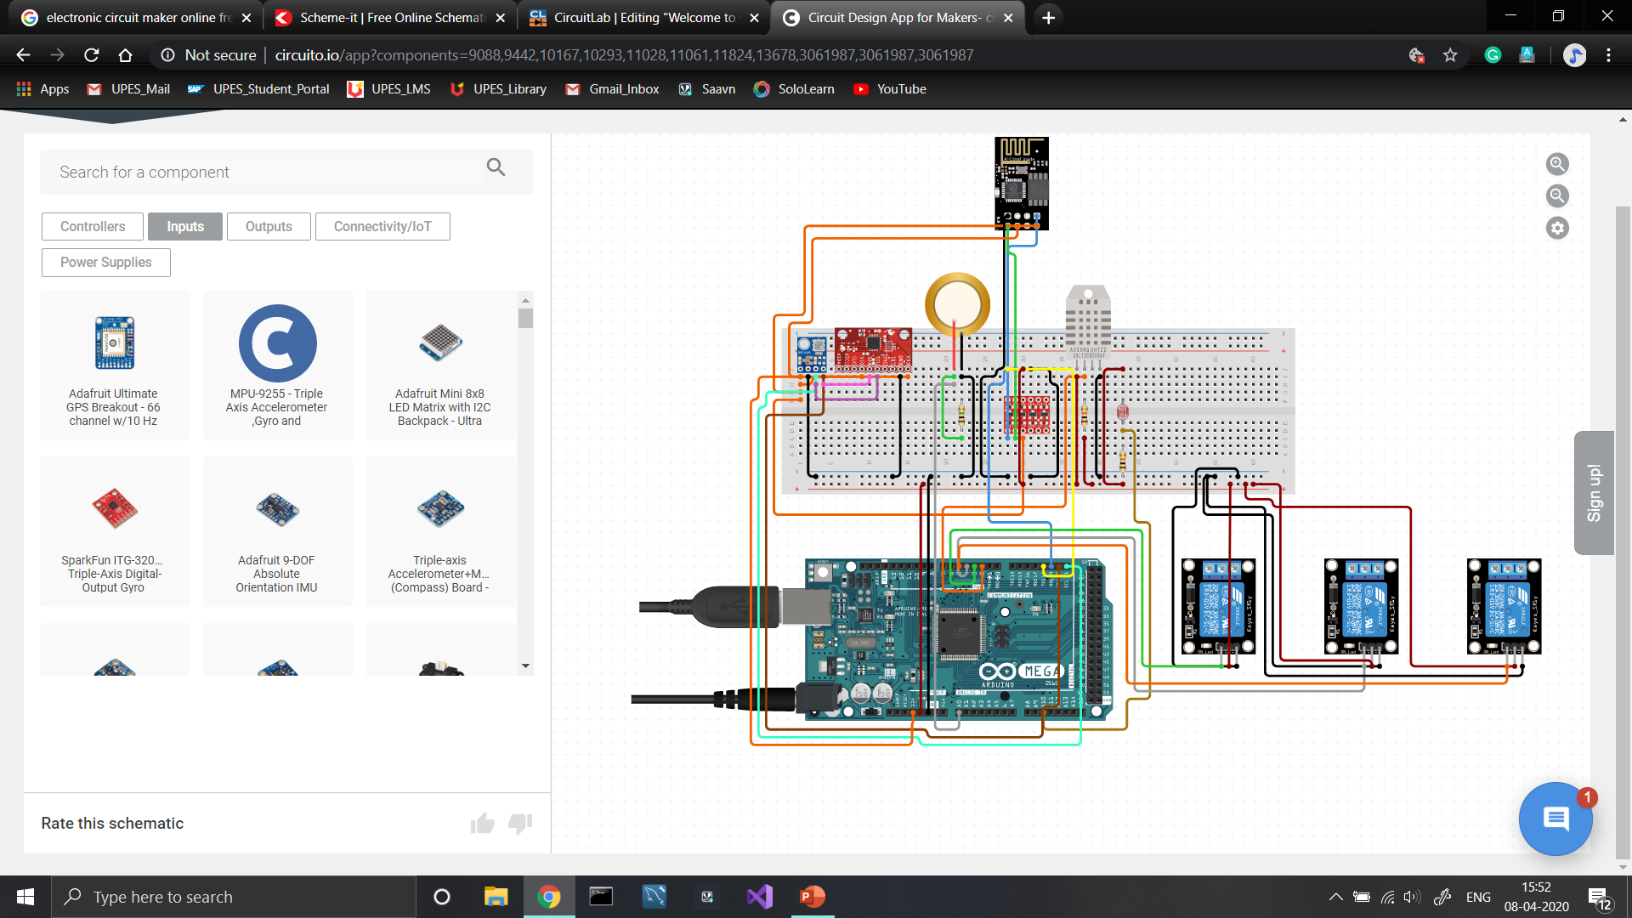

(i.3)

Hardware Design: -

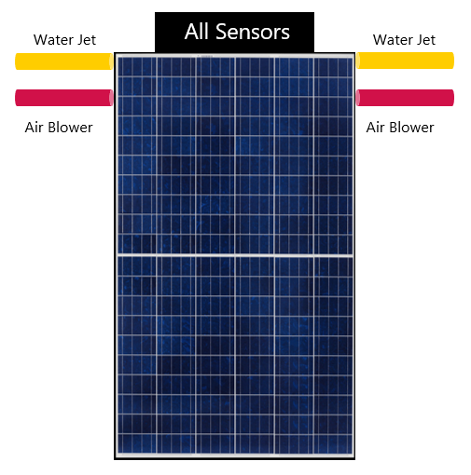

(i.4)

**6. PERT Chart**

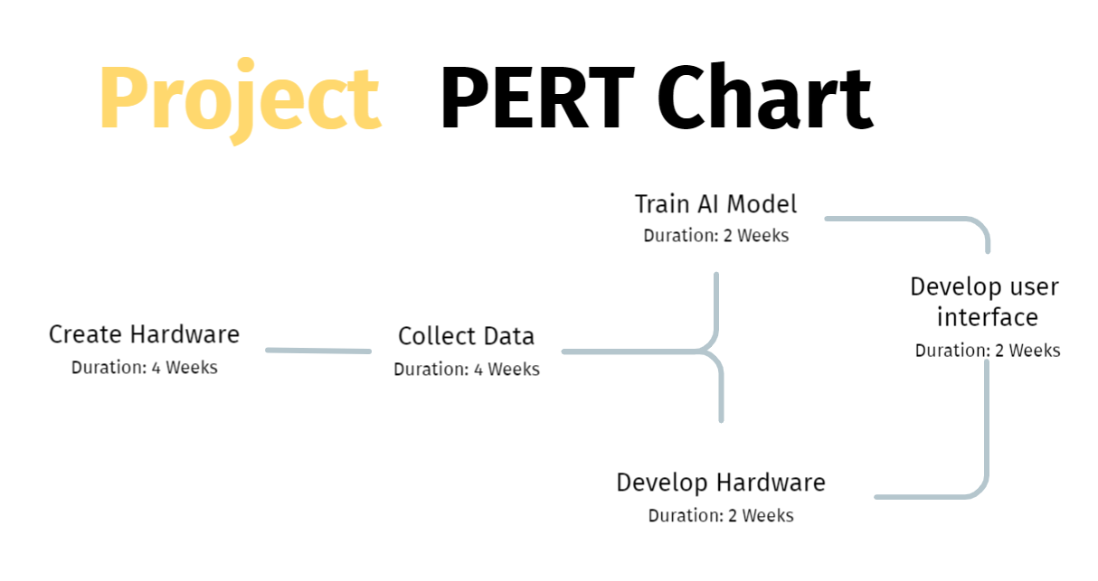

(i.5)

**References**

[1] [Nasib Khadka et al 2019 IOP Conf. Ser.: Earth Environ. Sci. **463** 012121](https://iopscience.iop.org/article/10.1088/1755-1315/463/1/012121/meta)

[2] [Milan Vaghani et al 2019 IRJET 2395-0056](chrome-extension://efaidnbmnnnibpcajpcglclefindmkaj/https:/d1wqtxts1xzle7.cloudfront.net/59805491/IRJET-V6I429420190620-45907-ql4vu3-libre.pdf?1561032526=&response-content-disposition=inline%3B+filename%3DIRJET_Automated_Solar_Panel_Cleaning_Sys.pdf&Expires=1679829840&Signature=YC0owv0l4NcKk9gKXXfe8Iz5vrdIm8HJH9CkszbMo~Vc-MD4-1xJHFimp4EP99rdZKgYDepUlQCbhfid9jz1giuVjvNwrXoOrI~3mPMwKYN3Jh1YIKquLpJg7~z1WNCHz~bL7REJa4XGlqUgNqGV52ovFJkGu-mFgYbcNsAIdn8XiggKbme0J2z6we8Rs81HCdkSw8KL4muWvCkqK-Ym40M4IeXZOqd9ewh84UUNSztnpkaX7JPwyrqfDyhBajn0FUrttIc5bnouM7VTGA-YOfNEXrw~NKIVWHTDn5B58BTCXItTMyWGk2iOrpM5IWl~~j218PEbVhUL2vBgmeU2BQ__&Key-Pair-Id=APKAJLOHF5GGSLRBV4ZA)

[3] [Manju B, Abdul Bari, & Pavan C M. (2018). Automatic Solar Panel Cleaning System. *International Journal of Advances in Scientific Research and Engineering (IJASRE), ISSN:2454-8006, DOI: 10.31695/IJASRE*, *4*(7), 26–31](https://doi.org/10.31695/IJASRE.2018.32778)

[4] [Piotr Vasiljev, Sergejus Borodinas, Regimantas Bareikis, Arunas Struckas, Ultrasonic system for solar panel cleaning, Sensors and Actuators A: Physical, Volume 200, 2013, Pages 74-78, ISSN 0924-4247](https://doi.org/10.1016/j.sna.2013.01.009.)

[5] [Xiaolong Lu, Qi Zhang, Junhui Hu, A linear piezoelectric actuator based solar panel cleaning system, Energy, Volume 60, 2013, Pages 401-406, ISSN 0360-5442](https://www.sciencedirect.com/science/article/abs/pii/S0360544213006646)

**Report Draft verified by**

**Project Guide HOD**

Ms. Sugandha Sharma Mr. T.P. Singh

(Assistant Professor)