# Analysis of Rubik’s Cube Solving Algorithm

A Synopsis Submitted

in Partial Fulfillment of the Requirements

for the Course of

# Minor Project - I

In

Third year – Fifth Semester of

**Bachelor of Technology**

specialization

In

# Artificial Intelligence & Machine Learning

Under

**Prof. Bikram Pratim Bhuyan**

By

# 500076532 R177219080 Garvit Khurana

# 500075815 R177219191 Tanya Malhotra

# 500075374 R177219194 Utkarsh Gupta

# 500076419 R177219196 Vanshaj Goel



DEPARTMENT OF INFORMATICS

SCHOOL OF COMPUTER SCIENCE

UNIVERSITY OF PETROLEUM AND ENERGY STUDIES, BIDHOLI, DEHRADUN, UTTRAKHAND, INDIA

# August, 2021

Synopsis

1. **Introduction**

The Rubik’s Cube or Magic Cube is a 3 – dimensional combination puzzle which was invented by a Hungarian sculptor and professor of architecture named Ernő Rubik in the year 1974. The main motive for developing a cube by the professor was to explain 3D geometry to his students.

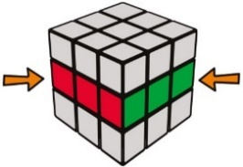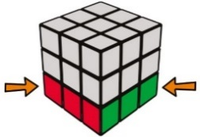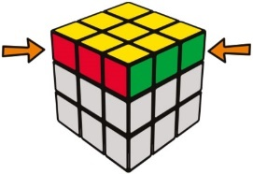

A 3x3x3 Rubik’s cube has six faces with eight corners, twelve edges and six center pieces. Each of the faces have one of these six colors – white, yellow, green, blue, red and orange.

There are three layers – Top, Middle and Bottom layer.

**Centers** - Each of the six faces are defined by their own centers, i.e., the center piece of each side remains intact, throughout the process of solving the cube. Centers can’t move.

In a typical cube, white center is opposite of yellow, blue is opposite the green center and hence, red is opposite of orange center piece.

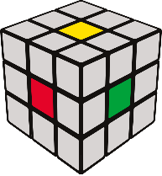

**Edges** – There are 12 edges in a cube with each edge piece having two colored tiles.

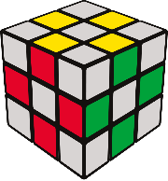

**Corner** – There are 8 corner pieces with each corner piece having three colored tiles.

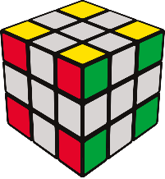

A solved Rubik’s cube is scrambled by twisting and turning its faces. Each face is represented by a letter.

R – Right face

L -Left face

U – Upward face

D – Downward face

F – Front face

B – Back face

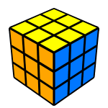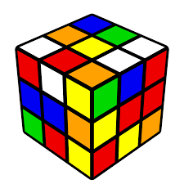

Scrambled Rubik’s Cube Solved Rubik’s Cube

There are 8! ways to arrange the corner cubes, i.e., 40,320 ways while there are 12! /2 (239,500,800) ways to arrange the edges. 11 edges can be flipped independently, with the flip of the twelfth depending on the previous ones, giving 211 (2,048) possibilities, which is approximately 43 quintillion. Basically, if one had one standard-sized Rubik's Cube for each permutation, one could cover the Earth's surface 275 times, or stack them in a tower 261 light-years high

There are a number of algorithms to solve a 3x3x3 Rubik’s cube. This project mainly aims at analyzing various algorithms, thereby comparing and computing their time and space complexities. The algorithms would be –

1. Thistlethwaite’s Algorithm

2. Kociemba’s Algorithm

3. Korf’s Algorithm

4. Tomas Rokicki’s Algorithm

1. **Motivation**

Rubik’s cube was invented with the purpose of teaching three-dimensional geometry to students, but over time it has not only motivated mathematicians & computer scientists to find the best & efficient solution to the cube, but also to find the best algorithm to scramble it properly. A staggering 43,252,003,274,489,856,000[1] possible states can be obtained by applying Markov-chain [1] Scientists around the world have often used Rubik’s cube as a case study for developing new and better solving, scrambling & permutation algorithms.

The reason for choosing Rubik’s cube is because it is very important in the field of Mathematics and Artificial Intelligence. Rubik’s cube can be used to form complex counting equations while studying permutations & combinations. It is also popularly used for testing, training, and developing new or improved existing Artificial Intelligence models & algorithms.

1. **Related work**

Rubik’s cube is a very popular mechanical puzzle which has attracted attention around the world because of its unique characteristics [8]. It is widely used for scientific research and development. Many scholars have worked on this to find an optimal solution to solve a Rubik’s cube & many are still working to optimize it more using different techniques. Some people are working on famous Rubik’s cube solving algorithm & optimizing them & some are working on mathematical approaches to develop a solution of their own.

The four most important approaches are the work of Thistlethwaite, Kociemba, Rokicki & Korf. Their advanced algorithms are based on group theory concepts and apply advanced concepts such as symmetry cancelation and dedicated traversal methods (e.g., Iterative Deep Searching combined with A*) [6].

Thistlethwaite’s Algorithm (TWA) works by dividing the problem into 4 sub-problems - speciﬁcally subgroups and subsequently solving those sequences until it is solved [6].

Kociemba’s Algorithm takes the idea of dividing the problem into subgroups from Thistlethwaite but reduces the number of needed subgroups to only 2. This method uses an advanced implementation of IDA*, generating small maps, calculating, and removing symmetries from the search tree and tends to solve the Cube close to the shortest number of moves possible [6].

Rokicki realized that the initial parts of the pathways computed by Kociemba’s Algorithm are solutions to a large set of related conﬁgurations. He exploits this property by dividing the problem into 2 billion cosets, each containing around 20 billion related conﬁgurations. With this method he was able to push the up-per bound to 22 moves suﬃcing to solve the Cube from any initial scrambled conﬁguration [6].

Korf's algorithm can solve any scrambled cube in 20 moves or fewer. It works by searching for solutions using IDA* [9].

There are many research papers in famous international journals which focus on study & development of an optimized algorithm for solving it & to find the God’s Number for the cube. God’s number is the maximum number of moves required to solve any of the 43 quintillion permutations combinations of the cube [10].

In today’s world many AI & Robotics enthusiasts are working to solve the Rubik’s Cube using deep neural networks & implementing it using a robotic arm [7]. Various Scientists are using Rubik’s Cube as a model to study crystal electron diffraction & other scientific issues. Research Papers & Articles of some famous algorithms have been listed below –

<https://tomas.rokicki.com/rubik25.pdf>

<https://www.researchgate.net/publication/226585368_Twenty-Two_Moves_Suffice_for_Rubik's_CubeR>

<http://www.youngscientist.com.au/wp-content/uploads/2015/02/Physics-10-12-Justin-Marcellienus-report.pdf>

<https://www.cs.princeton.edu/courses/archive/fall06/cos402/papers/korfrubik.pdf>

<https://www.nature.com/articles/s42256-019-0070-z>

1. **Proposed Method**

Programming Language: C

Solving Algorithms: Thistlethwaite’s, Kociemba’s, Korf’s, Tomas Rokicki’s Algorithm

Scrambling Algorithm: Markov-chain Algorithm

Representation of Rubik’s cube: The cube will be represented in three dimensional array as A[6][3][3]. All the colors will be represented in 6 integers ranging from 0 to 5.

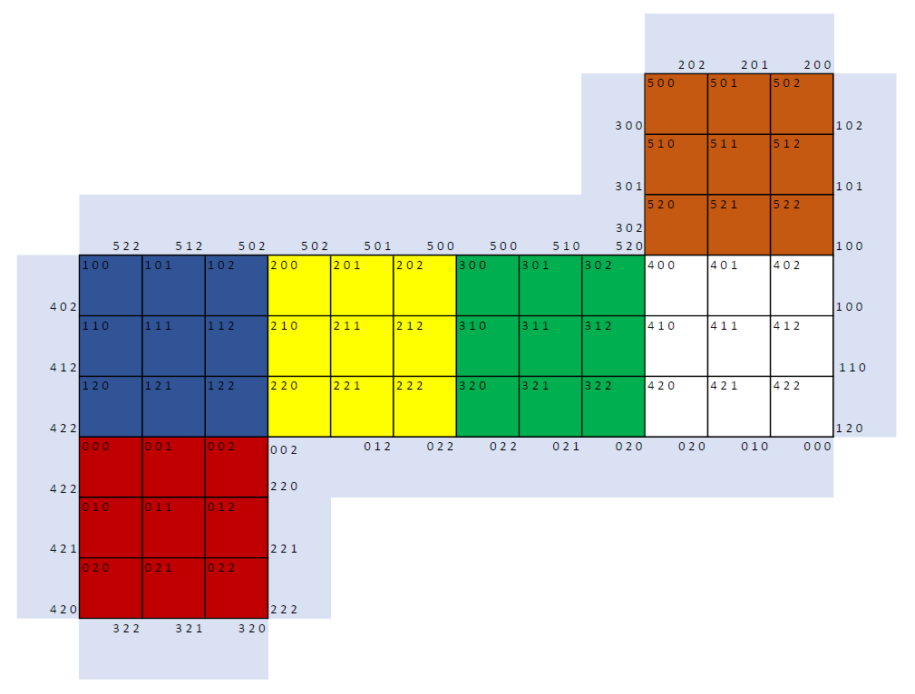

Environment Specifications:

|  |  |
| --- | --- |
| Type | Name |
| Operating System | Windows 10 V-21H1 B-19042.1110 64bit |
| Memory | 8 GB 2400 MHz DDR4 |
| Storage | 250 GB SATA3 2.4 SSD |
| C | Version ISO/IEC 9899:2018 OR C17 |
| IDE | Visual Studio 2019 V16.11 |

Parameters: Parameters for evaluation of the algorithms are

1. No. of Moves
2. Time Complexity
3. Space Complexity
4. Line of Code
5. **Methodology**

In this project, working of all the four algorithms - Thistlethwaite’s, Kociemba’s, Korf’s and Tomas Rokicki’s, would be studied and analysed, followed by coding of the algorithms. For the purpose of scrambling an unsolved cube, Markov-chain Algorithm would be studied and used. After merging the four algorithms and the scrambling algorithm in a single file, the four algorithms would be analysed on the basis of –

1. The number of steps each algorithm takes to solve the scrambled cube

2. Time and space complexity of each algorithm

Lastly, a project report would be prepared consisting of all the details of the project and the observed results.

1. **Plan of work**

|  |  |
| --- | --- |
| Date | Expected Work |
| 1st September 2021 – 15th September 2021 | * Detailed study and analysis of all the four algorithms that need to be implemented. |
| 16th September 2021 – 30th September 2021 | * Beginning the coding part * Designing a method to shuffle the Rubik’s Cube * Starting implementing the four main algorithms |
| 1st October 2021 – 20th October 2021 | * Completion of the code for all the algorithms * Merging all the algorithms into a single file * Starting designing an algorithm to solve the Rubik’s cube |
| 21st October 2021 – 10th November 2021 | * Analyzation of results of all the algorithms * Completion of the project * Preparation of Project Report |

1. **References**

[1]<https://theconversation.com/how-hard-is-it-to-scramble-rubiks-cube-129916>

[2]<https://www.researchgate.net/publication/220867821_An_Evolutionary_Approach_for_Solving_the_Rubik's_Cube_Incorporating_Exact_Methods>

[3]<https://d4mucfpksywv.cloudfront.net/papers/solving-rubiks-cube.pdf>

[4]<https://cjme.springeropen.com/articles/10.1186/s10033-018-0269-7>

[5]<https://personal.math.ubc.ca/~cass/courses/m308/projects/rtran/rtran.pdf>

[6]<https://www.researchgate.net/publication/220867821_An_Evolutionary_Approach_for_Solving_the_Rubik's_Cube_Incorporating_Exact_Methods>

[7] <https://d4mucfpksywv.cloudfront.net/papers/solving-rubiks-cube.pdf>

[8] <https://cjme.springeropen.com/articles/10.1186/s10033-018-0269-7>

[9] <https://medium.com/@benjamin.botto/implementing-an-optimal-rubiks-cube-solver-using-korf-s-algorithm-bf750b332cf9#:~:text=on%20my%20GitHub.-,Korf's%20Optimal%20Algorithm,is%20a%20tree%2Dtraversal%20algorithm>.

[10] <https://www.cubelelo.com/blogs/cubing/how-to-solve-rubiks-cube-in-20-moves>