

**PROPOSAL FOR शोध SUPPORT FOR STUDENTS**

*(Under the SHODH program for research)*

1. **SUMMARY SHEET:**

**Project proposal submitted under (tick mark the शोध scheme)**

**□ RISE (Research & Innovation for Science and Engineering)**

**□ RISoCS (Research & Innovation for Students of Computer Science)**

**□ RISoM (Research & Innovation for Students of Management)**

**□ RISoL (Research & Innovation for Students of Law)**

**□ RISoD (Research & Innovation for Students of Design)**

**□ RISoL (Research & Innovation for Students of School for Life)**

**□ RISoHS (Research & Innovation for Students of School Health Sciences)**

**□ RISoMM (Research & Innovation for Students of School for Modern Media)**

**□ RISoLS (Research & Innovation for Students of School for Liberal Sciences)**

|  |  |  |  |  |
| --- | --- | --- | --- | --- |
| Title: Saksham / Communication solution for disabled | | | | **OFFICE PURPOSE**  DATE RECEIVED (in R&D Office):  PROPOSAL No. |
|  | Duration  (Months)  10 | Amount  ₹ 55,600 | |
| 2. Name and Department of applicants with contact details (email and phone): | | | |
| *Applicant(s) (Name/Course/Department/SAP ID) & Signature | | | Mentor(s) (Name/Department) & Signature | |
| (i) Utkarsh Gupta / B. Tech CSE - AI & ML / 500075374  8938914511, u8karshgupta@gmail.com | | | Prof. Bikram Pritim Bhuyan  Department of Informatics | |
| (ii) Aradhya Singh/ B. Tech CSE - AI & ML / 500075358  8938822481, saaradhya0125@gmail.com | | |  | |
| (iii) Priyal Gupta / B. Tech CSE - AI & ML / 500076110  9415209873, priyalgupta804@gmail.com | | |  | |
| (iv) | | |  | |
| (v) | | |  | |

* A SHODH team will have minimum 2 students and a maximum of 5 students. SHODH team can have a maximum of 2 mentors (For SoE, there is no limit on number of mentors)

# Do not put any identifying information in Section (B)

(**This page intentionally left blank**)

**(B) DETAILS OF PROPOSAL:**

|  |  |
| --- | --- |
|  | **OFFICE PURPOSE**  DATE RECEIVED (in R&D Office):  PROPOSAL No. |

|  |
| --- |
| 1. Title (Title should be concise & specific)   Saksham / Communication solution for disabled |
| 1. Objectives of the proposal demonstrating contribution to excellence at national level (List pointwise) #   To develop remote communication software accessible to normal, blind, dumb and deaf people, and construct hardware i.e., an interactive, wireless refreshable Braille device that would be connected to the software to facilitate communication for blind people. |
| 1. Expected deliverables of the Proposal (Products/Publications/Patents/ New concept/Spinoff etc.) #   Copyright (software), Patent(hardware), Research Paper |
| 1. Importance/highlights (3-5 bullet points) #  * Communication software for normal, blind, deaf and dumb people. * A remote communication solution. * Interactive, refreshable, wireless Braille device for communication. |
| 1. Literature Review and advancement: Demonstrate knowledge of (with references (IEEE format) and contribution to the national state-of-the-art in the relevant area#   Annexure I |
| 1. Alignment to School specific priorities (SoE: State specifically how the proposal supports the Flagship Projects and expected impacts at Cluster and School levels)#   (v) Integration of AI and Machine Learning with Devices |
| 1. Methodology#   Annexure II |
| 1. Gantt chart of the activities#   Annexure III |
| 1. Budget with justification:   Annexure IV |
| 1. Additional information (as per requirement) |

Note: 1) Please attach one-page CVs of Mentors.

2) If required, annexures may be used for items 2-8.

# Annexure I

Paper [1] demonstrates the use of Convolutional Neural Network to process the images. First the images are preprocessed for identifying the hand gestures. This process reduces the chances of error by a huge margin. These images are fed directly to Convolutional Neural Network. The model then identifies the gesture of the hand and predict the label for the gesture. Further those labels are transferred to text to speech engine.

Paper [2] uses a sensor-based approach. It uses a series of motion sensors deployed in a hand glove. The motion sensed by the sensors will be transmitted to a nearby computer. The computer will then preprocess the data received for any redundant movement. Then this data will be sent to RNN for prediction of the label. Further the output label will be handed over to the text engine.

Paper [3] uses a vibrator-based approach for braille communication. The system consists of six vibration motors in a 3x2 matrix. The system receives a text message from a computer through serial communication. The received text will then be converted to the braille script. Now the braille script having a 3x2 matrix in the form of true falls will be used for output. In the matrix if a value is true, the vibration motor will be turned on.

The hardware discussed in paper [4] is using a combination of servos for creating a 3x2 matrix for braille scripts. The internal processing of the system is quite similar to that of paper [3]. The only difference is that this system is using a servo for providing a sense of touch instead of a vibration motor.

Paper [5] demonstrate a use of Gradient decent for Text to Speech engine. Stochastic differential equation is used along with forward differential neural network is used for conversion of text to speech.

Paper [6] discusses about a software that allows users to use their voices to control computer functions and dictate text so this system is made up of two parts: the first part is for processing acoustic signals acquired by a microphone, and the second part is for interpreting the processed signals and then mapping them to words. They have used Hidden Markov Models to create models for each letter (HMM) and Mel Frequency Cepstral Coefficients will be used to extract features (MFCC). Their dataset's features will be trained using vector quantization, and the dataset's features will be tested using the Viterbi algorithm. A speech recognition technology will be used only for home automation.

[1] [Ankit Ojha, Ayush Pandey, Shubham Maurya, Abhishek Thakur, Dr. Dayananda P 2020. Sign Language to Text and Speech Translation in Real Time Using Convolutional Neural Network](https://www.ijert.org/sign-language-to-text-and-speech-translation-in-real-time-using-convolutional-neural-network)

[2] [Mirza, S. F., & Al-Talabani, A. K. (2021). Efficient Kinect Sensor-based Kurdish Sign Language Recognition Using Echo System Network.](https://doi.org/10.14500/aro.10827)

[3] [Y. Neeraja,D.Susritha Reddy, J.Kalpana, K.Subhasri, D. Lokesh 2021, AN ADVANCED BRAILLE SYSTEM-COMMUNICATION DEVICE FOR BLIND-DEAF PEOPLE](https://www.journal-dogorangsang.in/no_1_NECG_21/22.pdf)

[4] [Himanshu Gautam, Prerna Gaur 2020, DRISHYAM: Real-Time Text to Braille Conversion and Realization](https://ieeexplore.ieee.org/abstract/document/9342522/)

[5] [Vadim Popov, Ivan Vovk, Vladimir Gogoryan, Tasnima Sadekova, Mikhail Kudinov 2021. Grad-TTS: A Diffusion Probabilistic Model for Text-to-Speech](https://proceedings.mlr.press/v139/popov21a.html)

[6] [Prerana Das, Kakali Acharjee, Pranab Das and Vijay Prasad 2015, VOICE RECOGNITION SYSTEM: SPEECH-TO-TEXT](https://www.researchgate.net/publication/304651244_VOICE_RECOGNITION_SYSTEM_SPEECH-TO-TEXT)

# Annexure II

Workflow: -

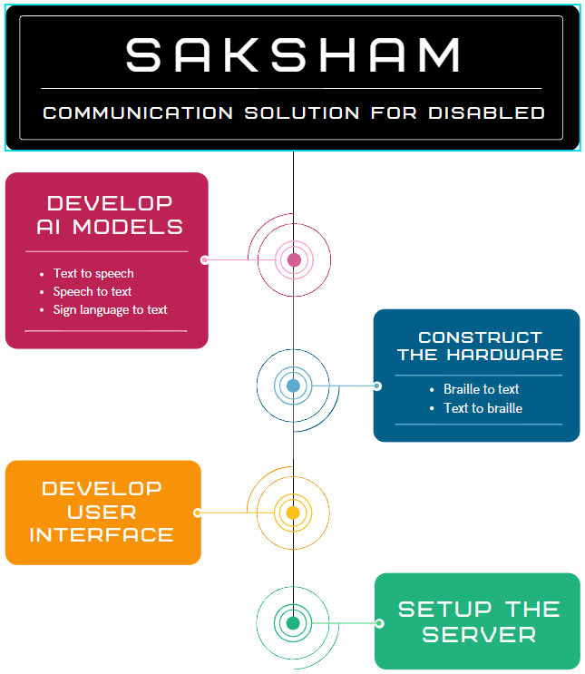

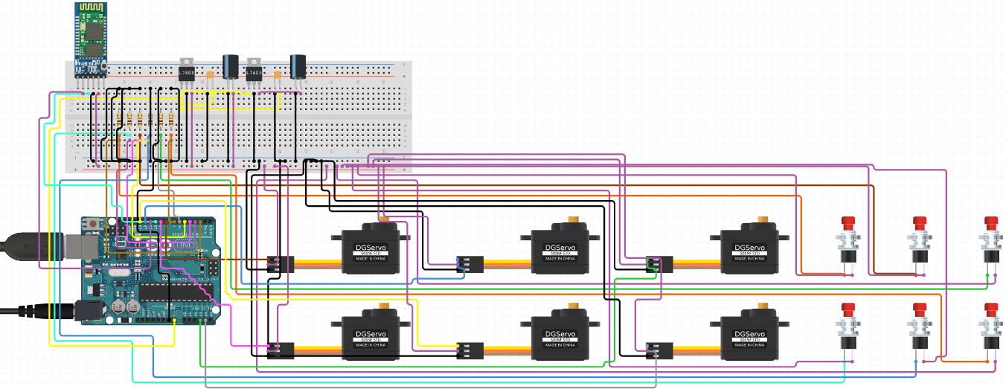Hardware: -

Arduino Uno

Bluetooth Module

# Annexure III

Input Buttons

Output Solenoid Actuators

# Annexure IV

Justification item wise:

|  |  |  |  |
| --- | --- | --- | --- |
| **Proposed expenditure** | Quantity | Value | **Total** |
| Consumables   * Arduino Uno * Bluetooth HC05 * Actuator * Buttons * PCB Bread Board | 2  2  12  16  2 | 1000  500  2000  100  1000 | 2000  1000  24000  1600  2000 |
| Equipment   * 3D Printer | 1 | 25,000 | 25,000 |
| Characterization | 0 | 0 | 0 |
| Any other (please specify) | 0 | 0 | 0 |
| **Total Budget** |  |  | ₹ 55,600 |