

**SCHOOL OF COMPUTER SCIENCE**

UNIVERSITY OF PETROLEUM & ENERGY STUDIES

Bidholi Campus, Energy Acres, Dehradun – 248007.

**Jan - May 2022**

**PROJECT REPORT**

**on**

# *Saksham – Communication solution for disabled*

**Submitted by:**

**Utkarsh Gupta**

*B. Tech CSE-AI & ML (B6) 3rd year*

*(Enroll No. R177219194 & Sap id 5000*75374*)*

**Aradhya Singh**

*B. Tech CSE-AI & ML (B6) 3rd year*

*(Enroll No. R177219206 & Sap id 500075358)*

## Priyal Gupta

*B. Tech CSE-AI & ML (B6) 3rd year*

*(Enroll No. R177219136 & Sap id 500076110)*

**Under the guidance of**

Prof. Bikram Pratim Bhuyan



**School of Computer Science**

### University of Petroleum & Energy Studies, Dehradun

**Content**

|  |  |
| --- | --- |
| **S. No.** | **Topic** |
| **1.** | Abstract |
| **2.** | Introduction |
| **3.** | Application |
| **4.** | Motivation |
| **5.** | Problem Statement |
| **6.** | Literature Review |
| **7.** | Objective |
| **8.** | Methodology |
| **9.** | Advantages |
| **10.** | Algorithm |
| **11.** | Future Aspects |
| **12.** | Gantt Chart |
| **13.** | Software Requirement |
| **14.** | Results |
| **15.** | References |

**Project Report**

**Minor II**

**PROJECT TITLE**

# Saksham – Communication solution for disabled

**ABSTRACT**

Single point solution for communication gap between blind, deaf, mute and normal population. Application is able to convert sign language, voice, braille & text to each other which enables almost everyone to be able to communicate with anyone. The sign language recognition will be achieved through computer vision, voice recognition will be achieved by DNN, braille will be achieved by a sophisticated wireless hardware.

**KEYWORDS**

Sign language, Voice recognition, Braille, Computer vision, Artificial Intelligence, Machine Learning

**INTRODUCTION**

Disability is part of the human condition. Almost everyone will be temporarily or permanently impaired at some point in life, and those who survive an accident may sometime experience increasing difficulties in functioning. Most extended families have a disabled member, and many non-disabled people take responsibility for supporting and caring for their relatives and friends with disabilities.[7]

According to the "World Report on Disability"[7], many people with disabilities do not have equal access to health care, education, and employment opportunities, do not receive the disability-related services that they require, and experience exclusion from everyday life activities. Following the entry into force of the United Nations Convention on the Rights of Persons with Disabilities (CRPD), disability is increasingly understood as a human rights issue. Disability is also an important development issue with an increasing body of evidence showing that persons with disabilities experience worse socioeconomic outcomes than persons without disabilities. Despite the magnitude of the issue, both awareness of and scientific information on disability issues are lacking.

According to The Census of India 2001[8] has revealed that over 21 million people in India as suffering from one or the other kind of disability. This is equivalent to 2.1% of the population. Among the total disabled in the country, 12.6 million are males and 9.3 million are females. Among the types of disabilities on which data has been collected, disability In seeing at 48.5% emerges as the top category. Others in sequence are: In movement (27.9%), Mental (10.3%), In speech (7.5%), and in hearing (5.8%).

Across the country, the highest number of disabled has been reported from the state of Uttar Pradesh (3.6 million). Significant numbers of disabled have also been reported from the state like Bihar (1.9 million), West Bengal (1.8million), Tamil Nadu and Maharashtra (1.6 million each). Tamil Nadu is the only state, which has a higher number of disabled females than males. Among the states, Arunachal Pradesh has the highest proportion of disabled males (66.6%) and lowest proportion of female disabled.[8]

|  |  |  |
| --- | --- | --- |
| Types of Disability | Population | Percentage (%) |
| Blind | 10,634,881 | 1.0 |
| Dumb(mute) | 1,640,868 | 0.2 |
| Deaf | 1,261,722 | 0.1 |

**Table 1.0**

**APPLICATION**

* The system can be deployed anywhere ranging from a government hospital to a school. It is capable of translating a conversation for blind, deaf, mute or any of the combination of these three disabilities.
* The system will enable the disabled user to very easily communicate with anyone who doesn't have any knowledge of sign language or Braille script.
* The system will be light weight enough that it will be able to run properly on even a pc with minimal features.

**MOTIVATION**

According to World Health Organization [[1]](https://www.who.int/), 40 million people are blind; 466 million people are hearing impaired and 1 million can’t speak all around the world. Combining all these numbers, around 507 million people around the world have difficulty communicating with people including each other. Being gifted with all these incredible abilities of Vision, Listening and speaking it is our responsibility to make this world a better place for them. This project can contribute to the society.

Also, it is an approach to learn about the image processing and NLP by developing a system to convert sign language and voice to text and learning to develop an efficient and low-cost digital Braille.

**PROBLEM STATEMENT**

To develop a communication software for normal, blind, deaf and dumb people. It will provide a remote communication solution with an interactive, refreshable, wireless Braille device for communication.

**LITERATURE REVIEW**

Paper [1] demonstrates the use of Convolutional Neural Network to process the images. First the images are preprocessed for identifying the hand gestures. This process reduces the chances of error by a huge margin. These images are fed directly to Convolutional Neural Network. The model then identifies the gesture of the hand and predicts the label for the gesture. Further those labels are transferred to text to speech engine.

Paper [2] uses a sensor-based approach. It uses a series of motion sensors deployed in a hand glove. The motion sensed by the sensors will be transmitted to a nearby computer. The computer will then preprocess the data received for any redundant movement. Then this data will be sent to RNN for prediction of the label. Further the output label will be handed over to the text engine.

Paper [3] uses a vibrator-based approach for Braille communication. The system consists of six vibration motors in a 3x2 matrix. The system receives a text message from a computer through serial communication. The received text will then be converted to the Braille script. Now the Braille script having a 3x2 matrix in the form of true falls will be used for output. In the matrix if a value is true, the vibration motor will be turned on.

The hardware discussed in paper [4] is using a combination of servos for creating a 3x2 matrix for Braille scripts. The internal processing of the system is quite similar to that of paper [3]. The only difference is that this system is using a servo for providing a sense of touch instead of a vibration motor.

Paper [5] demonstrates a use of Gradient decent for Text to Speech engine. Stochastic differential equation is used along with forward differential neural network is used for conversion of text to speech.

Paper [6] discusses about software that allows users to use their voices to control computer functions and dictate text so this system is made up of two parts: the first part is for processing acoustic signals acquired by a microphone, and the second part is for interpreting the processed signals and then mapping them to words. They have used Hidden Markov Models to create models for each letter (HMM) and Mel Frequency Cepstral Coefficients will be used to extract features (MFCC). Their dataset's features will be trained using vector quantization, and the dataset's features will be tested using the Viterbi algorithm. A speech recognition technology will be used only for home automation.

**OBJECTIVES**

The objective is to develop remote communication software accessible to normal, blind, dumb and deaf people for interaction. Thereafter, construct hardware i.e., an interactive, wireless refreshable "Braille" device that would be connected to the software to facilitate communication for blind people.

**Methodology**

1. Develop AI Model

* Test to Speech
* Speech to Text
* Sign Language to Text

1. Construct the Hardware

* Braille to Text
* Text to Speech

1. Develop user interface
2. Setup the server

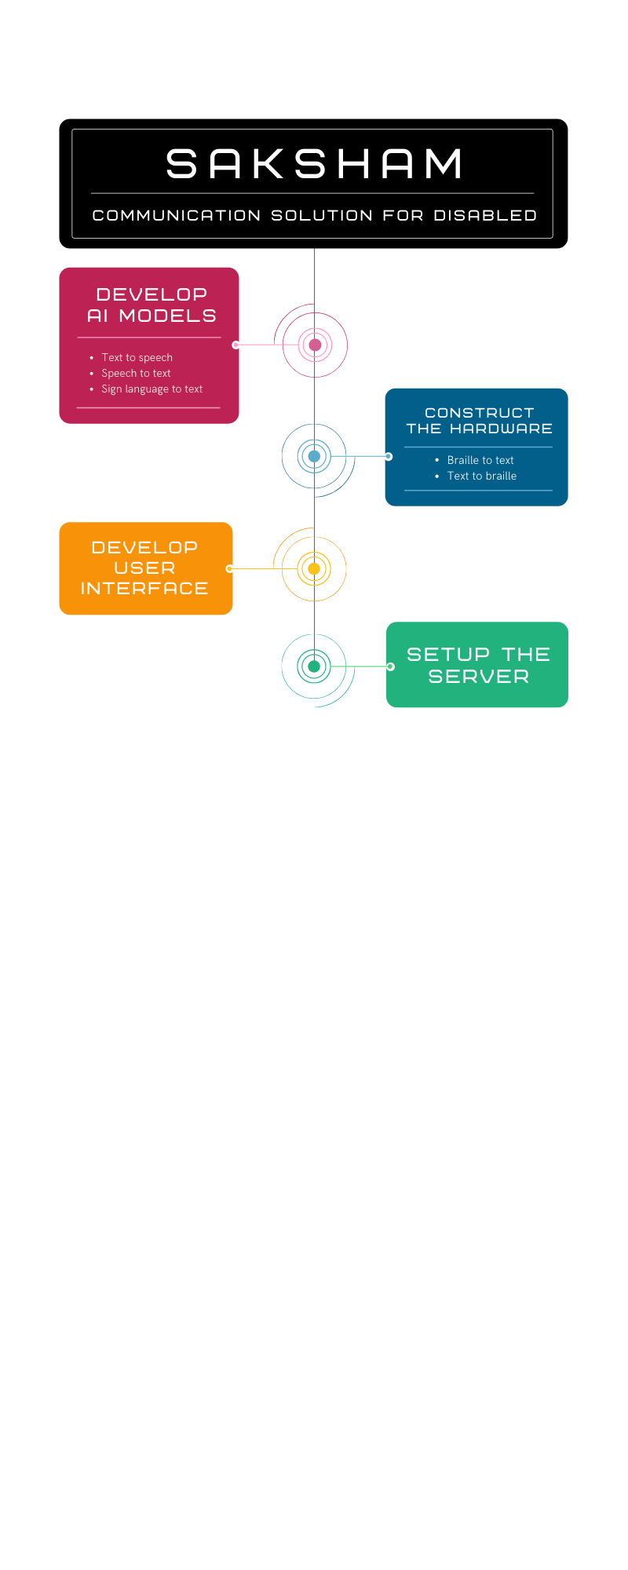

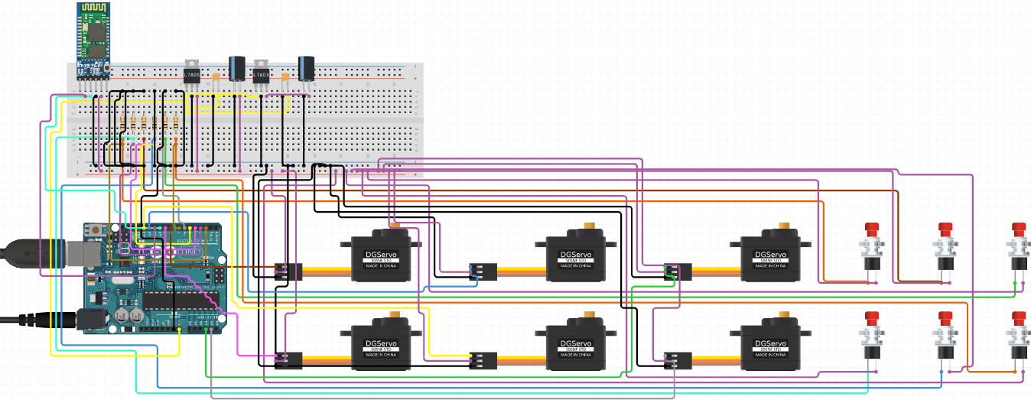Hardware: -

**Advantages**

* This project can be deployed to interact with disabled people i.e. blind, dump and deaf, in order to communicate in an efficient manner.
* It can be clubbed up with chat bots, so that people with disability can also use chat bots.

**Algorithm**

1. Login
2. Select Input/Output Method
3. InputEngine = InputMethod
4. OutputEngine = OutputMethod
5. Get InputMessage
6. POST InputMessage to localhost:4000
7. TextMessage = InputEngine(InputMessage)
8. OutputMessage = OutputEngine(TextMessage)
9. POST OutputMessage to localhost:3000
10. Display OutputMessage

**Future Aspects**

We are looking forward to improve this project in such a way that it could be commercialized and could be in reach of the target people to easy their life a bit.

To Improve our project following steps should be taken.

* The front end of the application will support multiple languages.
* The application will be able to translate different languages.
* The sign language detection will support live video translation.
* A database will be introduced to store communication between two people.
* Login/Signup and encryption will be added for more security over internet.
* The braille device will have actuators.
* The braille device will be wireless.
* The braille device will be smaller in size.

Further we are looking forward to write three research paper related to this project:

1. Wireless text to braille and braille to text conversion device.
2. Sign Language detection through TensorFlow.
3. Saksham: Communication solution for disabled.

**System Requirements**

|  |  |
| --- | --- |
| Type | Name |
| Operating System | Windows 10 V-21H1 B-19042.1110 64bit |
| Memory | 8 GB 2400 MHz DDR4 |
| Storage | 250 GB SATA3 2.4 SSD |
| Python | Version 3.8 |
| IDE | PyCharm 2022 V16.11 |

**Table 1.1**

**Timeline (Gantt chart)**

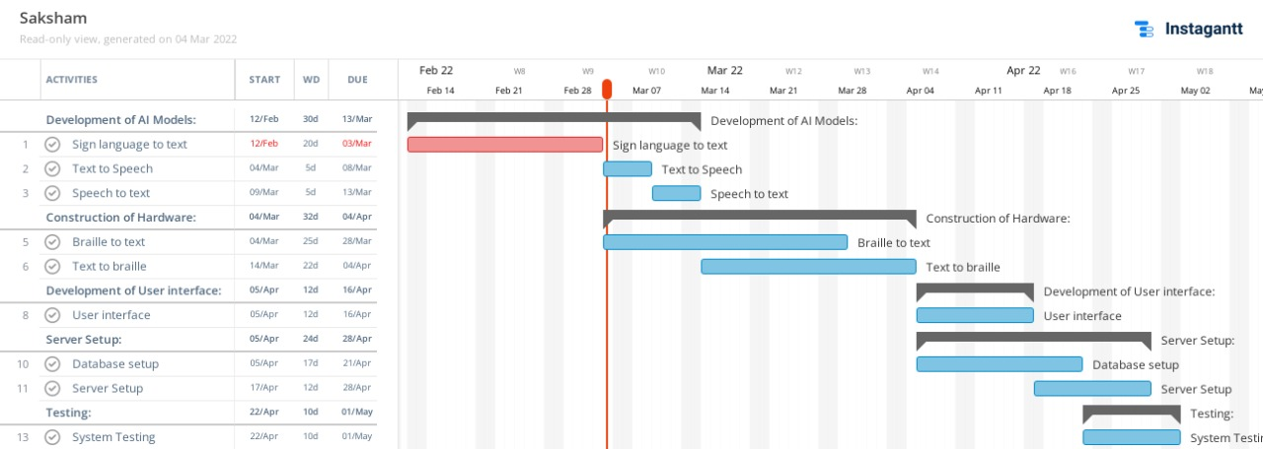

**Result**

The front end of the application is made in reactJS. We have kept the UI/UX design to minimalist for easy of access.

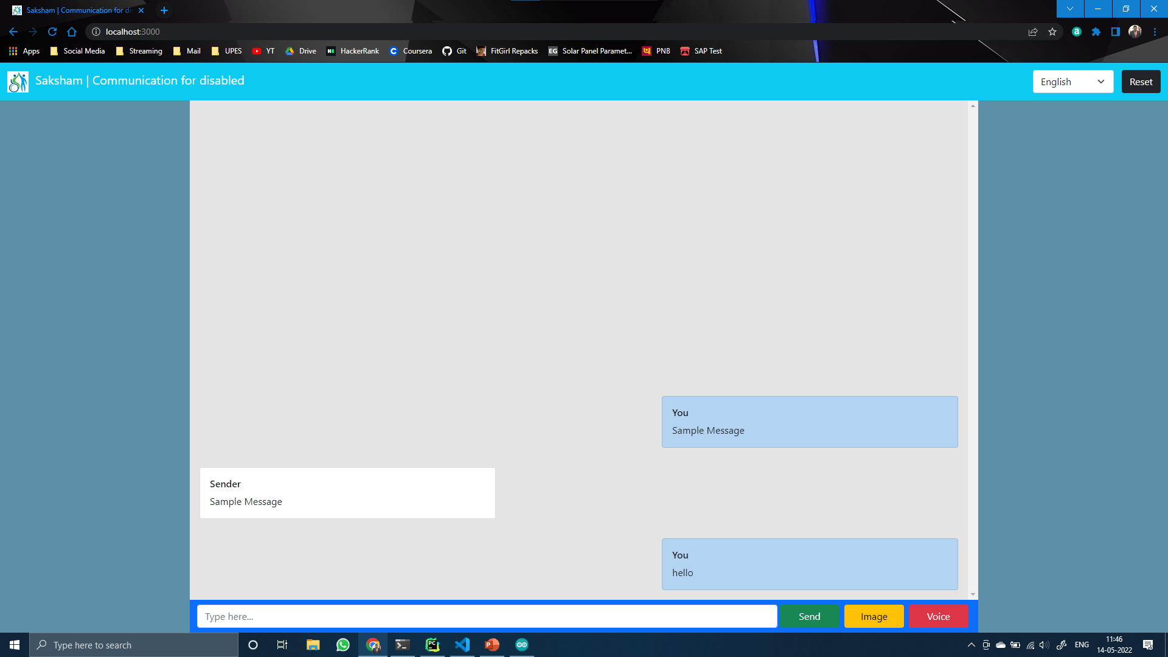

The hardware of the application is made with Arduino UNO. The circuit of the hardware is as follows:



The sign language recognition model is made in tensorflow. The model is a multiple layered CNN the structure of which is as follows:

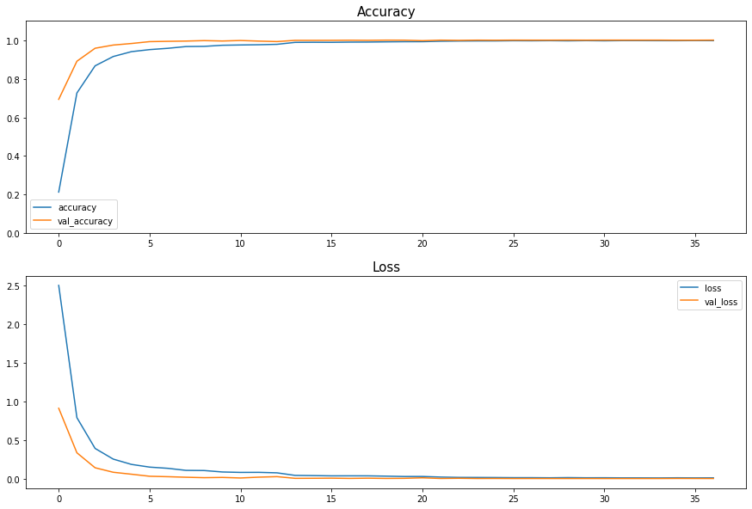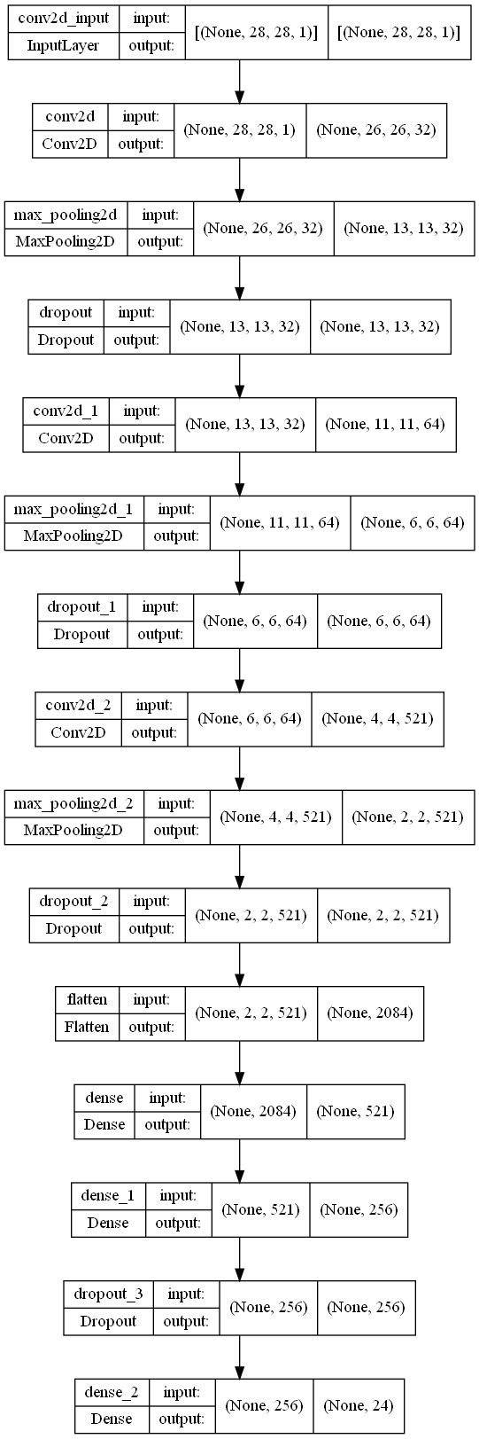

**References**

[1] <https://censusindia.gov.in/census_and_you/disabled_population.aspx>

[1] [Ankit Ojha, Ayush Pandey, Shubham Maurya, Abhishek Thakur, Dr. Dayananda P 2020. Sign Language to Text and Speech Translation in Real Time Using Convolutional Neural Network](https://www.ijert.org/sign-language-to-text-and-speech-translation-in-real-time-using-convolutional-neural-network)

[2] [Mirza, S. F., & Al-Talabani, A. K. (2021). Efficient Kinect Sensor-based Kurdish Sign Language Recognition Using Echo System Network.](https://doi.org/10.14500/aro.10827)

[3] [Y. Neeraja,D.Susritha Reddy, J.Kalpana, K.Subhasri, D. Lokesh 2021, AN ADVANCED BRAILLE SYSTEM-COMMUNICATION DEVICE FOR BLIND-DEAF PEOPLE](https://www.journal-dogorangsang.in/no_1_NECG_21/22.pdf)

[4] [Himanshu Gautam, Prerna Gaur 2020, DRISHYAM: Real-Time Text to Braille Conversion and Realization](https://ieeexplore.ieee.org/abstract/document/9342522/)

[5] [Vadim Popov, Ivan Vovk, Vladimir Gogoryan, Tasnima Sadekova, Mikhail Kudinov 2021. Grad-TTS: A Diffusion Probabilistic Model for Text-to-Speech](https://proceedings.mlr.press/v139/popov21a.html)

[6] [Prerana Das, Kakali Acharjee, Pranab Das and Vijay Prasad 2015, VOICE RECOGNITION SYSTEM: SPEECH-TO-TEXT](https://www.researchgate.net/publication/304651244_VOICE_RECOGNITION_SYSTEM_SPEECH-TO-TEXT)

[7] [World Report on Disability](https://www.who.int/disabilities/world_report/2011/report.pdf)

[8] [Census of India, 2001](https://censusindia.gov.in/census_and_you/disabled_population.aspx)

**Synopsis Draft verified by**

### Project Guide HOD

Prof. Bikram Pratim Bhuyan Mr. T.P. Singh

(Assistant Pro)