程式設計視窗實務期末作品

C107118202鄭育存、C107118219蔡佳蓁、C107118231溫玉婕

1. 緣起

「茱伊克」是由飲料的英文名稱「drink 」唸著唸著而演化成的，代表我們賣的純粹只有飲料。現在市面上越來越多黑心的不肖廠商會用低廉的成本製做出喝多了對身體有害的飲品，我們想在這塊人文與茶香兼具的土地上，一步一腳印、堅守品質與服務，堅持給台灣人最好的，也希望好的茶、好的飲品能讓更多人品嚐。

1. 系統特色

* 流水號

格式：日期＋三位數流水號

* 進行MSSQL DB讀寫操作
* 畫面精美、色彩繽紛
* 自動顯示總額及一些自動的功能
* 有適當的防呆機制

1. 操作介紹
2. 點選果汁系列、找奶茶、找咖啡、原味茶、夏季限定任一項後，點選該項目下的品項即會在右方做顯示

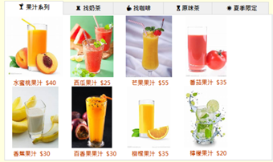

1. 點選下方甜度冰塊尺寸會相對應在右方做顯示（圖片上的價格是以小杯為售價，小杯為圖上價格、中杯＊1.25、大杯＊1.5、胖胖杯＊2即為單價）

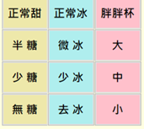

1. 數量部分可透過數字輸入

日後可用＋和-增減數量

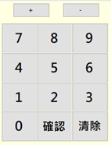

1. 一筆完成後小計即會顯示

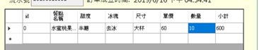

1. 點選新增按鈕即可新增下一筆品項繼續點餐

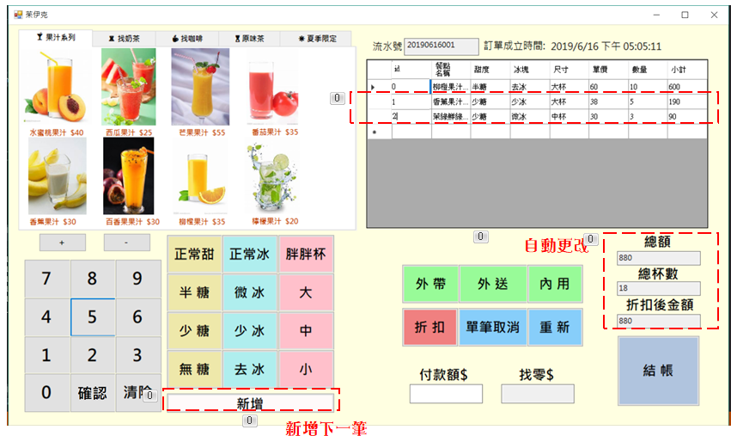下方的總額及總杯數及折扣後金額也會隨之變動

1. 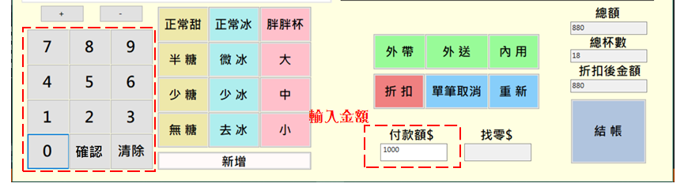付款額需要先點選輸入框後，在點選左方數字輸入鍵進行輸入
2. 點選外帶、內用、外送會顯示於右上方視窗

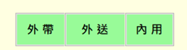

1. 再看是否點選折扣(可能因為是本店會員，會者今天有折價活動，總額會打八折優待)

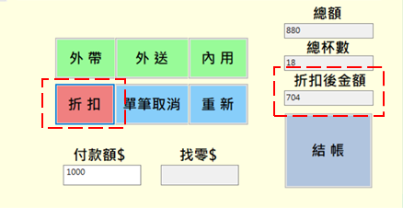

1. 點選結帳後會跳出本次消費金額、本次付款金額、找零金額

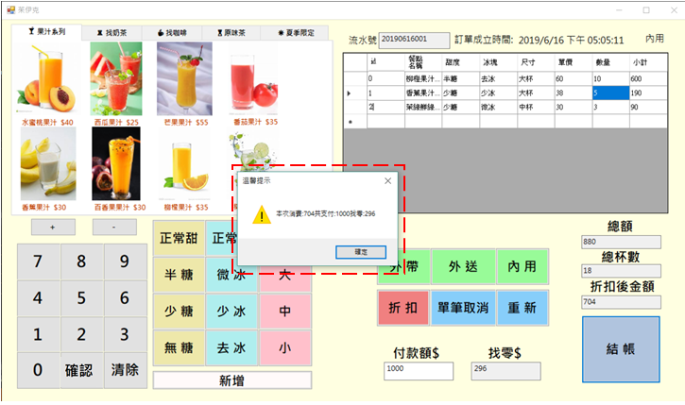

操作步驟補充：

單筆取消：選取的這筆資料從資料庫刪除

重新：選購的所有從DB中清除，流水號一樣、訂單成立時間重新取得並顯示



1. 程式碼展示

**<Form1.cs>**

using System;

using System.Collections.Generic;

using System.ComponentModel;

using System.Data;

using System.Drawing;

using System.Linq;

using System.Text;

using System.Threading.Tasks;

using System.Windows.Forms;

using System.Data.SqlClient;

using System.Diagnostics;

namespace pos_system_finaldamo

{

public partial class Form1 : Form

{

//全域變數宣告

int id_num;

int id_total = 1;

int rowIndex;

double discountNum = 1;

String serial_number = ((DateTime.Now.ToString("yyyyMMdd")).ToString())+"001";//流水號

String numKey = "";//數字鍵

Boolean payment = false;

Boolean num = false;

public Form1()

{

InitializeComponent();

//CSS

//杯子尺寸 淡綠色

fatCup.BackColor = Color.Pink;

bigCup.BackColor = Color.Pink;

mediumCup.BackColor = Color.Pink;

smallCup.BackColor = Color.Pink;

//冰度 淡藍色

normalIce.BackColor = Color.PaleTurquoise;

microIce.BackColor = Color.PaleTurquoise;

lessIce.BackColor = Color.PaleTurquoise;

noIce.BackColor = Color.PaleTurquoise;

//甜度 淡黃色

normalSweet.BackColor = Color.PaleGoldenrod;

halfSugar.BackColor = Color.PaleGoldenrod;

lessSugar.BackColor = Color.PaleGoldenrod;

sugarFree.BackColor = Color.PaleGoldenrod;

//新增

addData.BackColor = Color.Snow;

//內用外帶外送

takeout.BackColor = Color.PaleGreen;

delivery.BackColor = Color.PaleGreen;

InternalUse.BackColor = Color.PaleGreen;

//折扣

discount.BackColor = Color.LightCoral;

//單筆取消及重新

singleCancellation.BackColor = Color.LightSkyBlue;

delete.BackColor = Color.LightSkyBlue;

//結帳

checkOut.BackColor = Color.LightSteelBlue;

}

//當Form載入

private void Form1_Load(object sender, EventArgs e)

{

ClearData();//初始化

displayOrder();

//訂單建立時間

dateTime.Text = System.DateTime.Now.ToString();

serialNumber.Text = Convert.ToString(serial_number);

id_total = Convert.ToInt32(display.Rows[display.RowCount - 1].Cells[0].Value);

}

private void displayOrder()

{

SqlConnection con = new SqlConnection(@"Data Source=(LocalDB)\MSSQLLocalDB;AttachDbFilename=C:\Users\李偉慈\Desktop\pos_system_finaldamo\pos.mdf;Integrated Security=True;Connect Timeout=30");

SqlDataAdapter adapter;

con.Open();// 打開資料庫

DataTable dt = new DataTable();

adapter = new SqlDataAdapter("select * from pos", con);//建立查詢

//建立GridView欄位

adapter.Fill(dt);

display.DataSource = dt;

display.Columns[0].HeaderText = "id";

display.Columns[1].HeaderText = "餐點名稱";

display.Columns[2].HeaderText = "甜度";

display.Columns[3].HeaderText = "冰塊";

display.Columns[4].HeaderText = "尺寸";

display.Columns[5].HeaderText = "單價";

display.Columns[6].HeaderText = "數量";

display.Columns[7].HeaderText = "小計";

display.Columns[8].HeaderText = "基礎價格";

display.Columns[8].Visible = false;

display.AutoSizeColumnsMode = DataGridViewAutoSizeColumnsMode.Fill;

con.Close();

}

private void InsertDB(string columnName, string keyValue)

{

SqlConnection con = new SqlConnection(@"Data Source=(LocalDB)\MSSQLLocalDB;AttachDbFilename=C:\Users\李偉慈\Desktop\pos_system_finaldamo\pos.mdf;Integrated Security=True;Connect Timeout=30");

SqlCommand cmd;

con.Open();

//cmd = new SqlCommand("insert into pos("+ columnName + ") values(@keyValue)", con);

//cmd.Parameters.AddWithValue("@keyValue", keyValue);

// {0} = id_num, {1} = columnName, {2} = keyValue

string query;

int price;

int subtotal;

query = string.Format(@"

IF EXISTS (SELECT * FROM pos WHERE id={0})

UPDATE pos SET {1} = @keyValue

WHERE id={0}

ELSE

INSERT INTO pos(id, {1}) VALUES({0}, @keyValue)", id_total, columnName);

cmd = new SqlCommand(query, con);

cmd.Parameters.AddWithValue("@keyValue", keyValue);

cmd.ExecuteNonQuery();

con.Close();

displayOrder();

if (columnName == "size")//當杯子尺寸被選擇，同時要改變單價

{

price = CalSizePrice(id_num, keyValue);

InsertDB("price", Convert.ToString(price));

}

else if (columnName == "num")

{//當數量改時，同時要改變小計

subtotal = CalSubtotal(id_num);

InsertDB("total", Convert.ToString(subtotal));

}

else if (columnName == "total")//當小計改變時，同時改變總額 杯數 折扣後金額

{

CalTotal();

CalNum();

AmountAfterDiscount();

}

}

//計算尺寸價格

private int CalSizePrice(int id_num, string keyValue)

{

int unit_price;//計算單價

int base_price=1;//基礎價格

double multiple = 1.0;//倍數

String price_sql;

//依據杯子尺寸給出倍數帶入變數

if (keyValue == "小杯")

{

multiple = 1.0;

}

else if (keyValue == "中杯")

{

multiple = 1.2;

}

else if (keyValue == "大杯")

{

multiple = 1.5;

}

else if (keyValue == "胖胖杯")

{

multiple = 2;

}

//查詢基礎價格

SqlConnection con = new SqlConnection(@"Data Source=(LocalDB)\MSSQLLocalDB;AttachDbFilename=C:\Users\李偉慈\Desktop\pos_system_finaldamo\pos.mdf;Integrated Security=True;Connect Timeout=30");

SqlCommand cmd;

con.Open();

price_sql = string.Format(@"SELECT base_price FROM pos WHERE id={0}", id_num);

cmd = new SqlCommand(price_sql, con);

SqlDataReader reader = cmd.ExecuteReader(CommandBehavior.SingleRow);

reader.Read();

//System.Diagnostics.Debug.WriteLine("reader[base_price]:");

//System.Diagnostics.Debug.WriteLine(reader["base_price"]);

try

{

base_price = Convert.ToInt32(reader["base_price"]);

}

catch {

base_price = base_price;

}

con.Close();

displayOrder();

//計算最後單價

unit_price = (int)Math.Round(base_price * multiple, 0);

return unit_price;

}

//小計

private int CalSubtotal(int id_num)

{

int price;

int num;

int subtotal;

String subtotal_sql;

//查詢基礎價格

SqlConnection con = new SqlConnection(@"Data Source=(LocalDB)\MSSQLLocalDB;AttachDbFilename=C:\Users\李偉慈\Desktop\pos_system_finaldamo\pos.mdf;Integrated Security=True;Connect Timeout=30");

SqlCommand cmd;

con.Open();

subtotal_sql = string.Format(@"SELECT price,num FROM pos WHERE id={0}", id_num);

cmd = new SqlCommand(subtotal_sql, con);

SqlDataReader reader = cmd.ExecuteReader(CommandBehavior.SingleRow);

reader.Read();

price = Convert.ToInt32(reader["price"]);

num = Convert.ToInt32(reader["num"]);

con.Close();

displayOrder();

//計算小計

subtotal = price * num;

return subtotal;

}

//總額

private void CalTotal() {

int count;

int total=0;

String subtotal_sql;

String count_sql;

SqlConnection con = new SqlConnection(@"Data Source=(LocalDB)\MSSQLLocalDB;AttachDbFilename=C:\Users\李偉慈\Desktop\pos_system_finaldamo\pos.mdf;Integrated Security=True;Connect Timeout=30");

SqlCommand cmd;

con.Open();

count_sql = string.Format(@"SELECT COUNT(total) FROM pos");//SELECT COUNT(*) FROM table_name

cmd = new SqlCommand(count_sql, con);

SqlDataReader reader_count = cmd.ExecuteReader();

reader_count.Read();

count = Convert.ToInt32(reader_count[0]);

con.Close();

con.Open();

subtotal_sql = string.Format(@"SELECT total FROM pos");

cmd = new SqlCommand(subtotal_sql, con);

SqlDataReader reader_subtotal = cmd.ExecuteReader();

while (reader_subtotal.Read()) {

total += reader_subtotal.GetInt32(0);

}

//System.Diagnostics.Debug.WriteLine("count");

//System.Diagnostics.Debug.WriteLine(count);

con.Close();

displayOrder();

lumpSum.Text = total.ToString();

}

//總杯數

private void CalNum()

{

int num=0;

int count;

String num_sql;

String count_sql;

SqlConnection con = new SqlConnection(@"Data Source=(LocalDB)\MSSQLLocalDB;AttachDbFilename=C:\Users\李偉慈\Desktop\pos_system_finaldamo\pos.mdf;Integrated Security=True;Connect Timeout=30");

SqlCommand cmd;

con.Open();

count_sql = string.Format(@"SELECT COUNT(total) FROM pos");//SELECT COUNT(*) FROM table_name

cmd = new SqlCommand(count_sql, con);

SqlDataReader reader_count = cmd.ExecuteReader();

reader_count.Read();

count = Convert.ToInt32(reader_count[0]);

con.Close();

con.Open();

num_sql = string.Format(@"SELECT num FROM pos");

cmd = new SqlCommand(num_sql, con);

SqlDataReader reader_num = cmd.ExecuteReader();

while (reader_num.Read())

{

num += reader_num.GetInt32(0);

}

//reader_subtotal.Read();

//System.Diagnostics.Debug.WriteLine("count");

//System.Diagnostics.Debug.WriteLine(count);

con.Close();

displayOrder();

totalNumberOfCups.Text = num.ToString();

}

//折扣後金額

private void AmountAfterDiscount() {

try

{

total.Text = (int.Parse(lumpSum.Text) * discountNum).ToString();

}

catch {

total.Text = "";

}

}

//品項和價格寫入DB

private void pictureBox1_Click(object sender, EventArgs e)

{

InsertDB("name", "水蜜桃果汁");

InsertDB("base_price", "40");

}

private void pictureBox2_Click(object sender, EventArgs e)

{

InsertDB("name", "西瓜果汁");

InsertDB("base_price", "25");

}

private void pictureBox3_Click(object sender, EventArgs e)

{

InsertDB("name", "芒果果汁");

InsertDB("base_price", "55");

}

private void pictureBox4_Click(object sender, EventArgs e)

{

InsertDB("name", "番茄果汁");

InsertDB("base_price", "35");

}

private void pictureBox5_Click(object sender, EventArgs e)

{

InsertDB("name", "香蕉果汁");

InsertDB("base_price", "30");

}

private void pictureBox6_Click(object sender, EventArgs e)

{

InsertDB("name", "百香果果汁");

InsertDB("base_price", "30");

}

private void pictureBox7_Click(object sender, EventArgs e)

{

InsertDB("name", "柳橙果汁");

InsertDB("base_price", "35");

}

private void pictureBox8_Click(object sender, EventArgs e)

{

InsertDB("name", "檸檬果汁");

InsertDB("base_price", "20");

}

private void pictureBox16_Click(object sender, EventArgs e)

{

InsertDB("name", "芋頭奶茶");

InsertDB("base_price", "40");

}

private void pictureBox15_Click(object sender, EventArgs e)

{

InsertDB("name", "抹茶鮮奶茶");

InsertDB("base_price", "65");

}

private void pictureBox14_Click(object sender, EventArgs e)

{

InsertDB("name", "珍珠奶茶");

InsertDB("base_price", "55");

}

private void pictureBox13_Click(object sender, EventArgs e)

{

InsertDB("name", "焦糖奶茶");

InsertDB("base_price", "35");

}

private void pictureBox12_Click(object sender, EventArgs e)

{

InsertDB("name", "抹香奶茶");

InsertDB("base_price", "30");

}

private void pictureBox11_Click(object sender, EventArgs e)

{

InsertDB("name", "鐵觀音奶茶");

InsertDB("base_price", "35");

}

private void pictureBox10_Click(object sender, EventArgs e)

{

InsertDB("name", "布丁奶茶");

InsertDB("base_price", "40");

}

private void pictureBox9_Click(object sender, EventArgs e)

{

InsertDB("name", "仙草凍奶茶");

InsertDB("base_price", "65");

}

private void pictureBox19_Click(object sender, EventArgs e)

{

InsertDB("name", "黑咖啡");

InsertDB("base_price", "40");

}

private void pictureBox21_Click(object sender, EventArgs e)

{

InsertDB("name", "白布雷拿鐵");

InsertDB("base_price", "65");

}

private void pictureBox23_Click(object sender, EventArgs e)

{

InsertDB("name", "卡布奇諾");

InsertDB("base_price", "55");

}

private void pictureBox17_Click(object sender, EventArgs e)

{

InsertDB("name", "奶霜咖啡");

InsertDB("base_price", "35");

}

private void pictureBox24_Click(object sender, EventArgs e)

{

InsertDB("name", "厚重拿鐵");

InsertDB("base_price", "30");

}

private void pictureBox22_Click(object sender, EventArgs e)

{

InsertDB("name", "焦糖瑪奇朵");

InsertDB("base_price", "35");

}

private void pictureBox20_Click(object sender, EventArgs e)

{

InsertDB("name", "綠茶拿鐵");

InsertDB("base_price", "40");

}

private void pictureBox18_Click(object sender, EventArgs e)

{

InsertDB("name", "法式焦糖拿鐵");

InsertDB("base_price", "65");

}

private void pictureBox28_Click(object sender, EventArgs e)

{

InsertDB("name", "百花檸檬青");

InsertDB("base_price", "40");

}

private void pictureBox32_Click(object sender, EventArgs e)

{

InsertDB("name", "茉綠鮮綠茶");

InsertDB("base_price", "25");

}

private void pictureBox29_Click(object sender, EventArgs e)

{

InsertDB("name", "四季春茶");

InsertDB("base_price", "35");

}

private void pictureBox25_Click(object sender, EventArgs e)

{

InsertDB("name", "菊花普洱茶");

InsertDB("base_price", "35");

}

private void pictureBox27_Click(object sender, EventArgs e)

{

InsertDB("name", "炭焙烏龍茶");

InsertDB("base_price", "30");

}

private void pictureBox31_Click(object sender, EventArgs e)

{

InsertDB("name", "錫蘭紅茶");

InsertDB("base_price", "35");

}

private void pictureBox30_Click(object sender, EventArgs e)

{

InsertDB("name", "文山清茶");

InsertDB("base_price", "30");

}

private void pictureBox26_Click(object sender, EventArgs e)

{

InsertDB("name", "翡翠檸檬茶");

InsertDB("base_price", "45");

}

private void pictureBox35_Click(object sender, EventArgs e)

{

InsertDB("name", "抹茶綿綿冰");

InsertDB("base_price", "75");

InsertDB("sweetness", "無");

InsertDB("ice", "無");

}

private void pictureBox36_Click(object sender, EventArgs e)

{

InsertDB("name", "藍莓綿綿冰");

InsertDB("base_price", "70");

InsertDB("sweetness", "無");

InsertDB("ice", "無");

}

private void pictureBox38_Click(object sender, EventArgs e)

{

InsertDB("name", "芒果綿綿冰");

InsertDB("base_price", "85");

InsertDB("sweetness", "無");

InsertDB("ice", "無");

}

//+1數量-1數量

private void minusOne_Click(object sender, EventArgs e)

{

if (num)

{

//System.Diagnostics.Debug.WriteLine("Convert.ToInt32(numKey)");

//System.Diagnostics.Debug.WriteLine(Convert.ToInt32(numKey));

numKey = (Convert.ToInt32(numKey) - 1).ToString();

InsertDB("num", numKey);

}

}

private void addOne_Click(object sender, EventArgs e)

{

if (num)

{

numKey = (Convert.ToInt32(numKey) + 1).ToString();

InsertDB("num", numKey);

}

}

//數字鍵按鈕區塊

private void zero_Click(object sender, EventArgs e)

{

if (payment)

{

numKey += "0";

paymentAmount.Text = numKey;

} else if (num) {

numKey += "0";

InsertDB("num", numKey);

}

}

private void one_Click(object sender, EventArgs e)

{

if (payment)

{

numKey += "1";

paymentAmount.Text = numKey;

}

else if (num)

{

numKey += "1";

InsertDB("num", numKey);

}

}

private void two_Click(object sender, EventArgs e)

{

if (payment)

{

numKey += "2";

paymentAmount.Text = numKey;

}

else if (num)

{

numKey += "2";

InsertDB("num", numKey);

}

}

private void three_Click(object sender, EventArgs e)

{

if (payment)

{

numKey += "3";

paymentAmount.Text = numKey;

}

else if (num)

{

numKey += "3";

InsertDB("num", numKey);

}

}

private void four_Click(object sender, EventArgs e)

{

if (payment)

{

numKey += "4";

paymentAmount.Text = numKey;

}

else if (num)

{

numKey += "4";

InsertDB("num", numKey);

}

}

private void fives_Click(object sender, EventArgs e)

{

if (payment)

{

numKey += "5";

paymentAmount.Text = numKey;

}

else if (num)

{

numKey += "5";

InsertDB("num", numKey);

}

}

private void six_Click(object sender, EventArgs e)

{

if (payment)

{

numKey += "6";

paymentAmount.Text = numKey;

}

else if (num)

{

numKey += "6";

InsertDB("num", numKey);

}

}

private void seven_Click(object sender, EventArgs e)

{

if (payment) {

numKey += "7";

paymentAmount.Text = numKey;

}

else if (num)

{

numKey += "7";

InsertDB("num", numKey);

}

}

private void eight_Click(object sender, EventArgs e)

{

if (payment)

{

numKey += "8";

paymentAmount.Text = numKey;

}

else if (num)

{

numKey += "8";

InsertDB("num", numKey);

}

}

private void nine_Click(object sender, EventArgs e)

{

if (payment)

{

numKey += "9";

paymentAmount.Text = numKey;

}

else if (num)

{

numKey += "9";

InsertDB("num", numKey);

}

}

private void twoZero_Click(object sender, EventArgs e)

{

if (payment)

{

paymentAmount.Text = numKey;

payment = false;

}

else if (num)

{

num = false;

}

}

private void clear_Click(object sender, EventArgs e)

{

if (payment)

{

paymentAmount.Text = "";

}

else if (num)

{

numKey = "";

InsertDB("num", numKey);

}

}

//甜度按鈕區塊寫入DB

private void normalSweet_Click(object sender, EventArgs e)

{

InsertDB("sweetness", "正常甜");

}

private void halfSugar_Click(object sender, EventArgs e)

{

InsertDB("sweetness", "半糖");

}

private void lessSugar_Click(object sender, EventArgs e)

{

InsertDB("sweetness", "少糖");

}

private void sugarFree_Click(object sender, EventArgs e)

{

InsertDB("sweetness", "無糖");

}

//冰塊程度按鈕區塊寫入DB

private void normalIce_Click(object sender, EventArgs e)

{

InsertDB("ice", "正常冰");

}

private void microIce_Click(object sender, EventArgs e)

{

InsertDB("ice", "微冰");

}

private void lessIce_Click(object sender, EventArgs e)

{

InsertDB("ice", "少冰");

}

private void noIce_Click(object sender, EventArgs e)

{

InsertDB("ice", "去冰");

}

//杯子尺寸按鈕區塊寫入DB

private void fatCup_Click(object sender, EventArgs e)

{

InsertDB("size", "胖胖杯");

}

private void bigCup_Click(object sender, EventArgs e)

{

InsertDB("size", "大杯");

}

private void mediumCup_Click(object sender, EventArgs e)

{

InsertDB("size", "中杯");

}

private void middleCenter_Click(object sender, EventArgs e)

{

InsertDB("size", "小杯");

}

//新增資料

private void addData_Click(object sender, EventArgs e)

{

id_total++;

}

//顯示區域點擊事件

private void display_CellClick(object sender, DataGridViewCellEventArgs e)

{

if (this.display.Columns[e.ColumnIndex].Name=="num") {

num = true;

numKey = "";

}

try

{

id_num = Convert.ToInt32(display.Rows[e.RowIndex].Cells[0].Value);

rowIndex = e.RowIndex;

}

catch {

id_num = id_num;

}

}

//外帶外送內用

private void takeout_Click(object sender, EventArgs e)

{

label51.Text = "外帶";

}

private void delivery_Click(object sender, EventArgs e)

{

label51.Text = "外送";

}

private void InternalUse_Click(object sender, EventArgs e)

{

label51.Text = "內用";

}

//折扣

private void discount_Click(object sender, EventArgs e)

{

discountNum = 0.8;

AmountAfterDiscount();

}

//單筆取消

private void singleCancellation_Click(object sender, EventArgs e)

{

string del_row_sql;

//DataGridViewRow資料列清除

DataGridViewRow r1 = this.display.CurrentRow;

this.display.Rows.Remove(r1);

//單筆資料從DB清除資料

SqlConnection con = new SqlConnection(@"Data Source=(LocalDB)\MSSQLLocalDB;AttachDbFilename=C:\Users\李偉慈\Desktop\pos_system_finaldamo\pos.mdf;Integrated Security=True;Connect Timeout=30");

SqlCommand cmd;

con.Open();

del_row_sql = string.Format(@"Delete From pos Where id={0}", id_num);

cmd = new SqlCommand(del_row_sql, con);

cmd.ExecuteNonQuery();

con.Close();

displayOrder();

}

//重新

private void delete_Click(object sender, EventArgs e)

{

ClearData();

}

//付款額輸入

private void paymentAmount_Click(object sender, EventArgs e)

{

numKey = "";

payment = true;

}

//結帳

private void checkOut_Click(object sender, EventArgs e)

{

int giveChange_num = 0;

try{

giveChange_num = int.Parse(paymentAmount.Text) - int.Parse(total.Text);

giveChange.Text = (giveChange_num).ToString();

if (giveChange_num < 0)

{

MessageBox.Show("本次消費:$" + total.Text + "共支付:$" + paymentAmount.Text + "您還缺:$" + (int.Parse(total.Text) - int.Parse(paymentAmount.Text)).ToString(), "溫馨提示", MessageBoxButtons.OK, MessageBoxIcon.Warning);

}

else

{

MessageBox.Show("本次消費:$" + total.Text + "共支付:$" + paymentAmount.Text + "找零:$" + giveChange_num.ToString(), "溫馨提示", MessageBoxButtons.OK, MessageBoxIcon.Warning);

}

//清除資料

ClearData();

//流水號+1

serialNumber.Text = (Convert.ToDouble(serial_number) + 1).ToString();//流水號+1

}catch

{

MessageBox.Show("請先點餐再進行結帳", "溫馨提示", MessageBoxButtons.OK, MessageBoxIcon.Warning);

}

}

//清空資料

private void ClearData() {

string del_sql;

//清除DB資料

SqlConnection con = new SqlConnection(@"Data Source=(LocalDB)\MSSQLLocalDB;AttachDbFilename=C:\Users\李偉慈\Desktop\pos_system_finaldamo\pos.mdf;Integrated Security=True;Connect Timeout=30");

SqlCommand cmd;

con.Open();

del_sql = string.Format(@"TRUNCATE TABLE pos");

cmd = new SqlCommand(del_sql, con);

cmd.ExecuteNonQuery();

con.Close();

displayOrder();

//清除欄位資料

paymentAmount.Text = "";

giveChange.Text = "";

lumpSum.Text = "";

totalNumberOfCups.Text = "";

total.Text = "";

//訂單成立時間重新取得

dateTime.Text = System.DateTime.Now.ToString();

//外帶內用外送lable清除

label51.Text = "";

}

}

}

* 資料庫設計

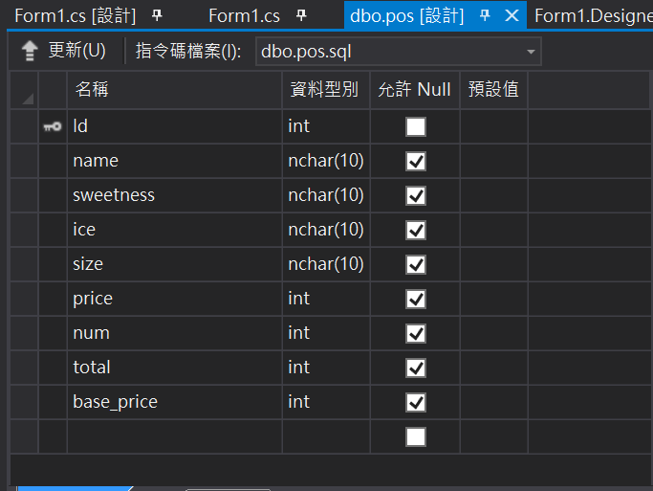

1. 自評

* 鄭育存

95分，本次專題我是負責程式撰寫。

在本次ＰＯＳ系統上基本功能有做到以外，變數以及控制項都是有效命名，且有連結資料庫進行ＳＱＬ操作，以及一些基本防呆功能，但一些深度的防呆操作因為時間因素而尚未完工。

* 蔡佳蓁

在這次報告中，我擔任設計介面的職務，相較其他職務聽起來或許很簡單，但也是需要時間去做顏色搭配，版面調整，字型樣式，圖片美觀，讓介面整體看起來舒爽好用，我的付出我認為至少可以90分。

* 溫玉婕

期末報告我負責簡報及文件檔的製作，雖然前面的製作大部分不是我製作的但也有根據討論的內容做回應及建議，之後把全部的東西整理成文件及簡報來呈現，我給我自己打92分。

1. 心得

* 鄭育存

本次專題同學們都很用心，大家都互相分工合作，遇到不會的互相學習與討論，在這次專題中獲益良多，但比較抱歉的事情是，本身事情比較多，所以在程式撰寫上完成日期接近繳交期限，導致壓縮組員撰寫文件以及製作簡報的時程。

* 蔡佳蓁

在這次C#課程中讓我學到，團隊合作非常重要，也很關鍵，尤其是在初期，每個合作的人都會有不一樣的想法，不一樣的願景，大家的希望、工作方式、目標也都不一樣，情感是否都能融合到一起也是個障礙，經過這次合作讓我吸收到很寶貴的經驗，也更能知道如何調適及找尋程式中遇到的問題。

* 溫玉婕

期末分組報告讓我深深體會到「三個臭皮匠，勝過一個諸葛亮」的團隊合作的道理，大家一起把想法說出或是提出意見、建議及分配所擅長的事務上，能夠讓呈現出的東西達到比想像中更完美的作品。

1. 建議

* 鄭育存

老師教得很輕鬆簡單，循序漸進的教法，帶大家入門也能夠讓大家引發對c#的興趣，讓大家不會有徬徨無助的感覺。希望老師可以在講深一點。

* 蔡佳蓁

在課程建議，我覺得程式解說上還可以再詳細說明一下，還有多給些範例可以參考，順便把厲害同學的程式作業可以公開讓大家多多學習，另外就是老師人很好，這學期辛苦你了。

* 溫玉婕

建議教一項東西時可以把顏色、造型簡略帶過，不用一直切畫面讓我們做，因為版面造型的部分其實是可以自己回家摸索。還有關於程式的部分把一些重要或注意的部分突出，簡單的程式可以精簡帶過。謝謝老師！