CS380: Final Report

Group 1: Koehl B., Alice W.

# Application Title

*Crop Calendar*

# Description of app

A calendar designed for farmers that makes it easier to plan and assess crop rotations. This application has been developed with the JavaFX UI toolkit with an accompanying MySQL database for user registration and sign-in.

*Crop Calendar* was designed as a tool for farmers to help with planning crop rotations. As crops are planted, they impact the soil’s nutrients for future crops, which can be scheduled to yield more plentiful crop harvests.

# Entry-point of App

To run our application please execute the file ‘src/calendar/Main.java’.

# Login information

User Login: “farmer”, “farming”

Database: farmers

Table Name: farmer

Database Credentials: “root”, “cs380”

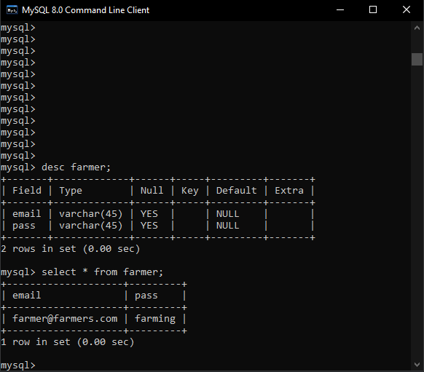

# Screenshots while running

Registering user farmer:  
