**Q29- Write a short essay, plus screenshots talking about performance tuning in SQL Server. Must include Tuning Advisor, Extended Events, DMV, Logs and Execution Plan.**

When a query is not running efficiently, we need to monitor the query performance to find out the source of problem. There are some tools to determine the problem.

SQL Server Profiler: is a tool used by system administrator and logs all slower activities by setting up “Trace Window”🡪 “ Events Selection”

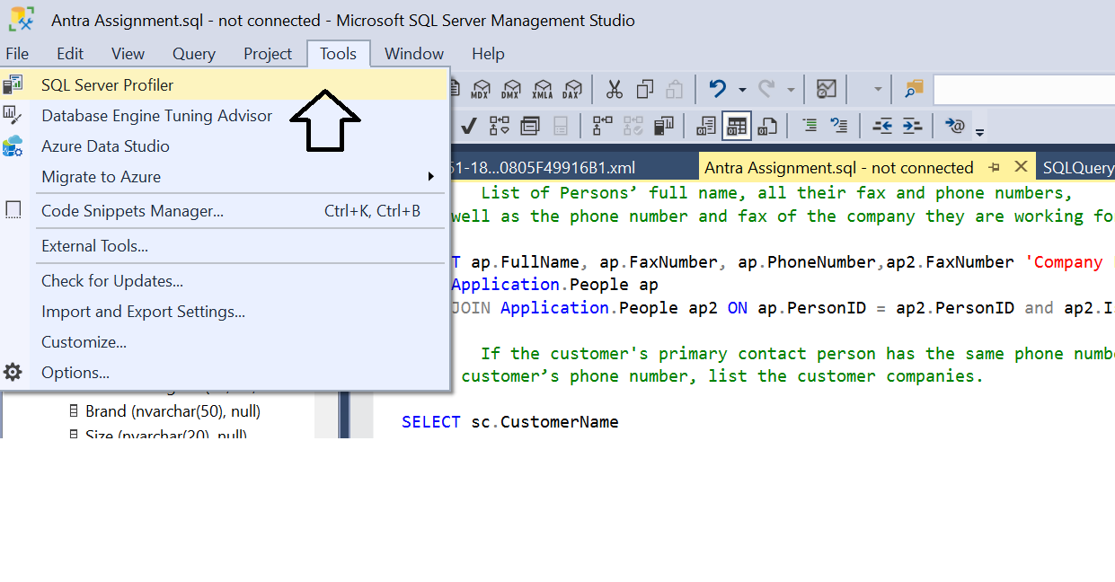

Any event we select there, compiler is going to react upon. This tool is an added layer top of SQL server and takes a lot of system resourced to monitor how SQL server programing is working.

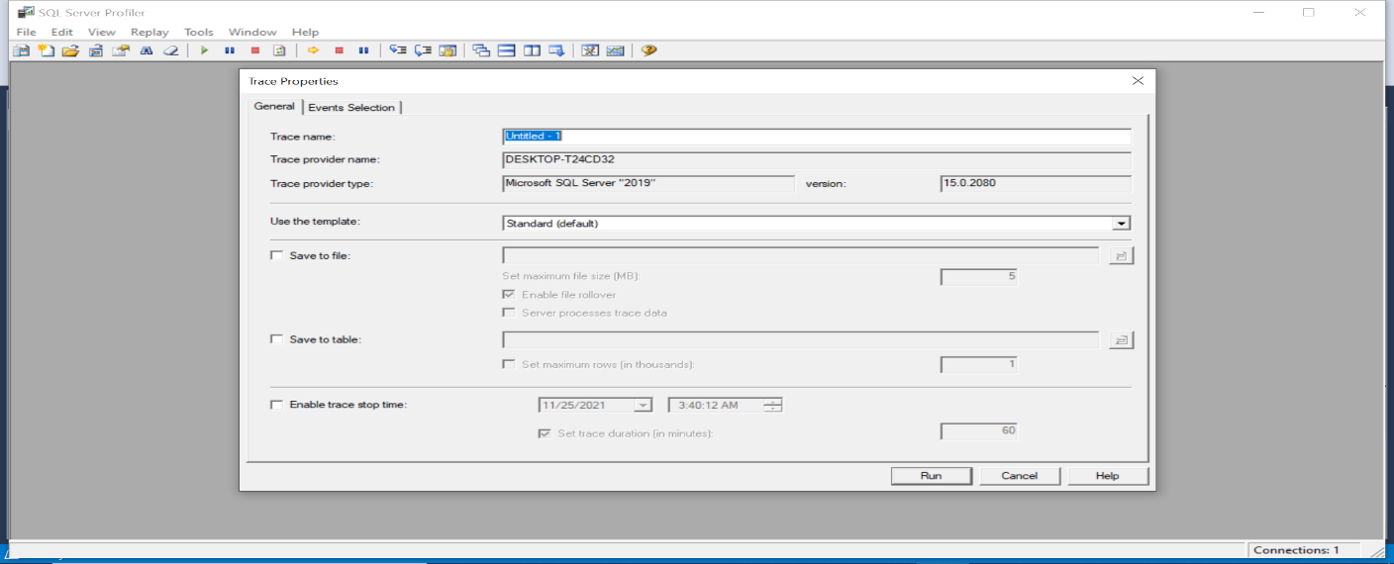

Updated plan to help reduce system resource usage with same amount of information we can get it is called “ *Extended Events*”.

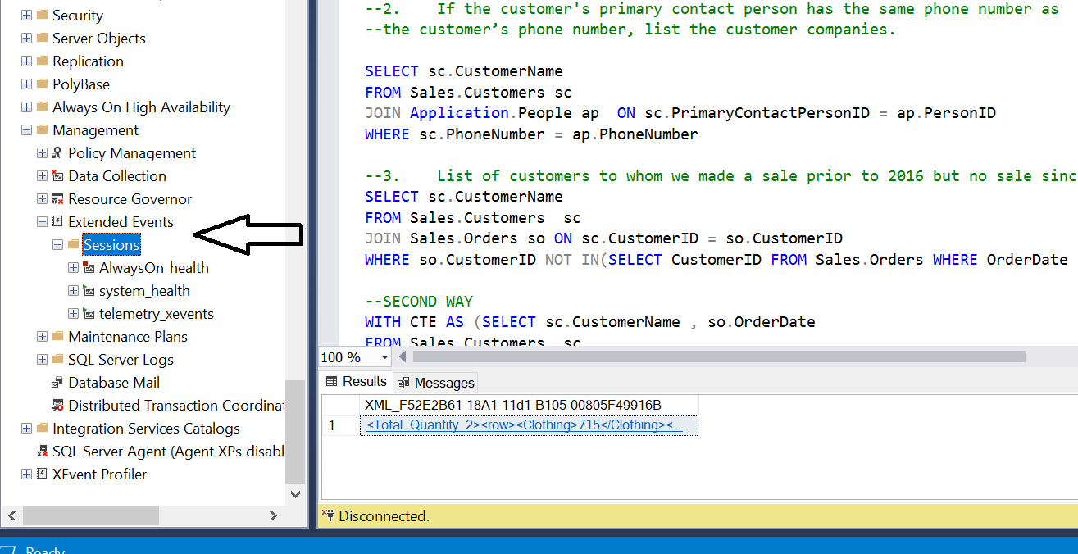

It is like profiler, but it is lighter weight performance monitoring and uses very few performance resources. It can capture all the events from bottom layer to top layer in a most efficient way.

It has an interface called “New Session Wizard” to create, modify, display and analyze our session data. We can select any event we desire system to capture. It is one of the most popular way to monitor performance.

SQL Serve Logs: Logs provide an overall picture of events on server and windows.

DBCC (Database Console Command): statements enable to check performance statistics and the logical, physical consistency of a database. Mostly use for Maintenance and Informational purposes. Very common usage of DBCC is to turn on flags (Trace flags: information about a specific activity) for a special event in database. “DBCC TRACEON” start tracing certain number of flags.

DMV (Dynamic Management View): this view is in master database. Whenever we call it, it will show the status of the system. Syntax is same with querying other views. We have multiple views “sys.dm”.

Is a collection of views, read data from lots of views to get information.

Performance Monitor: it is a windows application that we can add counters same as extended event and the report is like colorful histogram bars or lines.

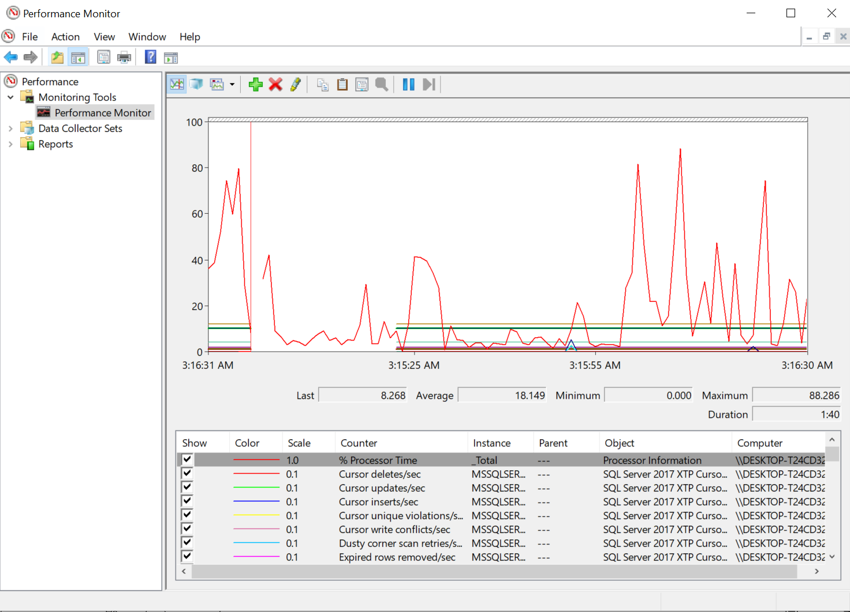

In order to solve the problem:

Execution plan: for any query we have “Execution Plan”. In any execution plan we are looking for several things:

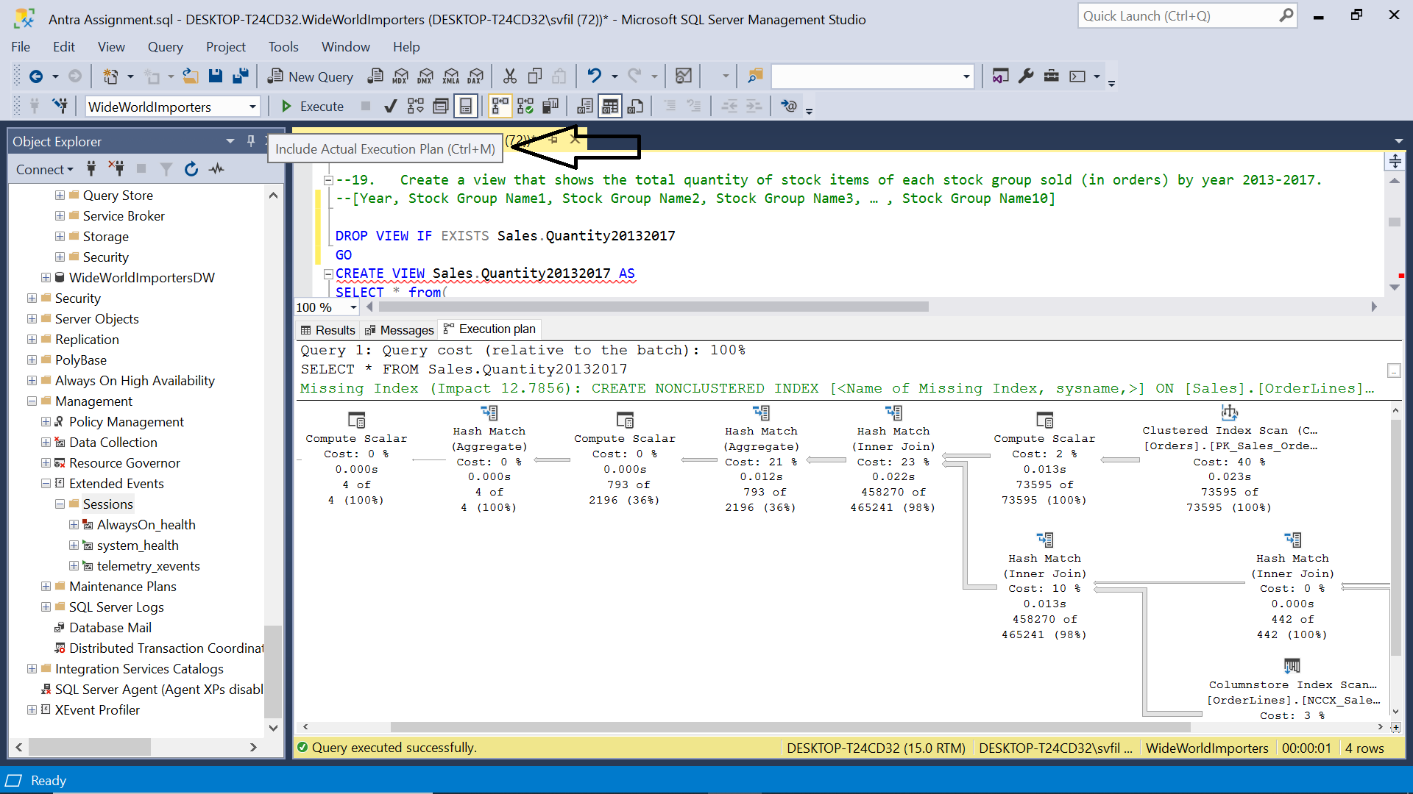

* Icon “Table Scan” is terrible and means index is not available for this step, so it must scan entire table for the columns to get data (missing index).
* Any high percentage is not good, (estimated operator cost) should be low.
* If we change our query and want to compare the performance, we can check and compare the percentage of query cost. Lower percentage better performance.

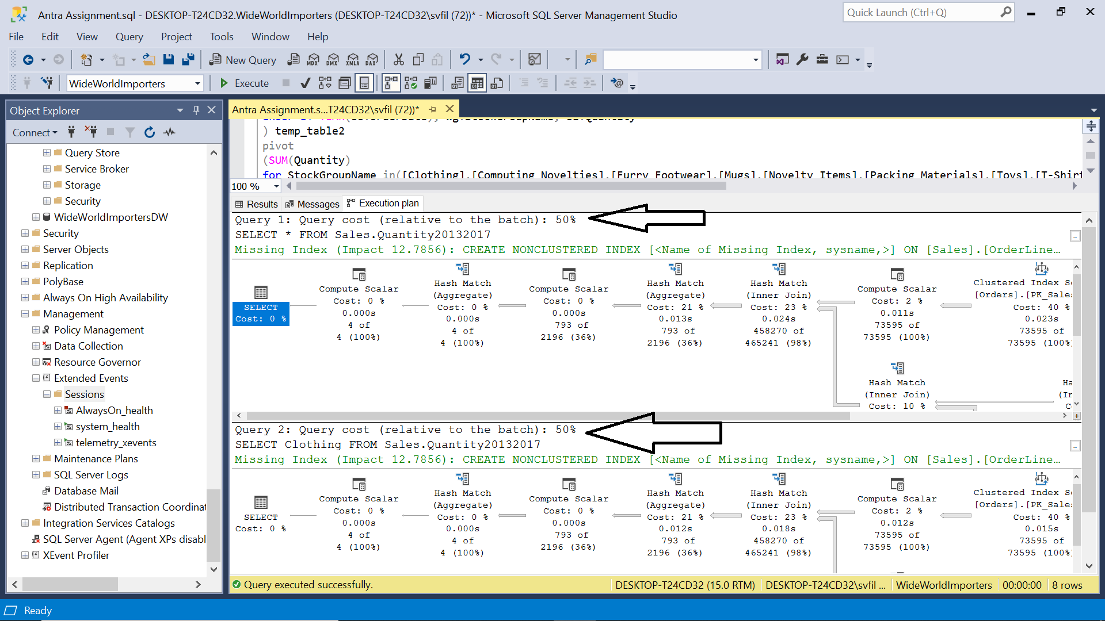

One of the best tools to find and create missing index very is “TUNNING ADVISOR”: ‘Do not keep any existing PDS’ will suggests you drop some unused index but we usually ‘Keep all existing PDS’.

Plan cache means all execution plans stored in. Query Store means all the wrong queries… TUNING ADVISOR automatically find missing index.

