**October 30, 2020**

**Norada, Ava Julia L.**

**Student**

**Institute of Information and Computing Sciences**

**University of Santo Tomas**Dear respondents,

Good day! We are BS in Computer Science students from the Institute of Information and Computing Sciences of the University of Santo Tomas. As part of our final requirements for the course Mobile Programming, we are tasked to design an automated system for our mobile application and hopefully, by the end of the semester, we are to develop and implement it for the course.

In line with this, may we request for your availability for our group to present a possible proposal for the program, Delubyocation. Delubyocation is an informal app with the primary purpose of giving updates on the latest news and calamities that is near a selected location. We hope with our system we could pique your interest into using it.

Thank you and hoping for your consideration.

Sincerely yours,



**Norada, Ava Julia L** Project Manager, ICS 26011, 3CSB

Approved by: Approved by:  


**Sharlene Danica G. Sy** **Karla Marie C. Suelto**   
Respondent, 3CSB President Respondent, 3CSA

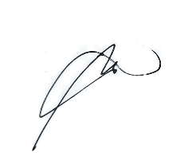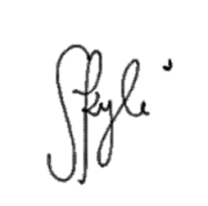Approved by: Approved by: Approved By:

**Kyle Nicole Sacriz Robby Laza Viany Manuel Jr.**   
Respondent Respondent Respondent