Final Project Milestone 1
Toronto BodySafe Public Health Inspections
Prepared by: Fatemeh Shahabdehkordi
City of Toronto Open Data Portal
April 2026
1.Introduction

1.1 Dataset Overview
This report presents an Exploratory Data Analysis (EDA) of the Toronto BodySafe Public Health Inspection dataset, sourced from the City of Toronto's Open Data Portal (open.toronto.ca). The BodySafe program is administered by Toronto Public Health and regulates personal service settings (PSS). Businesses such as hair salons, nail studios, tattoos, body piercing establishments, aesthetics clinics and micropigmentation studios operating within the City of Toronto.
These establishments are subject to inspection under Ontario Regulation 136/18 of the Health Protection and Promotion Act. Inspectors assess compliance across ten regulated categories covering equipment sterilization, hygiene, record-keeping and sanitary conditions. The dataset was originally distributed in GeoJSON format and converted to CSV for analysis. It contains 11,915 inspection records spanning from April 2022 to April 2026, across 17 original fields (reduced to 14 after cleaning).

1.2 Purpose and Motivation
The BodySafe dataset was selected for this analysis because it sits at the intersection of public health regulation and data analytics a domain with real-world implications for infection prevention. Unlike commonly analyzed datasets (e.g., DineSafe, traffic volumes, crime statistics), BodySafe has not been widely studied in academic or data science communities, making it an original and meaningful choice.

The primary objectives of this analysis are:
- To understand the overall compliance landscape across Toronto's personal service sector
- To identify which service types, pose the greatest public health risk based on infraction rates and severity
- To detect temporal trends in inspection activity and compliance from 2022 to 2026
- To identify establishments with persistent non-compliance patterns
- To compare infection-risk (blood/skin-penetrating) services against lower-risk services

1.3 Dataset Description
The dataset contains a mix of data types including categorical, text, date, numeric, and geographic fields.

Field Name | Data Type | Description
X_id | Integer | Sequential row identifier (1 to 11,915)
estId | Integer | Unique establishment identifier assigned by the City
estName | Text | Registered business name of the establishment
addrFull | Text | Full civic address of the establishment
srvType | Categorical | Type of personal service (8 categories: Aesthetics, Barbering & Hairdressing, Nails, Tattooing, Micropigmentation/Microblading, Body Piercing, Ear Piercing, Injectable Personal Services)
insStatus | Categorical | Outcome of inspection: Pass, Conditional Pass, or Closed
insDate | Date | Date the inspection was conducted (2022-04-12 to 2026-04-13)
observation | Text | Inspector's written field notes; NA if no infractions found
infCategory | Categorical | Category of infraction cited (10 categories); NA = no infraction
defDesc | Text | Full text description of the infraction found; NA if none
infType | Categorical | Severity of infraction: C-Crucial, S-Significant, or NA
actionDesc | Text | Enforcement action taken (e.g., Notice to Comply, Verbal Order, Ticket)
longitude | Numeric | Geographic longitude coordinate of the establishment
latitude | Numeric | Geographic latitude coordinate of the establishment

1.4 Data Cleaning
The raw GeoJSON file was first converted to CSV format, with latitude and longitude coordinates extracted from the geometry field. Upon loading into R, several data quality issues were identified and addressed:

- Date conversion: The insDate column was stored as a character string and converted to R's Date class using as.Date(), enabling time-based analysis.
- None string replacement: Five columns (observation, infCategory, defDesc, infType, actionDesc) used the string "None" to represent missing values. These were replaced with proper NA values using mutate(across(..., function(x) ifelse(x == "None", NA, x))). This was critical because R functions such as is.na(), filter(), and sum() only recognize NA, not arbitrary strings.
- Empty column removal: Three columns [ OutcomeDate, OutcomeDesc, and fineAmount ] contained 100% missing values (11,915 NAs each) and were dropped entirely using select() to reduce noise.
- Factor conversion: The categorical columns insStatus, srvType, infType, and infCategory were converted from character to factor type, enabling proper grouping and visualization.
- Duplicate check: No exact duplicate rows were found (sum(duplicated(ds)) = 0). Establishments appearing multiple times represent legitimate separate inspection events across different dates or service types.

After cleaning, the dataset retained 11,915 rows and 14 columns, with missing values appropriately represented as NA in the five infraction-related fields (reflecting inspections where no violations were found).
2. Data Analysis

2.1 Inspection Outcomes (Categorical Data)
The most fundamental question the dataset answers is: how often do personal service establishments pass their inspections? Table 2 and Figure 1 summarize the overall distribution of inspection outcomes across all 11,915 records.

Table 2: Overall Inspection Outcome Distribution
Outcome | Count | Percentage
Pass | 9,267 | 77.78%
Conditional Pass | 2,451 | 20.57%
Closed | 197 | 1.65%
Total | 11,915 | 100%

Most inspections (77.78% ) resulted in a Pass, indicating that most Toronto personal service establishments meet public health standards. However, approximately 1 in 5 inspections (20.57%) resulted in a Conditional Pass, meaning violations were found but were not severe enough to close the business. Establishments receiving a Conditional Pass are typically issued a Notice to Comply and re-inspected. The most severe outcome, Closed, affected 197 establishments (1.65%), indicating serious and immediate public health risk.

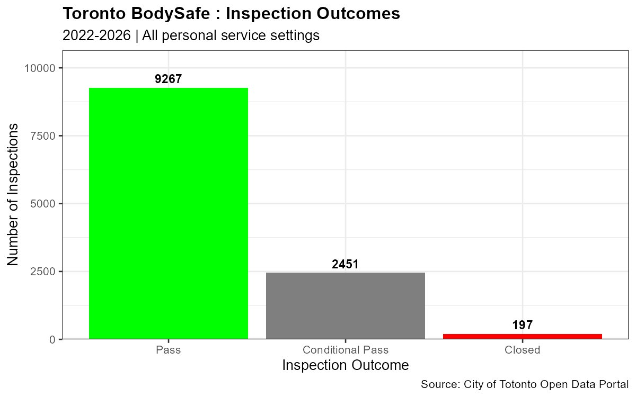
Figure 1: Distribution of Inspection Outcomes (2022–2026)

2.2 Inspection Records by Service Type (Categorical Data)
Figure 2 displays the volume of inspection records by service type. Aesthetics (3,772), Barbering & Hairdressing (3,651), and Nails (2,835) dominate the dataset, collectively accounting for 86.1% of all records. This is consistent with the distribution of personal service businesses across Toronto, where beauty salons and nail studios are far more numerous than tattoo or piercing parlours.

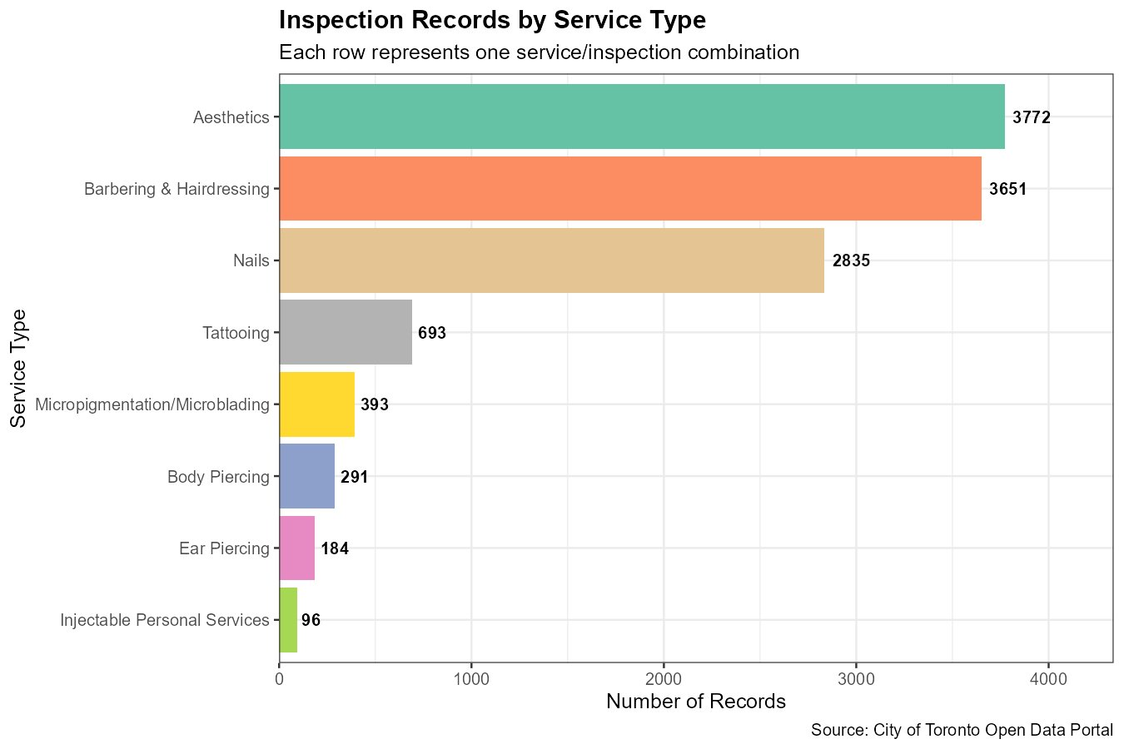
Figure 2: Inspection Records by Service Type

Injectable Personal Services (96 records) and Ear Piercing (184 records) represent the smallest categories. The volume disparity should be considered when interpreting compliance rates, lower-volume categories may show more volatile statistics due to smaller sample sizes.

2.3 Compliance Rate by Service Type
Figure 3 presents a proportional stacked bar chart showing the compliance rate (Pass, Conditional Pass, Closed) for each service type. This visualization normalizes for volume, allowing fair comparison across categories of very different sizes.

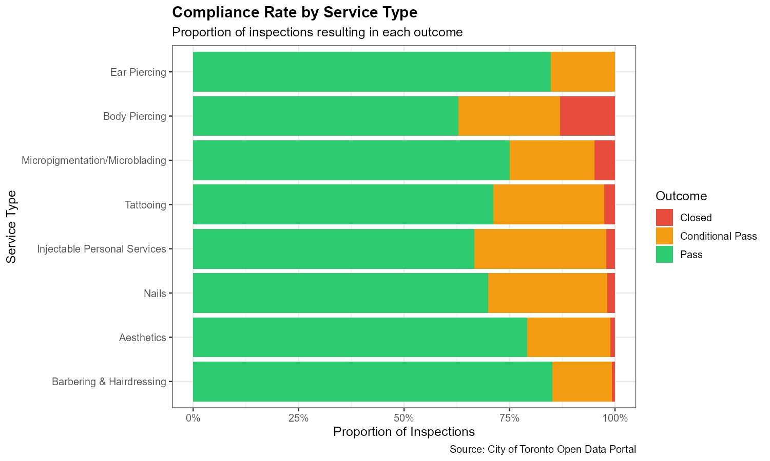
Figure 3: Compliance Rate by Service Type (Proportional)

Barbering & Hairdressing achieved the highest pass rate (85.2%), followed by Ear Piercing (84.8%) both well above the overall average of 77.78%. In contrast, Body Piercing had the lowest pass rate at 62.9%, with a notably high closure rate of 13.1%, the highest of any service type. This is a critical public health finding: body piercing involves skin penetration and carries a direct risk of bloodborne pathogen transmission when sterilization protocols are not followed.

Table 3: Inspection Outcomes Summary by Service Type
Service Type | Total | Pass | Cond. Pass | Closed | Pass Rate | Crucial Infractions
Aesthetics | 3,772 | 2,985 | 746 | 41 | 79.1% | 648
Barbering & Hairdressing | 3,651 | 3,109 | 516 | 26 | 85.2% | 412
Nails | 2,835 | 1,982 | 800 | 53 | 69.9% | 710
Tattooing | 693 | 493 | 182 | 18 | 71.1% | 173
Micropigmentation/Microblading | 393 | 295 | 79 | 19 | 75.1% | 85
Body Piercing | 291 | 183 | 70 | 38 | 62.9% | 103
Ear Piercing | 184 | 156 | 28 | 0 | 84.8% | 25
Injectable Personal Services | 96 | 64 | 30 | 2 | 66.7% | 26

The Nails category, despite its large volume, had a pass rate of only 69.9% , the third lowest. Nail technicians use tools such as files, clippers, and implements that contact skin and cuticles, and the high frequency of Crucial infractions (710) suggests that equipment reprocessing is a widespread issue in this sector.
2.4 Inspection Volume Over Time (Continuous/Date Data)
Figure 4 presents a histogram of inspection volume over time, with each bar representing approximately one month. The chart reveals a clear ramp-up pattern: 2022 had very low activity (only 83 records), as the program was in its early stages following pandemic-related disruptions. Activity grew substantially through 2023 and 2024, peaking in late 2025.

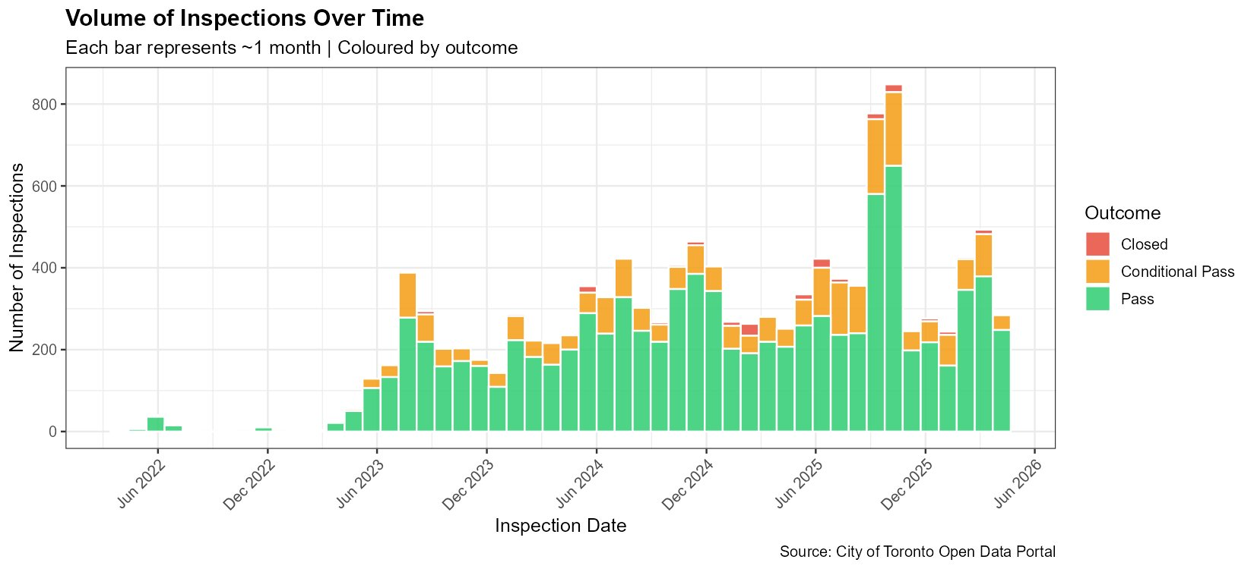
Figure 4: Monthly Inspection Volume Over Time (2022–2026)

A notable spike is visible in late 2025 (November–December), where monthly inspection volumes exceeded 800 records. This may reflect a year-end enforcement push by Toronto Public Health inspectors. The consistent presence of Conditional Pass outcomes (orange) throughout the timeline confirms that non-compliance is not a temporary phenomenon but a persistent structural issue within the sector.

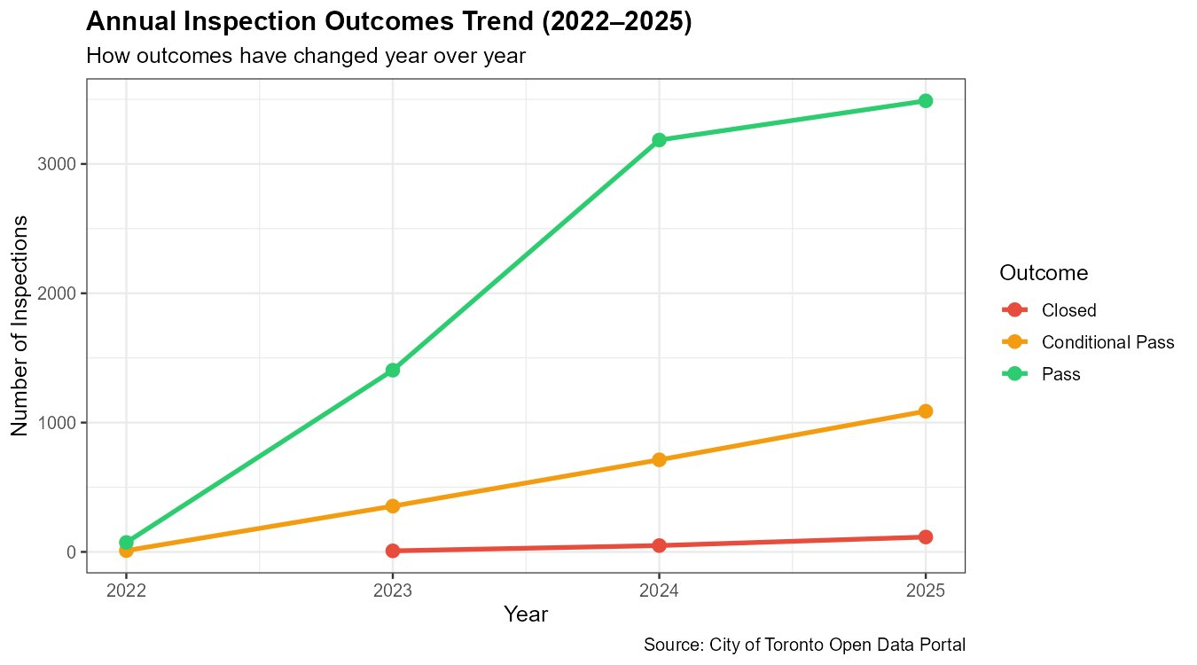
Figure 5: Annual Inspection Outcomes Trend (2022–2025)

Figure 5 shows the year-over-year trend by outcome. All three categories grew proportionally from 2022 to 2025, driven by the overall increase in inspection activity. Pass inspections grew from approximately 65 in 2022 to 3,524 in 2025. Importantly, Conditional Pass outcomes also increased year-over-year in absolute terms from roughly 15 in 2022 to 1,079 in 2025, suggesting that as the program expanded its reach, it uncovered proportionally more non-compliant establishments.

2.5 Infraction Analysis

2.5.1 Top Infraction Categories
Among the 2,616 inspections that identified violations, Table 4 and Figure 6 show the most frequently cited infraction categories.

Table 4: Top 10 Infraction Categories
Infraction Category | Count
04 - Reprocessing and Maintenance of Reusable Equipment/Instruments | 1,155
02 - General Setting Requirements | 336
05 - Single-Use Equipment & Instruments | 261
09 - Additional Record Requirements | 202
01 - Public Health Notification | 154
03 - Service Provider Hygiene & Handwashing | 140
08 - Product Dispensing and Storage | 132
06 - Sharps Handling & Disposal | 95
10 - Health Hazard and Sanitary Operation | 78
07 - Sterilization Requirements | 62

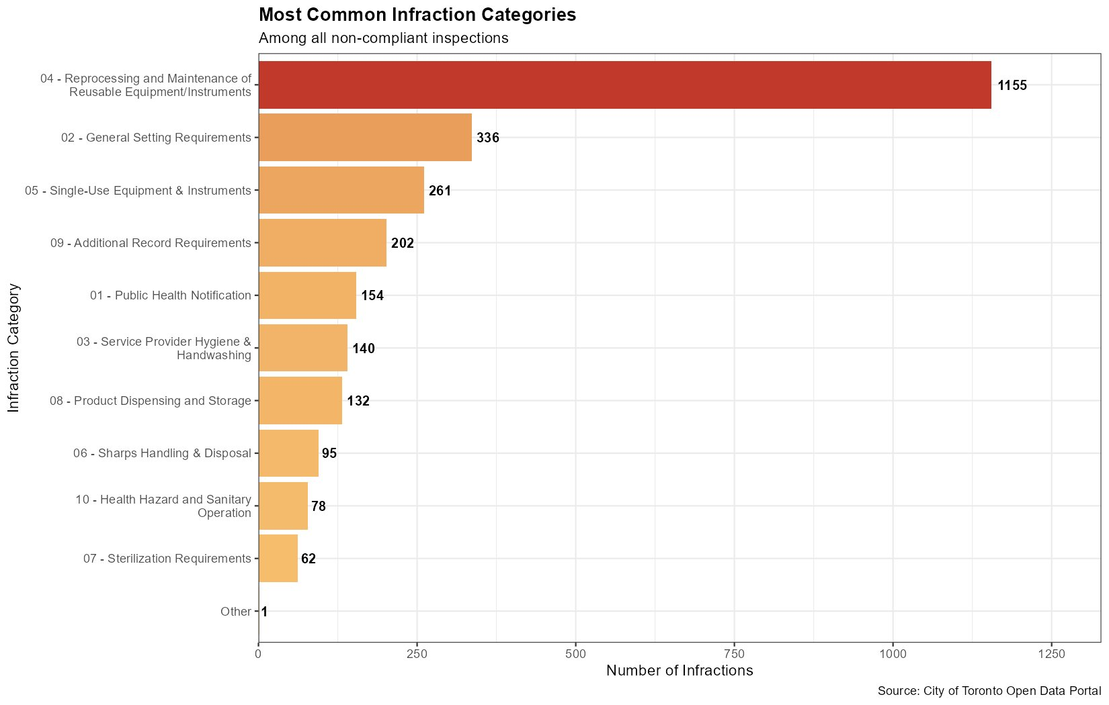
Figure 6: Most Common Infraction Categories

Category 04 (Reprocessing and Maintenance of Reusable Equipment/Instruments) is by far the most frequently cited infraction with 1,155 occurrences, nearly four times more than the second-ranked category. This infraction captures failures in the cleaning, disinfection, and sterilization of reusable tools such as nail clippers, tattoo machine parts, piercing equipment, and wax applicators. Improperly reprocessed equipment is the primary vehicle for transmitting hepatitis B, hepatitis C, MRSA, and fungal infections between clients.

The second and third most common categories are General Setting Requirements (336) and Single-Use Equipment & Instruments (261), related to the physical environment and misuse of disposable items. Together, the top three categories account for 1,752 of 2,616 total infractions (67%), indicating that many violations are concentrated in just a few critical practice areas.

2.5.2 Infraction Severity
Of the 2,616 infractions recorded, 2,182 (83.4%) were classified as Crucial, the most severe level under Ontario Regulation 136/18. Only 433 (16.6%) were classified as Significant. This distribution is striking it means that when inspectors find violations, they are overwhelmingly of the most dangerous type, not minor administrative oversights.

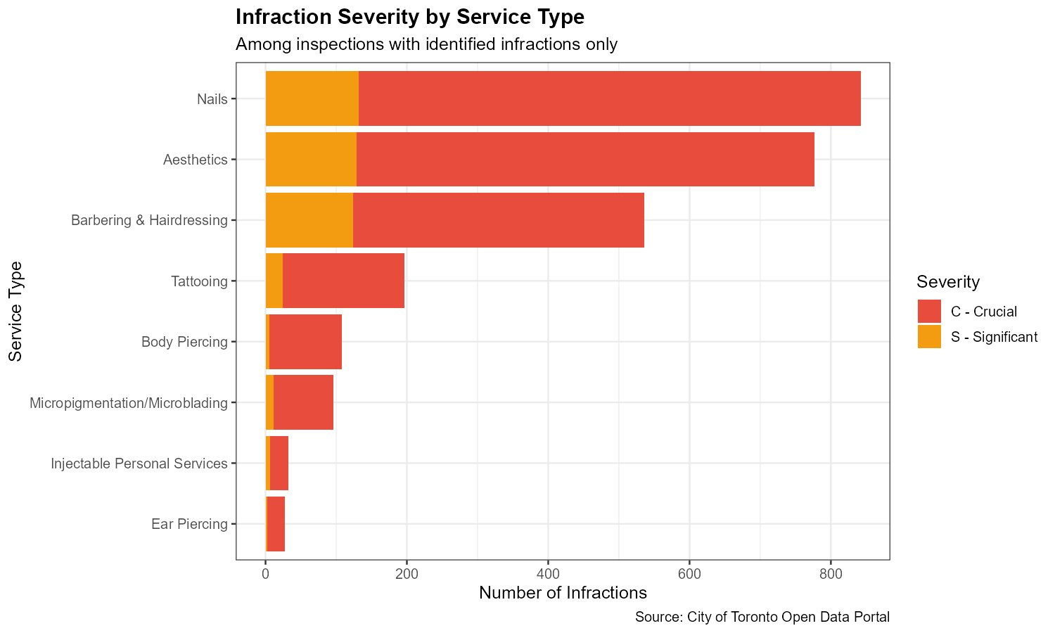
Figure 7: Infraction Severity by Service Type

Figure 7 shows infraction severity broken down by service type. Nails (710 Crucial infractions) and Aesthetics (648) have the highest absolute totals due to their larger volumes. However, Body Piercing stands out for having almost exclusively Crucial infractions with very few Significant ones, reinforcing the finding from the compliance rate analysis that this service category operates with the highest per-inspection risk profile.

2.6 Inspection Frequency per Establishment (Discrete Data)
Figure 8 presents a boxplot of how many times each establishment was inspected, grouped by service type. The central box spans the interquartile range (IQR), the line inside is the median, and red dots represent outlier’s establishments inspected far more frequently than typical.

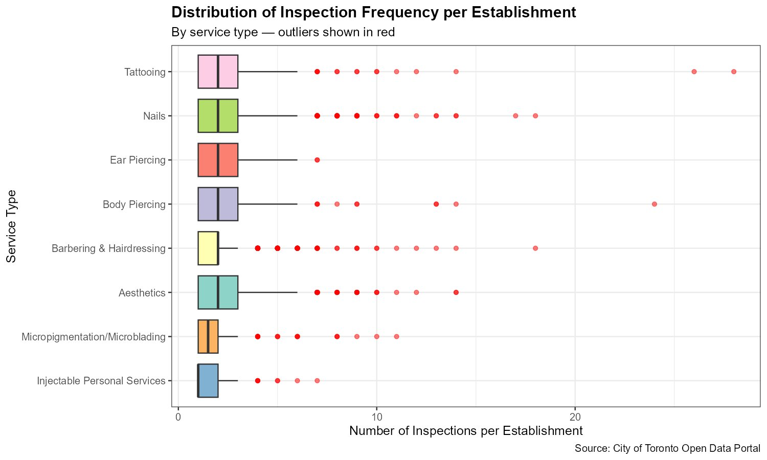
Figure 8: Distribution of Inspection Frequency per Establishment
Most establishments across all service types were inspected between 1 and 4 times over the study period. However, significant outliers exist certain Tattooing and Body Piercing establishments were inspected up to 30 and 25 times respectively, with Nails establishments reaching up to 18-19 inspections. This suggests repeated non-compliance and associated re-inspections at these locations. These outliers are not data errors they represent real patterns where the City has focused enforcement attention due to persistent violations.

2.7 Subset Analysis: High-Risk vs. Lower-Risk Services
A key analytical question is whether blood and skin-penetrating services like Tattooing, Body Piercing, Micropigmentation/Microblading, and Injectable Personal Services are demonstrating worse compliance than lower-risk services such as hair salons and nail studios.

Table 5: Compliance by Risk Group
Risk Group | Pass | Cond. Pass | Closed | Pass Rate
High Risk (Blood/Skin-Penetrating) | 1,035 | 361 | 77 | 70.3%
Lower Risk (Non-Penetrating) | 8,232 | 2,090 | 120 | 78.8%

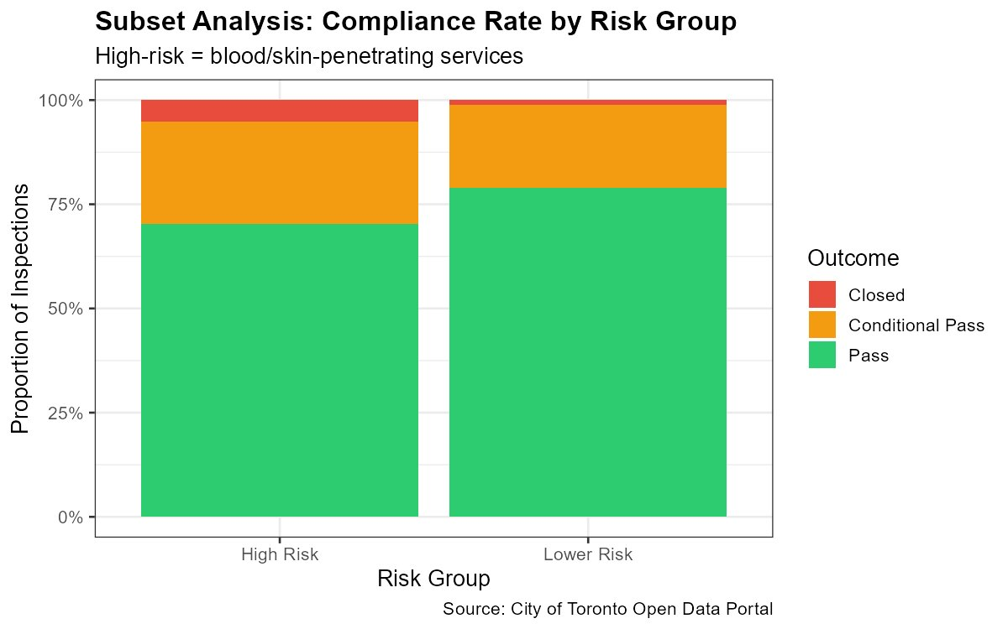
Figure 9: Subset Analysis — Compliance Rate by Risk Group

The data confirms the hypothesis: high-risk services had a pass rate of 70.3% compared to 78.8% for lower-risk services. More critically, the closure rate for high-risk services was 5.2%, nearly five times higher than the 1.1% closure rate for lower-risk services. Figure 9 makes this visually clear, the red (Closed) segment is substantially larger for the High-Risk group. This finding has direct implications for public health policy. Establishments performing skin-penetrating services should be subject to more frequent inspection cycles, and inspectors should prioritize sterilization protocol verification at these sites.

2.8 Subset Analysis: Repeat Non-Compliant Establishments
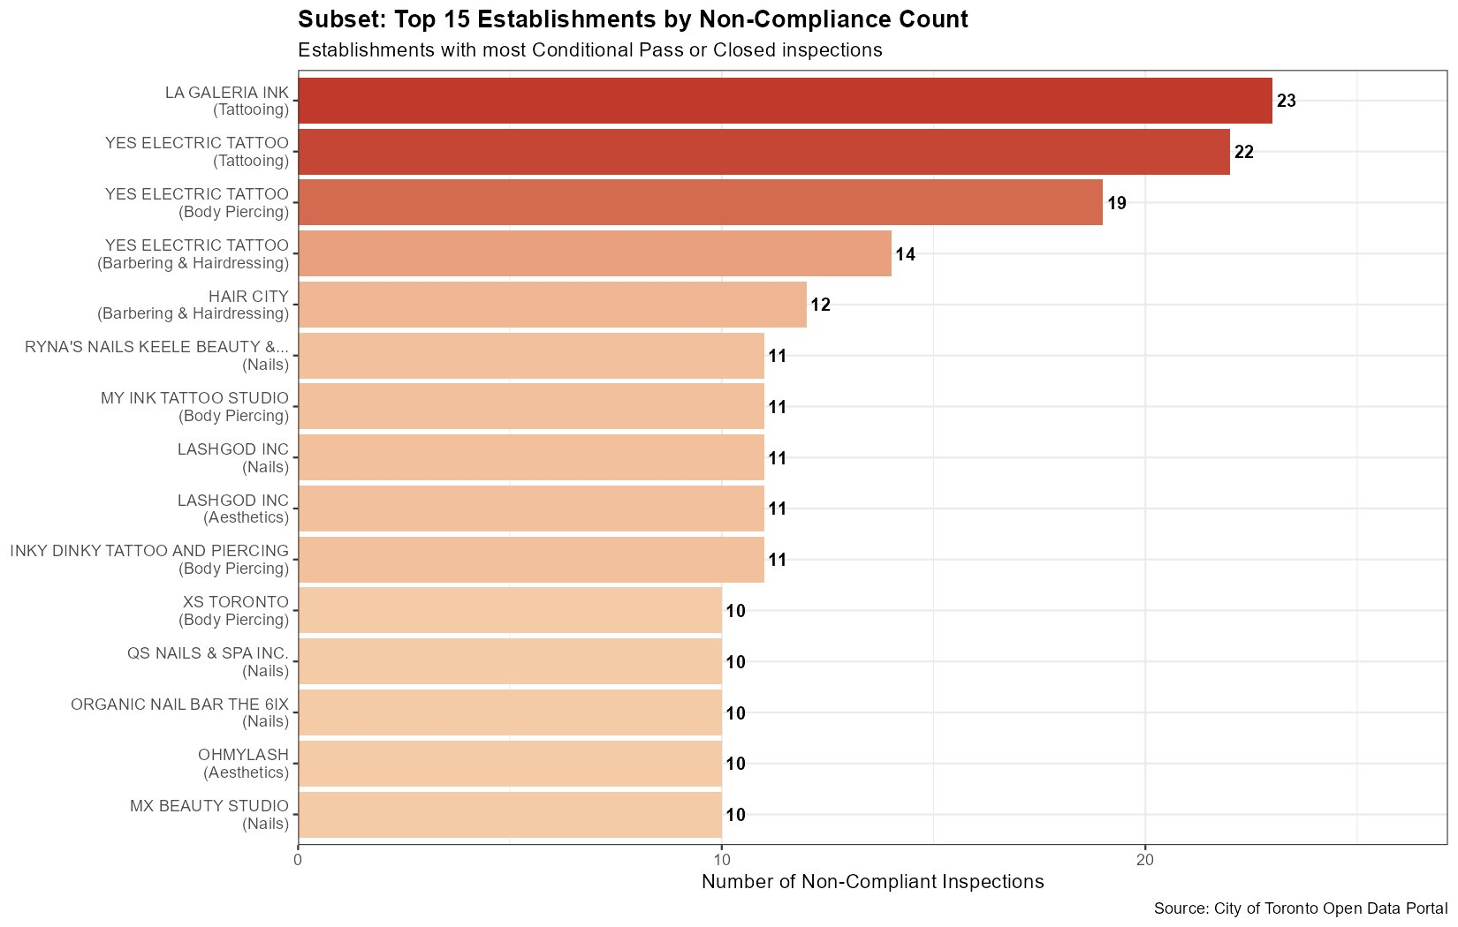
Figure 10: Top 15 Establishments by Non-Compliance Count

Figure 10 identifies the 15 establishments with the highest count of non-compliant inspections. LA Galeria Ink (Tattooing) leads with 23 non-compliant inspections, followed closely by Yes Electric Tattoo with 22 (Tattooing), 19 (Body Piercing), and 14 (Barbering & Hairdressing) appearing three times in the top 15 as a multi-service establishment with persistent compliance failures across all its service types.

The concentration of repeat offenders in Tattooing and Body Piercing categories reinforces the risk-group findings above. These establishments represent a small fraction of all businesses but a disproportionate share of enforcement resources. Continued regulatory attention to these locations is warranted.

3.Key Findings
This exploration data analysis of 11,915 Toronto BodySafe inspection records from April 2022 to April 2026 produced the following key takeaways:

- Overall compliance is moderate but not strong: 77.78% of inspections passed, while 22.22% resulted in Conditional Pass or Closure — meaning roughly 1 in 5 establishments inspected had identifiable public health violations.
- Equipment sterilization is the dominant failure point: Infraction Category 04 (Reprocessing and Maintenance of Reusable Equipment) accounted for 1,155 of 2,616 total infractions , 44.2% of all violations and represents the single greatest public health risk in the sector.
- 83% of infractions are Crucial level: When violations are found, they are overwhelmingly of the most severe type, not minor administrative issues. This underscores the seriousness of non-compliance in this regulated sector.
- Body Piercing is the highest-risk service type: With only a 62.9% pass rate and a 13.1% closure rate, body piercing establishments fail inspections far more often than any other category, posing the greatest risk of bloodborne pathogen transmission.
- Inspection activity grew substantially from 2022 to 2025: The program expanded from 83 records in 2022 to 4,691 in 2025, reflecting a major post-pandemic ramp-up in enforcement. A notable spike in late 2025 suggests targeted enforcement campaigns.
- High-risk services have nearly 5x the closure rate of lower-risk services: At 5.2% vs. 1.1%, skin-penetrating establishments are disproportionately represented in the most serious non-compliance outcomes.
- A small number of establishments account for a high share of violations: YES Electric Tattoo and LA Galeria Ink appeared repeatedly across the top 15 repeat-offender list, suggesting chronic systemic non-compliance at specific locations.

3.2 Questions for Further Exploration
This EDA opens several questions that warrant deeper investigation in future analyses:

- Do establishments that received a Conditional Pass subsequently achieve full compliance upon re-inspection, or do they continue to fail? This would require linking inspection records across time by establishment ID.
- Is there a geographic pattern to non-compliance? Mapping closure and Conditional Pass rates by Toronto ward or neighbourhood could reveal whether certain areas of the city have systematically lower compliance.
- Does the severity of the initial infraction predict future non-compliance? A regression or survival analysis approach could model the probability of repeat violations given prior inspection history.
- Are enforcement actions (Notices to Comply, Tickets, Written Orders) associated with improved subsequent compliance? The actionDesc field could be used to test whether stricter enforcement leads to better outcomes.
- Has the dramatic increase in inspection volume from 2022 to 2025 led to an improvement in overall compliance rates, or has the non-compliance rate remained stable?

3.3 Conclusion
The Toronto BodySafe dataset provides a rich, underexplored window into the public health compliance landscape of the city's personal service sector. The analysis reveals that while most establishments meet regulatory standards, equipment sterilization failures are alarmingly common and concentrated in the highest-risk service categories. The findings support a data-driven case for more frequent inspections of blood and skin-penetrating services, targeted enforcement at repeat offenders, and continued expansion of the inspection program to cover the full breadth of Toronto's personal service establishments.

References
Lehman, S. S., Graczyk, T. K., & Sheridan, J. F. (2010). Bloodborne pathogen risk reduction activities in the body piercing and tattooing industry. American Journal of Infection Control, 38(2), 130–138. https://doi.org/10.1016/j.ajic.2009.06.006
Ontario Ministry of Health. (2018). Personal service settings guideline 2018: Ontario Regulation 136/18 under the Health Protection and Promotion Act. Queen's Printer for Ontario. https://files.ontario.ca/moh-guidelines-personal-service-settings-guideline-en-2019.pdf
City of Toronto. (2024). BodySafe — Personal service settings inspection results [Data set]. Toronto Open Data Portal. https://open.toronto.ca/dataset/bodysafe/

