 

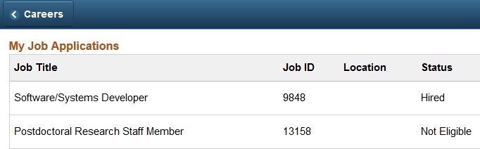 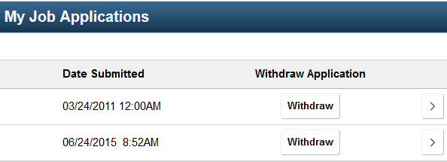

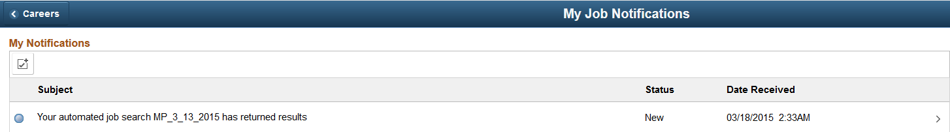

My total # of Applications My Calendar of events this month

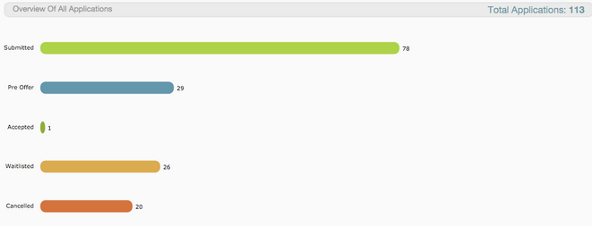

Career events happening close to my location My summary of skills

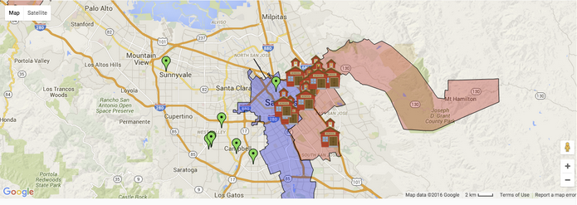

The 8 grading criteria related to the applicant dashboard (covering dashboard and data story)

**Who are its clients:** Applicants

**GUI design of the dashboard**: It has six pieces of information relevant to the applicant

1. My Active Job Applications (We all agreed this should be on the dashboard to attaching json file)
   * Displayed in a grid. Does not need to be a graph

Purpose: Can make decisions whether to withdraw, contact recruiter if taking too long, etc.

1. My Notifications
   * Display results from Notifications
     + Could be new jobs arrived (You signed up for job alerts when new jobs posted)
     + Could be email from recruiters regarding request for more information, etc.
     + Could be job offers
     + Could be invitations to an interview

Purpose: Quickly see new notifications and act on them accordingly

1. My total # of Applications
   * Display Applications by status since created the account
     + Statuses could be: Submitted, Rejected, Offer Received, Invited to Interview

Purpose: Applicant can get a feel for how well the application process is going and act accordingly, like for example, update resume, acquire more skills, focus on a different location, etc.

1. My calendar of Events this month
   * Display the calendar for the month with activities, job fair accepted, interview scheduled, etc.

Purpose: Stay organized and be reminded + motivation to increase effort if needed

1. Career events happening close to my location
   * Show a map of career fair events close to my location

Purpose: Be informed about the career fairs, increase exposure, increase motivation

1. My summary of skills
   * Show the summary of skills currently listed on my resume

Purpose: If response not good, I might want to increase my skill level, take more education, etc.

