Display first name and last name after converting the first letter of each name to upper case and  
the rest to lower case.

select UPPER(SUBSTRING(FIRST_NAME,1,1))+LOWER(SUBSTRING(FIRST_NAME,2,Len(FIRST_NAME)-1)) AS FNAME, UPPER(SUBSTRING(LAST_NAME,1,1))+LOWER(SUBSTRING(LAST_NAME,2,Len(LAST_NAME)-1)) AS LNAME FROM employees;

Display the first word in job title.

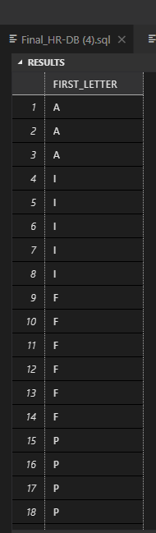

SELECT SUBSTRING(JOB_ID,1,1) AS FIRST_LETTER FROM employees;

Display the length of first name for employees where last name contain character ‘b’ after 3rd  
position.

SELECT LEN(FIRST_NAME) AS F1, LAST_NAME FROM employees WHERE charindex('B',LAST_NAME) = 3;

Display first name in upper case and email address in lower case for employees where the first  
name and email address are same irrespective of the case.

SELECT UPPER(FIRST_NAME) AS UC_FN, LOWER(EMAIL) AS LC_EM FROM employees where FIRST_NAME = EMAIL;

***#Display first name, salary, and round the salary to thousands.***

Display employee ID and the date on which he ended his previous job

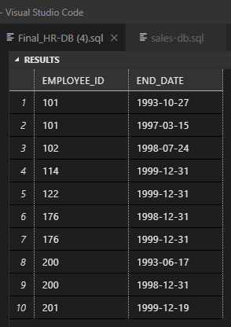

SELECT EMPLOYEE_ID, END_DATE FROM job_history;

***#Display first name and date of first salary of the employees***

Display first name and experience of the employees.

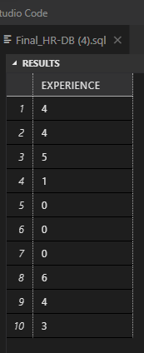

select DATEDIFF(YEAR,START_DATE,END_DATE) AS EXPERIENCE FROM job_history;

Display first name of employees who joined in 2001

Display employees who joined in the current year.

Display the number of days between system date and 1st January 2011.

Display number of employees joined after 15th of the month

Display third highest salary of employees.

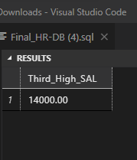

SELECT MAX(SALARY) as Third_High_SAL FROM employees where SALARY <(SELECT MAX(SALARY) FROM employees where SALARY < (SELECT MAX(SALARY) FROM employees));