Name: Avais Khan
College/University: Shri Ramswaroop Memorial University
Mail-ID: faizahmad756987@gmail.com

Titanic Survival Prediction Using Python

Objective
The objective of this project is to analyze the Titanic dataset and build a machine learning model to predict whether a passenger survived or not.

Tools and Technologies Used
Python, Pandas, Matplotlib, Seaborn, Scikit-learn

Dataset
The Titanic dataset contains information about passengers such as age, gender, ticket fare, class, and survival status.

Data Cleaning
Missing values in Age and Fare were filled using mean values. Unnecessary columns were removed.

Feature Engineering
A new feature called FamilySize was created using SibSp and Parch.

Model Used
Logistic Regression was used to predict survival.

Results
The model achieved an accuracy of approximately 80%.
The confusion matrix shows that most predictions were correct,
indicating that the model performs well on the dataset.

Output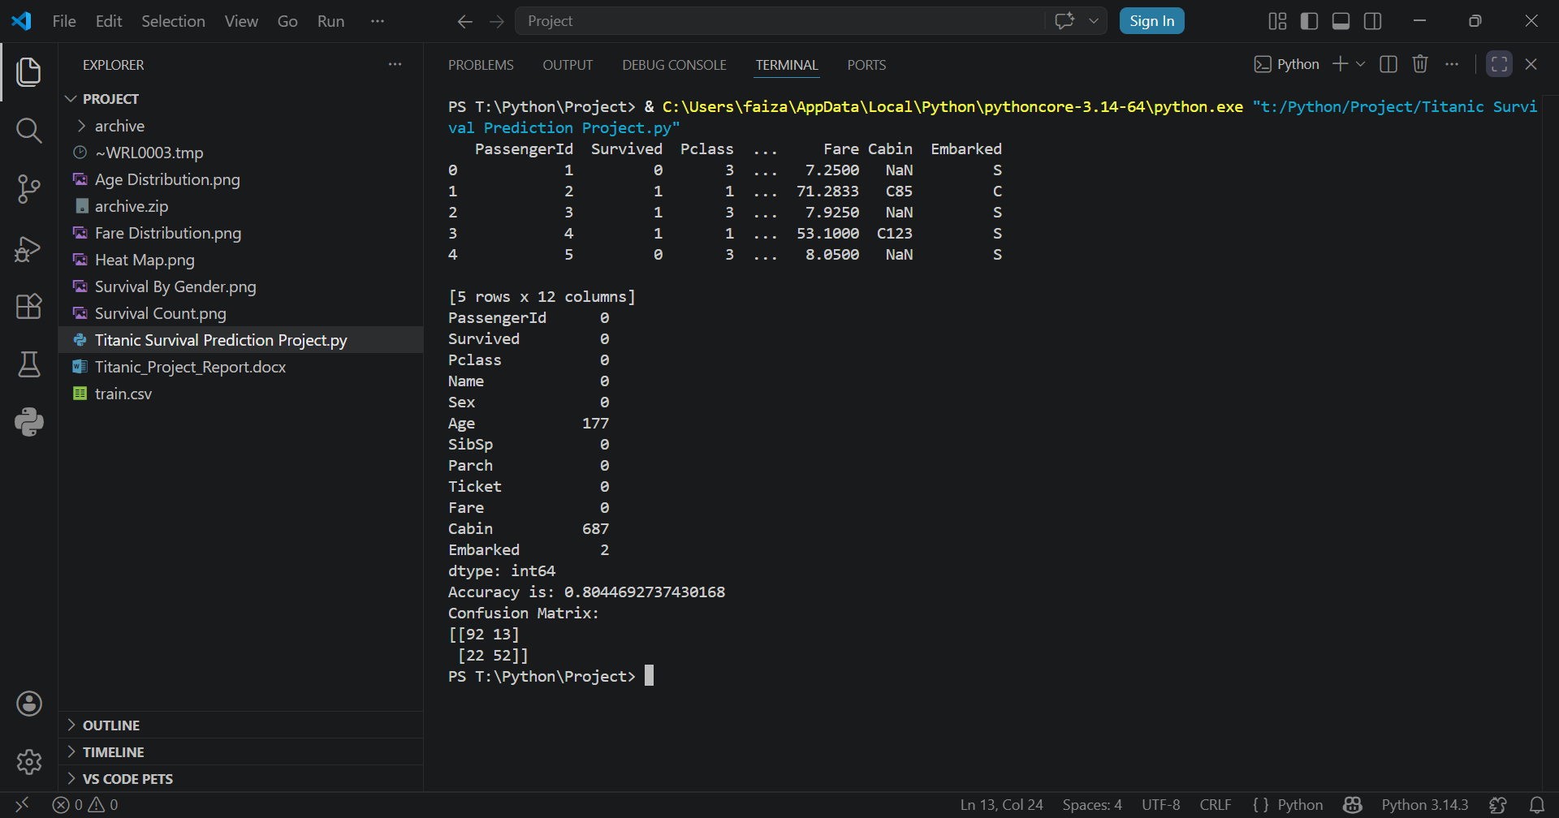

Confusion Matrix
This confusion matrix shows the number of correct and incorrect predictions made by the model. Most predictions are correct, which indicates good model performance.

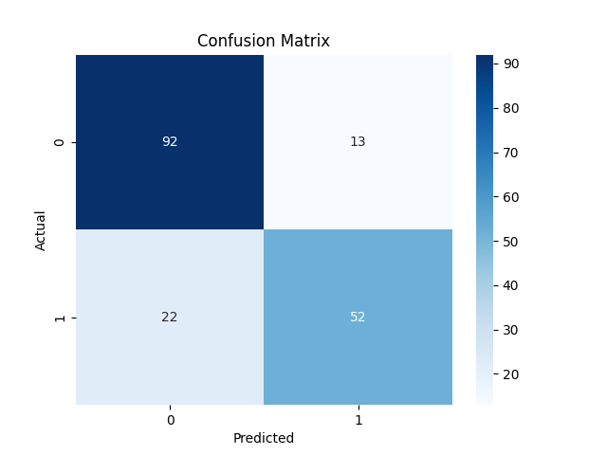

Survival Count Graph
This graph shows the number of passengers who survived and did not survive.
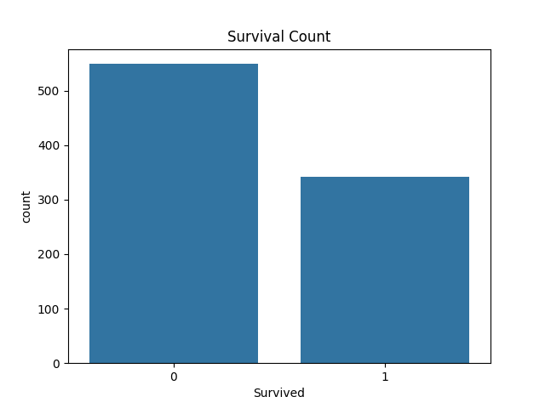

Survival By Gender Graph
This graph shows the survival count based on gender. It indicates that female passengers had a higher survival rate compared to male passengers.
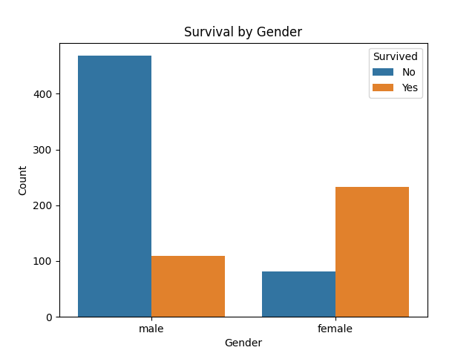

Age Distribution Graph
This graph shows the distribution of passengers based on age. It helps in understanding which age groups were more common on the Titanic.
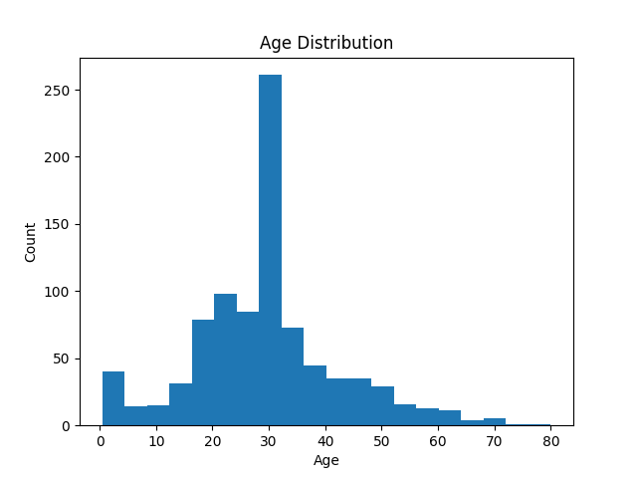

Fare Distribution Graph
This graph shows how ticket fares are distributed among passengers. Most passengers paid lower fares, while a few paid very high fares.
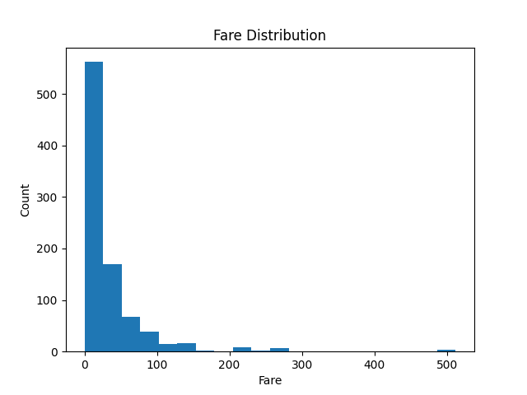

Heat Map Graph
This heatmap shows the correlation between different features like age, fare, class, and survival. It helps in identifying relationships between variables.
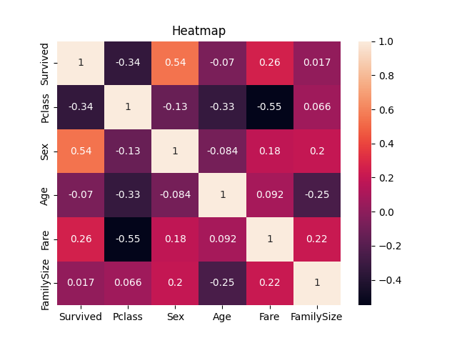

Conclusion
This project helped in understanding the complete data science workflow,
including data preprocessing, visualization, feature engineering,
model building, and evaluation. It shows how machine learning can
be used to make predictions from real-world data.

