Sanity Check Report

Test Details
Application: SauceDemo (https://www.saucedemo.com/)
Test Type: Login Sanity Check
Username: standard_user
Status: ✅ PASSED
Timestamp: 2026-04-01 00:07:34

Test Result
Login successful. Dashboard loaded correctly after authentication.

Screenshot
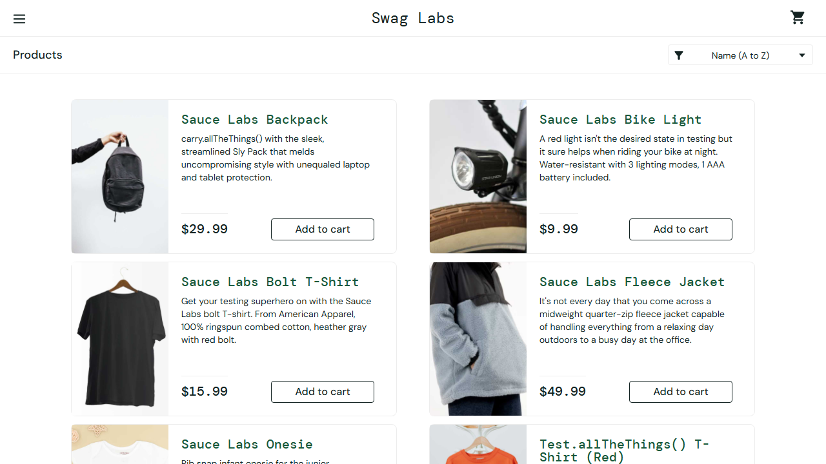

Report generated by automated sanity check script

