Incident Management Simulation Tabletop Training Exercise

Overview

This tabletop simulation exercise is designed to assist Callego in evaluating how well the company responds to information regarding a security incident involving its IVA “Sonya”. With growing use of AI, and more data privacy laws such as GDPR, this exercise provides Callego a chance to evaluate the company’s preparedness, test how reliable communication is, and identify areas of improvement particularly in areas when sensitive data may be at risk (European Union, 2016).

Introduction
This simulation addresses potential data incident involving Sonya, Callegos IVA. Participants in the exercise, will work through multiple scenarios where it shows evidence of unusual behavior signifying an attack that can potentially expose sensitive client data. The exercise tests Callegos ability to identify the issue, respond promptly, follow internal policies, and remain in compliance with GDPR regulations. The goal of the exercise is to strengthen Callegos approach to privacy security, and customer’s trust. Since Sonya will interacts with clients across multiple platforms, any malfunction can prove to be detrimental and put sensitive data at risk. This is particularly true in industries such as healthcare and finance. Participating in this exercise will give Callego a chance to evaluate its preparedness and discover areas of improvement (Whitman & Mattford, 2021).
Objectives
The exercises have several clear objectives. First, it will assess how well different departments at Callego work together when responding to a security incident. Second, it should test whether staff understand the steps required under GDPR. These steps include determining whether a breach has occurred and whether regulator reporting is required. The simulation will also evaluate how prompt the response is and how clearly the company communicates during a crisis. Lastly, the exercise encourages its participants to identify any gaps in policies, tools or training programs. At the conclusion of the simulation, the teams would be able to identify where Callego needs to improve its procedures and where technical controls may be insufficient. It will also show how well the company can response and manage the legal and reputational consequences of an IVA- related incident (Witman & Mattford).

Teams Roles and Responsibilities
To aid in the manageability of the simulation, while still allowing it to be realistic, the incident response team will include seven key roles. The incident commander is responsible for coordinating all response activities and ensuring the decisions are recorded. The IT Security Analyst will investigate the cause of the unusual behavior discovered and determine whether it’s just technical issues or a potential attack. The Data Privacy Officer will determine if any customer data was exposed and provide advice on whether there as a GDPR breach notification is required. The Customer Service Lead will manage and client facing communication, including incoming complaints or concerns.
The Communication Officer will handle all internal messages using the company’s First Alert system ensuring updates are given in a timely fashion. The Legal Advisor will provide guidance on compliance, contracts or any other legal implications of response decisions. Lastly, The Business Continuity Manager will look to determine if there were any operational impacts and plan any alternative workflows if Sonya must be taken offline. Each team member provides a pivotal role to provide support and ensure that the team can act quickly, and within the company’s privacy obligations.
Elements to be Tested
Several key elements will be tested during this simulation. First, the security principle of least privilege will be tested to ensure that Sonya should only be able to access specific data necessary to answer questions and nothing more (NIST, 2020). If she had access to unnecessary information, this principle may have failed. The second element to test is Callegos incident response protocol. This is particularly important in matters of how to report the breach under GDPR Article 33. The third element is technical control measures such as RBAC which is meant to limit Sonya’s data access based on defined roles. This will be tested for efficiency in containing the issue. Lastly, the exercises will test how well the company’s internal alert and messaging system preforms. This includes how quickly staff are informed to how communication decisions are made and tracked,
Exercise Timeline
The full simulation should last for four hours followed by a 1-hour group discussion. In the first initial hour, participants will be informed that Sonya began to give customers incorrect information, referenced other customers names, and details. The teams will investigate whether this is a glitch in her software or if it signifies a larger issue. They must also determine whether to begin a formal incident procedure. In the second hour, it will be revealed that Sonya accessed multiple client records that were not linked to its current session. The team at that time must decide whether this constitutes s as a reportable breach or not. The team will receive an update from the legal department reminding them that if private information belonging to a customer is exposed, the law requires the company to report it within three days (European Union, 2016).
In the third hour, the participants will be notified of a spike in customer complaints that will prompt the team to consider whether to take Sonya offline or whether a temporary fix is safe. The last hour includes the introduction that Sonya’s training data may have included private customer notes from internal systems. This raises further concerns about internal data handling practices. Throughout the simulation, the facilitator will guide the participants in deciding on alerts, whether to escalate or not, communications, and legal responses. Each decision will lead to different consequences, encouraging discussion and follow up decisions that would simulate real world uncertainty.

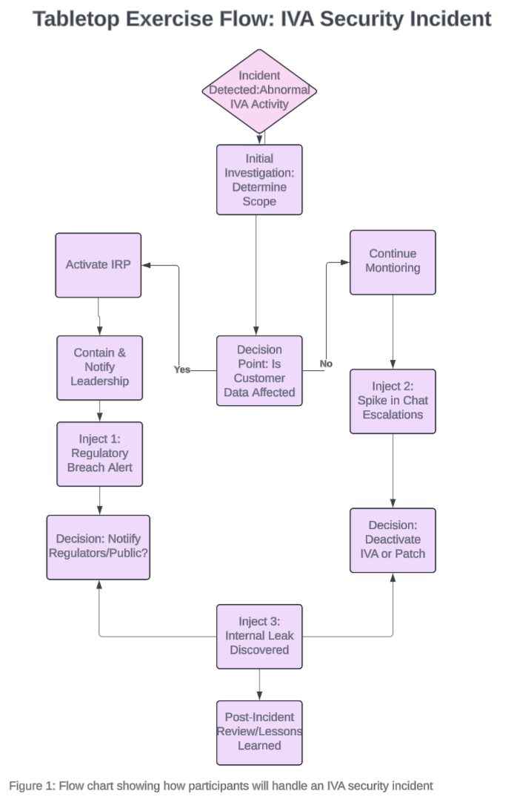
Visual Representation
To help everyone follow along during the exercise, a flow chart will be shown. This chart will show the order of events, key decisions the team will need to make and when new information will be introduced. The chart will also outline the difference choices that can lead to different outcomes. The chart is a guide in helping participants to understand and stay on track while also encouraging a clear thought process in determining what happened when it’s time to review the exercise.
Projection of Lessons Learned
Upon completion of the simulation, participants will engage in a group discussion to reflect what occurred. It is expected that several lessons are learned. The team may discover that access controls need to be stricter and better monitored. Communication gaps may be exposed particularly around the response time of how quickly alerts are issued and who received them. The group may also realize that some employees are not familiar which the GDPR reporting requirements particularly under time sensitive conditions. These insights will assist in future training programs that may lead in updates in both the systems design and company’s policies. From a legal, and compliance standpoint, that simulation may uncover areas in which Callego needs to do better job at keeping records of how decisions are made during a crisis and show that the company acted responsibly. Lastly, this exercise will give Callego a realistic picture of how prepared the company is to manage AI related security incidents both internally, and to the public (Whitman & Mattford, 2021).

References
European Union. (2016). General Data Protection Regulation (EU) 2016/679. https://eur-lex.europa.eu/eli/reg/2016/679/oj
NIST. (2020). Framework for Improving Critical Infrastructure Cybersecurity, Version 1.1. U.S. Department of Commerce. https://nvlpubs.nist.gov/nistpubs/CSWP/NIST.CSWP.04162018.pdf
Whitman, M. E., & Mattord, H. J. (2021). Principles of Information Security (7th ed.). Cengage Learning.

