Executive Summary and Plan

Executive Summary
Early 2025, Finger Lakes Community Bank was targeted by a politically motivated hacktivist group known as the Peoples Brigade for Web Justice. The attackers executed a multi-phase attack that involved website defacement, DDoS attempt and a phishing attack that deployed a RAT via email that was opened by internal staff. The breach led to an attempted unauthorized funds transfer by using a spoofed executive email. This executive summary outlines a comprehensive incident response and mitigation strategy for the company to address what happened and how to mitigate future attacks. This plan also includes specific counter measure such as role-based responsibilities’, legal, and regulatory considerations as well as operational practices that align with industry best practices and the NIST Incident Response Framework ( Valdez, 2025).
To further reduce operational risks, the banks should ensure that all incident response steps are documented in accordance with audit and regulatory requirements. The CFO and legal team will play key roles in verifying transfer polices and communication protocols. The IT security team will ensure that system modifications during incident containment are subject to change management oversight. These steps provide both accountability and defensibility using post incident reviews. To ensure coordination, and effective responses in the future, the bank adopted a structure Incident Response Process aligned with NIST guidelines. This process outlines key stages, including detection, containment, eradication, recovery and post incident review. The visual incident response diagram included below offers a clear breakdown of how incidents will be handled from initial identification through recovery and organization learning. It serves as a roadmap for staff across departments to understand their responsibilities in the event of an attack ensuring that the response efforts are compliant with regulatory standards (Brook, 2024).
Table 1

Detection
Step | Role and Responsibility | Rationale Behind Assignment:
Continuous Monitoring | SOC Team/ Security Analyst | The security analyst or SOC team will use tools to monitor the system for anomalies
Incident logging | Security Analyst | The analyst will log the incident in the system after detection and begins documentation
Categorizing/Classification | Incident Response Team | The team will determine the severity of the incident, the type of the incident, and the impact it has on the system
Notification of Initial Findings | CISO or Security Manager | Ensures that all stakeholders are in communication with each other regarding the incident
Notes: The detection step in an IR determines if an incident occurred, its severity, and what type of incident (Cranford, 2023). Table 1 lists the steps of the detection of an incident, who is responsible for the detection and the rationale behind assigning those roles.

Table 2

Response
Step | Role and Responsibility | Rationale Behind Assignment
Containment | Network Engineer/ Incident Response Team | The team will isolate the affected area to avoid the spread of contamination to other systems.
Evidence Collection | Digital Forensics Analyst | Ensures that the evidence that is collected maintains proper chain of custody to ensure legal admissibility
Threat Analysis | Threat Intelligence Analyst | Determines how the attacked occurred and what vulnerabilities were discovered
Eradication | System Admin/IR Team | Removes threat in its entirety and ensures that all patches and systems are updated
Recovery | IT | Restores business back to normal
Post Incident Review | Compliance Officer, IT security | Prevents reoccurrence of incident by gathering the information that was collected

Notes: The response step in IR involves the action after the incident is detected (Brook, 2024). The response step includes the containment, eradication and recovery in the aftermath (Brook, 2024). Table 2 lists the steps of the response of an incident, who is responsible for the response and the rationale behind assigning those roles.
Table 3

Communication and Reporting
Step | Role and Responsibility | Rationale Behind Assignment
Internal Alert | Security Analyst | Detects the incident when it first occurs and informs the appropriate party
Communication to affected parties | Public Relations | Notifies customers, media etc. of breach to protect reputation and provide transparency
Documentation of incident | IR Team | Maintains a auditable trail of the events that occurs for learning and external review
Post Incident | CISO | Identifies lessons learned and how to improve the system to prevent future breaches and communicates this with leadership

Notes: In communication and reporting, it is essential that all parties that are affected by the incident are aware to ensure that the organization is compliant with regulatory standards and prevent legal and reputational damage (Cranford, 2023). Table 3 lists the steps of communicating and reporting an incident, who is responsible for the response and the rationale behind assigning those roles.

Table 4

Prevention
Step | Role and Responsibility | Rationale Behind Assignment
Security Awareness Training | HR | Ensures staff are knowledgeable on social engineering tactics and best practices to prevent them as well as reducing human errors.
Vulnerability Scanning and Patching | IT Security Team | Ensures the regularly scanning of systems and preventing security gaps
Network Segmentation and Access Control | Network Engineer | Reduces attack surface
Endpoint protection & Monitoring | IT Security Team | Monitors all endpoints, adding additional layer of defense such as MFA
Data Encryption & Backup | IT infrastructure Team | Ensures the protection of sensitive data and ensures that it is retrievable in the event of an incident.

Notes: The prevention phase focuses on mitigating the risks and preventing the incident from reoccurring (Cranford, 2023). This step includes actions such implementing security controls, monitoring for suspicious activity and preventing future steps. Table 4 lists the steps of the prevention phase, who is responsible for the response and the rationale behind assigning those roles.

Detection Approach

The attack on the bank was identified through a combination of user reporting and system-based anomalies. This showed indicators of compromise or IoCs that included CPU spiked, suspicious outbound connects and logged anomalies across email servers and firewall logs. Following the incident, the bank implemented a detection framework using SIEM tools, IDS, and endpoint monitoring (Valdez, 2025). These tools will allow the bank to continuously track and correlate system behavior, isolate threats and ensure rapid response (Goss, 2025).
Objective
Finger Lakes Community Bank suffered a cyber-attack by an activist group known as the “People’s Brigade for Web Justice. The attack included website defacement and performed a DDoS attack attempt, and a deployment of a RAT attack via a phishing email. This led to an unauthorized funds transfer attempt. The table listed below outlines the full attack flow and the countermeasures that are necessary to detect, contain, and mitigate future incidents ( Valdez, 2025).
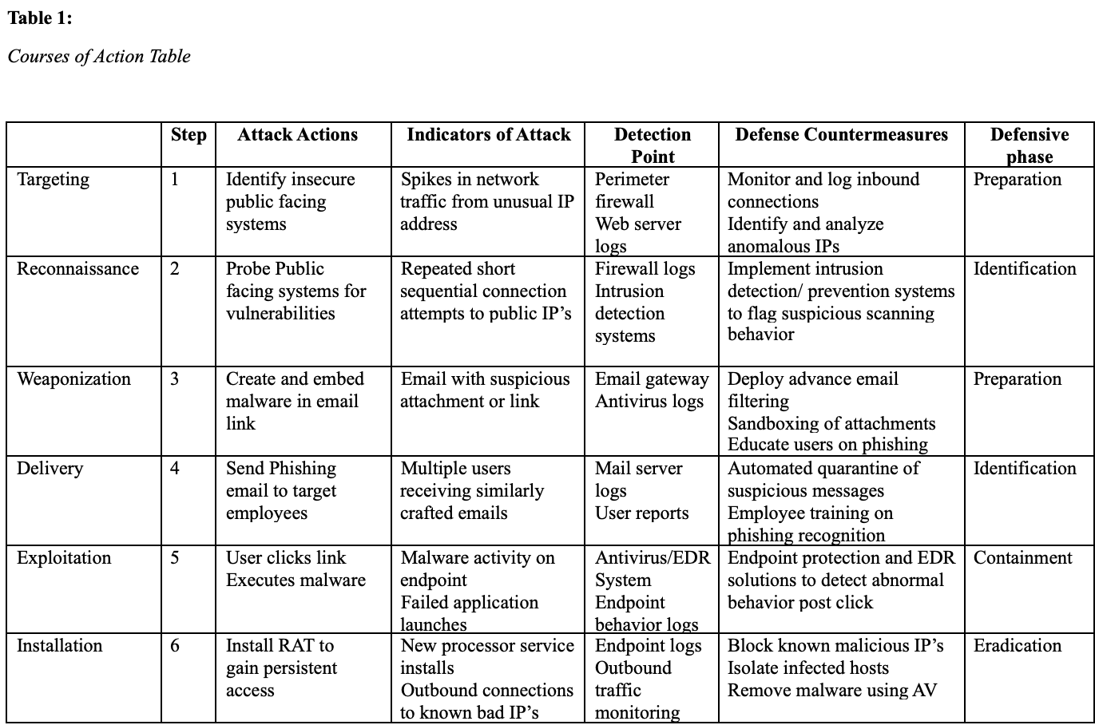
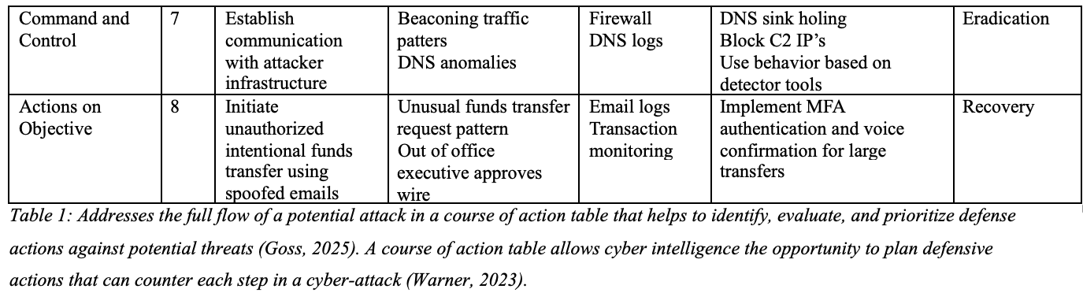
Lesson Learned
The attack revealed several critical vulnerabilities in the Finger Lake Community Bank’s cybersecurity infrastructure. The lack of a continuous monitoring allowed the attacker to probe and exploit weaknesses therefore being able to go undetected over multiple days (Goss, 2025). Proactive vulnerability assessments are an essential step in providing real time anomaly detection to reduce attack surface exposure. Next a phishing email exposed a human error due to limited awareness training and employee email filters. Employee training and education along with phishing simulation tests is essential in mitigating threats in the future (Warner, 2023). The unauthorized internal funds transferred exploited a lack in financial, and escalation controls( Valdez, 2025). To mitigate future incidents, executives should require MFA before approving high risk transactions (Goss, 2025). The attack also emphasized the need for log correlation and automated response tools such as SIEM systems. This will allow for faster identification and containment of intrusions (Warner, 2023). Lastly, due to the banks absence of external audits and cyber policies, it allowed the bank to be exposed. Annual policy awareness and compliance improvement will mitigate any further vulnerabilities in the future (Goss, 2025).
Countermeasures Analysis
The course of action table was developed by analyzing the attack that impacted Finger Lakes Community Banks. The attackers used multiple methods including DDoS attempts, phishing and remote access trojan development to gain access to the system to perform an authorized funds transfer attempt (Valdez, 2025). To interrupt the attackers progress, there were specific countermeasures that were selected that emphasized on proactive detection, containment, and mitigation strategies (Goss,2025).
Impact on systems
Security measures such as firewalls, IDS/IPS and EDR solutions were used to strength the banks technology systems. These systems watch for anomalies and unusual traffic patterns that would indicate an attack for containment. The systems also look for vulnerabilities such as open ports or other ways an attacker can sneak into the network. If there is a spike in unusual activity or anomalies, the firewall can block the connection and alert security personnel for rapid response (Warner, 2023). Endpoint detection and response tools are critical as they monitor employee’s computer for unusual behavior. Additionally, tools like SIEM platforms can help retrieve data from different sources like firewall logs, and antivirus alerts to detect patterns that would suggest the network is under attack. All levels of protection would work in connection with each other to ensure the safety and protection of the banks network and its data from being compromised (Goss, 2025).
Impact of Operations
Cyber-attacks not only have an impact on the network systems, but they also have an impact on the businesses operations. For Finger Lakes Community Bank, phishing emails and unauthorized wire transfers are huge risks to the organization’s operations. To mitigate risks, it is critical that email security tools are implemented and up to date. The emails should contain filters that would help block suspicious emails before they reach inboxes filtering them to the trash or areas that they would not pose risks to the network’s security. The email should also contain sandboxes that will test links and attachments to ensure their safety. In addition to better technology, the bank should also implement additional layers such as MFA tools for approval for high-risk transactions like transferring money.
Specific examples would include if a request for the transfer of funds, instead of just clicking approve, the executive would have to verify their identity using MFA. These steps can ensure that any unauthorized attempts would be blocked such as a cybercriminal pretending to be someone they’re not. It would also be useful to use automated tools to flag abnormal transactions such as money being sent outside normal business hours or to unusual accounts. These countermeasures will ensure that the bank is running efficiently even when facing a current threat. (Goss, 2025).
Impact on Personnel
In cyber-attacks systems, and operations are not the only risks. User error can cause vulnerabilities to an organizations network as well. This can be due to a lack of employee awareness and training. In this specific case, a phishing email led to the attack of the organizations system and allowed malware to be installed on a computer. These acts exposed the network for further and deeper attacks. To prevent this from happening in the future, the organization should implement quarterly training to employees and send out phishing simulation tests that will teach employees how to recognize and report suspicious emails or links. Simulated phishing tests are emails where fake phishing emails are sent to see how employees respond. Lastly, having an incident response plan will help ensure that if a cyber incident were to occur, employees are aware of who to contact, what steps to take, and how to report the incident (Valdez, 2025). These steps will mitigate security risks to the organization and help build a confident security team.

References
Brook, C. (2024, December 19). What is an incident response plan (IRP)?. Fortra’s Digital Guardian. https://www.digitalguardian.com/blog/what-incident-response-plan-irp
Cranford, J. (2023, July 6). Incident response plan: Frameworks and steps. CrowdStrike. https://www.crowdstrike.com/en-us/cybersecurity-101/incident-response/incident-response-steps/
Goss, A. (2025, January 10). Unraveling the courses of action matrix: Full guide to COA. Kraven Security. https://kravensecurity.com/the-courses-of-action-matrix/
Warner, C. (2023, December 11). Courses of action matrix in cyber threat intelligence. Medium. https://warnerchad.medium.com/courses-of-action-matrix-in-cyber-threat-intelligence-82bf49243e46
Valdez, A. (2025, April 12). Milestone One: Incident Response Process Diagram [Unpublished manuscript]. Southern New Hampshire University.

Valdez, A. (2025, May 4). Milestone Two: Course of Action Table [Unpublished manuscript]. Southern New Hampshire University.

Valdez, A. (2025, May 10). Milestone Three: Countermeasure Analysis [Unpublished manuscript]. Southern New Hampshire University.

