Module 8: Portfolio Project Part II

David Gray
Colorado State University Global
CSC450: Programming III
Dr. Bindu George
July 2, 2026

Source Code for Concurrency Program in Java:
/*==============================================================================================
== Name : main.java
== Author : Dave Gray
== Version : v1
== Description : Simple Java Program that creates a method for counting Up 0-20 and another
method to count down 20 - 0. Each method is run in a separate thread. The 2nd
thread does not start until the 1st has completed its task.
================================================================================================
*/
class Main {

// Create Count Up Method //
public static void countUp() {
System.out.println("Counting Up: ");
for (int i = 0; i <= 20; i++) {
System.out.print(i + " ");
}
System.out.println();
}

// Create Count Down Method //
public static void countDown() {
System.out.println("Counting Down: ");
for (int i = 20; i >= 0; i--) {
System.out.print(i + " ");
}
System.out.println();
}
/* Create Main for calling methods in 2 different threads. Thread2 runs After Thread1
completes. */
public static void main(String[] args) throws InterruptedException {
Thread thread1 = new Thread(() -> countUp());
thread1.start();
thread1.join();

System.out.println();

Thread thread2 = new Thread(() -> countDown());
thread2.start();
thread2.join();

}
}

Screenshot Of Execution:

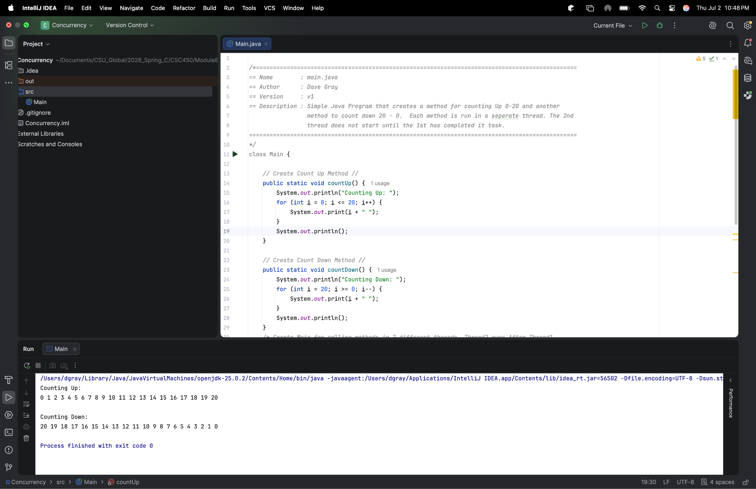

Analysis:

The Java application demonstrates basic concurrency by creating two separate threads that act as counters. The first thread counts upward from 0 to 20. After the first thread completes, the second thread counts downward from 20 to 0. The program uses the start() method to begin each thread and the join() method to ensure that the first thread finishes before the second thread begins. This demonstrates thread creation and thread synchronization.
One performance issue with concurrency is that creating and managing threads adds overhead. In this program, the counting task is very small, so using threads does not improve performance compared to a regular loop. In fact, the program may be slightly less efficient because the JVM must create, schedule, and manage each thread. However, in larger applications, concurrency can improve performance and responsiveness when tasks can run independently, such as handling multiple users, processing background jobs, or performing file and network operations.
String vulnerabilities are minimal in this program because it does not accept or manipulate user-provided strings. The strings used, such as output labels, are hard-coded and do not create much security risk. However, in larger Java applications, strings can still present vulnerabilities if user input is not validated. For example, unsafe string handling can contribute to injection attacks, improper logging of sensitive data, or excessive memory use if very large input is accepted. Using immutable Java String objects reduces some risks compared to lower-level languages, but developers still need to validate input and avoid storing sensitive data in plain text strings.
The data types used in this program are also low risk because the counters use small integer values from 0 to 20. The int data type is appropriate because the range is far below its maximum value. However, data type security becomes more important in larger applications. Choosing a type that is too small could cause overflow, while using signed and unsigned values incorrectly in other languages could create logic errors. For this program, the integer counters are safe, predictable, and appropriate for the required range.
Overall, this application shows a basic but important concurrency concept: one thread can be started, completed, and joined before another thread begins. While the program itself is simple, it introduces important ideas about thread management, synchronization, performance overhead, input safety, and choosing appropriate data types.

Comparison: Java and C++ Concurrency Applications

The C++ and Java concurrency programs were designed to demonstrate the use of multithreading by creating two separate threads that execute sequentially. The first thread counts upward from 0 to 20, and after it completes, the second thread counts downward from 20 to 0. This behavior is achieved by calling join() after the first thread is started, ensuring that the program waits for the first thread to finish before allowing the second thread to begin execution. This synchronization guarantees that the counters execute in the correct order and demonstrates one of the fundamental concepts of concurrent programming. Because both programs perform the same task using nearly identical logic, the primary differences are not found in the algorithm itself but rather in how each language implements concurrency. This paper compares the C++ and Java implementations by examining their performance characteristics, security considerations, and the advantages and disadvantages of each language's approach to multithreaded programming.
Although both the C++ and Java implementations perform the same task and produce identical output, the way each language manages concurrency differs. For a simple program such as this one, there is virtually no noticeable difference in execution time because each thread only counts between 0 and 20. However, the underlying implementations of concurrency become much more important as applications increase in size and complexity.
One of the primary differences between the two languages is how threads are managed. In C++, threads are created using the Standard Library's std::thread class, which provides direct access to operating system threads. Because C++ compiles directly to native machine code, it generally has less runtime overhead and can provide better performance than Java. This gives developers more control over system resources and allows highly optimized multithreaded applications to be developed. The tradeoff, however, is that developers are also responsible for properly managing resources and synchronization, making it easier to introduce programming errors.
Java approaches concurrency differently by creating threads that are managed through the Java Virtual Machine (JVM). Although Java threads ultimately execute as operating system threads, the JVM provides an additional layer of management that simplifies many aspects of concurrent programming(Oracle, n.d.). This additional abstraction introduces a small amount of runtime overhead compared to C++, but it also improves portability because the same Java program can execute on multiple operating systems without modification. Modern Just-In-Time (JIT) compilation has also significantly improved Java's performance, reducing much of the performance gap that once existed between Java and C++.
Memory management also contributes to the performance differences between the two languages. C++ relies on manual memory management, giving developers complete control over memory allocation and deallocation. While this approach can improve efficiency, it also increases the risk of memory leaks and other programming errors if resources are not managed correctly. Java automatically manages memory through garbage collection, reducing the likelihood of these errors while simplifying application development(Deitel & Deitel, 2022). Although garbage collection can occasionally pause program execution, the impact is generally minimal for most business applications.
For this particular concurrency application, the performance differences between C++ and Java are negligible because the workload is extremely small. The program simply creates two threads that execute sequentially rather than simultaneously, with the join() operation ensuring that one thread completes before the next begins. As a result, the execution time is dominated more by console output than by thread management. In larger, more computationally intensive applications, however, the differences in runtime performance, memory management, and resource control between C++ and Java become much more significant.
Although both the C++ and Java implementations perform the same concurrency task, Java is generally considered less vulnerable to common security threats because of the safeguards built into the language and the Java Virtual Machine (JVM). While both programs execute the same logic and do not process user input, the underlying language features have a significant impact on the security of larger applications.
One of the primary security advantages of Java is its automatic memory management. Java uses garbage collection to automatically allocate and reclaim memory, eliminating many of the memory management errors that developers must handle manually in C++. This reduces the likelihood of vulnerabilities such as memory leaks, dangling pointers, and use-after-free errors that can lead to application crashes or security exploits. In contrast, C++ gives developers direct control over memory allocation and deallocation, providing greater flexibility and performance but also increasing the responsibility to manage memory correctly (Deitel & Deitel, 2022).
Another important difference involves string handling. Although neither version of this assignment processes user-provided strings, Java's String class is immutable, meaning that once a string has been created, its contents cannot be modified. This characteristic helps reduce accidental data modification and can improve application security by making strings more predictable. In C++, the std::string class provides many built-in safety features compared to traditional character arrays, but the language still allows lower-level memory manipulation through pointers and C-style strings. If developers choose to use these lower-level features improperly, vulnerabilities such as buffer overflows and memory corruption can occur (Oracle, n.d.).
The data types used within both applications are also secure because the counters use the int data type to store values between 0 and 20. This range is well within the limits of a standard integer in both languages, making integer overflow impossible within this application. However, selecting appropriate data types remains an important security consideration in larger software projects. Choosing data types that are too small can lead to overflow conditions, while using inappropriate types for sensitive information may result in unexpected behavior or data corruption. Strong type checking in both C++ and Java helps reduce these risks, although Java provides additional runtime checks that can prevent certain programming errors before they become security vulnerabilities (Oracle, n.d.).
The Java implementation can be considered the less vulnerable of the two because the language provides automatic memory management, runtime safety checks, immutable strings, and stronger protections against many common programming errors. While C++ offers greater performance and direct access to system resources, these advantages come with increased responsibility for the programmer to prevent memory-related vulnerabilities and ensure safe resource management. For simple applications such as this concurrency program, both implementations are secure; however, in larger and more complex software systems, Java's built-in safety features generally make it less susceptible to common security threats.
This project demonstrated that although the C++ and Java applications used the same algorithm to implement concurrency, each language approaches multithreaded programming differently. Both implementations successfully created two threads that executed sequentially by using the join() operation to synchronize execution. While the functionality of the two programs was identical, the underlying implementations highlighted important differences in performance, memory management, and security.
From a performance standpoint, C++ generally offers greater efficiency because it compiles directly to native machine code and provides developers with greater control over system resources. Java, while introducing some additional overhead through the Java Virtual Machine (JVM) and garbage collection, offers excellent portability and has significantly improved performance through modern Just-In-Time (JIT) compilation. For a small application such as this one, the performance differences are negligible, but they become more noticeable as applications grow in complexity.
From a security perspective, Java provides several built-in safeguards that reduce the likelihood of common programming errors and security vulnerabilities. Features such as automatic memory management, immutable strings, and runtime safety checks help developers create more secure applications with less risk of memory-related issues. Although C++ provides greater flexibility and performance, it also places more responsibility on the programmer to manage memory and system resources correctly.
This project reinforced my understanding of concurrent programming while demonstrating that selecting a programming language involves balancing performance, security, and ease of development. It also strengthened my appreciation for how different programming languages solve the same problem using different implementation approaches. As I continue my studies and pursue a career in IT, understanding the strengths and tradeoffs of both C++ and Java will help me choose the most appropriate language for future software development project.

References
Deitel, P., & Deitel, H. (2022). Java: How to program (12th ed.). Pearson.
Oracle. (n.d.). Concurrency. The Java Tutorials.
https://docs.oracle.com/javase/tutorial/essential/concurrency/

