Module 1: Critical Thinking
Java Bag Data Structure

David Gray
Colorado State University Global
CSC400: Data Structures and Algorithms
Dr Dajani
September 20, 2026

Java Code -
Bag.java
public class Bag<T> {
private T[] items;
private int numberOfEntries;

// Bag Constructor //
public Bag() {
numberOfEntries = 0;
items = (T[]) new Object[100];
}

// Add Method Adds item to the Bag //
public void add(T item) {
if (numberOfEntries == items.length) {
System.out.print("Your bag is full");
}
else{
items[numberOfEntries] = item;
numberOfEntries++;
}

}

// Removes one occurrence of the specified item from the Bag //
public void remove(T item) {

for (int i = 0; i < numberOfEntries; i++) {
if (items[i].equals(item)) {
items[i] = items[numberOfEntries -1];
items[numberOfEntries -1] = null;
numberOfEntries--;
return;
}
}
}

// Contains Method for checking if the Bag contains item //
public boolean contains(T item) {

for (int i = 0; i < numberOfEntries; i++) {
if (items[i].equals(item)) {
return true;
}
}
return false;
}

// Count Method returns the number of occurrences of the specified item in the Bag //
public int count(T item) {

int count = 0;

for (int i = 0; i < numberOfEntries; i++) {
if (items[i].equals(item)) {
count++;
}
}
return count;
}

// Display Method displays the contents of the Bag //
public void display() {

for (int i = 0; i < numberOfEntries; i++) {
System.out.println(items[i]);
}

}
}

Java Code
main.java
public class Main {
public static void main(String[] args) {

// Create a Bag object called bag //
Bag<String> bag = new Bag<>();

// Add 5 items into bag //
bag.add("puck");
bag.add("stick");
bag.add("helmet");
bag.add("puck");
bag.add("glove");
// Display contents of bag //
System.out.println("Original Bag Contents:");
bag.display();
// Checks if bag contains "puck" //
System.out.println("Does the bag contain a puck? " + bag.contains("puck"));
// Shows number of "puck" items in bag //
System.out.println("Number of pucks: " + bag.count("puck"));
// Removes one occurrence of "puck" from the bag //
bag.remove("puck");
// Displays contents of bag after removal //
System.out.println("\nBag Contents After Removing a Puck:");
bag.display();
// Checks again if bag contains "puck" //
System.out.println("Does the bag contain a puck? " + bag.contains("puck"));

// Checks that count has decreased after removal //
System.out.println("Number of pucks: " + bag.count("puck"));
// Checks if bag contains "helmet" //
System.out.println("Does the bag contain a helmet? " + bag.contains("helmet"));
// Checks number of "helmet" items in bag //
System.out.println("Number of helmets: " + bag.count("helmet"));
// Checks if bag contains "skates" //
System.out.println("Does the bag contain skates? " + bag.contains("skates"));

// Checks number of "skates" items in bag //
System.out.println("Number of skates: " + bag.count("skates"));
}
}

Code Running:
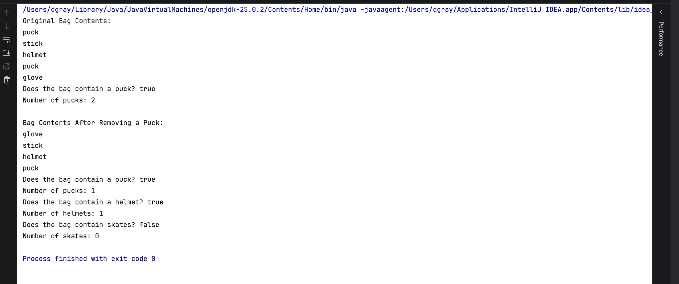

Pseudocode:
CLASS Bag<T>
DECLARE an array called items with a capacity of 100
DECLARE an integer called numberOfEntries
CONSTRUCTOR Bag
SET numberOfEntries to 0
CREATE an array that can hold 100 items
END CONSTRUCTOR

METHOD add(item)
IF numberOfEntries equals the array capacity THEN
DISPLAY "Your bag is full"
ELSE
STORE item at index numberOfEntries
INCREASE numberOfEntries by 1
END IF
END METHOD
METHOD remove(item)
FOR each occupied position in the array
IF the current item equals the specified item THEN
REPLACE the current item with the last item in the Bag
SET the old last position to null
DECREASE numberOfEntries by 1
EXIT the method
END IF
END FOR
END METHOD
METHOD contains(item)
FOR each occupied position in the array
IF the current item equals the specified item THEN
RETURN true
END IF
END FOR
RETURN false
END METHOD
METHOD count(item)
SET count to 0
FOR each occupied position in the array
IF the current item equals the specified item THEN
INCREASE count by 1
END IF
END FOR

RETURN count
END METHOD
METHOD display()
FOR each occupied position in the array
DISPLAY the current item
END FOR
END METHOD
END CLASS

BEGIN Main
CREATE a new Bag that stores strings
ADD "puck" to the Bag
ADD "stick" to the Bag
ADD "helmet" to the Bag
ADD "puck" to the Bag
ADD "glove" to the Bag
DISPLAY "Original Bag Contents:"
DISPLAY the contents of the Bag
DISPLAY whether the Bag contains "puck"
DISPLAY the number of occurrences of "puck"
REMOVE one occurrence of "puck" from the Bag
DISPLAY "Bag Contents After Removing a Puck:"
DISPLAY the contents of the Bag
DISPLAY whether the Bag contains "puck"
DISPLAY the number of occurrences of "puck"
DISPLAY whether the Bag contains "helmet"
DISPLAY whether the Bag contains "skates"
DISPLAY the number of occurrences of "skates"
END Main

