Group Project – Build A Web Application

Name and student numbers of all team members and Web Application Name

Student Name 1: | Mert Bekar | Student Number | 3050376
Student Name 2: | Vinicius Bellomo | Student Number | 3052662
Student Name 3: |  | Student Number

Web Application Name: | 園児Enji

The main pages
Screenshots and a line of explanation for each.

Additional pages
4-5 screenshots of member and admin sections and a line of explanation for each.

Extra features and improvements, (if any)
Screenshots and a line of explanation for each.

Extra features and improvements, (if any)
A table listing all the pages and the features which are working and not working. You can use the table from the project specification as an outline.

Link to Knuth deployment
Please provide a link to your live website together with childcare centre usernames, passwords, & their roles. This will be used for testing purposes. You must also submit a zipped version of your application to Moodle as per the project description.

Set up instructions
Please bullet point the steps required to install the web application on a new machine/server.

ERD of Final Database Design
Provide the final version of your database design (ERD).

Site Map of Final Website
Include a site map showing how the pages specified in the wireframe section link together and a few sentences of explanation.
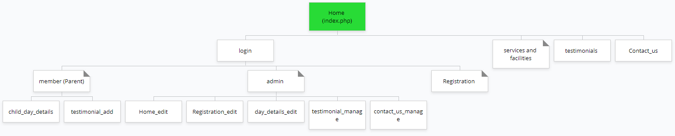
(https://www.gloomaps.com/36qeNcAsV)

Wireframes:
https://www.figma.com/file/HBgcHd8zfVPFAxlHw4jXwP/SWD---final-project?node-id=0%3A1

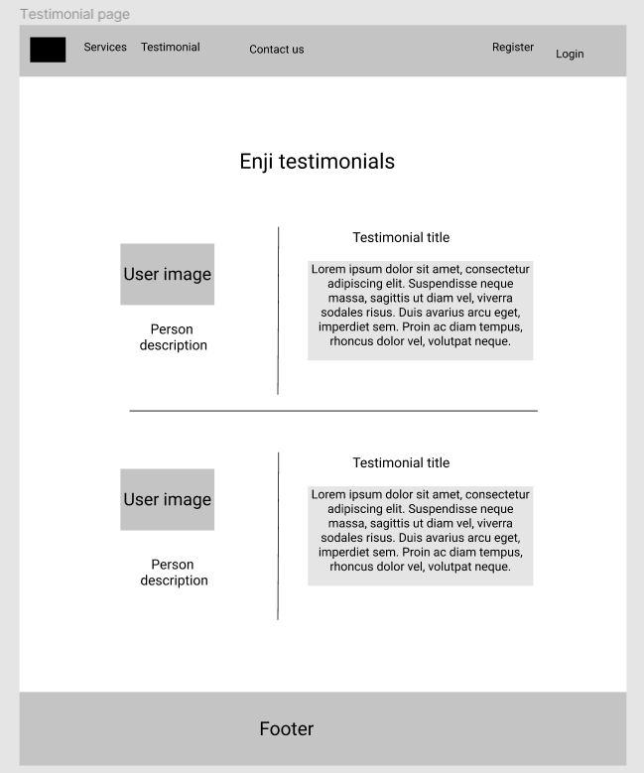

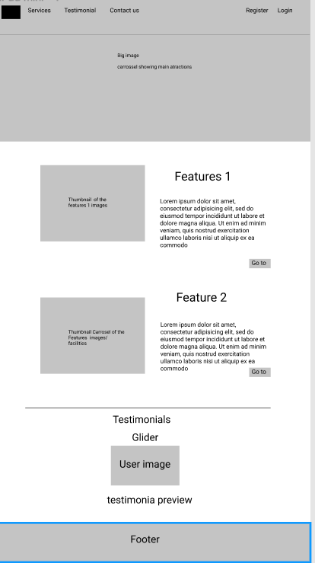

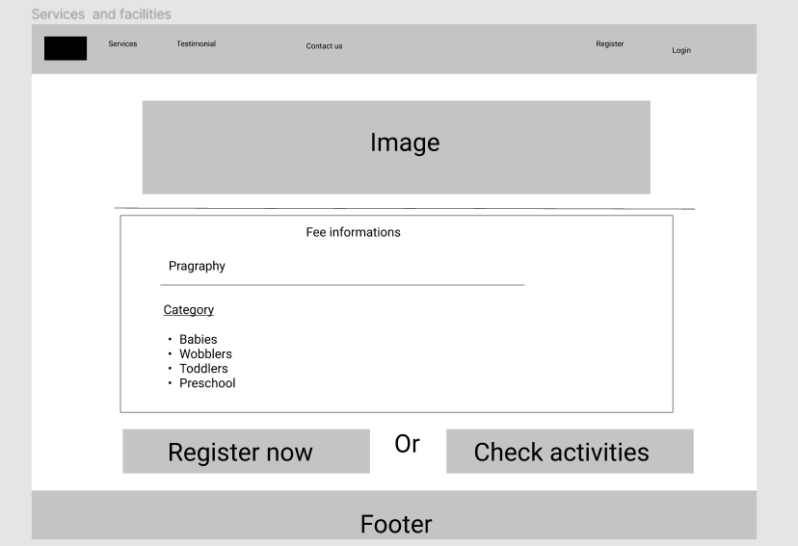

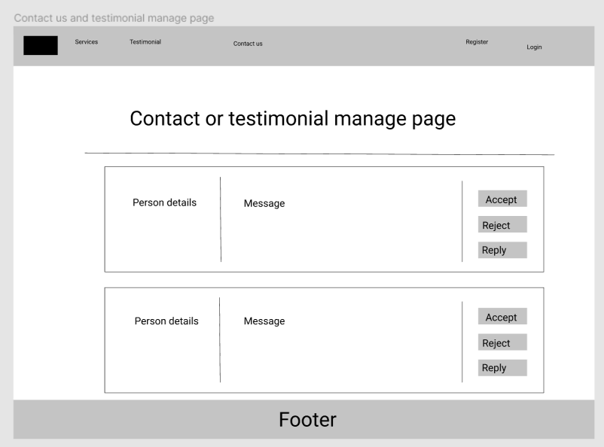

Division of Labour

Please complete the sections below regarding the estimate of the division of work between the three team members.

Summary of the division of work
If the work was split in the range of 25% to 40% per team member, that is fine and simply say, “Work was evenly divided”. If this was not the case, then state with a summary sentence.
Division of work: work was evenly divided

Percentage of work completed by each partner on each class/task
Some area requires more work than others, so this is only for reference.

Filename / Task | Student Name 1 | Student Name 2 | Student Name 3
Database Design | 100%
Database implementation | 10% | 40% | 50%
GUI design |  | 100%
GUI implementation | 50% | 50% | 10%
Etc.

