Schedulix

A Constraint-Based Smart College Timetable Generation System

Phase 1 – Synopsis Document

1. Introduction
Educational institutions spend considerable time and effort preparing semester timetables while ensuring that faculty, classrooms, laboratories, and subjects are allocated without conflicts. Manual timetable creation becomes increasingly difficult as the number of departments, courses, and scheduling constraints grows.
The proposed system, Schedulix, is a web-based application that automates the management and generation of college timetables. The system validates scheduling constraints before allocating lectures and immediately reports conflicts when invalid schedules are detected. The application aims to reduce manual effort, improve resource utilization, and maintain accurate academic schedules.
The project follows a modular service-oriented architecture consisting of independent modules for user management, academic management, resource management, and timetable generation.

2. Problem Statement
Most colleges prepare timetables manually using spreadsheets or paper-based methods. This process often leads to several problems, including:
- Faculty assigned to multiple lectures at the same time.
- Double booking of classrooms or laboratories.
- Incorrect allocation of rooms with insufficient seating capacity.
- Laboratory subjects assigned to regular classrooms.
- Frequent timetable modifications requiring manual adjustments.
- Poor utilization of available academic resources.
These issues increase administrative workload and reduce scheduling efficiency.
The proposed system aims to automate timetable management while enforcing scheduling constraints to eliminate conflicts.

3. Objectives
The objectives of the project are:
- Develop a centralized timetable management system.
- Automate lecture scheduling.
- Prevent scheduling conflicts.
- Optimize utilization of classrooms and laboratories.
- Manage teacher availability efficiently.
- Generate semester-wise timetables.
- Provide faculty and students with timetable viewing facilities.
- Reduce manual administrative effort.
- Produce conflict reports for invalid schedules.

4. Scope of the Project
The proposed system supports four major modules.

Module 1 – User Management
- User authentication
- Role management
- Administrator login
- Faculty login
- Student login

Module 2 – Academic Management
- Department management
- Program management
- Semester management
- Teacher management
- Subject management
- Teacher-subject allocation

Module 3 – Resource Management
- Classroom management
- Laboratory management
- Capacity management
- Resource availability

Module 4 – Timetable Management
- Create timetable
- Assign lectures
- Validate scheduling constraints
- Detect conflicts
- Generate semester timetable
- Faculty timetable
- Classroom timetable

5. Technologies Used

Frontend
- React.js
- HTML5
- CSS3
- Bootstrap / Material CSS / Tailwind CSS
- TypeScript

Backend
- Core PHP
- REST APIs using PHP

Database
- MySQL

Development Tools
- Visual Studio Code
- XAMPP
- Git
- GitHub
- Postman

6. Expected Outcome
The proposed system will successfully automate the creation and management of college timetables by considering faculty availability, classroom capacity, laboratory requirements, and academic constraints.
The system will detect scheduling conflicts before timetable generation and provide meaningful feedback to administrators. It will reduce manual effort, improve resource utilization, and provide an organized timetable management solution.

Functional Requirements

Authentication
- User Login
- Logout
- Session Management

Teacher Management
- Add Teacher
- Update Teacher
- Delete Teacher
- Assign Subjects
- Set Availability

Subject Management
- Add Subject
- Assign Semester
- Assign Faculty
- Specify Lecture/Lab

Resource Management
- Add Classroom
- Add Laboratory
- Update Capacity
- Manage Availability

Timetable Management
- Generate Timetable
- Modify Timetable
- Delete Lecture
- Conflict Detection
- Faculty Timetable
- Student Timetable

Non Functional Requirements

Performance
- Response time below 3 seconds

Security
- Password hashing
- Session authentication
- Input validation

Reliability
- Prevent duplicate scheduling

Maintainability
- Modular PHP APIs

Scalability
- Support multiple departments

Service Architecture
Although implemented in Core PHP, the system is divided into four logical services.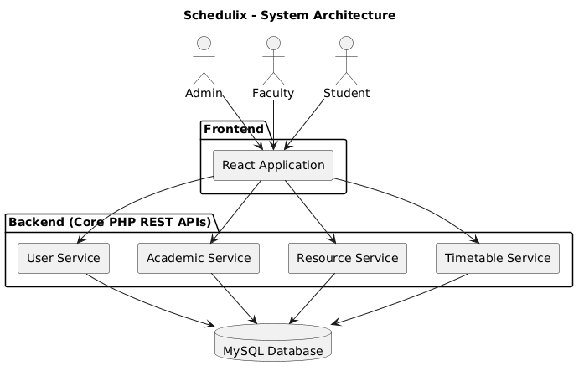

ERD
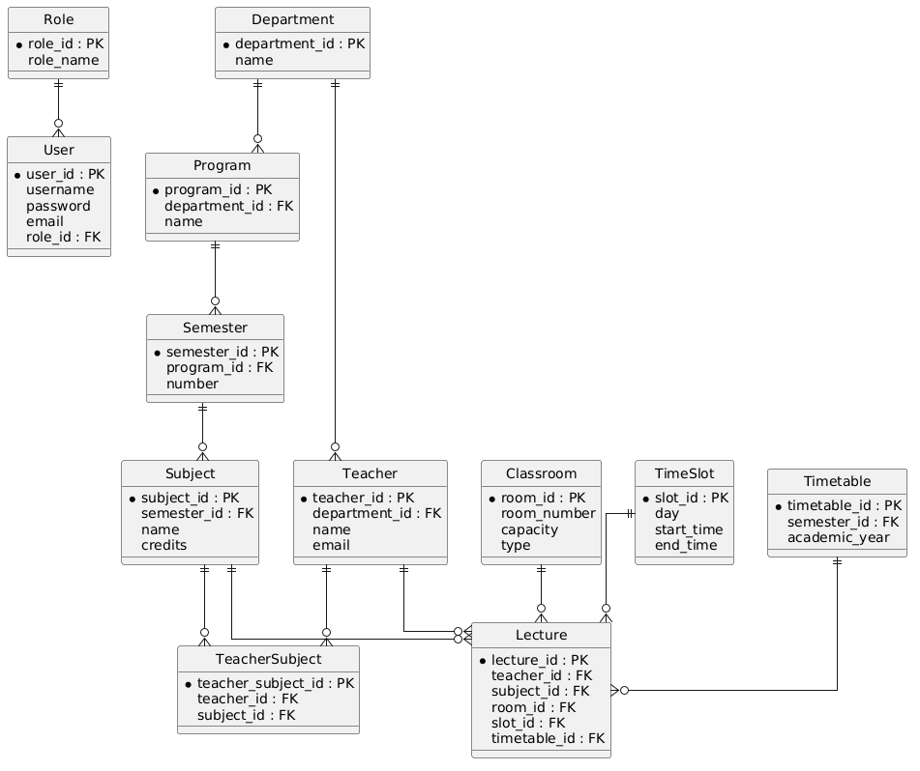
Use Case Diagram
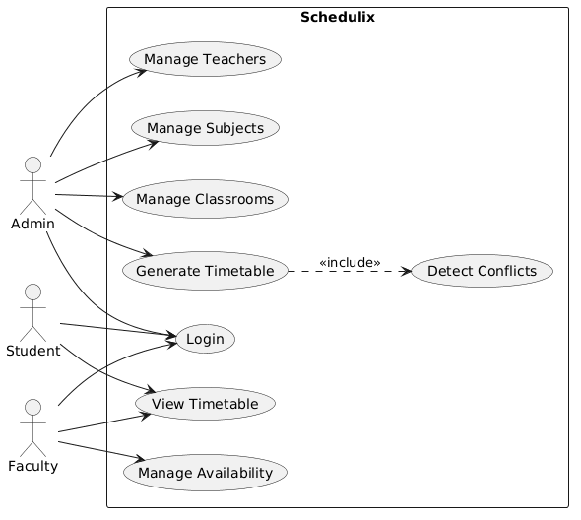
Component Diagram
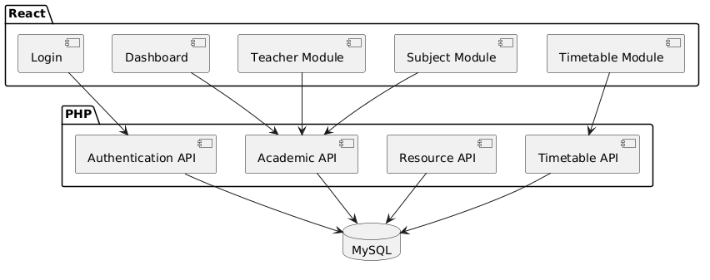
Data Flow Diagram
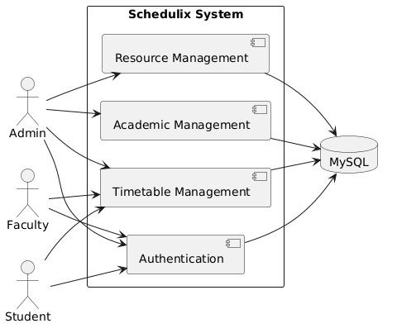

Database Normalization
The database is designed up to Third Normal Form (3NF).

First Normal Form (1NF)
- Atomic values
- No repeating groups

Second Normal Form (2NF)
- Full dependency on primary keys
- Junction table (TeacherSubject) resolves many-to-many relationships

Third Normal Form (3NF)
- No transitive dependencies
- Department, Program, Semester, Teacher, Subject, Classroom, and User data are stored independently to eliminate redundancy

Engineering Challenges
The project focuses on solving real scheduling problems rather than simple CRUD operations.
The system implements validation rules such as:
- A teacher cannot be assigned to multiple lectures in the same time slot.
- A classroom cannot host multiple lectures simultaneously.
- Laboratory subjects must be scheduled only in laboratory rooms.
- Classroom capacity must be greater than or equal to the student strength.
- Teacher availability is checked before assignment.
- Semester lectures cannot overlap.
- Scheduling conflicts are detected before saving the timetable.
- Administrators receive descriptive conflict reports for invalid schedules.

Project By
Avaneesh Chopdekar (A067) - 70612600066
Vanshaj Madeshiya (A033) - 70612600018
Harshal Yadav (A063) - 70612600021

