# Exploratory Data Analysis Report

## Shopping Trend Analysis

Customer ID Age Purchase Amount (USD) Review Rating Previous Purchases  
count 120.000000 120.00000 119.000000 120.000000 120.000000  
mean 60.500000 44.52500 59.420168 3.875000 28.666667  
std 34.785054 15.44084 24.069636 0.734304 14.167268  
min 1.000000 18.00000 20.000000 2.600000 1.000000  
25% 30.750000 31.00000 37.500000 3.200000 17.000000  
50% 60.500000 47.50000 58.000000 4.000000 31.000000  
75% 90.250000 56.00000 80.000000 4.600000 42.250000  
max 120.000000 70.00000 100.000000 5.000000 50.000000  
Top 5 Rows  
 Customer ID Age Gender Item Purchased Category ... Discount Applied Promo Code Used Previous Purchases Preferred Payment Method Frequency of Purchases  
0 1 55 Male Blouse Clothing ... Yes Yes 14 Venmo Fortnightly  
1 2 19 Female Sweater NaN ... Yes Yes 2 Cash Fortnightly  
2 3 50 Male Jeans Clothing ... Yes Yes 23 Credit Card Weekly  
3 4 21 Female Sandals Footwear ... Yes Yes 49 PayPal Weekly  
4 5 45 Female Blouse Clothing ... Yes Yes 31 PayPal Annually  
  
[5 rows x 19 columns]  
Bottom 5 Rows  
 Customer ID Age Gender Item Purchased Category ... Discount Applied Promo Code Used Previous Purchases Preferred Payment Method Frequency of Purchases  
115 116 53 Female Skirt Clothing ... Yes Yes 48 Debit Card Every 3 Months  
116 117 55 Male Shoes Footwear ... Yes Yes 12 Venmo Annually  
117 118 50 Female Sandals Footwear ... Yes Yes 29 Cash Fortnightly  
118 119 50 Female Sweater Clothing ... Yes Yes 27 Cash Bi-Weekly  
119 120 38 Female Coat Outerwear ... Yes Yes 44 Cash Annually  
  
[5 rows x 19 columns]  
Customer ID int64  
Age int64  
Gender category  
Item Purchased object  
Category object  
Purchase Amount (USD) float64  
Location object  
Size object  
Color object  
Season object  
Review Rating float64  
Subscription Status object  
Payment Method object  
Shipping Type object  
Discount Applied object  
Promo Code Used object  
Previous Purchases int64  
Preferred Payment Method object  
Frequency of Purchases object  
dtype: object  
The size of the CSV dataset is: (120, 19)  
The total number of NULL values present in the datas by columns :  
Customer ID 0  
Age 0  
Gender 0  
Item Purchased 0  
Category 1  
Purchase Amount (USD) 1  
Location 0  
Size 0  
Color 0  
Season 0  
Review Rating 0  
Subscription Status 0  
Payment Method 0  
Shipping Type 0  
Discount Applied 0  
Promo Code Used 0  
Previous Purchases 0  
Preferred Payment Method 0  
Frequency of Purchases 0  
dtype: int64  
Average of the Purchased Amount is 59.42016806722689  
The maximum amount purchased is: 100.0  
The minimum amount purchased is: 20.0  
NO.of duplicates 0  
No. of Colors purchased : Color  
Maroon 8  
Gray 7  
Green 7  
Charcoal 6  
White 6  
Olive 6  
Teal 6  
Violet 6  
Silver 6  
Orange 6  
Red 5  
Pink 5  
Purple 5  
Black 5  
Brown 4  
Lavender 4  
Gold 4  
Blue 4  
Cyan 4  
Turquoise 3  
Peach 3  
Magenta 3  
Indigo 3  
Beige 2  
Yellow 2  
Name: count, dtype: int64  
Payment Method  
Bank Transfer 24  
Debit Card 23  
PayPal 21  
Credit Card 20  
Cash 16  
Venmo 16  
Name: count, dtype: int64  
Size  
L 2006.0  
M 3154.0  
S 1285.0  
XL 626.0  
Name: Purchase Amount (USD), dtype: float64  
Total amount of purchased: 7071.0  
Location Shipping Type  
Alabama Next Day Air 2  
 Express 1  
 Standard 1  
Alaska Free Shipping 1  
 Standard 1  
Name: count, dtype: int64

## Visualizations

Histogram of Age

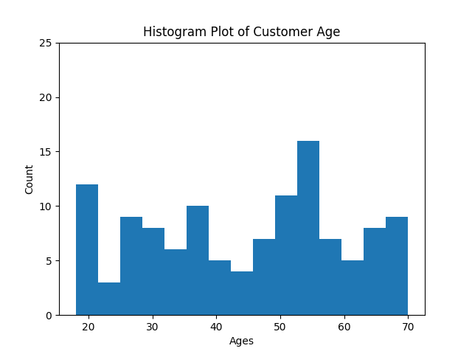

Purchase Amount vs Review Rating

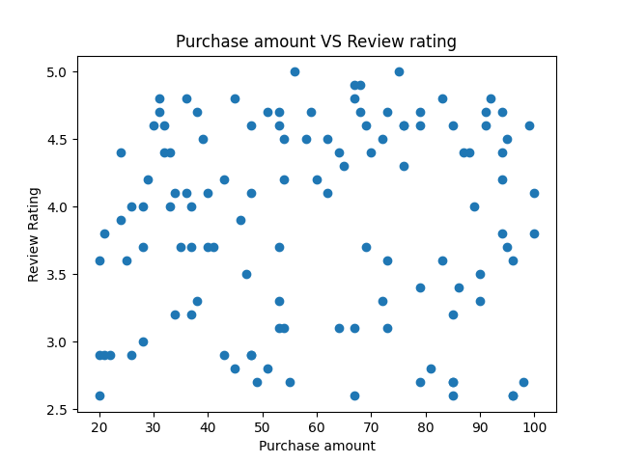

Gender vs Ratings

