In this part of exam, all steps must be shown clearly and thoroughly. Answers can either be directly typed or inserted photos of work as images. The first part of exam must be submitted as a single file and no extra files are not accepted.

1. [10 pts] Using the definition, $E\left[x\right]=μ$**,** show

$$E\left[xx^{T}\right]=μμ^{T}+Σ$$

and

$$E\left[x_{n}x_{m}^{T}\right]=μμ^{T}+I_{nm}Σ$$

where $x_{n}$ denotes a data point sampled from a Gaussian distribution with mean $μ$ and covariance $Σ$**,** and $I_{nm}$ denotes the $(n,m)$ element of the identity matrix.

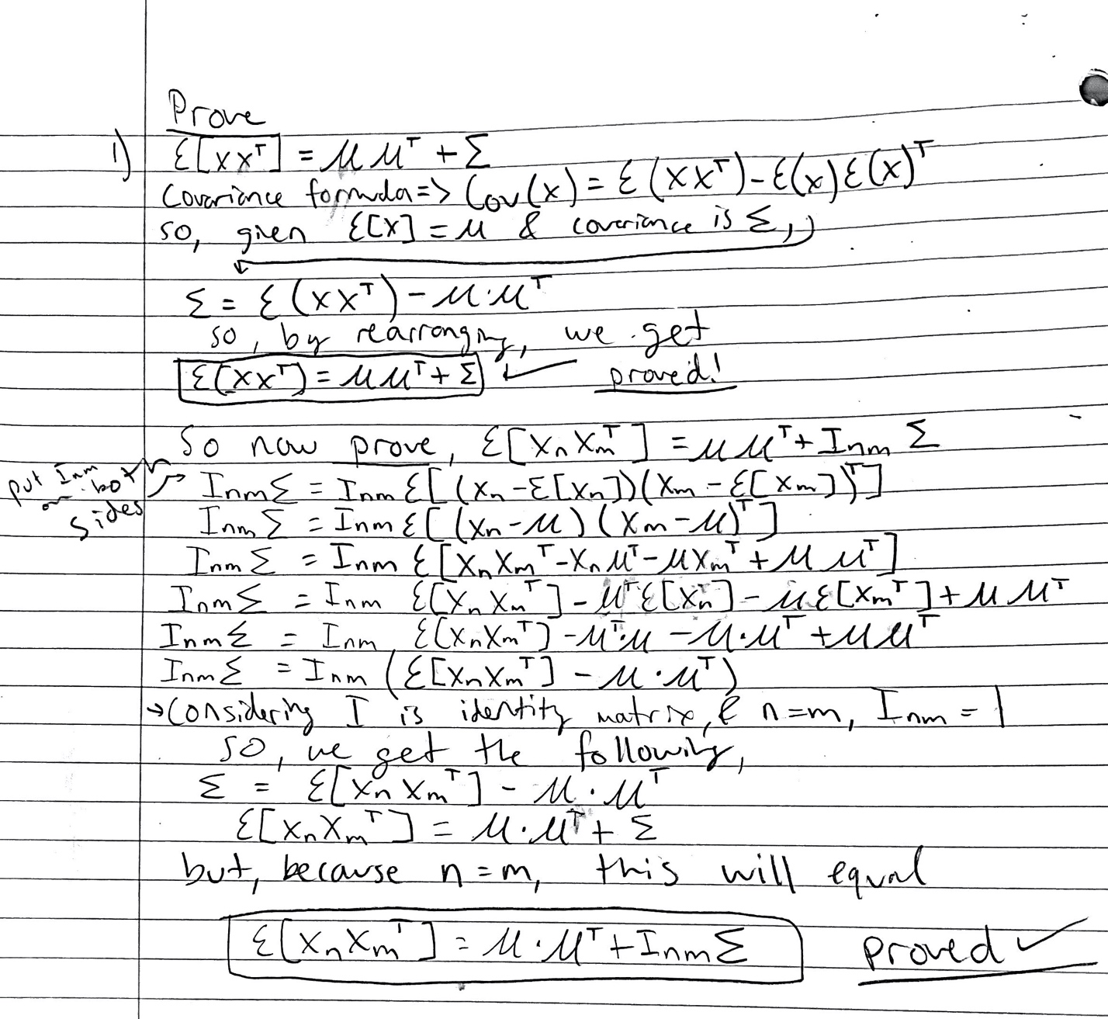

2. [10 pts] Consider a data set in which each data point $t_{n}$ is associated with a weighting factor $r_{n}>0$, so that the sum-of-squares error function becomes

$$E_{D}\left(w\right)=\frac{1}{2}\sum_{n=1}^{N}{r_{n}{\left\{t_{n}-w^{T}x_{n}\right\}}^{2}}.$$

Find an expression for the solution $w^{*}$ that minimizes this error function.

