Game Design Document

Fill up the Following document

1. Write the title of your project.

Kabaddi

1. What is the goal of the game?

The goal of the game is that one of the teams has to score the given amount of points. The first team to reach the limit wins.

1. Write a brief story of your game?

Rohan is not a person who is good at sports. But he is excellent at studies. But he still wants to defeat his elder brother, Rohit. So, we have to help him defeat his Rohit in this game of kabaddi which is not on the ground but on the laptop.

1. Which are the playing characters of this game?

* Playing characters are the ones which respond to the user based on the input from the user
* Cars, monkeys, dinos, wizards etc, are the playing characters in the game.

|  |  |  |
| --- | --- | --- |
| Number | Character Name | What can this character do? |
| 1 | Rohan | This character is controlled by one of the players. It can move up, down, left and right and touch other opponents or catch them to gain points. |
| 2 | Rohit | This character is just like the first one, except it is controlled by another player. |
| 3 |  |  |
| 4 |  |  |
| 5 |  |  |
| 6 |  |  |
| 7 |  |  |
| 8 |  |  |

1. Which are the Non Playing Characters of this game?

* Non Playing characters are the ones which don't have an action or a behavior when the user interacts with the game.
* Hurdles, stones, bananas, coins, etc are non playing characters in the game.

|  |  |  |
| --- | --- | --- |
| Number | Character Name | What can this character do? |
| 1 |  |  |
| 2 |  |  |
| 3 |  |  |
| 4 |  |  |
| 5 |  |  |
| 6 |  |  |
| 7 |  |  |
| 8 |  |  |

Draw your imagination of this game. What does this game look like?

* Draw the game either on your computer or on paper,
* Add images of scenes of the game to show each of the playing and non-playing characters at least once.

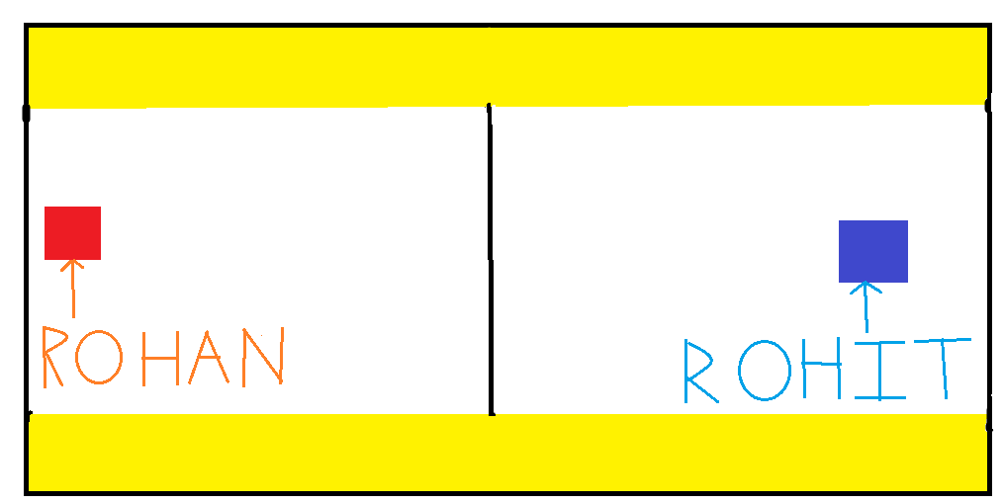

How do you plan to make your game engaging?

Two people can play this game from anywhere in the world (only if they have a Wi-Fi connection of course;)), hence, it will connect relatives or friends living in different parts of the world and engage them.