**ADDRESS BOOK**

**Prepared by**

PRIYA NASIT (16IT057)

AVANI PATEL(16IT064)

**Under the supervision of**

Prof. Ayesha Shaikh

A Report Submitted to

Charotar University of Science and Technology

for Partial Fulfillment of the Requirements for the

Degree of Bachelor of Technology

in Information Technology

IT244 Software Group Project-I (3rd sem)

**Submitted at**



**DEPARTMENT OF INFORMATION TECHNOLOGY**

**Chandubhai S. Patel Institute of Technology**

**At: Changa, Dist: Anand – 388421**

**November 2017**



**CERTIFICATE**

This is to certify that the report entitled “**Address Book**” is a bonafied work carried out by **Ms. Priya Nasit**  and **Ms. Avani Patel** under the guidance and supervision of for the subject **Software Group Project-I(IT244)** of **3rd** Semester of Bachelor of Technology in **Information Technology** at Faculty of Technology & Engineering – CHARUSAT, Gujarat.

To the best of my knowledge and belief, this work embodies the work of candidate themselves have duly been completed, and fulfills the requirement of the ordinance relating to the B.Tech. Degree of the University and is up to the standard in respect of content, presentation and language for being referred to the examiner.

|  |
| --- |
| Under supervision of,  Prof. Ayesha Shaikh  Assistant Professor  Dept. of Information Technology  CSPIT, Changa, Gujarat. |
| Prof. Parth Shah  Head & Associate Professor  Department of Information Technology  CSPIT, Changa, Gujarat. |

**Chandubhai S Patel Institute of Technology**

At: Changa, Ta. Petlad, Dist. Anand, PIN: 388 421. Gujarat

**Acknowledgement**

A scholarly and quality work like designing of any project work can be

accomplished by motivation, guidance and inspiration of certain quarters besides the individual efforts. Let me in this page express my heartiest gratitude to all those who helped me in various stages of this study.

We are very much thankful to **Mr. Parth Shah**, HOD, IT for giving me the

permission to undergo this project and providing all the necessary facilities.

During my project period all the staff members of department have helped us with

their skills. Here by I express our sincere thanks to project guide **Ms.**

**Ayesha Shaikh** Assistant Professor, IT whose valuable guidance and kind

cooperation without which this project would have not been possible.

With Sincere Regards,

16IT057-Priya Nasit

16IT064-Avani Patel

**Abstract**

The title of this project is “Address Book”. The main purpose of address book is to manage hostel girls’ details efficiently. This system basically directory has been frequently in use in our daily life. Address Book website

provides the ability to search, view, and manage entries in a database

This website gives the user option to ,

Registration, update and delete details. User can update her details whenever required and it provides option for delete the entry for any girl whenever admission canceled in hostel.

**List of Figure**

1. 3.1.1Graphical representation of project…………………………......08
2. 3.1.2 Data flow diagram….…………………………………………..09
3. 4.1 Implementation Environment………………………………....... 11
4. 4.2 Module specification……………………………………………..12

**List Of Table**

**1**. 3.2.1 Data Dictionary……………………………………………. ..…10

Chapter:1 Introduction

**1.1 Project Overview**

**Project Name : ADDRESS BOOK**

**Project Description**: Address Book is book or database used for storing entries called contacts. Each contact entry usualy consist of a few standard fields for example name, address , phone no ,birth date,email id,address ,semester ,branch.

Team Size: 2

Languages used: java,HTML,

**1.2 Scope:**

An address book can combine contact details and much more information people add to it. Now, imagine these contacts are updated constantly adding new information available depending on each person and the social network they belong to.

**1.3 Objective:**

* 1. Objective
* To enter address book information
* To locate address book records
* To audit address book records
* To search any particular user’s data
* To maintain lots of user’s data

Chapter:2 SYSTEM ANALYSIS

**2.1 User Characteristics**

**2.1.1**

Every system or project can use to the many user. But it can access different different way.

Every user of the system are given some authentication and according to that they can perform the task.

In our website we are having users like Registered user and other user which can access our website.

**User:**

**They have to register on our website. After then they can view the project.**

1. Login
2. Register
3. Search
4. View details
5. Update details
6. Delete contacts

**2.2 Tools and Technology**

**2.2.1**

**Software requirement**

1. Operating system : Microsoft windows
2. Front End :NetBeans IDE 8.2
3. Back End: Xampp control panel v3.2.2

**Programming Language**

1. Java
2. HTML

Chapter:3 SYSTEM Design

* + 1. **Graphical representation of project**

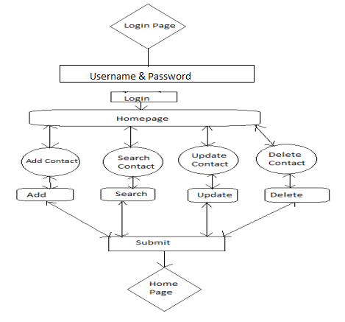

**3.1.2 Data flow diagram:**

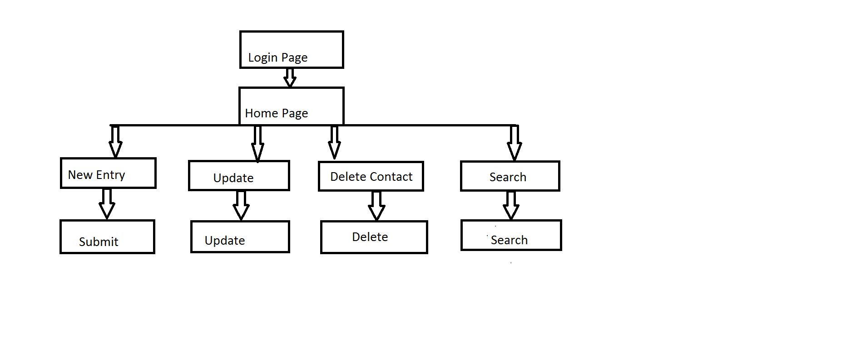

**3.2.1 Data Dictionary**

|  |  |  |  |  |  |
| --- | --- | --- | --- | --- | --- |
| **Field Name** | **Data type** | **Data Formate** | **Field Size** | **Description** | **Example** |
| **College_Id** | **varchar** | **NNITNNN** | **10** | **Unique id no for all users** | **16it064** |
| **First_Name** | **varchar** |  | **50** | **First name of user** | **Vinee** |
| **Last_Name** | **varchar** |  | **50** | **Surname of user** | **Patel** |
| **Birth_Date** | **date** | **yyyy/mm/dd** |  | **birth date of user** | **04/12/1998** |
| **Contact_No** | **varchar** |  | **10** | **contact** | **9353666523** |
| **City** | **text** |  |  | **City** | **Ahmedabad** |
| **Pincode** | **varchar** |  | **6** | **area pincode** | **Amreli-365601** |
| **Department** | **varchar** |  | **10** | **department of student** | **cspit** |
| **Branch** | **varchar** |  | **12** | **branch of student** | **it** |
| **Email_Add** | **text** | [_____@gmail.com](mailto:_____@gmail.com) |  | **unique email add** | [Avanip_22@gmail.com](mailto:Avanip_22@gmail.com) |
| **Address** | **text** |  |  | **residential area** | **Navrangpura , Ahmedabad** |

Chapter 4: IMPLementation

**4.1 Implementation Environment**

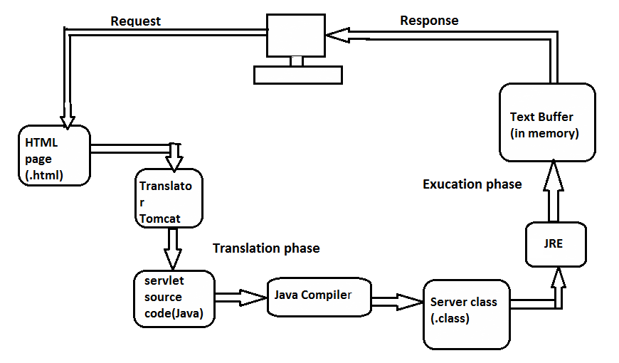

**4.2 Module specification**

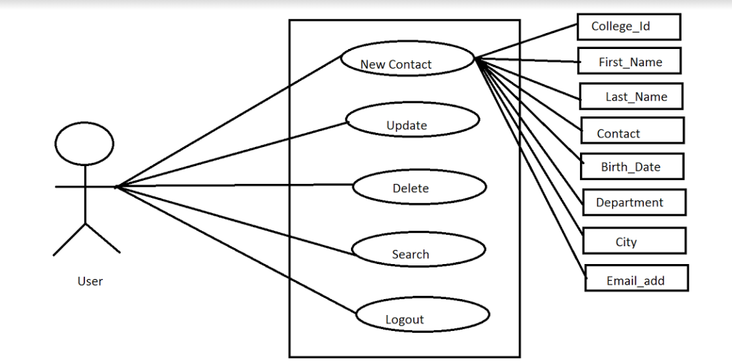

4.3 Coding Standards

import java.sql.*;

import java.io.IOException;

import java.io.PrintWriter;

import java.sql.Connection;

import java.sql.DriverManager;

import java.sql.Statement;

import javax.servlet.RequestDispatcher;

import javax.servlet.ServletException;

import javax.servlet.annotation.WebServlet;

import javax.servlet.http.HttpServlet;

import javax.servlet.http.HttpServletRequest;

import javax.servlet.http.HttpServletResponse;

@WebServlet(urlPatterns = {"/Userlogin"})

public class Userlogin extends HttpServlet {

protected void processRequest(HttpServletRequest request, HttpServletResponse response)

throws ServletException, IOException {

response.setContentType("text/html;charset=UTF-8");

PrintWriter out = response.getWriter();

try {

String College_Id = request.getParameter("College_Id");

String First_Name = request.getParameter("First_Name");

String Last_Name = request.getParameter("Last_Name");

String Contact_No= request.getParameter("Contact_No");

String City = request.getParameter("City");

String Pincode = request.getParameter("Pincode");

String Department = request.getParameter("Department");

String Branch = request.getParameter("Branch");

Date Birth_Date=Date.valueOf(request.getParameter("Birth_Date"));

String Email_Add = request.getParameter("Email_Add");

String Address=request.getParameter("Address");

Class.forName("com.mysql.jdbc.Driver");

Connection cn = (Connection) DriverManager.getConnection("jdbc:mysql://localhost:3306/project3rdsem", "root", "");

Statement st = cn.createStatement();

String q_ins = "insert into register (College_Id,First_Name,Last_Name,Contact_No,City,Pincode,Department,Branch,Birth_Date,Email_Add,Address) values('" + College_Id + "','" + First_Name + "','" + Last_Name + "','" + Contact_No + "','" + City + "','"+Pincode+"','"+Department+"','"+Branch+"','"+Semester+"','"+Birth_Date+"','"+Email_Add+"','"+Address+"')";

out.print("q:"+q_ins);

st.execute(q_ins);

RequestDispatcher disp=request.getRequestDispatcher("home.html");

disp.forward(request, response);

response.sendRedirect("home.html");

}

catch (Exception e) {

out.print("exception:"+e);

}

}

@Override

protected void doGet(HttpServletRequest request, HttpServletResponse response)

throws ServletException, IOException {

processRequest(request, response);

}

@Override

protected void doPost(HttpServletRequest request, HttpServletResponse response)

throws ServletException, IOException {

processRequest(request, response);

}

@Override

public String getServletInfo() {

return "Short description";

}

}

Update code:

import java.io.IOException;

import java.io.PrintWriter;

import java.sql.Connection;

import java.sql.DriverManager;

import java.sql.Statement;

import javax.servlet.ServletException;

import javax.servlet.http.HttpServlet;

import javax.servlet.http.HttpServletRequest;

import javax.servlet.http.HttpServletResponse;

import java.sql.*;

import javax.servlet.annotation.WebServlet;

/**

*

* @author my com

*/

@WebServlet(urlPatterns = {"/Updateentry"})

public class Updateentry extends HttpServlet {

protected void processRequest(HttpServletRequest request, HttpServletResponse response)

throws ServletException, IOException {

response.setContentType("text/html;charset=UTF-8");

disp.forward(request, response);

response.sendRedirect("home.html");

}

catch (Exception e) {

out.print("exception:"+e);

}

}

@Override

protected void doGet(HttpServletRequest request, HttpServletResponse response)

throws ServletException, IOException {

processRequest(request, response);

}

@Override

protected void doPost(HttpServletRequest request, HttpServletResponse response)

throws ServletException, IOException {

processRequest(request, response);

}

@Override

public String getServletInfo() {

return "Short description";

}

}

PrintWriter out = response.getWriter();

try {

String College_Id = request.getParameter("College_Id");

String First_Name = request.getParameter("First_Name");

String Last_Name = request.getParameter("Last_Name");

String Contact_No= request.getParameter("Contact_No");

String City = request.getParameter("City");

String Pincode = request.getParameter("Pincode");

String Department = request.getParameter("Department");

String Branch = request.getParameter("Branch");

//String Semester = request.getParameter("Semester");

//Date Birth_Date=Date.valueOf(request.getParameter("Birth_Date"));

//java.util.Date Birth_Date= new SimpleDateFormat("dd-mm-yyyy").parse(request.getParameter("Birth_Date"));

String Email_Add = request.getParameter("Email_Add");

String Address=request.getParameter("Address");

Class.forName("com.mysql.jdbc.Driver");

Connection cn = (Connection) DriverManager.getConnection("jdbc:mysql://localhost:3306/project3rdsem", "root", "");

Statement st = cn.createStatement();

if( First_Name!= ""){

String q_upd = "update register set First_Name ='"+First_Name+"'where College_Id='"+College_Id+"'";

st.execute(q_upd);

}

if(Last_Name!= ""){

String q_upd = "update register set Last_Name ='"+Last_Name+"'where College_Id='"+College_Id+"'";

st.execute(q_upd);

}

if(Contact_No != ""){

String q_upd = "update register set Contact_No='"+Contact_No+"'where College_Id='"+College_Id+"'";

st.execute(q_upd);

}

if(City != ""){

String q_upd = "update register set City='"+City+"'where College_Id='"+College_Id+"'";

st.execute(q_upd);

}

if(Pincode!= ""){

String q_upd = "update register set Pincode='"+Pincode+"'where College_Id='"+College_Id+"'";

st.execute(q_upd);

}

<html>

<head>

<title> login </title>

<style>

body {background-color: silver;}

</style>

</head>

<body>

<table border='0' style="width:100%; height:100%">

<tr>

<td rowspan="2" style="width:3%">

<img src="Addressbook.png" style="width:200px;height:228px;padding:1px">

</td><td>

<h1 style="font-size:400%; color:black; text-align:center">Welcome to Addressbook</h1>

</td>

</tr>

<tr>

<td>

</td>

</tr>

</table>

<table border='0' style="width:100%">

<tr><td style="width:50%"> </td>

<td><image style="height:80px;align:center" src="userloginfinal.jpg"></td></tr>

</table>

<form action="home.html" method="Post">

<table border='0' style="width:100%; height:100%">

<tr><td style="width:22%"></td><td align="right">User Name: </td><td><input type="text" name="User Name" style="width:150px"></td></tr>

</table>

<table border='0' style="width:100%; height:100%">

<tr><td style="width:25.8%"></td><td align="right">Password: </td><td><input type="password" name="Password" style="width:150px"></td></tr>

</table>

<table border='0' style="width:100%; height:100%">

<tr><td style="width:49.5%"></td> <td><a href='home.html'></a></td> <td><input type="Submit" value="Login" style="font-size:80%;width:100px;height:30px "></td></tr>

</table> </form></body></html>

</form>

</body>

</html>

if(Department != ""){

String q_upd = "update register set Department='"+Department+"'where College_Id='"+College_Id+"'";

st.execute(q_upd);

}

if(Branch!= ""){

String q_upd = "update register set Branch='"+Branch+"'where College_Id='"+College_Id+"'";

st.execute(q_upd);

}

if(Email_Add != ""){

String q_upd = "update register set Email_Add='"+Email_Add+"'where College_Id='"+College_Id+"'";

st.execute(q_upd);

}

if(Address != ""){

String q_upd = "update register set Address='"+Address+"'where College_Id='"+College_Id+"'";

st.execute(q_upd);

}

response.sendRedirect("Update.html");

}

catch(Exception e){

out.print("exc"+e);

}

finally {

out.close();

}

}

@Override

protected void doGet(HttpServletRequest request, HttpServletResponse response)

throws ServletException, IOException {

processRequest(request, response);

}

@Override

protected void doPost(HttpServletRequest request, HttpServletResponse response)

throws ServletException, IOException {

processRequest(request, response);

}

@Override

public String getServletInfo() {

return "Short description";

}// </editor-fold>

}

**4.4 Snapshots:**

**1. Login Page**

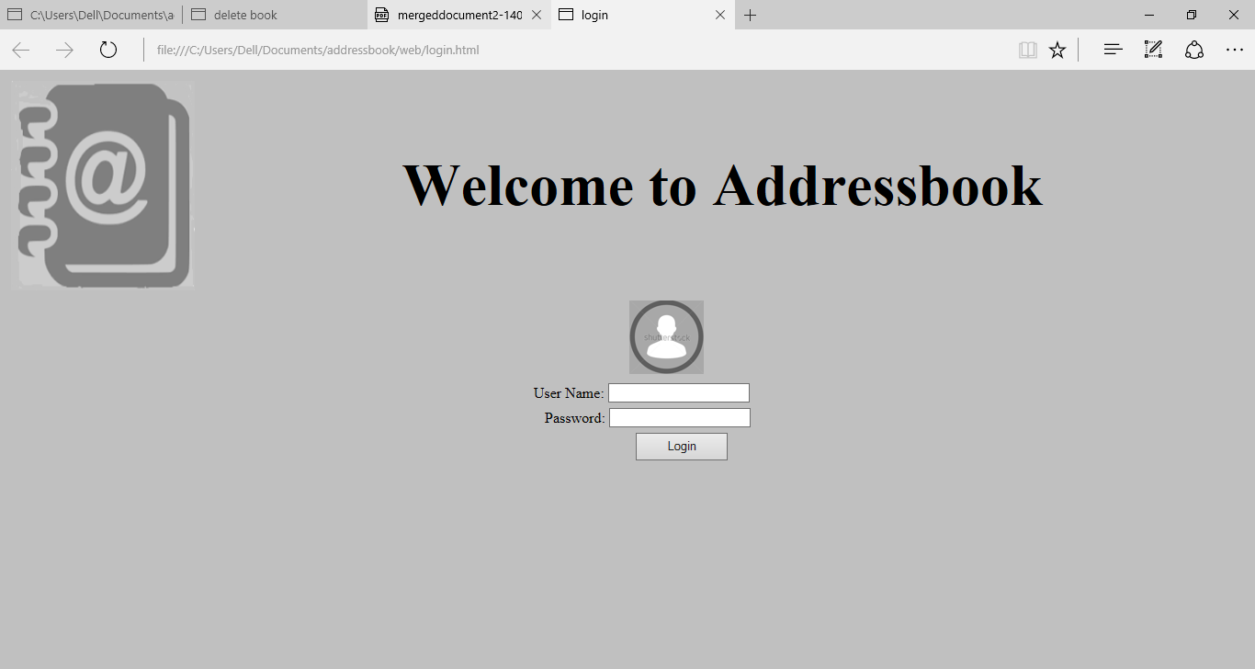

1. Home page

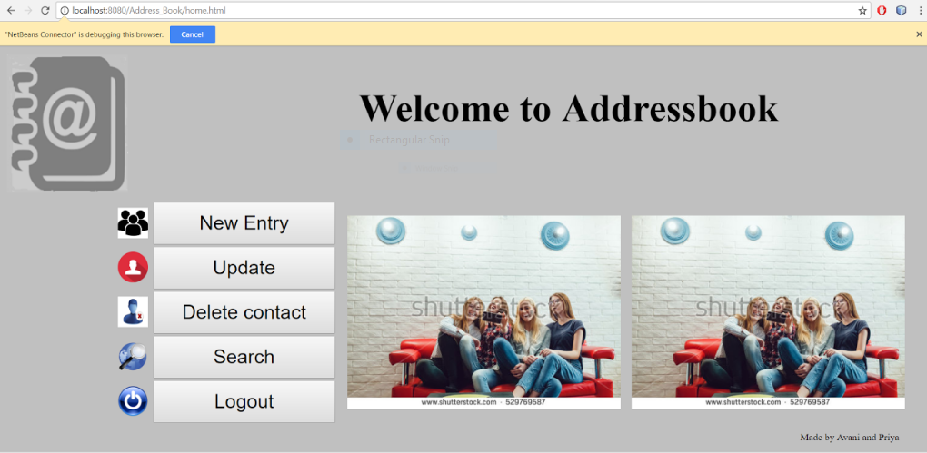

1. Entry page

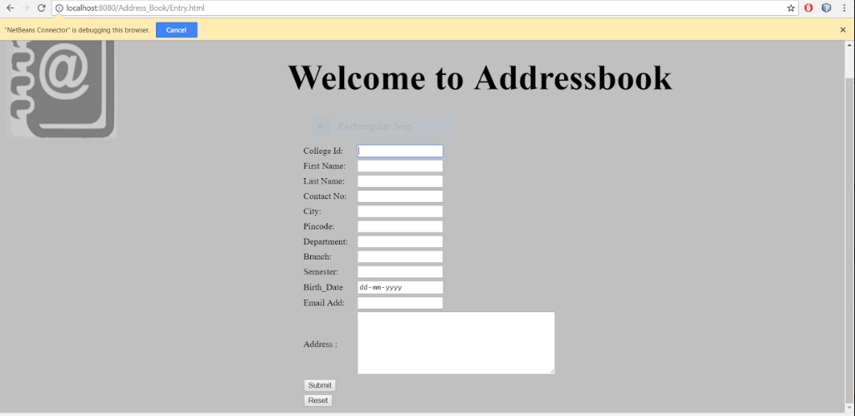

1. Update page

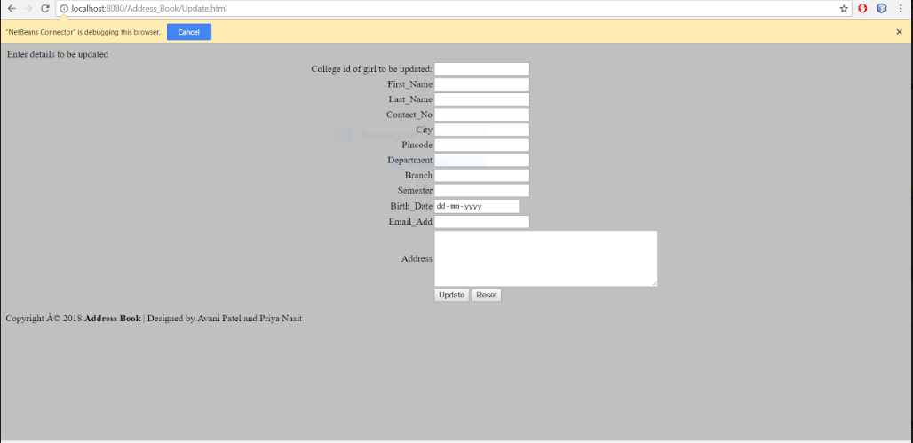

1. Search page

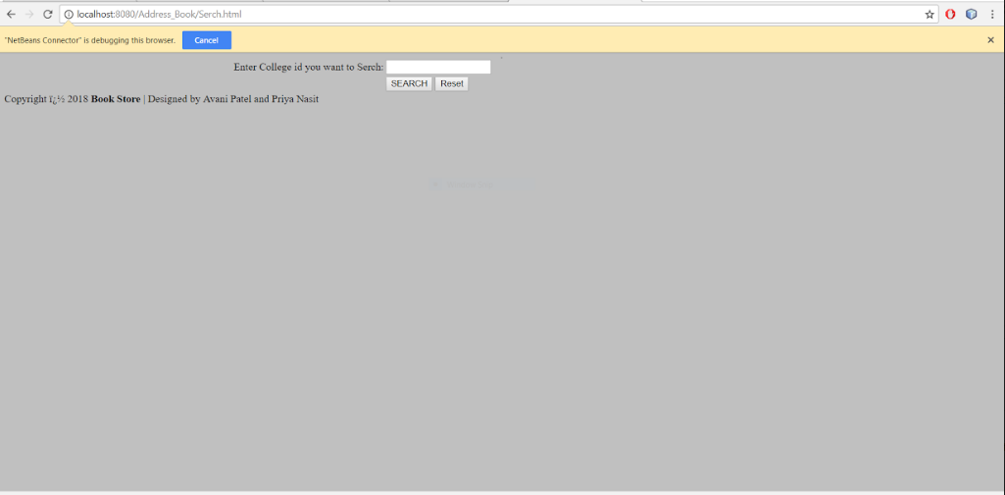

1. Delete page

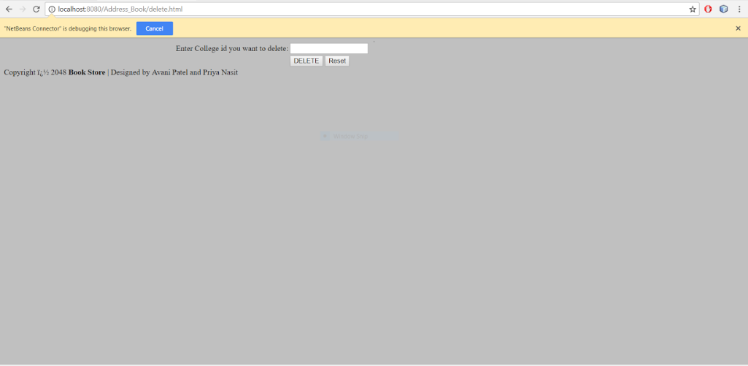

1. Enter and delete Entry

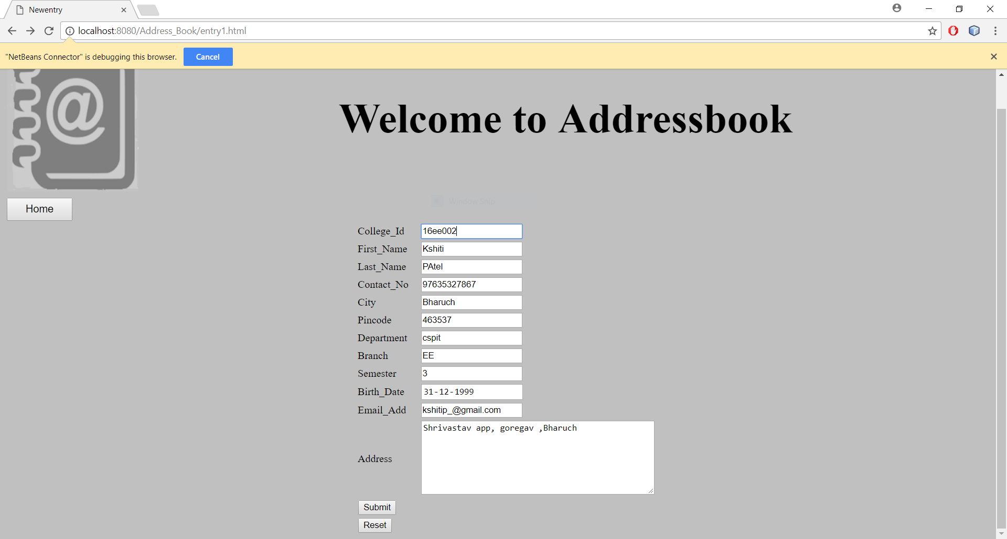

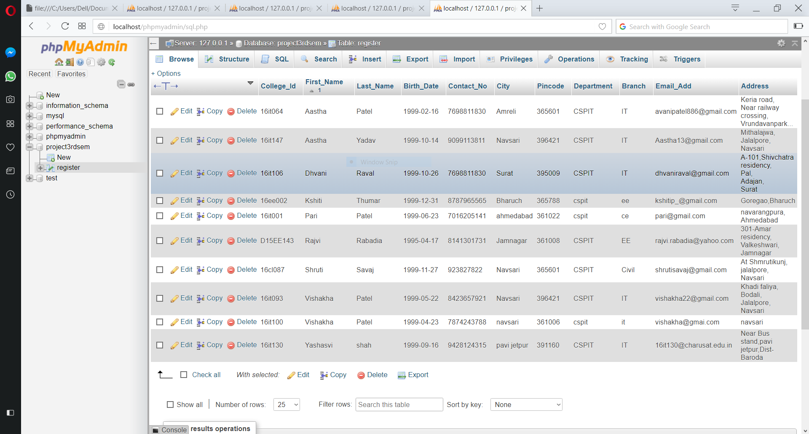

* Updated data:

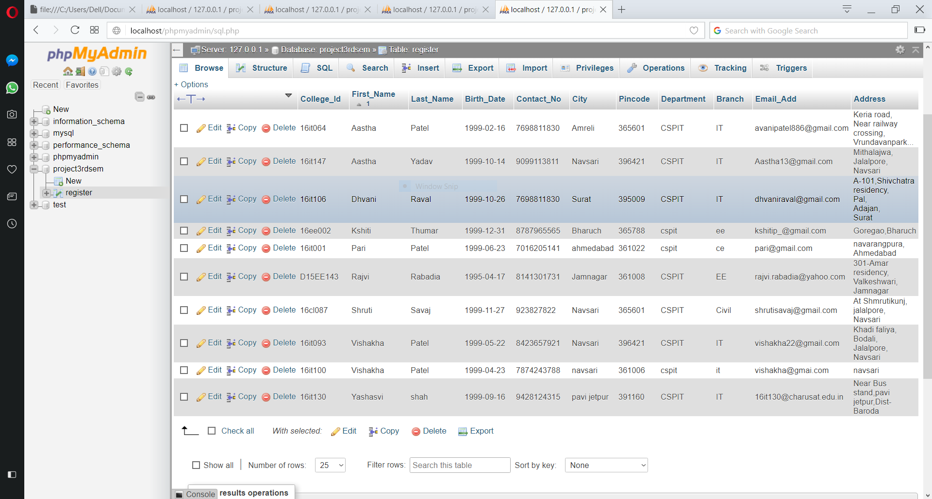

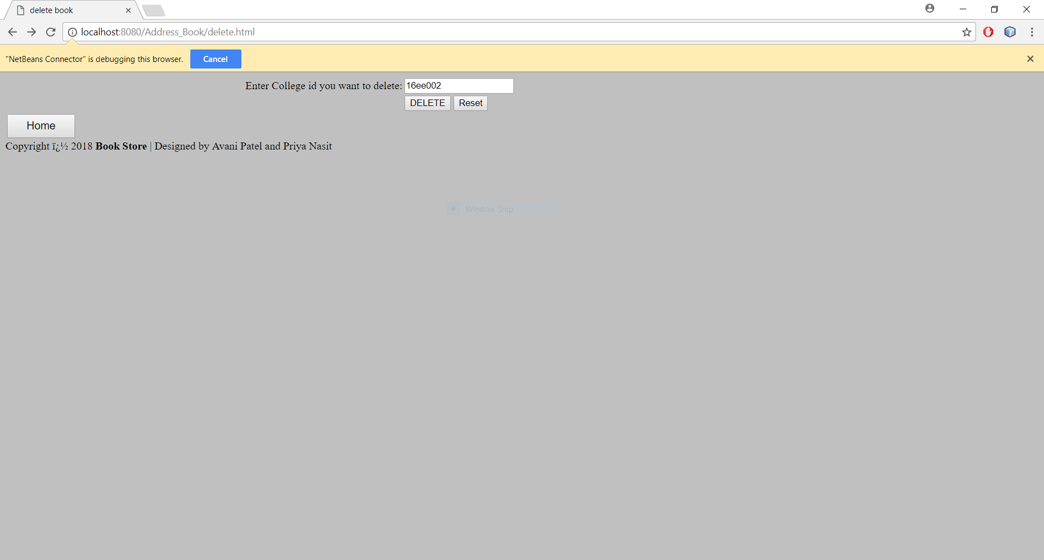

* After delete contact:

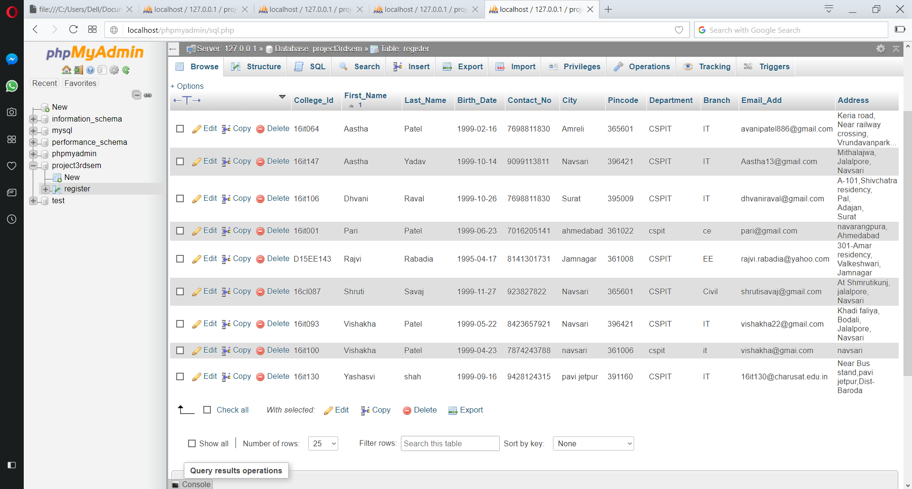

Chapter 5: Constraints

5.1 Constraints:

1. May be website works slowly sometimes due to network problem and some mistake in system.

Due to that it take more time to perform.

2. It is possible that person may not be present at certain address due to mistake in update entry.

3. It is possible that sometimes some mistakes occure in data storage.

Chapter 6: Conclusion

Simple address book system provides the user a basic address book which is used to store the details of the person. The special functions like update,save ,sorting ,delete. User can easily find details of any student whenever required.

References:

<https://www.w3schools.com>

Java Complete Reference

<https://stackoverflow.com>

<https://www.tutorialspoint.com/>