## A

## PROJECT REPORT

## ON

**“Cargo Ship Mangagement System”**

SUBMITTED BY:

## Miss. Avani Sameer Kulkarni(2124UCEF1074)

## Subject

**PROGRAMMING AND PROBLEM SOLVING USING C++**

# Under the guidance of

**Prof.Ishwari Tirse And Prof.Jyotimoyee Kalita**



**Department of Computer Science and Engineering**

**Sanjivani Rural Education Society’s**

**SANJIVANI UNIVERSITY**

## KOPARGAON – 423603, DIST : AHMEDNAGAR

## 2024-2025

|  |  |  |
| --- | --- | --- |
| **SR.**  **NO** | **CONTENT** | **PAGE NO.** |
| **1.** | **INTRODUCTION** | **3** |
| **2.** | **CODE** | **4** |
| **3.** | **OUTPUT** | **7** |
| **4.** | **CONCLUSION** | **8** |

**INDEX**

**__________________________________________**

**INTRODUCTION**

**_________________________________________________________**

In an increasingly globalized economy, efficient management of cargo shipping is essential for optimizing supply chains and ensuring timely deliveries. A Cargo Ship Management System developed in C++ provides a robust solution for managing various aspects of cargo shipping, including inventory tracking, scheduling, and route optimization. This system aims to streamline operations, reduce costs, and enhance overall productivity within the shipping industry. By leveraging the capabilities of C++, the system can handle complex algorithms and large datasets, making it ideal for real-time applications in cargo management.

**CODE**

**______________________________________________**

#include <iostream>

using namespace std;

const int MAX_CARGO_SHIPS = 100; // Maximum number of cargo ships

struct CargoShip {

char name[50];

float weight;

char destination[50];

};

class CargoShipManagement {

private:

CargoShip cargoShipList[MAX_CARGO_SHIPS];

int cargoShipCount;

public:

CargoShipManagement() : cargoShipCount(0) {}

void addCargoShip() {

if (cargoShipCount >= MAX_CARGO_SHIPS) {

cout << "Cargo ship limit reached. Cannot add more cargo ships.\n";

return;

}

cout << "Enter Cargo Ship Name: ";

cin >> cargoShipList[cargoShipCount].name;

cout << "Enter Cargo Ship Weight (in teu): ";

cin >> cargoShipList[cargoShipCount].weight;

cout << "Enter Destination: ";

cin >> cargoShipList[cargoShipCount].destination;

cargoShipCount++;

cout << "Cargo ship added successfully!\n";

}

void displayCargoShips() {

if (cargoShipCount == 0) {

cout << "No cargo ships registered yet.\n";

return;

}

cout << "\nRegistered Cargo Ships:\n";

for (int i = 0; i < cargoShipCount; i++) {

cout << "Cargo Ship Name: " << cargoShipList[i].name

<< ", Weight: " << cargoShipList[i].weight

<< " teu, Destination: " << cargoShipList[i].destination << "\n";

}

}

};

int main() {

CargoShipManagement cargoShipManagement;

int choice;

do {

cout << "\n1. Add Cargo Ship\n2. Display Cargo Ships\n3. Exit\n";

cout << "Enter your choice: ";

cin >> choice;

switch (choice) {

case 1:

cargoShipManagement.addCargoShip();

break;

case 2:

cargoShipManagement.displayCargoShips();

break;

case 3:

cout << "Exiting...\n";

break;

default:

cout << "Invalid choice. Please try again.\n";

}

} while (choice != 3);

return 0;

}

**OUTPUT**

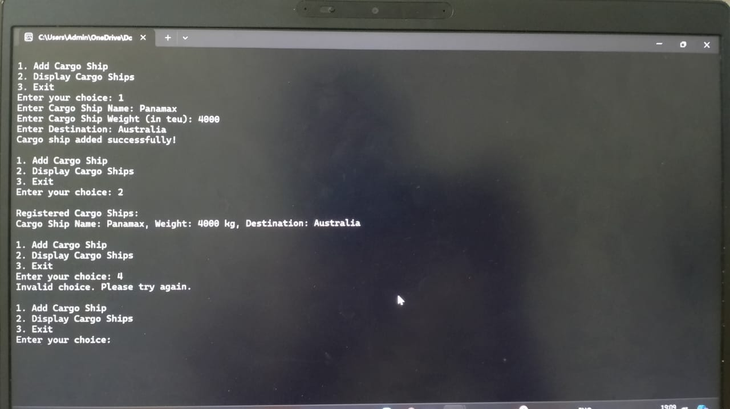

**CONCLUSION**

The Cargo Ship Management System developed using C++ demonstrates the potential of software solutions to transform the shipping industry. With its ability to effectively manage cargo logistics, improve operational efficiency, and reduce human errors, this system serves as a vital tool for shipping companies. As the industry continues to evolve, integrating advanced technologies like this system will be crucial for staying competitive and meeting the demands of modern trade. Ultimately, the implementation of a C++-based cargo management system can lead to significant improvements in service delivery and customer satisfaction.