Experiment No: 21 Date: Enrollment No: 92400133104

Aim: Practical based on Interacting with Web APIs
IDE:
To interact with web APIs using Python and libraries like requests. The practical will involve making GET and POST requests, handling responses, and parsing JSON data. Library Installation pip install requests
Select an API: Choose a public API for testing. For this tutorial, we’ll use the JSONPlaceholder API, a free fake online REST API for testing and prototyping.
Making a GET Request
Fetch a list of posts.
import requests

# Define the API endpoint
url = 'https://jsonplaceholder.typicode.com/posts'

# Make a GET request response = requests.get(url)

# Check the status code if response.status_code == 200: # Parse JSON response posts = response.json() Experiment No: 21 Date: Enrollment No: 92400133104

print("Fetched Posts:") for post in posts[:5]: # Print the first 5 posts print(f"Title: {post['title']}") else: print(f"Failed to retrieve posts. Status code: {response.status_code}")
Output:

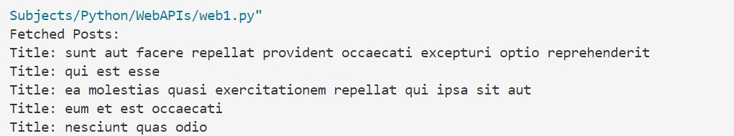
Making a POST Request
Create a new post. import requests

# Define the API endpoint
url = 'https://jsonplaceholder.typicode.com/posts'

# Define the data to send new_post = {
"title": "My New Post",
"body": "This is the content of my new post.",
"userId": 1
Experiment No: 21 Date: Enrollment No: 92400133104

}

# Make a POST request
response = requests.post(url, json=new_post)

# Check the status code if response.status_code == 201: # Parse JSON response created_post = response.json() print("Created Post:") print(f"Title: {created_post['title']}") print(f"Body: {created_post['body']}") else: print(f"Failed to create post. Status code: {response.status_code}")
Output:

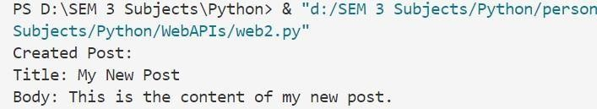
Error Handling
Handle potential errors in API requests.
import requests
Experiment No: 21 Date: Enrollment No: 92400133104

url = 'https://jsonplaceholder.typicode.com/posts/1000' # Non-existent post

response = requests.get(url)

if response.status_code == 200: post = response.json() print("Fetched Post:", post) else:
print(f"Error: {response.status_code} - {response.reason}")
Output:

Post Lab:
Building a Simple API Client (Write a simple Python class that encapsulates the functionality for making GET and POST requests to the JSONPlaceholder API. Include methods for fetching posts and creating a new post.)
Code:

import requests
class JSONPlaceholderClient:
def init (self):
self.base_url = "https://jsonplaceholder.typicode.com"
def fetch_posts(self):
"""Fetches a list of posts.""" try:
response = requests.get(f"{self.base_url}/posts")

Python (01CT1309)
Experiment No: 21 Date: Enrollment No: 92400133104

response.raise_for_status() return response.json()
except requests.exceptions.RequestException as e:
print("Error fetching posts:", e) return None
def create_post(self, title, body, user_id):
"""Creates a new post.""" payload = {"title": title, "body": body, "userId": user_id} try:
response = requests.post(f"{self.base_url}/posts", json=payload) response.raise_for_status() return response.json()
except requests.exceptions.RequestException as e:
print("Error creating post:", e) return None
if name == " main ":
client = JSONPlaceholderClient() posts = client.fetch_posts() if posts:
print("Fetched posts:", posts[:2]) new_post = client.create_post("Sample Title", "Sample body content", 1) if new_post:
print("Created post:", new_post)

Output:

