CS/ECE/EEE/INSTR F241 - Microprocessor and Interfacing

# Smart Lighting System

Group 13 Date: 21/04/2023



# BITS Pilani, K K Birla Goa Campus



**Submitted by:**

Hridya Arora 2021A7PS2538G

Krishna Sethiya 2021A7PS1440G

Pathik Shah 2021A7PS2085G

Jatin Dahiya 2021A7PS2067G

Avani Agarwal 2021A7PS2585G

Pratyush Suvarna 2021A7PS1441G

## INDEX

|  |  |
| --- | --- |
| **TITLE** | **PAGE NUMBER** |
| PROBLEM STATEMENT | 3 |
| ASSUMPTIONS | 4 |
| DEVICE SPECIFICATIONS | 4 |
| HARDWARE DEVICES | 5 |
| JUSTIFICATION | 6 |
| ADDRESS MAP | 7 |
| FLOWCHART | 8 |
| DESIGN | 11 |
| LIST OF ATTACHMENTS | 12 |

## PROBLEM STATEMENT

Description: This is a lighting system for a conference room. As the seats get filled the light should be turned on. The rows are filled from row1 onwards. There are 4 lights per row. As each row begins to get filled the lights get turned on. As each rows empties completely the light gets turned off. You can assume there are at least 5 rows. Entry to the auditorium is restricted to a certain point of time. Exit can be at any point of time.

System Details:

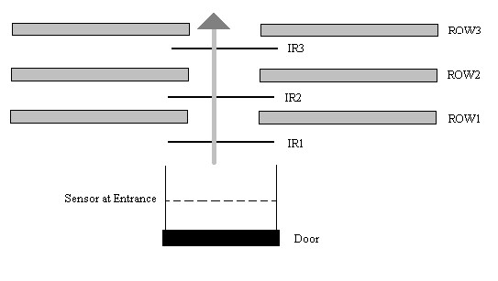

## ASSUMPTIONS

* Only one person can enter or exit at any given time.
* The conference room has 5 rows.
* Each row has a maximum capacity of 10 people.
* People cannot switch rows.
* Entry to the auditorium is restricted to a certain point of time. Exit can be at any point of time.
* Rows are filled sequentially i.e. The lower rows have to be completely filled before the upper rows can begin to be occupied.
* The ALP written does not access any non-usable memory locations.

## DEVICE SPECIFICATIONS

* 1 IR sensor for the entry/exit gate (IR0).
* 1 IR sensor for each individual row (IR1, IR2, IR3, IR4, IR5).
* Each IR sensor is high active output.

## HARDWARE DEVICES

|  |  |  |
| --- | --- | --- |
| **CHIP NUMBER** | **CHIP** | **QUANTITY REQUIRED** |
| 8086 | Microprocessor | 1 |
| 2716 | ROM 2K | 4 |
| 6116 | RAM 2K | 2 |
| 74LS373 | 8 Bit Latch | 3 |
| 74LS138 | 3:8 Decoder | 1 |
| 74LS245 | 8 Bit Buffer | 2 |
| 8255 | Programmable  Peripheral Interface | 1 |
| 8259 | Programmable  Interrupt Controller | 1 |
| LED | Common Anode  Configuration | 20 |
| SRD 05V-DC SL-C | Optical Relay | 5 |
| 555-28027 | PIR Sensor | 6 |
| OR, NOT | Gates | 3 NOT, 10 OR |

## JUSTIFICATION

* 8086: Microprocessor
* 8284: For Stable Clock Timer
* LED: Connected to relays.
* 8255: Input and Output ports
* 6116: Smallest RAM chip available is of 2K and is required for stack, temporary storage and the odd and even banks.
* 2716: Smallest ROM chip available is 2K, and is required for even and odd banks with base address 00000H and reset address at FFFF0H
* PIR Sensor: For motion detection
* 74LS138: A 3:8 line decoder
* SRD 05V-DC SL-C Optical Relays: Common cathode light amplification
* 74LS373,74LS245 and required gates
* PIR Sensor: Motion Detection

## ADDRESS MAP

Total RAM - 4KB

Total ROM - 8KB

RAM consists of two 2K chips.

ROM consists of four 2K chips.

**MEMORY MAPPING**

ROM 1: 00000H - 00FFFH

RAM 1: 01000H – 01FFFH

ROM 2: FF000H - FFFFFH

**I/O MAPPING**

8255: 00H – 06H

PORTA - 00H (Not Used)

PORTB – 02H (Not Used)

PORTC – 04H (Output to LEDs)

CWR – 06H (CONTROL REGISTER)

8259A: 08H-0AH

ICWR – 08H

OCWR – 0AH

## FLOW CHART

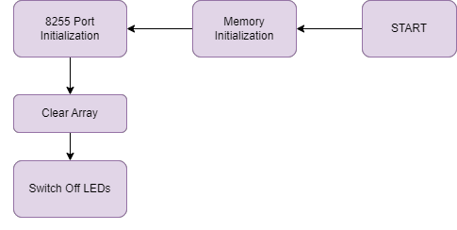

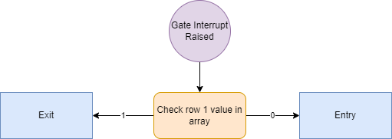

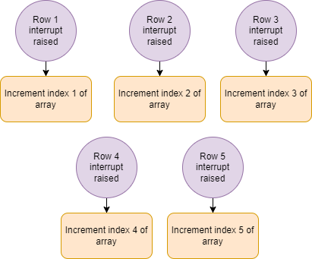

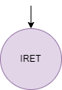

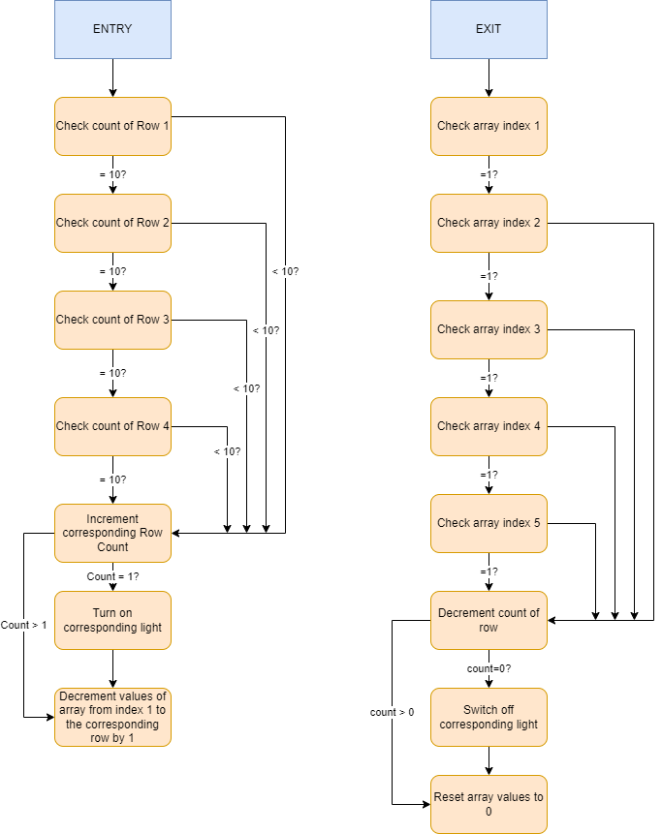

## DESIGN

* Optical Relay

* Infrared Sensor

* 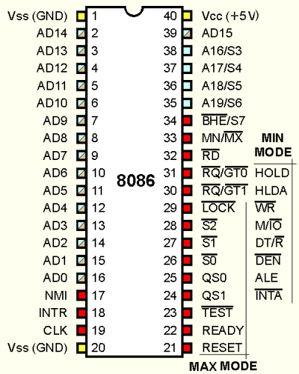**8086 Microprocessor pinout:**

## 2716 Rom Pinout:

## 

## 6116 Ram Pinout:

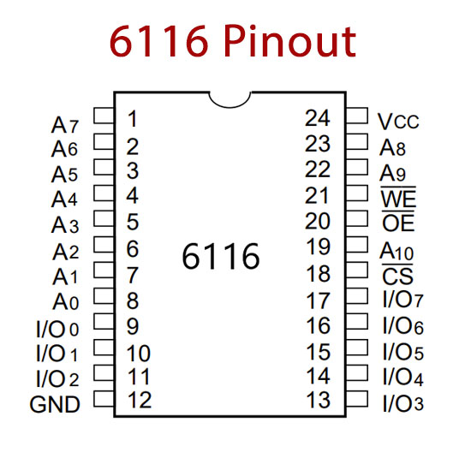

* **74LS373 Latch Pinout:**

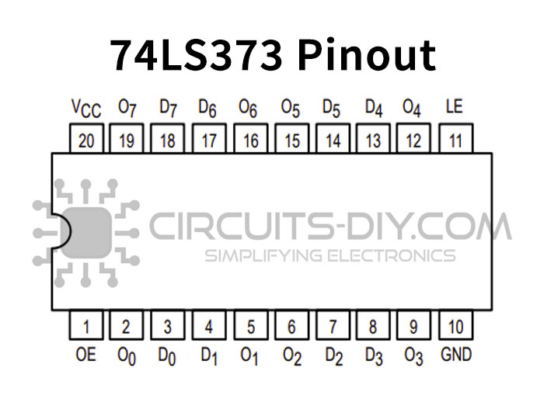

* **74LS138 Decoder Pinout:**

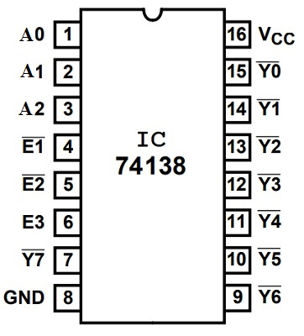

## 74LS245 Buffer Pinout:

## 

* 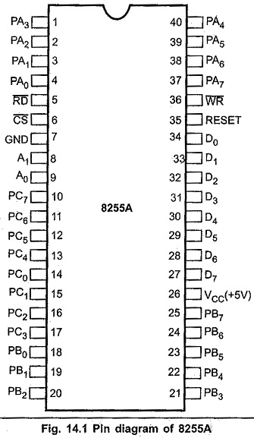**8255 Programmable Peripheral Interface Pinout:**

## 8259 Programmable Interrupt Handler

## 

THANK YOU