**Entity Relational Model(ERD):**

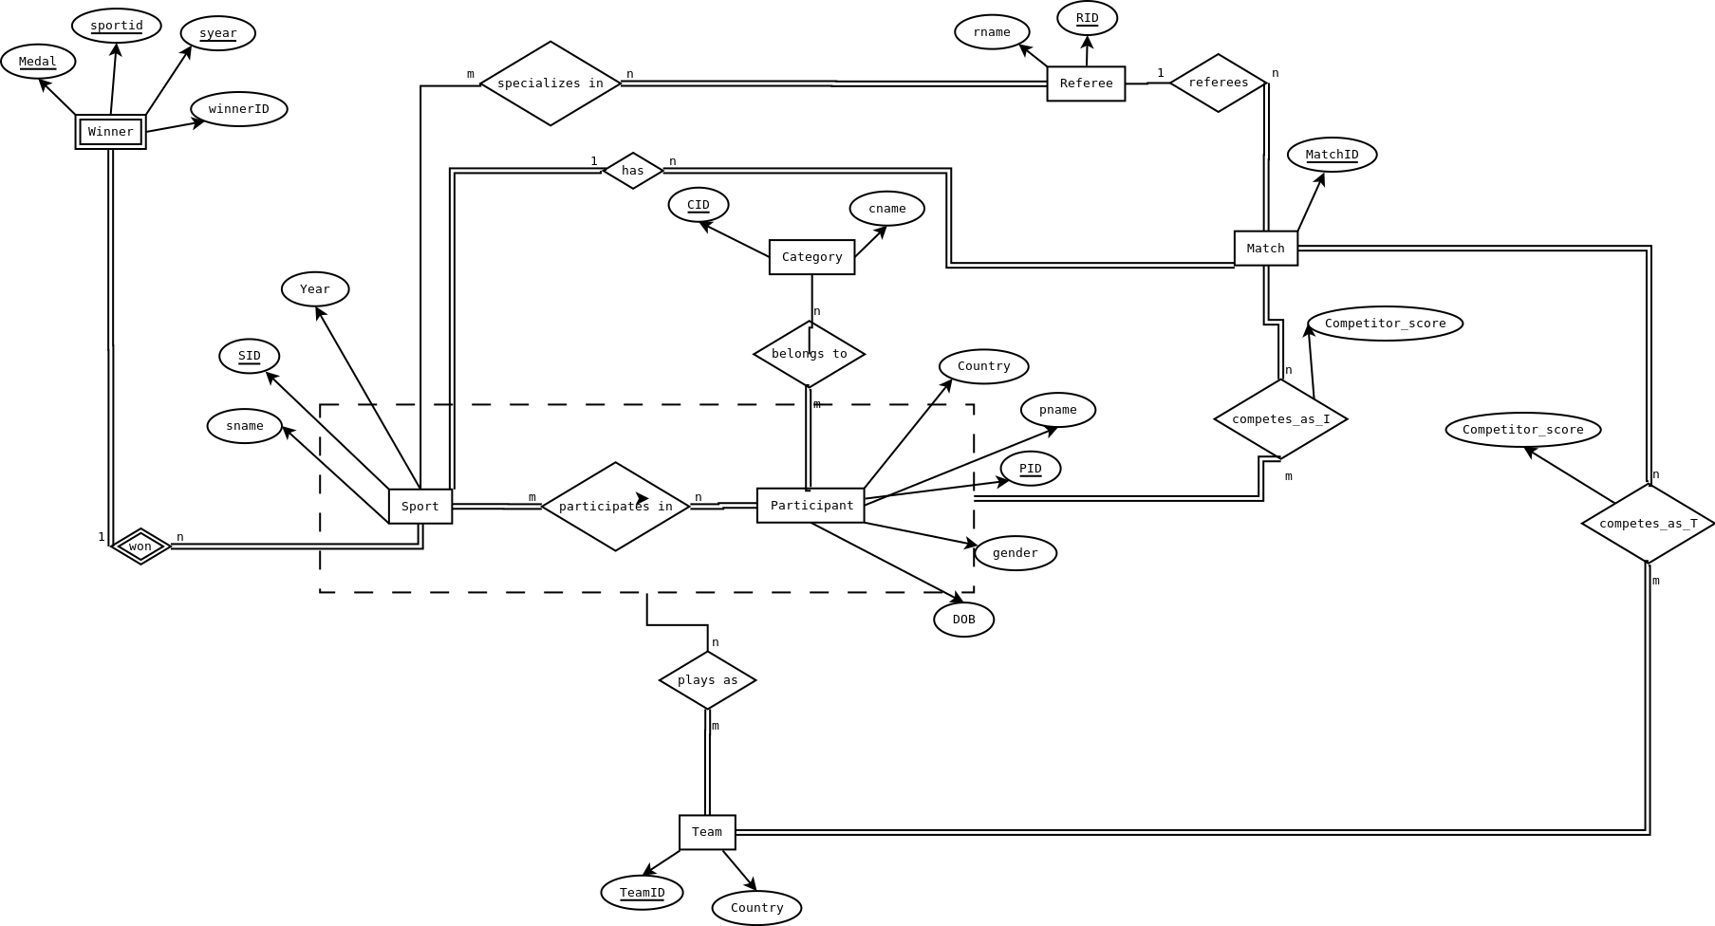

**Relational Schema:**

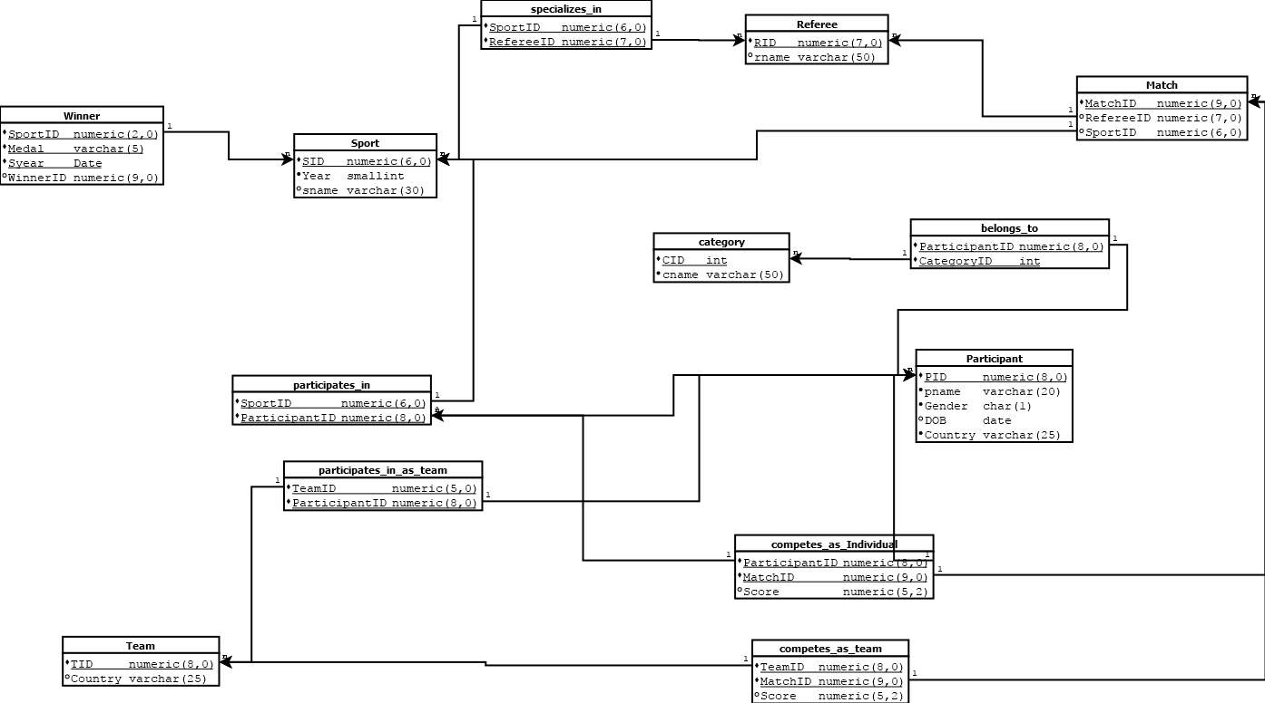

**Relational Model:**

* **Sport**(SID,Year,sname)
* **Participant**(PID,pname,gender,DOB,Country)
* **Category**(CID,cname)
* **BelongsTo**(ParticipantD,CategoryID)
* **Team**(TID,Country)
* **ParticipatesIn**(SportID,ParticipantID)
* **ParticipatesInTeam**(TeamID,ParticipantID)
* **Match**(MatchID,RefereeID,SportID)
* **Referee**(RID,rname)
* **SpecializesIn**(SportID,refereeID)
* **CompetesAsIndividual**(ParticipantID,MatchID,Score)
* **CompetesAsTeam**(teamtID,MatchID,Score)
* **Winner**(sportID,medal,syear,winnerID)

**Functional Dependencies :**

**Sports :**

Minimal FDs:

* SID →sname
* SID →Year

Canonical Form :

* SID →{sname,year}

**Participant :**

Minimal FDs :

* PID → pname
* PID → gender
* PID → DOB
* PID → Country

Canonical Form :

* PID → {pname,gender,DOB,Country}

**Category :**

* CID → cname

**Team :**

* TID → Country

**Match :**

Minimal FDs :

* MatchID → RefereeID
* MatchID → SportID

Canonical Form:

* MatchID → {RefereeID,SportID}

**Referee** :

* RID → rname

**CompetesAsIndividual :**

* {ParticipantID,MatchID}→ Score

**CompetesAsTeam :**

* {teamID, MatchID} → Score

**Winner :**

* {SportID,Medal,Syear} → WinnerID

**All the relations in the given database are in BCNF.**