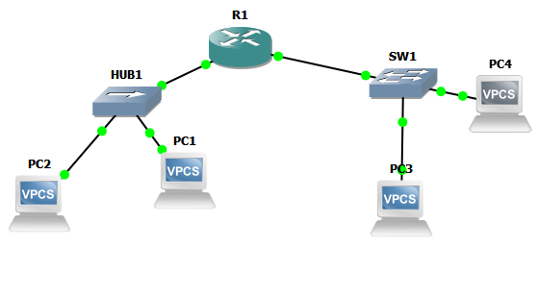

R1#sh run

Building configuration...

Current configuration : 1827 bytes

!

version 12.4

service timestamps debug datetime msec

service timestamps log datetime msec

no service password-encryption

!

hostname R1

!

boot-start-marker

boot-end-marker

!

!

no aaa new-model

!

resource policy

!

memory-size iomem 5

ip subnet-zero

no ip icmp rate-limit unreachable

ip cef

ip tcp synwait-time 5

!

!

no ip dhcp use vrf connected

!

ip dhcp pool inside

network 192.168.1.0 255.255.255.0

default-router 192.168.1.1

!

ip dhcp pool outside

network 192.168.2.0 255.255.255.0

default-router 192.168.2.1

!

!

no ip domain lookup

!

!

!

!

!

!

!

!

!

interface FastEthernet0/0

ip address 192.168.1.1 255.255.255.0

duplex auto

speed auto

!

interface Serial0/0

no ip address

shutdown

clock rate 2000000

!

interface FastEthernet0/1

ip address 192.168.2.1 255.255.255.0

ip helper-address 192.168.2.1

duplex auto

speed auto

!

interface Serial0/1

no ip address

shutdown

clock rate 2000000

!

interface Serial0/2

no ip address

shutdown

clock rate 2000000

!

interface FastEthernet1/0

!

interface FastEthernet1/1

!

interface FastEthernet1/2

!

interface FastEthernet1/3

!

interface FastEthernet1/4

!

interface FastEthernet1/5

!

interface FastEthernet1/6

!

interface FastEthernet1/7

!

interface FastEthernet1/8

!

interface FastEthernet1/9

!

interface FastEthernet1/10

!

interface FastEthernet1/11

!

interface FastEthernet1/12

!

interface FastEthernet1/13

!

interface FastEthernet1/14

!

interface FastEthernet1/15

!

interface FastEthernet2/0

no ip address

shutdown

duplex auto

speed auto

!

interface Vlan1

no ip address

!

ip classless

!

no ip http server

no ip http secure-server

!

no cdp log mismatch duplex

!

!

control-plane

!

!

!

line con 0

exec-timeout 0 0

privilege level 15

password \*\*\*\*\*

logging synchronous

line aux 0

exec-timeout 0 0

privilege level 15

logging synchronous

line vty 0 4

login

!

!

end