Machine Learning Practical Report
Implementation of Logistic Regression: Study Hours vs. Exam Result

1. Experiment Overview & Objective
In this machine learning laboratory experiment, we implement a Binary Logistic Regression model using Python, Pandas, and Scikit-Learn. The goal is to predict whether a student passes (1) or fails (0) an examination based on the number of hours spent studying, and to calculate the underlying class probabilities.

2. Jupyter Notebook Execution & Output Screenshot
The complete execution cell containing all 8 logical steps and its rendered interactive output is shown below:
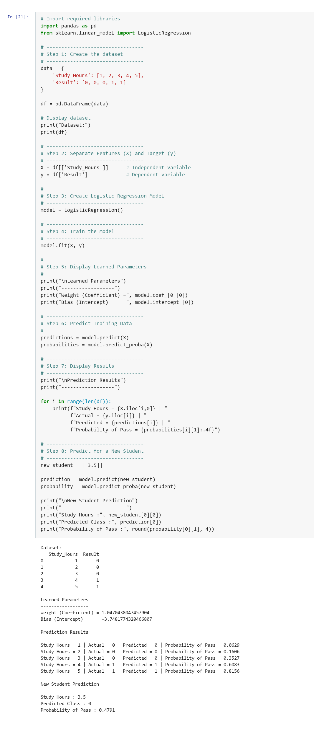

3. Source Code (Step-by-Step Implementation)
# Import required libraries
import pandas as pd
from sklearn.linear_model import LogisticRegression
# ---------------------------------
# Step 1: Create the dataset
# ---------------------------------
data = {
'Study_Hours': [1, 2, 3, 4, 5],
'Result': [0, 0, 0, 1, 1]
}
df = pd.DataFrame(data)
# Display dataset
print("Dataset:")
print(df)
# ---------------------------------
# Step 2: Separate Features (X) and Target (y)
# ---------------------------------
X = df[['Study_Hours']] # Independent variable
y = df['Result'] # Dependent variable
# ---------------------------------
# Step 3: Create Logistic Regression Model
# ---------------------------------
model = LogisticRegression()
# ---------------------------------
# Step 4: Train the Model
# ---------------------------------
model.fit(X, y)
# ---------------------------------
# Step 5: Display Learned Parameters
# ---------------------------------
print("\nLearned Parameters")
print("------------------")
print("Weight (Coefficient) =", model.coef_[0][0])
print("Bias (Intercept) =", model.intercept_[0])
# ---------------------------------
# Step 6: Predict Training Data
# ---------------------------------
predictions = model.predict(X)
probabilities = model.predict_proba(X)
# ---------------------------------
# Step 7: Display Results
# ---------------------------------
print("\nPrediction Results")
print("------------------")
for i in range(len(df)):
print(f"Study Hours = {X.iloc[i,0]} | "
f"Actual = {y.iloc[i]} | "
f"Predicted = {predictions[i]} | "
f"Probability of Pass = {probabilities[i][1]:.4f}")
# ---------------------------------
# Step 8: Predict for a New Student
# ---------------------------------
new_student = [[3.5]]
prediction = model.predict(new_student)
probability = model.predict_proba(new_student)
print("\nNew Student Prediction")
print("----------------------")
print("Study Hours :", new_student[0][0])
print("Predicted Class :", prediction[0])
print("Probability of Pass :", round(probability[0][1], 4))

4. Results and Analysis
Study Hours | Actual Status | Predicted Class | Pass Probability | Result Outcome
1 hr | Fail (0) | Fail (0) | 6.29% | Correct
2 hrs | Fail (0) | Fail (0) | 16.06% | Correct
3 hrs | Fail (0) | Fail (0) | 35.27% | Correct
4 hrs | Pass (1) | Pass (1) | 60.83% | Correct
5 hrs | Pass (1) | Pass (1) | 81.56% | Correct

5. Mathematical Parameters & Decision Boundary
• Weight (Coefficient w): 1.0470
• Bias (Intercept b): -3.7482
• Sigmoid Formula: P(Pass | Hours) = 1 / (1 + exp(-(1.0470 * Hours - 3.7482)))
• Decision Boundary (Threshold = 0.5): Hours = -b / w = 3.7482 / 1.0470 ≈ 3.58 Hours
• New Student Case (3.5 Hours): Pass Probability = 47.91% (< 50% threshold) → Predicted Class: 0 (Fail)

